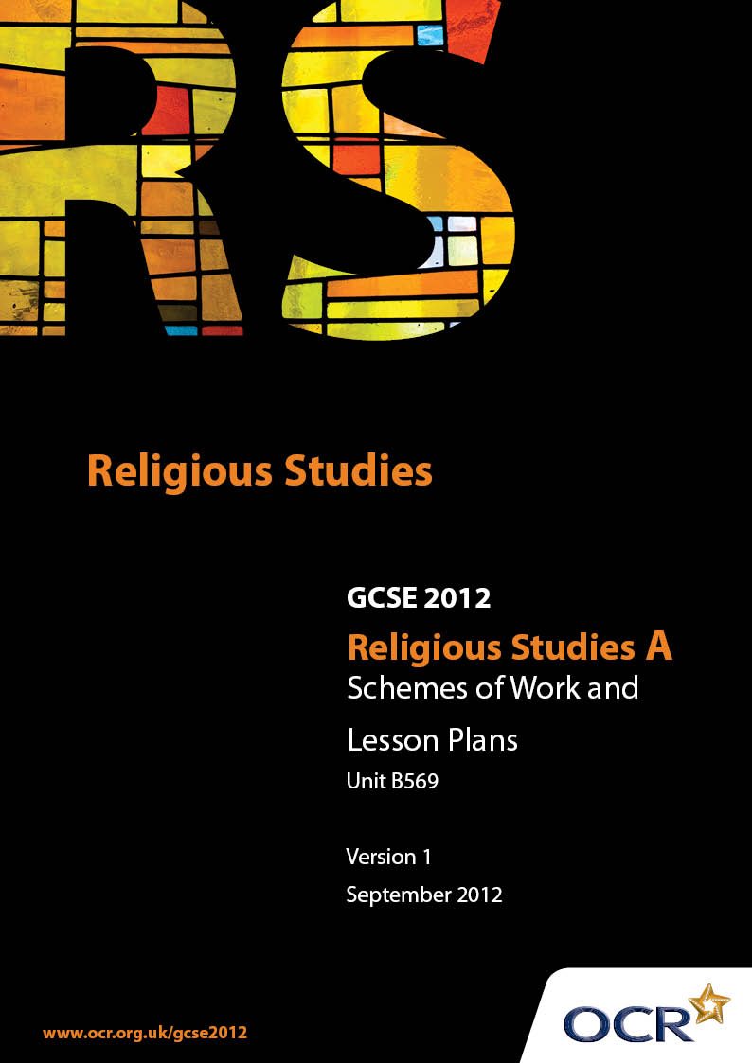

Contents
Contents 2
Introduction 3
Sample Scheme of Work: Unit B569: Buddhism 1 (Beliefs, Special Days, Divisions and Interpretations) 5
Sample Lesson Plan: Unit B569: Buddhism 1 (Beliefs, Special Days, Divisions and Interpretations) 14

Introduction

Background
Following a review of 14 – 19 education and the Secondary Curriculum Review, the Qualifications and Curriculum Authority (QCA) has revised the subject criteria for GCSEs, for first teaching in September 2009. This applies to all awarding bodies.
The new GCSEs have more up-to-date content and encourage the development of personal, learning and thinking skills in your students.
We’ve taken this opportunity to redevelop all our GCSEs, to ensure they meet your requirements. These changes will give you greater control of assessment activities and make the assessment process more manageable for you and your students. Controlled assessment will be introduced for most subjects.
From September 2012 assessment tasks may be undertaken at any point between release of the task and the examination series for which the task must be submitted. Centres must ensure that candidates undertake a task that is valid for submission in the year in which the candidate intends to submit it.
OCR has produced a summary brochure, which summarises the changes to Religious Studies. This can be found at www.ocr.org.uk, along with the new specification.
In order to help you plan effectively for the implementation of the new specification we have produced these Schemes of Work and Sample Lesson Plans for Religious Studies. These Support Materials are designed for guidance only and play a secondary role to the Specification.

Our Ethos
OCR involves teachers in the development of new support materials to capture current teaching practices tailored to our new specifications. These support materials are designed to inspire teachers and facilitate different ideas and teaching practices.
Each Scheme of Work and set of sample Lesson Plans is provided in Word format – so that you can use it as a foundation to build upon and amend the content to suit your teaching style and students’ needs.
The Scheme of Work and sample Lesson plans provide examples of how to teach this unit and the teaching hours are suggestions only. Some or all of it may be applicable to your teaching.
The Specification is the document on which assessment is based and specifies what content and skills need to be covered in delivering the course. At all times, therefore, this Support Material booklet should be read in conjunction with the Specification. If clarification on a particular point is sought then that clarification should be found in the Specification itself.

A Guided Tour through the Scheme of Work

= Innovative Teaching Idea
This icon is used to highlight exceptionally innovative ideas.


= ICT Opportunity
This icon is used to illustrate when an activity could be taught using ICT facilities.

Unit B569: Buddhism 1 (Beliefs, Special Days, Divisions and Interpretations)
Suggested teaching time | 9 hours | Topic | Core Beliefs
Topic outline |  | Suggested teaching and homework activities |  | Suggested resources | Points to note
Introduction to different lifestyles  What does it mean to be part of the royal family today? |  | - Stimulus: celebrity magazines, websites of the ‘rich and famous’  - How does money, wealth, luxury etc feature in celebrity lifestyle?  - Consider how the modern royal family is depicted, particularly its younger members.  Do they have an enviable lifestyle?  - Make a comparative study of the life of a young royal and their own, education, occupation, marriage, possessions, money etc  - What expectations are common to all future monarchs? What expectations are common to the students? |  | - The Buddhist Experience  [Mel Thompson]  - Buddhism For today  [Chris Wright]  - This is RE 1  [Cath Large]  - Introduction to the Buddhist Experience  Donald Mitchell  - Various websites including  www.thebuddhistsociety.org | - This is an introduction into the lifestyle of people whose lives are often made enviable by the press and internet. How do their lifestyles compare to our own?  - Do students value the monarchy?  - What do they perceive their role to be?  - Students should be in a position to understand how the role of the monarch may have changed but was once considered imperative to the future of an individual country from a political and religious viewpoint
The Birth and Life of Siddhartha |  | - Construct a narrative timeline of the main points of the birth and early life of Siddhartha to include:  - His birth at Lumbini and the myths  surrounding his special status  - The forecast for his future by ascetics.  - His upbringing, education and marriage  - The role of Shuddhodana in preventing his  son’s social education |  | As above
The Four Sights |  | - Stimulus: Most Buddhism text books depict the four sights. Students are invited to evaluate compare these images to the modern day equivalent of death, poverty illness, the role of a priest etc  - Create a comparative list of Siddhartha’s life of luxury and the life of his subjects  - Use this list to assess what Siddhartha will be giving up if he leaves the palace  - Construct a letter from Siddhartha to his father to explain what has happened and why he is prepared to give up his life of luxury and abandon his royal responsibilities |  | As above | - Students should focus on the nature of the experience Siddhartha gained from the four sights  - Students should look to evaluate and understand how the aspect of ‘suffering’ has become a focus for Siddhartha and will later dominate the philosophy of Buddhism

Unit B569: Buddhism 1 (Beliefs, Special Days, Divisions and Interpretations)
Suggested teaching time | 12 hours | Topic | Special Days
Topic outline |  | Suggested teaching and homework activities |  | Suggested resources | Points to note
Introduction  The meaning of special days.  The ways in which Buddhists observe them.  Uposatha Days  Wesak  Rain retreats |  | - Brainstorm religious special day, e.g. Christmas day and a personal special day, e.g. their birthday  - Using the teachings of the Buddha in various textbooks, evaluate the lack of relevance placed on religious festivals by Buddhists but the importance of attitude and how festivals help to reinforce community spirit and commemorate the Buddha’s teachings  - Construct a timeline of four columns to contain, month, name of festival, relation to the Buddha and festivities that occur |  | - Introduction to the Buddhist Experience  [D.Mitchell]  - Various internet websites | - Students should note the elements of celebrating special days that are both common and traditional to all schools of Buddhism  - Can students identify the links between the activities connected to celebration and the teachings concerned with specific days during the festivals,  e.g. Asala, the first day of Vassa and Kathina
The Rain Retreats |  | - In groups of 2 to 6, students take each festival and create a television script to describe events related to this celebration  The Rain Retreats  - Their script should include  - A narrative introduction of the history of  the tradition of this festival.  - The activities that mark the beginning and  end of the retreat  - The meaning of relevant key words  should be explained to the ‘audience’  - An interview with members of the laity  who often some of the retreat  - The conclusion of the script should  contain evidence of the significance of the  Rain Retreats to both the Sangha and  laity |  | Various internet sites  e.g. en.wikipedia.org/wiki/Vassa | - Students will investigate the three special festivals related to this part of the specification with an objective to:  - Evaluate the ways in which the festivals might affect the life of the Buddhist  - How the teachings of the Dhamma are reinforced during each festival  - How the community, both Sangha and laity are brought together
The significance of special days and spiritual development |  | - Using the television scripts made by individual groups related to special days, students can evaluate the importance of making the commitment to observe these special times and how it might reinforce aspects of their faith  - Interpret the emphasis of the three refuges as the focus of the festivals |  | - As above | - When evaluating the conclusions drawn about the significance of special days to a Buddhist, relevance could be drawn to the statement: ‘Special days are not important to a Buddhist.’ Do you agree?

Unit B569: Buddhism 1 (Beliefs, Special Days, Divisions and Interpretations)
Suggested teaching time | 12 hours | Topic | Major Divisions and Interpretations
Topic outline |  | Suggested teaching and homework activities |  | Suggested resources | Points to note
Introduction to the different types of Buddhism:  Therevada, Mahayana, Tibetan and Zen, the Western Buddhist Order. |  | - Research the spread of Buddhism through different eastern countries and eventually to western countries with a view to understanding the cultural adaptations that have taken place to Buddhist traditions  - Investigate each different type of Buddhism and produce a ‘Focus File’ to evaluate the different elements of each tradition  Each file should include:  - Country of origin  - Styles of shrines, viharas, temples  - Types of meditation and worship  - The relationship between the Sangha and the laity  - Adaptations of the Buddha’s teachings |  | - The Buddhist Experience  [M. Thompson]  - Introduction to the Buddhist Experience  [D.Mitchell]  - Various internet websites | - Students should attempt to link the way in which the passage of time and the different attitude of cultures may have affected the original meaning of Buddhism and teachings of the Buddha  - Are there elements of Buddhism that have remained prominent within the different types of Buddhism?
Comparing similarities and differences between the different forms of Buddhism. |  | - Students pool their resources  - Activities may include:  - Presentations of findings by:  Group and individual presentations  - Speaking and Listening  - Power point adaptations  - Create a poster to advertise the form of Buddhism they would most like to follow that will promote the features they find the most appealing  - Consolidate their work by using each others and their own research to make personal notes |  | - Text books as above  - Various internet websites | - Students may wish to reflect on the areas of each Buddhist tradition they might find the easiest or most difficult to accept or adapt to  - Question: Which elements of Buddhist practice proves both discipline and devotion?
Reinforcing the main elements of Buddhism to and how they are reflected in the different schools of Buddhism. |  | - Recap on the work investigating the different Buddhist schools  - Create a revision overview to compare the similarities and differences between the different traditions  - Consider why different forms of Buddhism now exist  - Evaluate whether the different adaptations of Buddhism have strengthened or weakened the Buddha’s original teachings |  | - As above | - Creating a revision overview will allow students to draw together many elements and strands from this course in preparation for their exam

Unit B569: Buddhism 1 (Beliefs, Special Days, Divisions and Interpretations)

The Life of the Buddha
OCR recognises that the teaching of this qualification above will vary greatly from school to school and from teacher to teacher. With that in mind this lesson plan is offered as a possible approach but will be subject to modifications by the individual teacher.
Lesson length is assumed to be one hour.

Learning Objectives for the Lesson
Objective 1 | Students to understand the term ‘suffering’ and how it may act in both a positive and negative way in choose to live our lives.
Objective 2 | Students to create a timeline of events to describe the Siddhartha’s birth, childhood and marriage.
Objective 3 | Students create a letter from Siddhartha to his father to analyse the reason for his departure from the palace in search of the answer to suffering.

Recap of Previous Experience and Prior Knowledge
- Students recap on prior lessons connected to the early life of Siddhartha, the facts about his birth, protected upbringing and marriage until the experience of the Four Sights.

Content
Time | Content
5 minutes | Stimulus: Students asked to define the word ‘suffering’ and provide a verbal account examples of suffering of an individual and a global basis. Students conclude with a written definition.
5 minutes | Students brainstorm a timeline of the early life of Prince Siddhartha and what they know relating to his father’s efforts to protect him from the world outside the palace.  Students add at least one fact which gives an indication of the nature of Siddhartha’s future, e.g. his mothers dream, his birth, the forecast of his future by an ascetic.
15 minutes | Teacher [using available text book and verbal explanation] gives an account of the Four Sights.  - Old Age  - Sickness  - Death  - The Sadhu
15 minutes | Students work in pairs to create a rough draft of a letter from Siddhartha to his father to explain;  - Why he disobeyed his father and left the palace grounds.  - A description of the Four Sights  - Why he must leave to search for an answer to end the suffering of his people.
10 minutes | Selected students’ feedback to others by reading their letter. They are asked to empathise with the feelings of both Siddhartha and his father.  Class vote: Students debate and vote on the difference Siddhartha can make to the lives of his subjects if he leaves the palace or stays to become their future king.

Consolidation
Time | Content
5 minutes | Students continue to work in pairs to find five key words to describe how Siddhartha might be feeling about what he is about to do.
 | Homework or future lesson: Students formulate a written response from Siddhartha’s father asking three questions that will help him to understand how Siddhartha can help his subjects by leaving the palace and giving up the throne.

Unit B569: Buddhism 1 (Beliefs, Special Days, Divisions and Interpretations)

Investigating Wesak
OCR recognises that the teaching of this qualification above will vary greatly from school to school and from teacher to teacher. With that in mind this lesson plan is offered as a possible approach but will be subject to modifications by the individual teacher.
Lesson length is assumed to be one hour.

Learning Objectives for the Lesson
Objective 1 | Students to understand why a particular day is considered special.
Objective 2 | Students investigate the festival of Wesak and its relevance to the life of Siddhartha
Objective 3 | Students produce an A3 overview of the main elements of the festival to prompt knowledge and understanding.

Recap of Previous Experience and Prior Knowledge

Content
Time | Content
5 minutes | Stimulus: Students view power point, photo display of different religious festivals religious festivals.  Discussion: Why are they important to followers of their relevant faith?
5 minutes | Students make a list of the types of celebration relevant to a world faith of their choice and how the celebrations help the followers to remember why that day is special.
15 minutes | Students work in small groups using internet and library research to investigate the Buddhist festival of Wesak.
15 minutes | Students continue to consolidate the information they have found by creating an A3 overview to include photocopied and cut and paste extracts, photographs of the celebrations etc.
10 minutes | Students feedback their knowledge gained:  - Each group presents their work.  - Students are invited to test their knowledge through peer question and answer sessions.

Consolidation
Time | Content
5 minutes | Students asked to think of a key word that might explain why it might be useful to have special days like Wesak as part of the Buddhist tradition. Students link key words to examples in their A3 overviews.
 | Homework or future lessons: Students write a postcard home as an observer of the festival to describe some of the festivities and the way in which the community may be strengthened by them.

Unit B569: Buddhism 1 (Beliefs, Special Days, Divisions and Interpretations)

Zen Buddhism Meditation Game
OCR recognises that the teaching of this qualification above will vary greatly from school to school and from teacher to teacher. With that in mind this lesson plan is offered as a possible approach but will be subject to modifications by the individual teacher.
Lesson length is assumed to be one hour.

Learning Objectives for the Lesson
Objective 1 | Students aim to recap their knowledge Zen Buddhism.
Objective 2 | Students think of five rules they can apply to stimulate their senses to make an ordinary event in their everyday lives more special.
Objective 3 | Students create a set of meditation cards to aid concentration and focus.

Recap of Previous Experience and Prior Knowledge
- This lesson is intended to help the students to revise on a particular part of Zen Buddhism; they could apply the game to other areas of this course. They will need access to various resources to create professional looking playing cards.

Content
Time | Content
5 minutes | Students recap on their knowledge of Zen Buddhism, particularly the aid of a visual stimulus to help concentration and meditation.
5 minutes | Students divide into groups of four with each person adopting one of the senses, sight, touch, smell, sound. They each choose two everyday acts, examples might include;  - packing their school bag  - making breakfast  - walking to school  - standing in the lunch queue  Thereby creating the provision for eight meditation cards.
15 minutes | Each student applies the Zen principle of becoming focused on every detail of that activity and training their mind to the simplest pleasure that may surround it by applying each of the four senses in their description.
15 minutes | Students continue to produce the narrative stimulus for the cards.
10 minutes | Class discussion: Students discuss and share the ways in which their prolonged use of the senses they normally take for granted might help them to  - Think more deeply  - Help solve problems  - Create a deeper understanding of their goal of enlightenment.

Consolidation
Time | Content
5 minutes | Students’ feedback on the progress made and they feel they have personally benefited from applying a ‘sensory’ point of view to what they may have previously considered to be everyday mundane acts.
 | Homework or future lessons: Students find internet of photographic stimulus for the front of their Zen meditation cards.

