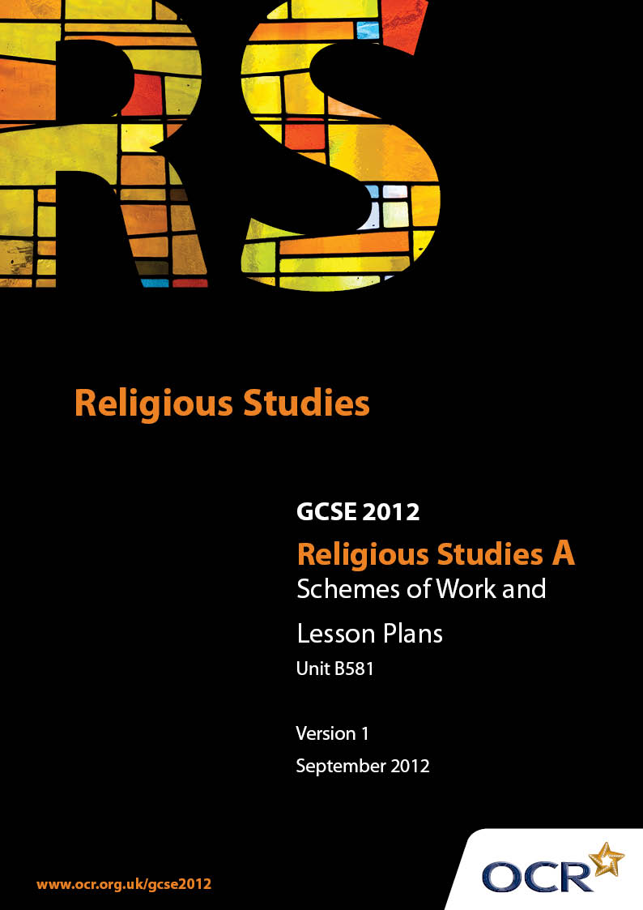

Contents
Introduction 3
Sample Scheme of Work: Unit B581: Sikhism 1 (Beliefs, Special Days, Divisions and Interpretations) 5
Sample Lesson Plan: Unit B581: Sikhism 1 (Beliefs, Special Days, Divisions and Interpretations) 11

Introduction

Background
Following a review of 14 – 19 education and the Secondary Curriculum Review, the Qualifications and Curriculum Authority (QCA) has revised the subject criteria for GCSEs, for first teaching in September 2009. This applies to all awarding bodies.
The new GCSEs have more up-to-date content and encourage the development of personal, learning and thinking skills in your students.
We’ve taken this opportunity to redevelop all our GCSEs, to ensure they meet your requirements. These changes will give you greater control of assessment activities and make the assessment process more manageable for you and your students. Controlled assessment will be introduced for most subjects.
From September 2012 assessment tasks may be undertaken at any point between release of the task and the examination series for which the task must be submitted. Centres must ensure that candidates undertake a task that is valid for submission in the year in which the candidate intends to submit it.
OCR has produced a summary brochure, which summarises the changes to Religious Studies A. This can be found at www.ocr.org.uk, along with the new specification.
In order to help you plan effectively for the implementation of the new specification we have produced these Schemes of Work and Sample Lesson Plans for Religious Studies A. These Support Materials are designed for guidance only and play a secondary role to the Specification.

Our Ethos
OCR involves teachers in the development of new support materials to capture current teaching practices tailored to our new specifications. These support materials are designed to inspire teachers and facilitate different ideas and teaching practices.
Each Scheme of Work and set of sample Lesson Plans is provided in Word format – so that you can use it as a foundation to build upon and amend the content to suit your teaching style and students’ needs.
The Scheme of Work and sample Lesson plans provide examples of how to teach this unit and the teaching hours are suggestions only. Some or all of it may be applicable to your teaching.
The Specification is the document on which assessment is based and specifies what content and skills need to be covered in delivering the course. At all times, therefore, this Support Material booklet should be read in conjunction with the Specification. If clarification on a particular point is sought then that clarification should be found in the Specification itself.

A Guided Tour through the Scheme of Work

= Innovative Teaching Idea
This icon is used to highlight exceptionally innovative ideas.


= ICT Opportunity
This icon is used to illustrate when an activity could be taught using ICT facilities.

Unit B581: Sikhism 1 (Beliefs, Special Days, Divisions and Interpretations)
Suggested teaching time | 12 hours | Topic | Beliefs
Topic outline |  | Suggested teaching and homework activities |  | Suggested resources | Points to note
Introduction  - The meaning of guru.  - The ways in which the lifestyle of Sikhs are affected by the teachings of the ten gurus |  | - How would students define the word guru? What does it mean in every sense of the word?  - Students should explore and evaluate the contributions made by the ten gurus and the significance of the first and last guru in relation to the way Sikhism began and how it evolved and survived as a world faith  - How do the teachings of sewa and the symbolism of the Khalsa brotherhood affect the everyday lives of the Sikh community? |  | - The Sikh Experience [Emmet]  - Sikhism For Today [Kanwaljit Kaur Singh]  - Internet research  - www.amritsar.com/ Gurus.shtml | - There were ten living gurus but their individual contributions make the elements of Sikh the faith a community faith  - Students should be in a position to compare the similarities and differences between Guru Nanak Dev Ji and Guru Govind Singh Dev Ji and their particular contributions to the Sikh faith
Guru Nanak Dev Ji |  | Students create an overview of aspects of Guru Nanak’s life to include:  - Facts about his birth, family and occupation  - Early childhood stories  - His spiritual experience  - The Four Great Journeys  - Examples of his teachings, e.g. Lalo’s bread  - The succession of the next guru |  | - The Sikh Experience [Emmet]  - Sikhism For Today [K.K.Singh]  - Internet research  - Guru Nanak Sikh Museum www.thesikhmuseum.com | - Students should focus on the nature of Guru Nanak’s spiritual experience to understand the meaning of Sikhism and its relationship to God  - Creating an overview of the life of Guru Nanak will allow students to give references to his experiences and achievements in relation to the knowledge and understanding sections of GCSE questions.  - Students should attempt to include references to the Guru Granth Sahib in relation to Guru Nanak’s teachings
Guru Govind Singh Dev Ji |  | Students create an overview of aspects of Guru Govind Singh’s life to include:  - - The sacrifice made by his father Tegh Bahadur and the personal loss of Guru Govind Rai with the death of his sons  - Baisakhi and the initiation of the Panj Pyare  - Amrit  - The 5 Ks  - The rules that now apply to Sikhism and how they bound the Sikh community together |  | - The Sikh Experience [Emmet]  - Sikhism For Today [ K.K.Singh]  - Internet research | - Students should focus on the concept that Sikhism has now become a recognised faith through a special uniform to identify Khalsa Sikhs  - You may wish to question the fact the tenth guru has challenged the ideals of the original message given to Nanak, ‘there is neither Hindu nor Muslim’ by creating a visible faith that is different to others  - Do Nanak’s ideals remain as part of the Khalsa brotherhood?

Unit B581: Sikhism 1 (Beliefs, Special Days, Divisions and Interpretations)
Suggested teaching time | 12 hours | Topic | Sacred writings and major divisions and interpretations.
Topic outline |  | Suggested teaching and homework activities |  | Suggested resources | Points to note
Introduction  - The Guru Granth Sahib  - What it means and how it is used |  | - The importance of the holy book as the final guru is significant. Students analyse why the final guru placed so much significance of the Guru Granth Sahib  - View photos of the placement of the Guru Granth Sahib when both in use or resting in the gurdwara  - How is the holy book treated as a human guru?  - Make an overview of the ways in which the holy book is used for worship, ritual, rites of passage, and during festivals  - Read and evaluate the Mul Mantra and explain how it helps to describe the nature of God and their main beliefs  - Students consider the difference between public and private worship and how a Sikh family may treat the Guru Granth Sahib in their home |  | - The Sikh Experience [Emmet]  - Sikhism For Today [K.K.Singh]  - Sir Guru Granth Sahib [CD]  - [Dr Sant Singh]  - www.sikhs.org | - Students should be in a position to label and discuss the contents of the diwan hall, in particular, the furniture and position of the Guru Granth Sahib  - When evaluating the Mul Mantra, consider and discuss how the text may be used as evidence in response to a GCSE question
Divisions and Interpretations  - What is the caste system?  - The work and teachings of Guru to eliminate caste [jati] |  | - Students are invited to interpret the word caste in its simplest form and compare it to the main beliefs of Sikhism related to equality  - Make notes on the teachings of Guru Nanak Dev Ji, Guru Amar Das Ji, Guru Ram Das Ji and Guru Givind Singh Ji and discuss how they opposed the caste system and promoted equality amongst Sikhs. |  | - The Sikh Experience [Emmet]  - Sikh Experience For Today [K.K.Singh]  - www.sikhpoint.com/community/Articles  - Sri Guru Granth Sahib [CD] [Dr Sant Singh]  - www.sikhs.org | - Students might find it valuable to focus on an overview of the life of Guru Nanak Dev Ji with particular reference to the early childhood stories which reveal his rejection of the sacred thread ceremony and helping the poor  - Relevance should be drawn to the words/rules written outside some gurdwaras which states ‘Sikhism abolishes caste system, class exclusiveness and untouchability.’

Unit B581: Sikhism 1 (Beliefs, Special Days, Divisions and Interpretations)
Suggested teaching time | 6 hours | Topic | Pilgrimage
Topic outline |  | Suggested teaching and homework activities |  | Suggested resources | Points to note
Introduction  - What is pilgrimage?  - How might it affect the life of a religious person? |  | Stimulus:  - Students research famous places of pilgrimage connected to the main world religions  - A comparative study may be approached and written work completed which shows the connection between religious shrines, miracles and people particularly connected to each place of pilgrimage |  | - ICT internet research for famous places of pilgrimage | - This is a generic study to allow students to focus on the importance of pilgrimage and the idea of commitment to understand pilgrimage as part of worship and devotion
- The history of the Golden Temple  - at Amritsar  - The customs are reinforced when visiting the Golden Temple |  | - Students construct a timeline of the building of the Golden Temple and complete notes on those involved  - Other names associated with the temple e.g. Harimandir [temple of God] and Darbar Sahib [court of the Lord] could be analysed to evaluate the importance of the Golden Temple and why  - Students compare a visit to an ordinary gurdwara with a visit to the Golden Temple, exterior, interior, rules, customs etc  - What is the significance of the layout of the Golden Temple? |  | - The Sikh Experience [Emmet]  - www.pilgrimage-india.com/north-india-pilgrimage/  - fateh.sikhnet.com/goldenTemple | - It should be made relevant to students that Guru Nanak Dev Ji did not place any sense of significance on the ideal of pilgrimage but that the Golden Temple is a significant place of worship because it contained the original Adi Granth and is associated with many of the gurus
- The significance of pilgrimage and spiritual development |  | - Using the notes complied relating to pilgrimage students should evaluate the importance of making the commitment to go on a pilgrimage and how it might reinforce aspects of their faith  - Students should evaluate the ways in which a visit to the Golden Temple might help to reinforce the spiritual awareness of Sikh follower by listing the customs in relation to visiting a gurdwara, the teachings of Guru Nanak Dev Ji and Guru Govind Singh Ji and joining the community langar after each visit |  | - As above | - It is helpful that students also evaluate the significance of other important takhts connected to the gurus, particularly those at Anandpur, Nanded, Patna, and Talwandi Sabo and why they are also places of pilgrimage

Unit B581: Sikhism 1 (Beliefs, Special Days, Divisions and Interpretations)

Belief: Guru Nanak’s spiritual experience
OCR recognises that the teaching of this qualification above will vary greatly from school to school and from teacher to teacher. With that in mind this lesson plan is offered as a possible approach but will be subject to modifications by the individual teacher.
Lesson length is assumed to be one hour.

Learning Objectives for the Lesson
Objective 1 | Students to understand the nature of a spiritual experience and what form it may take.
Objective 2 | Students to create a written overview of the details surrounding Guru Nanak’s disappearance and how he became God’s messenger.
Objective 3 | Students to analyse two stories from the Guru’s teachings in order to understand the message he was asked to give.

Recap of Previous Experience and Prior Knowledge
- Students recap on prior lessons connected to Guru Nanak, his early childhood stories and the facts about his life until he was almost 30 years of age.

Content
Time | Content
5 minutes | Stimulus: Students asked to define the word miracle and provide a verbal account of any miracles they have heard about.  Students asked to conclude with a written definition of the word ‘miracle’ and one written example. Students may conclude the definition of miracle to be an ‘unexplained event.’  Stimulus: Selection of key words written on whiteboard.  MIRACLE, HINDU, CASTE, MUSLIM, KA’BAH, EQUALITY, MONOTHEISM, MESSENGER
5 minutes | Teacher [using available text book and verbal explanation] gives an account of;  - Guru Nanak’s spiritual experience  - That he was taken to the court of God and given the message, ‘There is neither Hindu, nor Muslim.’  - The consequence of the spiritual experience leading to the Four Great Journey’s.
15 minutes | Students work in pairs to discuss what happened to Guru Nanak and to analyse the message given by God.  They may recognise the experience as a miracle.  They should recognise the message as that of equality.  Students prompted to recap any early childhood stories that explained Nanak’s recognition of equality amongst Hindus.
15 minutes | Students continue to work in pairs.  - First student given access to story of Lalo’s bread.  - Second student asked to look at story of Guru Nanak pointing his feet towards the Ka’bah.  - Students asked to interpret the meaning behind their individual story and how it may be related to the message given by God during the Guru’s spiritual experience.
10 minutes | Selected student’s feedback their analysis to other class members. They are asked to construct formal sentences by including the key words written on the whiteboard and to be able to offer a definition of the key word as part of their feedback.

Consolidation
Time | Content
5 minutes | Students are asked to write an account of Guru Nanak’s spiritual experience, the message given by God and examples of how the guru interpreted this message on his Four Journeys.
 | Homework, to complete written account in rough. ICT research The Four Great Journeys of Guru Nanak for the next lesson.

Unit B581: Sikhism 1 (Beliefs, Special Days, Divisions and Interpretations)

Festivals, Fasts and Special Days: Baisakhi 1699
OCR recognises that the teaching of this qualification above will vary greatly from school to school and from teacher to teacher. With that in mind this lesson plan is offered as a possible approach but will be subject to modifications by the individual teacher.
Lesson length is assumed to be one hour.

Learning Objectives for the Lesson
Objective 1 | Students investigate the first day of the Baisakhi festival when Guru Govind Singh made a very unusual request of his followers.
Objective 2 | Students understand how and why the creation of the Panj Pyare changed Sikhism forever.
Objective 3 | Students analyse the ways in which the invention of the Khalsa helped to reform the Sikh faith and encouraged conformity and commitment.

Recap of Previous Experience and Prior Knowledge
- This lesson is intended to be the first in a sequence of three to investigate the initiation of the Khalsa brotherhood by Guru Govind Singh at the festival of Baisakhi and how the actions of the tenth guru changed Sikhism forever

Content
Time | Content
5 minutes | Introduction to activity: Produce a newspaper article to show how the events at Baisakhi 1699 led by Guru Govind Singh changed Sikhism forever.
5 minutes | Teacher/students, using available text books review the relevant information;  - The request made by Guru Govind Singh for men who would be prepared to die for their faith.  - The creation of the Panj Pyare as the Khalsa brotherhood.
15 minutes | Students work individually to create a newspaper article which reflects the headline news of the day. Their report should include;  - The atmosphere and anticipation of the crowd.  - The mood of the tenth guru.  - The reaction when all five men are viewed alive and well and wearing the 5 Ks.  - The significance of amrit  - The new rules which apply to Sikhism
15 minutes | Students plan the relevant information for their newspaper article rough draft, ensuring that they have addressed each heading.  Students look at the ways in which this article may be developed;  - An interview with the tenth guru  - Questioning they might ask the Panj Pyare  - Evaluating the significance and symbolism of the 5Ks  - Questioning the ways in which amrit and the new rules might help to make followers of Sikhism more committed to their faith.
10 minutes

Consolidation
Time | Content
5 minutes | Can students suggest how the changes made by Guru Govind Singh may support or go against the teachings of Guru Nanak?
 | Homework or future lesson: This is the first of three lessons; students continue to prepare a rough draft of their newspaper report.

Unit B581: Sikhism 1 (Beliefs, Special Days, Divisions and Interpretations)

Sacred Writings: How and why do Sikhs show respect to the Guru Granth Sahib?
OCR recognises that the teaching of this qualification above will vary greatly from school to school and from teacher to teacher. With that in mind this lesson plan is offered as a possible approach but will be subject to modifications by the individual teacher.
Lesson length is assumed to be one hour.

Learning Objectives for the Lesson
Objective 1 | Students will be able to recognise the significance of the Guru Granth Sahib to Sikhs as a community and as individuals.
Objective 2 | Students identify ways in which respect is shown to the holy book.
Objective 3 | Students are aware of the ways in which the Guru Granth Sahib is treated as a living guru.

Recap of Previous Experience and Prior Knowledge

Content
Time | Content
5 minutes | Working in small groups with A3 paper and pens students review their prior knowledge of the Guru Granth Sahib by creating spider grams to reflect what the book contains and how it is used by the Sikh community and individuals.
5 minutes | Students feedback from each group to the teacher and each other. Their spider grams should include evidence of the teachings and work of some of the gurus, how the book is used in everyday worship, during rites of passage and religious festivals. Students may suggest that the book provides a life guide for the individual Sikh.
15 minutes | Stimulus: Photographic evidence of the diwan hall showing the positioning of the Guru Granth Sahib, the chanani, takht, chari, romalla, Sikh symbolism and offerings of flowers and fruit. etc  Stimulus: Photographic evidence of Sikhs bowing to the Guru Granth Sahib, the holy book being carried to its resting place, the role of the granthi and the ragis in relation to worship.  Teacher models the ways in which each photograph may be interpreted to show respect by choosing one example to explain.
15 minutes | Students continue to work in their groups by adding a written description for each photograph to their spider gram, they define their analysis into two areas,  - Description of artefact or personal act  - How and why it shows respect.
10 minutes | One student from each group feeds back individual examples of how the artefacts, furniture and members of the gurdwara might show respect to the holy book and why.  Students peer assess each other’s progress and add to their notes if necessary as feedback progresses.

Consolidation
Time | Content
5 minutes | Students construct individual written answers in response to the question,  ‘Describe some of the ways in which the Guru Granth Sahib is treated like a living guru.’
 | Homework or future lesson: Create a guide booklet to explain how and why the Guru Granth Sahib is shown respect by Sikhs.

Unit B581: Sikhism 1 (Beliefs, Special Days, Divisions and Interpretations)

Pilgrimage: A visit to the Golden Temple at Amritsar
OCR recognises that the teaching of this qualification above will vary greatly from school to school and from teacher to teacher. With that in mind this lesson plan is offered as a possible approach but will be subject to modifications by the individual teacher.
Lesson length is assumed to be one hour.

Learning Objectives for the Lesson
Objective 1 | Students to understand the definition and significance of a religious pilgrimage as a special journey related to worship and belief.
Objective 2 | Students evaluate the importance of the Golden Temple and why it has become the most popular place of pilgrimage for Sikhs.
Objective 3 | Students produce a television script or storyboard for a travel guide programme to educate non Sikhs intending to visit the Golden Temple.

Recap of Previous Experience and Prior Knowledge
- This lesson is intended to be the GCSE revision lesson where students who have previously viewed information related to the contributions of the gurus and the relevance of the gurdwara now analyse the importance of the Golden Temple as a place of pilgrimage.

Content
Time | Content
5 minutes | Stimulus: Students view power point, photo display of famous places of pilgrimage, e.g. Hajj, Lourdes and Jerusalem.  Discussion: Why they are important to followers of their relevant faith?
5 minutes | - Students choose one of the places of pilgrimage and write a brief explanation under the following headings.  - Place of pilgrimage  - Faith  - Religious messenger or founder of faith involved.  - Followers of this faith visit -------- because ------
15 minutes | Students work in small groups on A3 paper. Using the previous headings students evaluate The Golden Temple at Amritsar as a place of pilgrimage for Sikhs.  Student’s feedback to other groups and swap information to update individual group notes.
15 minutes | Continuing to use the original headings provided, students are asked to create a ‘Wish You Were Here’ type holiday programme script to prepare viewers for a visit to the Golden Temple. The programme is aimed at non Sikhs and is intended to be educational but entertaining.  Students are invited to be imaginative and creative; they may wish to include photographs or video clips of the interior and exterior of the Golden Temple and imaginary interviews with the gurus.
10 minutes | Students continue to produce script and create a storyboard to include the ways in which their Golden Temple video clip will be presented.

Consolidation
Time | Content
5 minutes | Students produce a checklist for their programme contents to ensure the original headings for the information intended have been adhered to.  Student progress feedback to teacher.
 | Homework or future lesson: Depending on time allowed and equipment available, students could make a short video sequence about the Golden Temple.

