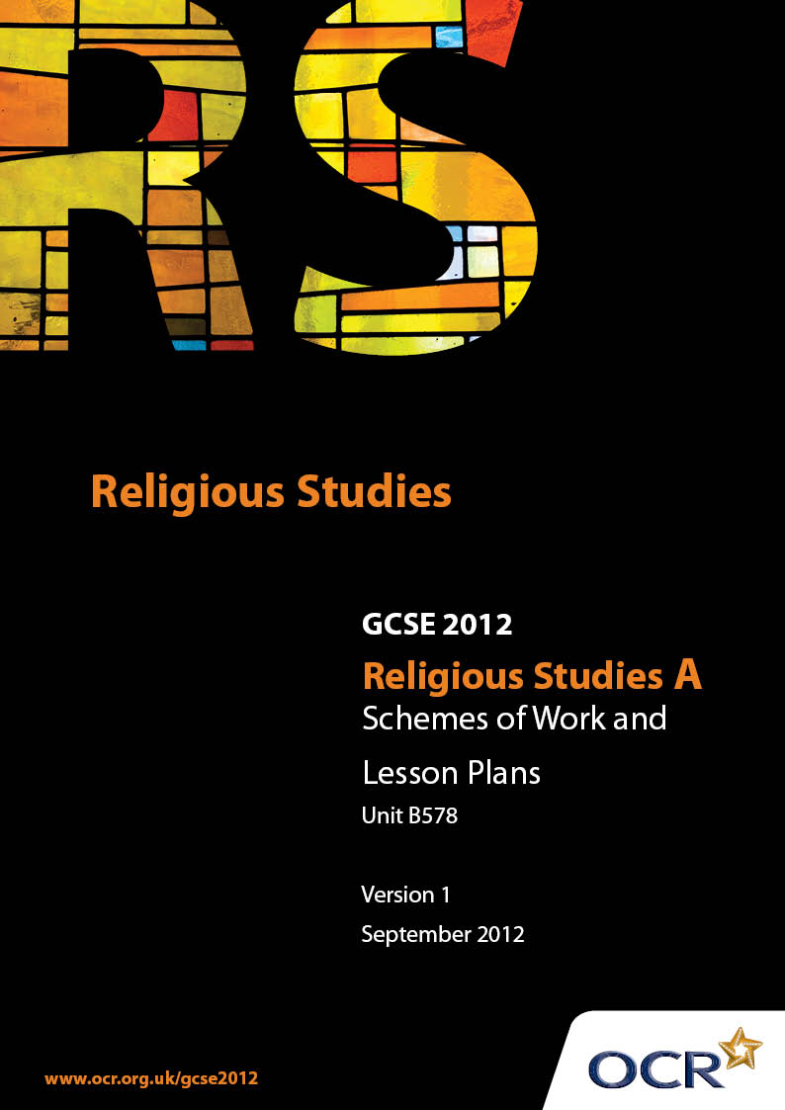

Contents
Introduction 3
Sample Scheme of Work: Unit B578: Islam 2 (Worship, Community and Family, Sacred Writings) 5
Sample Lesson Plan: Unit B578: Islam 2 (Worship, Community and Family, Sacred Writings) 13

Introduction

Background
Following a review of 14 – 19 education and the Secondary Curriculum Review, the Qualifications and Curriculum Authority (QCA) has revised the subject criteria for GCSEs, for first teaching in September 2009. This applies to all awarding bodies.
The new GCSEs have more up-to-date content and encourage the development of personal, learning and thinking skills in your students.
We’ve taken this opportunity to redevelop all our GCSEs, to ensure they meet your requirements. These changes will give you greater control of assessment activities and make the assessment process more manageable for you and your students. Controlled assessment will be introduced for most subjects.
From September 2012 assessment tasks may be undertaken at any point between release of the task and the examination series for which the task must be submitted. Centres must ensure that candidates undertake a task that is valid for submission in the year in which the candidate intends to submit it.
OCR has produced a summary brochure, which summarises the changes to Religious Studies. This can be found at www.ocr.org.uk, along with the new specification.
In order to help you plan effectively for the implementation of the new specification we have produced these Schemes of Work and Sample Lesson Plans for Religious Studies. These Support Materials are designed for guidance only and play a secondary role to the Specification.

Our Ethos
OCR involves teachers in the development of new support materials to capture current teaching practices tailored to our new specifications. These support materials are designed to inspire teachers and facilitate different ideas and teaching practices.
Each Scheme of Work and set of sample Lesson Plans is provided in Word format – so that you can use it as a foundation to build upon and amend the content to suit your teaching style and students’ needs.
The Scheme of Work and sample Lesson plans provide examples of how to teach this unit and the teaching hours are suggestions only. Some or all of it may be applicable to your teaching.
The Specification is the document on which assessment is based and specifies what content and skills need to be covered in delivering the course. At all times, therefore, this Support Material booklet should be read in conjunction with the Specification. If clarification on a particular point is sought then that clarification should be found in the Specification itself.

A Guided Tour through the Scheme of Work

= Innovative Teaching Idea
This icon is used to highlight exceptionally innovative ideas.


= ICT Opportunity
This icon is used to illustrate when an activity could be taught using ICT facilities.

Unit B578: Islam 2 (Worship, Community and Family, Sacred Writings)
Suggested teaching time | 8-10 hours | Topic | Places and forms of worship
Topic outline |  | Suggested teaching and homework activities |  | Suggested resources | Points to note
Introduction to Places and forms of worship: |  | - Stimulus: Using stimulus “activity” cards or similar, ask students to rank how vital the activities are for daily life  - Explain that for a Muslim, prayer and worship should be as natural as breathing and that this lesson will give an overview of the key features about Muslim worship. Using prior knowledge and imagination students consider a number of questions  - Why do Muslims pray?  - When do Muslims pray?  - Where do Muslims pray?  - How do Muslims pray?  - Using relevant photos/models of Mosques and Prayer Mats, encourage students to understand that once the time for prayer arrives, that place is their Mosque  Explain that this area of the unit will focus always on the WHY and that WHEN, WHERE and HOW are to help support the WHY |  | - Stimulus “activity” cards could include eat, drink, sleep, visit bathroom, dress, breathe, watch TV, catch a bus, see a movie, meet friends, exercise etc | - This topic is primarily about worship, its source, its focus and its spiritual benefit - not simply about the practicalities  - It must also be remembered that this unit must acknowledge the diversity within Islam, but that it is always seen as a Living Faith
Personal prayer  (The ways in which Muslims use features and artefacts in their worship – and how these features and artefacts support and influence the beliefs and attitudes of the worshippers) |  | - Stimulus: Ask students when they last prayed  - Show students a prayer mat and prayer beads and ask them (whether they have prior knowledge or not) to describe to each other what they see, what they feel and how they react to the items  - Develop work on these artefacts by explaining their association with prayer.  - Remind students that whilst there are rules about prayer, the key part of prayer is the relationship between the Muslim and Allah through two main kinds of prayer: Salah and Du’a  - Explore other aids for prayer: compass, prayer clocks, calendar (For students studying B577, the small block of Karbala clay used in prayer by Shi’a Muslims could also be mentioned)  Evaluate how helpful/unhelpful these items might be in terms of the true purpose of prayer |  | - The new OCR Publication on Islam by Janet Green and Jon Mayled  - Artefacts: prayer mat, beads, compass or photographs of same, prayer calendar | - In examinations, students need to meet all the assessment objectives – a focus on the purpose of prayer will be important to achieve these, which is why it is suggested that personal prayer is taught before Salah in the Community  - Technological developments include electronic clocks, linked to a radio signal, which sound the call to prayer at the correct times each day
Preparing for Prayer in a Mosque |  | - Stimulus: Invite students to provide in small groups the key facts they have discovered about Mosques from previous homework  - Explain that you will focus on how a Mosque helps Muslims pray, rather than looking at the Mosque as a building. This may be taught over two lessons, depending on time allocation, as a two part process  - A) Preparing for prayer (making sure the Muslim is in the right attitude for prayer)  - B) Reading the prayer (fulfilling the obligations of personal submission to Allah)  - Preparing for prayer (what is done and why it is done)  - Listen for the call to prayer – by a Muezzin from a Minaret at the correct time, 5 times each day  - At the Mosque remove shoes and perform the ritual of Wudu in the area provided  - Move to gender specific prayer areas and ensure (culturally) appropriate clothing is worn  - Stand in rows using the Qibla to identify the direction of the Ka’ba.  - Make the correct intention  - Although this has been set in the context of a Mosque, explain to students that exactly the same pattern should be followed for prayer whether on one’s own or with others.  - Students may write this up – one effective way is using a “flow diagram” with thumbnail reminder pictures of each stage |  | - Illustrations/ DVD (Some carefully selected YouTube material) showing preparation for prayer | - Some school systems may block YouTube material – advice will need to be sought from IT Administrators
Prayer in the Mosque |  | - Stimulus: Use the thumbnails from last lesson as a prompt for students to recap on “Preparation for prayer”  - Explain that the focus is now reading the prayer Salah (what is done and why it is done)  - Follow the Imam’s leading (Imam = in the front)  - Prayer positions and sequence of movements  - Number of Rakah  - Acknowledgement of the angels and the fellow believers  - Additional personal prayer, Du’a  - Although this has been set in the context of a Mosque, explain to students that exactly the same pattern should be followed for prayer whether on one’s own or with others  - Students may write this up – one effective way is to develop the “flow diagram” used earlier with thumbnail reminder pictures of each stage  - Explain prayer must be genuine – not an empty ritual. Explore ways in which the correct attitude is maintained: men and women pray separately to avoid distraction; decoration in the Mosque is limited to Calligraphy and geometric patterns to avoid idolatry; Wudu and making intention is to help clear and focus the mind |  | - Illustrations/ DVD (Some YouTube material) showing patterns of prayer | - Sensitive use of Muslim members of a group can provide an extraordinarily helpful insight into this topic
The Mosque as a Muslim centre |  | - Stimulus: most schools and colleges have a large hall or assembly area, Ask students to make a list of the different ways in which it may be used and explain that in many schools it is the heart of a large amount of the school’s activity  - Develop the similarity in many ways with the Mosque and the number of roles it has:  - Jumu'ah Friday Prayer and Khutbah sermon  - Place of study/Library; including Madrassah  - law court  - Venue for rites of passage  - meeting point/ social centre  - mortuary  (n.b. some of these features also link to 3.10.3 Religion in the faith community and the family)  - Explain that these functions of a Mosque require individuals to take the lead in various ways: Imam, Muezzin, Preacher  - Imam’s role (sometimes paid, sometimes a volunteer) in prayer, teaching, advising communities, families and individuals, caretaker  - Other roles (which may or may not be undertaken by the Imam): Muezzin; preacher  - For Candidates taking B577, it may be helpful here to distinguish the Shi’a understanding of Imam  - Using a large scale diagram of the layout of the Mosque, groups of students can annotate how the Mosque fulfils the needs of the Muslim community. (Students will need to know that a Mosque may not be a purpose build building)  - Create a list of the key features of a Mosque, in table format explain how the features benefit the community and the individual |  | - One of the best resources for understanding the topic is to arrange an educational visit to a local Mosque, or set up a visit to the School from a local Imam, if at all possible | - Examples of the use of a school hall could include: “Assembly”/ Collective worship, exams, meals, parents evenings, community events and meetings, training, concerts and performances, break time shelter in wet weather)
Summary Places and forms of worship |  | - Does it make a difference? In this unit, students have explored Worship as a feature of a living faith. In this summary lesson, in addition to using exemplar assessment material, students are evaluating the significance of prayer for a Muslim. For example:  - Feel closer to God  - Have a greater desire to follow the requirements of Islam  - Bring their own concerns, fears and responsibilities to Allah  - Have a stronger sense of ummah  - Have a more charitable attitude to the needs of people |  | - OCR Website materials – link to web page here | - Exam Tip: ensure students are familiar with the expectations of examiners in terms of the two assessment objectives

Unit B577: Islam 1 (Beliefs, Special Days, Divisions and Interpretations)

Personal Prayer
OCR recognises that the teaching of this qualification above will vary greatly from school to school and from teacher to teacher. With that in mind this lesson plan is offered as a possible approach but will be subject to modifications by the individual teacher.
Lesson length is assumed to be one hour.

Learning Objectives for the Lesson
Objective 1 | Students to know why Muslims pray.
Objective 2 | Students to be able to reflect on how various artefacts support a Muslim in prayer.

Recap of Previous Experience and Prior Knowledge
- Briefly review the GCSE Introductory lesson which took an overview of area 3.9.1 Core Beliefs.

Content
Time | Content
5 minutes | Stimulus: Remind students of the broad sweep of previous lesson and that this lesson begins the detailed work. Ask students when they last prayed. (A question which can provide a huge variety of astonishing answers!).
10 minutes | Group Discussion: Show students a prayer mat and prayer beads and ask them (whether they have prior knowledge or not) to describe to each other what they see, what they feel and how they react to the items.
10 minutes | Teacher input: Explain that although the image of Muslim prayer for many people is a line of Muslims standing in a Mosque, much – possibly most - prayer is offered by a Muslim on their own and that the key part of prayer is the relationship between Muslims and Allah.  Explain that an individual praying on their own will pray two main kinds of prayer: Salah: the formal 5 times/day prayer and Du’a; more personalised prayer – sometime called a “cry from the heart”. (At this stage, keep the explanation of Salah brief – it will be covered in more detail in the context of the Mosque). Students draw up a simple A Map showing the basics of the two kinds of prayer.
15 minutes | Students will work on a presentation (PowerPoint / display work / write up in books) which reflects on how the two artefacts (Mat and beads) already mentioned and other artefacts (clean water, compass, clocks, calendar) support a Muslim in prayer. (For students studying B577, the small block of Karbala clay used in prayer by Shi’a Muslims could also be mentioned.) Appropriate text and other resources will be required.
15 minutes | Students present findings, either in large group, or to each other in smaller groups – and are then interrupted to evaluate their work by responding to one or more of a series of challenge questions: What if there is no (water / certainty about the direction of the Ka’bah / knowledge of the accurate time) - is the prayer invalid? How could the various artefacts prevent the prayer being from the heart? What makes prayer real?

Consolidation
Time | Content
5 minutes | Selected students share their evaluation responses.
 | Homework: Complete some research on Mosques, ready for next lesson.

