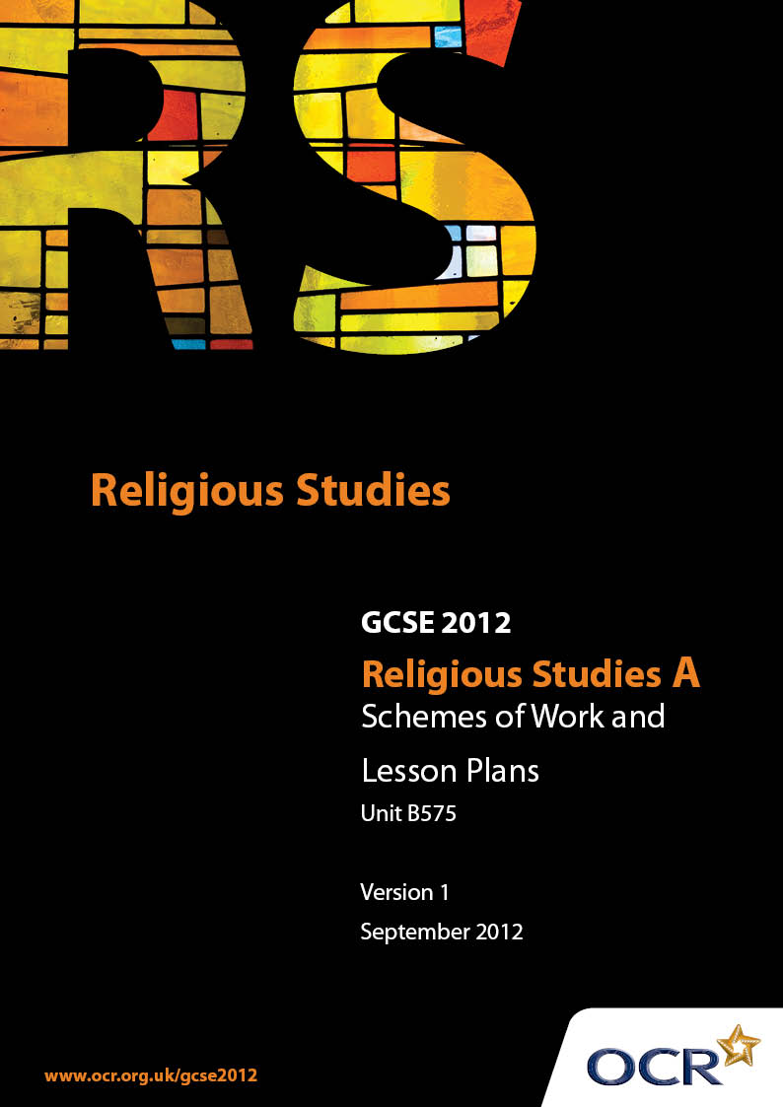

Contents
Contents 2
Introduction 3
Sample Scheme of Work: Unit B575: Hinduism 1 (Beliefs, Special Days, Divisions and Interpretations) 5
Sample Lesson Plan: Unit B575: Hinduism 1 (Beliefs, Special Days, Divisions and Interpretations) 7

Introduction

Background
Following a review of 14 – 19 education and the Secondary Curriculum Review, the Qualifications and Curriculum Authority (QCA) has revised the subject criteria for GCSEs, for first teaching in September 2009. This applies to all awarding bodies.
The new GCSEs have more up-to-date content and encourage the development of personal, learning and thinking skills in your students.
We’ve taken this opportunity to redevelop all our GCSEs, to ensure they meet your requirements. These changes will give you greater control of assessment activities and make the assessment process more manageable for you and your students. Controlled assessment will be introduced for most subjects.
From September 2012 assessment tasks may be undertaken at any point between release of the task and the examination series for which the task must be submitted. Centres must ensure that candidates undertake a task that is valid for submission in the year in which the candidate intends to submit it.
OCR has produced a summary brochure, which summarises the changes to Hinduism. This can be found at www.ocr.org.uk, along with the new specification.
In order to help you plan effectively for the implementation of the new specification we have produced these Schemes of Work and Sample Lesson Plans for Hinduism. These Support Materials are designed for guidance only and play a secondary role to the Specification.

Our Ethos
OCR involves teachers in the development of new support materials to capture current teaching practices tailored to our new specifications. These support materials are designed to inspire teachers and facilitate different ideas and teaching practices.
Each Scheme of Work and set of sample Lesson Plans is provided in Word format – so that you can use it as a foundation to build upon and amend the content to suit your teaching style and students’ needs.
The Scheme of Work and sample Lesson plans provide examples of how to teach this unit and the teaching hours are suggestions only. Some or all of it may be applicable to your teaching.
The Specification is the document on which assessment is based and specifies what content and skills need to be covered in delivering the course. At all times, therefore, this Support Material booklet should be read in conjunction with the Specification. If clarification on a particular point is sought then that clarification should be found in the Specification itself.

A Guided Tour through the Scheme of Work

= Innovative Teaching Idea
This icon is used to highlight exceptionally innovative ideas.


= ICT Opportunity
This icon is used to illustrate when an activity could be taught using ICT facilities.

Unit B575: Hinduism 1 (Beliefs, Special Days, Divisions and Interpretations)
Suggested teaching time | 6 hours | Topic | Major divisions and interpretations
Topic outline |  | Suggested teaching and homework activities |  | Suggested resources | Points to note
Shaivism (devotion to Shiva) |  | - Introduce idea of Hindu sects dedicated to Shiva, Vishnu and Shakti  - Discuss reasons for different sects with focus on Shaivism. What are the main reasons?  - Group activity on key aspects of Shaivism using PowerPoint. Produce a set of information cards or sheets to use later for revision exercise. Students to collate these to gain an overview of Shaivism  - Work on meaning of Shaiva symbolism-3 horizontal marks-tripundra |  | - Om Namah Shivay mantra (Lord Shiva song)-music available online  - PowerPoint on Shiva nataraj (with dancers as devotees) Shiva as yogi (with ascetics as devotees), key terms, symbolism, typical shrines of Shaivas, gurus and yogis  - Information sheets on Shaiva Siddhanta and lingayats (for stretch and challenge) | - Reasons for different sects: devotion to different gods (Shiva, Vishnu, Devi), choice of ishtadevata or personal deity, family tradition  - Goal of Shivas self-realisation and Shiva consciousness through yoga, meditation, rituals, initiation by a guru
Vaishnavism (devotion to Vishnu) |  | - Stimulus: look at the life of a famous Vaishnava such as Sri Chaitanya. What did he teach? What is the Hare Krishna mantra? How does ISKON promote these beliefs?  - Investigate the story of Shambo the cow or Shevak Sharan. Students write an article with quotes explaining how Vaishnava outlook and lifestyle are reflected in the events  - Project work on forms of devotion to Krishna at the Bhaktivedanta Manor  - Discuss the similarities and differences with Shaivism and summarise  - Work on Vaishnava symbolism 2 vertical lines-urdhva-pundra. How is it similar or different to Shaiva practice? |  | - Hare Krishna mantra-online music available  - www.iskon.com (website of the Society for Krishna Consciousness)  - www.krishnatemple.com/home/ (Bhaktivedanta Manor) for research and arranging visits  - www.truetube.co.uk (religion and ethics section for videos about Shambo the cow)  - information sheet on Sevak Sharan and his project  - information on Shri Chaitanya Mahaprabhu | - 16th c Chaitanya Bengali who popularised the Hare Krishna mantra and Krishna consciousness  - Sevak Sharan set up Vrindavan Conservation Project to replant Krishna’s forest  - Similar to Shaivism as a Hindu sect, God consciousness, use of mantras, promotion of teachings worldwide, method of applying symbols  - Different in emphasis on bakti rather than meditation and yoga, less reliance on a guru, the environmental concerns, different meaning behind symbols
Shaktism (devotion to the Goddess) |  | - Stimulus: look at the life of a famous Shakta such as Ramakrishna. What did he teach? What does his prayer mean?  - Explain that Shaktism is the worship of the Divine Mother, Shakti or Devi as the Supreme Brahman  - Brainstorm ideas about energy as both benevolent and destructive. Create collage of images to illustrate idea of Shakti in both forms using different forms of Devi  - Research Durga puja at Belur Math and present a report on different ways that Shaktas show devotion at this festival  - Discuss similarities and differences with Shaivism and Vaishnavism and create a chart to show this |  | - Jai Mata Di (Ma Durga mantra)-music online with collection of Devi images  - www.belurmath.org (for photos and videos)  - Ritual Art of India Ajit Mookerjee p122 (prayer of Ramakrishna)  - www.indiadivine.org/audarya/ammachi/220354-sri-ramakrishna-prayer-mother.html (prayer of Ramakrishna online) | - 19th c Ramakrishna was a devotee of Kali. The Ramakrishna Mission is based at Belur Math in Kolkata and is also worldwide  - Similar to Shaivism, advaitic union god-consciousness, rituals, similar to Vaishnavism with worldwide groups, all have schools of thought within each sect  - Different in focus on divine energy (shakti) as a means of spiritual liberation (moksha), devotion to mother (Ma), god as female

Unit B575: Hinduism 1 (Beliefs, Special Days, Divisions and Interpretations)

Shakti: Durga worship
OCR recognises that the teaching of this qualification above will vary greatly from school to school and from teacher to teacher. With that in mind this lesson plan is offered as a possible approach but will be subject to modifications by the individual teacher.
Lesson length is assumed to be one hour.

Learning Objectives for the Lesson
Objective 1 | Students to know about the concept of shakti and Hindu beliefs about devotion to the goddess Durga
Objective 2 | Students to understand different Hindu beliefs about Shakti
Objective 3 | Students to be able to explain how these beliefs might affect the lifestyles and outlooks of modern Hindus

Recap of Previous Experience and Prior Knowledge
- Briefly review GCSE work on different forms of energy (shakti) and previous work on core beliefs about shakti. How are different forms reflected in images of Devi? Alternatively the teacher may choose to play the Maa Durga mantra (available on YouTube) as a stimulus at the start of the lesson to start work on devotion to the goddess Durga.

Content
Time | Content
5 minutes | Recap and review of previous learning. Why is meant by Shakti? Why may Shaktas see Shakti as benevolent and kind as well as violent and destructive?
5 minutes | Stimulus: Jai Mata Di (Maa Durga mantra) online song and images. How does the song encourage devotion to Durga as a loving mother (Ma)? Alternatively, stimulus on board of prayer to Durga ‘Salutations to Devi who pervades the whole universe and abides in all beings as consciousness’ How does this show that Shakti is the same as the Supreme Brahman?
10 minutes | Research: in pairs use Belur Math website to look at photos and video clips of Durga puja for that year. How would people who attend benefit? What might they learn from the experience? How are different people showing devotion?
15 minutes | Group work: pairs form small groups to share what they have found out about different ways Shaktas show devotion at Durga puja. They have an A3 piece of paper with some prompts:  Priests may show devotion by…  The congregation may show devotion by…  Children may show devotion by…  Students complete prompts and add their own observations on the sheet of paper. Groups swap sheets and attempt to add to what has already been written by other groups. Encourage use of key terms: darshan, arti, prashad, Shakti, kumari, Devi, puja, Ma, Chandi, Navratri, Durga puja, mantra  Information sheet on Durga Puja from the website may be used to help particularly the general information about puja at Belur Math.
10 minutes | Students write a short summary of what they have learnt about the different ways Shaktas show devotion at Durga puja. Does Durga puja highlight some aspects of Shakti more than others?

Consolidation
Time | Content
5 minutes | Selected students read out their responses to the task.
 | Homework or future lesson: Produce an at a glance chart to show the similarities and differences between Shaktism, Shaivism and Vaishnavism

