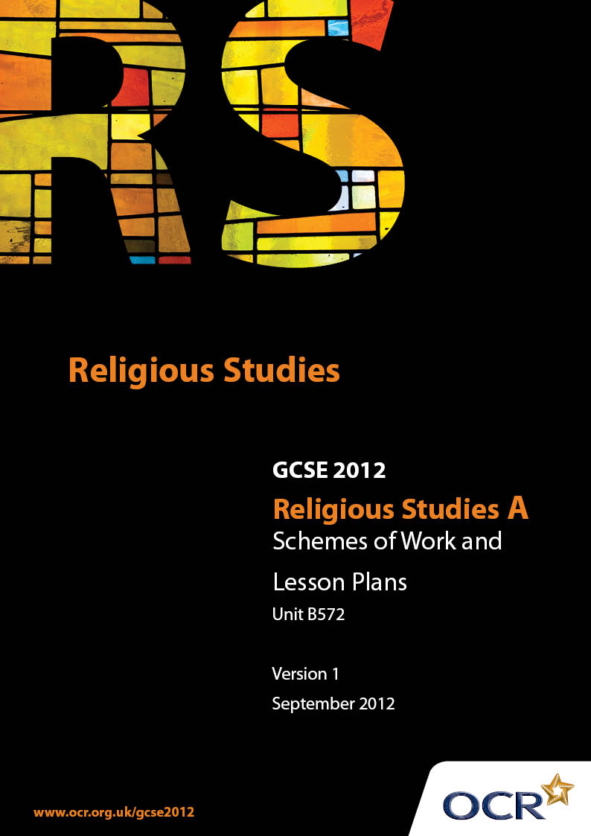

Contents
Contents 2
Introduction 3
OCR Sample Scheme of Work Unit B572: Christianity 2 (Worship, Community and Family, Sacred Writings) 5
OCR Sample Lesson Plan Unit B572: Christianity 2 (Worship, Community and Family, Sacred Writings) 14

Introduction

Background
Following a review of 14 – 19 education and the Secondary Curriculum Review, the Qualifications and Curriculum Authority (QCA) has revised the subject criteria for GCSEs, for first teaching in September 2009. This applies to all awarding bodies.
The new GCSEs have more up-to-date content and encourage the development of personal, learning and thinking skills in your students.
We’ve taken this opportunity to redevelop all our GCSEs, to ensure they meet your requirements. These changes will give you greater control of assessment activities and make the assessment process more manageable for you and your students. Controlled assessment will be introduced for most subjects.
From September 2012 assessment tasks may be undertaken at any point between release of the task and the examination series for which the task must be submitted. Centres must ensure that candidates undertake a task that is valid for submission in the year in which the candidate intends to submit it.
OCR has produced a summary brochure, which summarises the changes to Religious Studies. This can be found at www.ocr.org.uk, along with the new specification.
In order to help you plan effectively for the implementation of the new specification we have produced these Schemes of Work and Sample Lesson Plans for Religious Studies. These Support Materials are designed for guidance only and play a secondary role to the Specification.

Our Ethos
OCR involves teachers in the development of new support materials to capture current teaching practices tailored to our new specifications. These support materials are designed to inspire teachers and facilitate different ideas and teaching practices.
Each Scheme of Work and set of sample Lesson Plans is provided in Word format – so that you can use it as a foundation to build upon and amend the content to suit your teaching style and students’ needs.
The Scheme of Work and sample Lesson plans provide examples of how to teach this unit and the teaching hours are suggestions only. Some or all of it may be applicable to your teaching.
The Specification is the document on which assessment is based and specifies what content and skills need to be covered in delivering the course. At all times, therefore, this Support Material booklet should be read in conjunction with the Specification. If clarification on a particular point is sought then that clarification should be found in the Specification itself.

A Guided Tour through the Scheme of Work

= Innovative Teaching Idea
This icon is used to highlight exceptionally innovative ideas.


= ICT Opportunity
This icon is used to illustrate when an activity could be taught using ICT facilities.

Unit B572: Christianity 2 (Worship, Community and Family, Sacred Writings)
Suggested teaching time | 12 guided learning hours | Topic | Places and forms of worship
Topic outline |  | Suggested teaching and homework activities |  | Suggested resources | Points to note
3.4.1  Places and forms of worship  - Design, symbols, artefacts and features including:  - altar or Communion Table  - Font  - Baptistery  - Pulpit  - Lectern  - Stations of the Cross  - Iconostasis  5 GLH |  | - If Unit B571 has not already been studied, it will be useful to do a short introduction to the foundation and development of the main Christian groups (Roman Catholic, Orthodox and Protestant [and key groups within Protestant Church]) in order to understand the variations in features and forms of worship  - Consider the organisation of the Anglican Church (parish, diocese) and the hierarchy of clergy (e.g. vicar, bishop, archbishop); you may wish to do similar with any other denomination that you might choose to study in depth  - Examine the external (shape, orientation, surrounding area) and internal design of a church and the associated features  - Consideration of the altar rail and the iconostasis (as physical barriers between the clergy and the laity) can be a useful lead into the idea that God and man are separated by mankind’s sin and that the breach can only be bridged through the Eucharist  - Consider aids to worship; for example how icons and The Rosary are used  - Research and identify the main symbols found in Christian places of worship  - Discuss these symbols and record their meanings, e.g. candles, cross/crucifix, sanctuary light  - Discuss the role of a Cathedral in the community and the place of the bishop as overseer of a diocese. Depending on how close you are to a cathedral, visit one and compare to local church  - Possible Homework  i) Create a grid for each of the main features with 4 columns. In the first column give the name of the feature, in the second write a physical description of the feature. In the third describe what happens at that feature or what it is used for; in the fourth column identify the main Christian belief associated with that action. For example, for a font would explain that infant baptism happens there and discuss about the Christian belief of forgiveness or washing away of sins through the sacrifice of Jesus on the cross and re-birth into a new life  ii) Research the main features of an icon and design one of your own  iii) “Christians need a special building in which to worship.” Discuss this statement. You should include different, supported points of view and a personal viewpoint.  You must refer to Christianity in your answer. |  | - For whole topic on Places and forms of worship:  - “Christianity” by John Mayled (Hodder & Stoughton) – chapter 5  - “Christianity: A New Approach” by Kevin O’Donnell (Hodder Murray) – chapters 8 & 7  - www.bbc.co.uk/religion/religions/christianity/  - www.bbc.co.uk/schools/religion/christianity/  - www.cofe.anglican.org  - A visit to a local Christian place of worship is invaluable; better still to places of worship of different denominations for comparison. Many churches are more than happy to accommodate school visits  - ICT Opportunities:  - While visiting a local place of worship, take digital photographs; when back at school use in a PowerPoint in class to reinforce learning  - In a word document create a plan of a church and insert names and pictures of the main features in the incorrect place. On the computer, students can move the pictures and names around until correct  - Research icons, finding examples and explain why they look the way they do  - Many cathedrals produce excellent DVDs of the building and their work in the community. Go to a cathedrals website to see the resources available | - The features to be studied come from a variety of denominations. It is important that consideration is given to the variations between places and forms of worship in Christianity  - When discussing the Altar and the Communion Table, it is important that the description of the feature, its position in the church and its use in the service is used to reflect the varying beliefs about the Eucharist/ Mass/ Lord’s Supper depending on the denomination. It could also be useful for students to look at a denomination which does not perform this act of worship, such as the Quakers  - Before setting students a homework task similar to the one suggested in this section ((ii) “Christians need a special …..) ensure that you have gone through the assessment criteria with the students for an AO2 question  - In the possible homework task on icons the main features mentioned refer to the fact that, usually, Jesus is shown in three ways on an icon; as King of Heaven, as a Teacher or as a child with his mother, Mary
3.4.1  Places and forms of worship  The different ways in which the place of worship might be used by the community.  2 GLH |  | - Brainstorm reasons why a person might visit a church or a church complex  - Invite a local vicar or minister into school to talk to the class about the many activities that might take place in his/her church  - Do a survey of the reasons they might have visited a church during the last two years  - Discuss the importance of a church as a centre of the community, not just a place of worship. This might also allow some reflection on the work of the vicar/priest/minister in the community  - Consider whether or not it is important that the church is available for more than worship |  | - For whole topic on Places and forms of worship:  - “Christianity” by John Mayled (Hodder & Stoughton) – chapter 5  - “Christianity: A New Approach” by Kevin O’Donnell (Hodder Murray) – chapters 8 & 7  - www.bbc.co.uk/religion/religions/christianity/  - www.bbc.co.uk/schools/religion/christianity/  - ICT Opportunity  - Record the results of any surveys on a spreadsheet and turn into a graph  - Students can write an article for a newspaper on a week in the life of their local church.
3.4.1  Places and forms of worship  Public Acts of worship:  Eucharist/Holy Communion  Sunday Services  Prayer  3 GLH |  | - Research the Biblical origins of the Eucharist / Holy Communion  - Study the Anglican Eucharistic service; consider the Liturgy of the Word and the Liturgy of the Eucharist. Discuss which important Christian beliefs about Jesus and His death are reflected in the service  - Compare and contrast the Holy Communion service in the Roman Catholic Church, the Anglican Church and the Methodist Church. Discuss what the variations teach about each denomination’s particular beliefs and practices  - Study the order of service of a typical Sunday Service. It would be useful to have a copy of Common Worship to be able to look at the main features of a service. Compare and contrast with, for example, a Baptist Sunday service or a Society of Friends service  - Discuss what the most important parts of a Christian service of worship might be, and reasons why. Also consider if services of worship are in tune with modern society or do they need up-dating?  - Research prayer in the Gospels. Look at examples of when Jesus talked about prayer or used prayer  - Discuss the reasons why people might want to prayer and what is a good definition of prayer  - Discuss the different types of prayer (for example, praise, intercession, thanksgiving, confession) and how a Christian might use these different types of prayer and how they may benefit spiritually from prayer. Also consider set prayers as opposed to extempore prayer; ask for opinions of each type and which, if any, is more appropriate and meaningful for the worshipper  - Consider the Lord’s Prayer as an “ideal”.  - In general, discuss the benefits of worshipping as a community. Consider if there are any aspects of Christian worship that can only be achieved as a group (e.g. the Eucharist). Discuss if there is any Biblical imperative for worshipping as a community  - Possible Homework:  i) What do you think is the most important part of a Christian service of worship? Give reasons for your answer. (approx 150-200 words)  ii) “Prayer is just a waste of time.” Discuss this statement. You should include different, supported points of view and a personal viewpoint. You must refer to Christianity in your answer |  | - For whole topic on Places and forms of worship:  - “Christianity” by John Mayled (Hodder & Stoughton) – chapter 5  - “Christianity: A New Approach” by Kevin O’Donnell (Hodder Murray) – chapters 8 & 7  - www.bbc.co.uk/religion/religions/christianity/  - www.bbc.co.uk/schools/religion/christianity/  - Biblical Passages:  - The Last Supper – Matthew 26:17-30  - Book of Common Prayer  - Common Worship  - Biblical Passages:  - Jesus teaches The Lord’s Prayer – Matthew 6:5-15  - Jesus prays in Gethsemane – Matthew 26:36-46  - Biblical Passage:  - Matthew 18:20 | - When considering Public Acts of worship, as well as the topics stated in the specification, it may be of use to consider:  - - the sermon  - - readings from the Bible  - - hymns/choir  - and their importance in worship
3.4.1  Places and forms of worship  Private acts of worship:  Worship at home  Prayer  1 GLH |  | - Explore ways in which Christians might worship alone or with their family at home. You may also wish to consider House Churches and Bible Study groups  - Discuss if worshipping alone is as meaningful for the individual as worshipping within the Christian community. Consider any benefits of worshipping privately  - Discuss personal aids to prayer e.g. The Rosary and icons and how they are used for worship  - Consider the place of private prayer as opposed to public prayer and how each may affect the spiritual growth of the believer |  | - For whole topic on Places and forms of worship:  - “Christianity” by John Mayled (Hodder & Stoughton) – chapter 5  - “Christianity: A New Approach” by Kevin O’Donnell (Hodder Murray) – chapters 8 & 7  - www.bbc.co.uk/religion/religions/christianity/  - www.bbc.co.uk/schools/religion/christianity/
Private Acts of worship:  The role and significance of religious leaders in worship.  1 GLH |  | - Research and discuss the role played by religious leaders of differing denominations in public worship. Include the role of the Roman Catholic priest in confession and intercession in contrast to the role of, for example,  a Methodist minister  - Discuss whether a religious leader is necessary for worship  - If possible, invite a religious leader into class to discuss their role

Unit B572: Christianity 2 (Worship, Community and Family, Sacred Writings)
OCR recognises that the teaching of this qualification above will vary greatly from school to school and from teacher to teacher. With that in mind this lesson plan is offered as a possible approach but will be subject to modifications by the individual teacher.
Lesson length is assumed to be one hour.

Learning Objectives for the Lesson
Objective 1 | Students will be able to list and explain different types of prayer
Objective 2 | Students will understand the reasons why Christians pray privately as well as in public services of worship
Objective 3 | Students will be able to explain the use of i) the rosary ii) icons in private worship

Recap of Previous Experience and Prior Knowledge
- Students will have previously discussed prayer as part of public acts of worship
- Students will already be familiar with aids to prayer but as used in public worship

Content
Time | Content
10 minutes | Starter: Ask students to recall the different types of prayer used in worship (intercession, praise etc.) On a white board or on a photocopied sheet, show the Lord’s Prayer and ask the students to identify examples of each of the types of prayer within the Lord’s Prayer.
10 minutes | If teacher feels it is appropriate, ask students if and when any of them have ever prayed. Discuss whether prayers are only said by “religious” people or whether all people might at some time pray. Allow short class discussion on the significance of prayer by non-religious people. Seek a class definition of “prayer” and discuss if it is an appropriate definition from a Christian point of view.
10 minutes | In groups, ask the class to write down reasons for and against private prayer as opposed to public prayer. Ask the class to explain and develop the points they make; each group disseminate to the class. Discuss what the practical and spiritual benefits of prayer might be for Christians.
15 minutes | If possible have one or more set of Rosary Beads and copies of Praying the Rosary in class and some icon pictures (they may be icons designed by the students when they were being discussed as part of public worship). Consider how each is used in private worship. Discuss whether reciting a set pattern of prayer is better than extempore prayer. Consider the place of meditation as a form of worship.

Consolidation
Time | Content
5-10 minutes | Ask each pupil – in a 5-10 minute slot – to compose a prayer that may be used by a Christian (it may be a personal prayer, for their family or for a national/global issue that is relevant at that particular time.)
5 minutes | Invite volunteers to read out their prayer. Ask the class to identify what type of prayer it is, recapping on the different types. Set homework/assignment.

