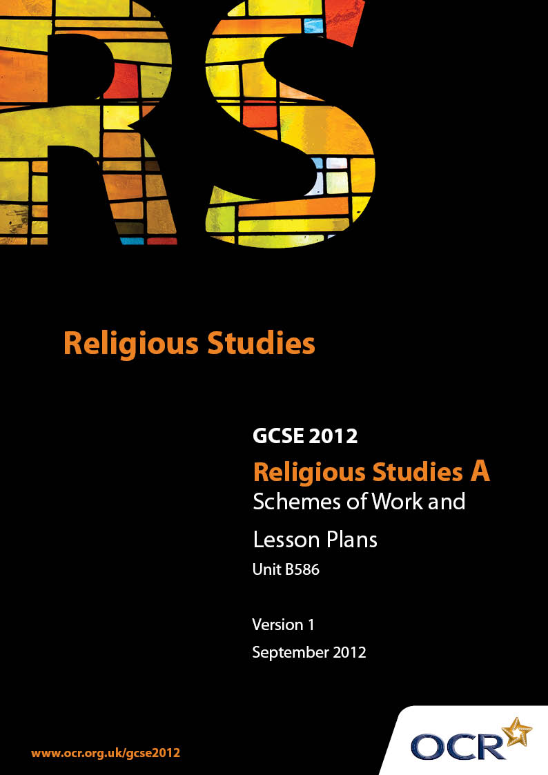

Contents
Introduction 3
Sample Scheme of Work: Unit B586: Jewish Scriptures 2 (Talmud) 5
Sample Lesson Plan: Unit B586: Jewish Scriptures 2 (Talmud) 20

Introduction

Background
Following a review of 14 – 19 education and the Secondary Curriculum Review, the Qualifications and Curriculum Authority (QCA) has revised the subject criteria for GCSEs, for first teaching in September 2009. This applies to all awarding bodies.
The new GCSEs have more up-to-date content and encourage the development of personal, learning and thinking skills in your students.
We’ve taken this opportunity to redevelop all our GCSEs, to ensure they meet your requirements. These changes will give you greater control of assessment activities and make the assessment process more manageable for you and your students. Controlled assessment will be introduced for most subjects.
From September 2012 assessment tasks may be undertaken at any point between release of the task and the examination series for which the task must be submitted. Centres must ensure that candidates undertake a task that is valid for submission in the year in which the candidate intends to submit it.
OCR has produced a summary brochure, which summarises the changes to Religious Studies. This can be found at www.ocr.org.uk, along with the new specification.
In order to help you plan effectively for the implementation of the new specification we have produced these Schemes of Work and Sample Lesson Plans for Religious Studies. These Support Materials are designed for guidance only and play a secondary role to the Specification.

Our Ethos
OCR involves teachers in the development of new support materials to capture current teaching practices tailored to our new specifications. These support materials are designed to inspire teachers and facilitate different ideas and teaching practices.
Each Scheme of Work and set of sample Lesson Plans is provided in Word format – so that you can use it as a foundation to build upon and amend the content to suit your teaching style and students’ needs.
The Scheme of Work and sample Lesson plans provide examples of how to teach this unit and the teaching hours are suggestions only. Some or all of it may be applicable to your teaching.
The Specification is the document on which assessment is based and specifies what content and skills need to be covered in delivering the course. At all times, therefore, this Support Material booklet should be read in conjunction with the Specification. If clarification on a particular point is sought then that clarification should be found in the Specification itself.

A Guided Tour through the Scheme of Work

= Innovative Teaching Idea
This icon is used to highlight exceptionally innovative ideas.


= ICT Opportunity
This icon is used to illustrate when an activity could be taught using ICT facilities.

Unit B586: Jewish Scriptures 2 (Talmud)
Suggested teaching time | 14 hours | Topic | Talmud
Topic outline |  | Suggested teaching and homework activities |  | Suggested resources | Points to note
The Nature of the Talmud |  | - Create a contents list and summary for the Talmud
The Covenant Relationship between G-d and the Israelites |  | - Examine simple contracts (perhaps including a home-school agreement). Write up a simplified version of the Covenant in a similar format  - Research stories in which the Israelites break the covenant, and examine the consequences for the Israelites. Make a list of quotations summarising the resolution of these situations
The role and uses of the Talmud and the Covenant relationship in daily life and worship |  | - Prepare a timetable of activities from a students’ average week. Apply teachings from the Talmud to these activities to assess the impact on an individual  - Use stories from soap TV, Characters from English Literature or from other sources to provide case studies to apply the Talmud and principles of the Covenant |  |  | - Students should not concentrate on the negative effects of Jewish teachings – the positive impact should be emphasised
 |  | - Write a worship manual, providing worshippers with a commentary on the acts of worship at the Synagogue and at Home, identifying the role of the Talmud

Unit B586: Jewish Scriptures 2 (Talmud)
Suggested teaching time | 14 hours | Topic | The Shema
Topic outline |  | Suggested teaching and homework activities |  | Suggested resources | Points to note
Unity of G-d |  | - Research the Unity of G-d online. Compare blogs and on-line sermons on the topic. Prepare a summary of the discussions and create a poster or on-line resource  - “Translate” the Shema into more “everyday” language, aiming to summarise its teaching. Design a summary in the form of a devotional card, poster, tea-towel design or similar artefact (as available in shops such as Judaica Online) |  | - Blogs, Video Sermons, Youtube posts and similar | - Teachers will need to pre-view sites to ensure that blogs are at least relevant and accurate
Covenant |  | - Summarise the covenant as expressed in the Shema. Draw up guidelines for implementing the Shema in modern Britain
Tefilin, tzitzit, mezuzah |  | - Design the packaging for commercially available tefilin &c. Include a picture of the design of the product, and on the back of the packaging include instructions and explanations  - Look for video instructions for the use of Tefilin &c online. Download and edit into a single resource |  | - Consult with GCSE Graphics students and teachers for techniques and resources  - On-line stores selling Jewish artefacts can provide inspiration  - Youtube includes a range of video posts explaining the use of these artefacts. Downloaded (and converted) the videos can be edited together in a programme such as media maker
Torah Study |  | - Develop a timetable for Torah Study for a schul. Include topics and an explanation for the focus. Look for Torah courses online, or for notices about Torah Study on Synagogue websites. Combine these into a programme of study for Torah students.  - Write a companion booklet to a Torah Study programme, summarising the aims and objectives of such a course |  |  | - Teachers will need to preview any resources used by students online to ensure accuracy and appropriateness
The Land of Israel |  | - Prepare a brochure for a specialist Jewish Travel Company, offering guided tours of Israel. Identify key sites and explain the significance of these sites  - Invent a political partyor charity campaigning to raise the status of the Land of Israel in British Political life. Write a hsutings speech detailing the beliefs of Judaism regarding the land itself |  | - A publisher programme, and photos gathered from the internet, would allow students to prepare a professional looking document  - Invite Leisure and Tourism students to collaborate on the production of the brochure | - Any study of “The Land of Israel” can involve a discussion about the Palestinian issue. Teachers will need to be sensitive in the handling of this issue
The Exodus |  | - Identify key points in the story, and “hotseat” characters involved at that stage in the narrative. Interview them to establish their views on the importance and significance of the events that unfold around them  - Identify modern day news stories where the teachings from the Exodus can be applied. Create a series of posters discussing these
Individual Relationships with G-d |  | - Use characters from TV Dramas, books and plays studied in English, or other sources, to discuss the nature of the relationship between G-d and an Individual. Write a character analysis as though the person studied is Jewish, and draw conclusions from their behaviour. Write advice for a Jewish version of that Character  - For situations in familiar stories (such as soaps, books or films) invent a Jewish character, and show how their relationship with G-d would influence their lives
Sacrifice for Religious Commitment |  | - Make a list of 10 people with a high media profile (they should be there for positive reasons!). Analyse their lifestyles, and identify incompatibilities with Jewish teaching. What would a Jewish person need to “miss out on”?  - Examine individual stories of Religious Persecution where a person’s Judaism and the following of Jewish teaching has caused personal risk  - Make a list of modern day expectations from life, and compare these with the commitments required by a Jewish lifestyle |  | - Students should have no difficulty identifying the lifestyle features of celebrities. In the event of any problems, consult the BBC Entertainment pages
Use of Material Wealth: tzedaka |  | - Conduct a case study of a Jewish Charity. Identify the elements of its Mission Statement that specifically coincide with Jewish teaching  - Design a “Children in need” style telethon appeal for a Jewish Charity. Make sure that there are plenty opportunities to appeal to the Jewish teachings when appealing for money |  | - Use resources recorded from TV appeals, and overdub with the students’ own scripts
Education of Children |  | - Prepare a programme for the various classes held at a Synagogue. Add notes to help the deliverers to understand the importance of the programme  - Research programmes posted by Synagogues on their websites
Reward and Punishment |  | - Compile a list of the teachings in the Torah and other sources that refer to rewards for moral behaviour  - Survey different Jewish views about Heaven and Hell. Display the results in a poster or other graphic format  - Produce a booklet advising Jewish people on how to live the Halakhic life |  | - Research Halakha online

Unit B586: Jewish Scriptures 2 (Talmud)
Suggested teaching time | 7 hours | Topic | The Amidah
Topic outline |  | Suggested teaching and homework activities |  | Suggested resources | Points to note
The Amidah |  | - Write (or print out) the relevant paragraphs from the Amidah. Write a commentary on each one to explain its meaning |  | - There are Jewish blogs and teaching websites that perform a similar service, though often with their own bias | - As ever, teachers should check on-line resources for bias and inaccuracy
The Patriarchs |  | - Write short biographies of the Patriarchs.  - Create a timeline of key events in Patriarchal history. Write blogs or diary entries for each event
Forgiveness and Repentance |  | - Write a schedule for a family’s observation of Rosh Hashanah and Yom Kippur  - Research the Chief Rabbi’s “Thought for the Day” presentations at Rosh Hashanah. Write his next one  - Write an agony aunt page for a Jewish Newspaper, explaining the appropriate attitude to forgiveness  - Describe and Explain the Yom Kippur rituals in a blog or diary |  | - www.chiefrabbi.org archives the Chief Rabbi’s presentations
Prayer |  | - Write a prayer manual for a boy approaching his Bar Mitzvah. Explain the importance of the different rituals.  - Identify the different daily activities at home that become prayerful
Dependence on G-d |  | - Review work done on the Covenant – analyse the Amidah’s emphasis on G-d’s activity. Present findings in groups.  - Compare the words of the Amidah with high profile Jewish people. Write biographies of the people studied for a Jewish teaching programme for older children emphasising the work of G-d |  | - Use presentation software to prepare the presentations. Students can download Open Office freely and without charge
Gratitude |  | - Research Jewish blogs and websites for expressions of gratitude for G-d’s activity. Compile a survey of the posts, and summarise |  | - A simple search for “Jewish Gratitude” will lead to a range of sites | - As usual, teachers should be vigilant for websites that are inaccurate, or which have a political or religious bias
Peace and War |  | - Research recent conflicts that have involved Jewish forces. Compare the circumstances of these conflicts with the Jewish concept of Holy War  - Carry out a class debate on the concept of Holy War. Divide the class into supporters of the Holy War concept, and supporters of Jewish Pacifism |  | - Students could collaborate with the History Department for the background to 20th Century conflicts, which can be complex!
The Synagogue |  | - Prepare a prayer card for worshippers at a Synagogue. The card should include the words of the prayer, and a commentary to explain the importance of the words

Unit B586: Jewish Scriptures 2 (Talmud)
Suggested teaching time | 7 hours | Topic | Grace after Meals
Topic outline |  | Suggested teaching and homework activities |  | Suggested resources | Points to note
The Land of Israel |  | - Research the concept of the Promised Land. Compile a list of reasons for Jewish people to hope to celebrate Pesach in Jerusalem  - Create travel agent style posters for Israel, highlighting the importance of the land for Jewish people
Purim and Hanukkah |  | - Write a translation of the al hanisim prayers used at Hannukah and Purim. Add annotations to explain why this is used at these times  - Write brief summaries of the events of Purim and Hannukah. These could be in written or cartoon form  - Create illustrated children’s books of each of the two blessings, telling the stories and explaining the prayers |  | - Students from Child Development courses can advise on the presentation of the story for specific age groups
Festivals and Shabbat |  | - Devise a general guidance for the celebration of festivals in the home and at Synagogue. Note similarities and differences and emphasise the role of formal meals in the celebrations. From this, write a guidance card explaining the role of the different prayers – emphasise the Grace after festival meals |  | - There are many videos posted on sites such as Youtube detailing family celebrations of festivals
The Role of the Individual |  | - Write a guidance booklet for individuals thinking about converting to Judaism. The booklet should emphasise the relationship of the individual with G-d, using the Grace as the basis for its explanation
Responsibility for the World |  | - Identify the parts of the grace that could be associated with Stewardship. Create a “Manifesto for the World” based on the Jewish teachings behind the Grace
Wrongdoing, repentance and forgiveness |  | - Hold mock courts using cases from the news, but applying Jewish teaching to the sentencing of the convicted  - Groups can look at notorious cases in the last century – both criminals such as Myra Hindley and International Figures such as General Pinochet – and apply Jewish teaching about Forgiveness  - Identify the parts of the Grace that invite attitudes of forgiveness and tolerance,, intolerance of wrongdoing and punishment, and note them in a poster or similar |  | - Local media usually feature a number of reports from the Crown Courts
Jewish/Non-Jewish Relations |  | - Use the words from the Grace to develop arguments for tolerance of other Religions

Unit B586: Jewish Scriptures 2 (Talmud)
Suggested teaching time | 7 hours | Topic | Ethics of the Fathers
Topic outline |  | Suggested teaching and homework activities |  | Suggested resources | Points to note
The Need for legal and absolute expression of ethics |  | - Plan a debate in which students argue for objective and subjective ethics. When concluded, summarise the arguments. Make sure that the “objective“ argument refers to the tradition of absolute source of ethics  - Make notes to identify the ways in which Jewish people behave as though there is an absolute ethical authority. Discuss ways of protecting writings from adjustment or development
The Chain of tradition from the Sinai Covenant |  | - Discuss the need for an unbroken tradition from the origins of Judaism, compared with the alternative view that traditions need re-evaluating in modern life. Research the different views. Present the arguments and organise a debate
Responsibility for others |  | - Write a review for a Jewish Newspaper of a charity TV event such as Children in Need. Identify the arguments that a Jewish person would consider when deciding whether to support the charity |  | - Teachers and students can use digital TV Hard drive recorders to access TV Telethons. Alternatively highlights are often posted on Youtube and similar video sharing sites
Justice, peace and a just society |  | - Create a set of rules for the dispensation of Justice. Discuss the nature of today’s society, and match news stories to Jewish teachings about Justice and Society |  | - Use local papers for news stories about communities

Unit B586: Jewish Scriptures 2 (Talmud)

Tefilin, Tzitzit and Mezuzah
OCR recognises that the teaching of this qualification above will vary greatly from school to school and from teacher to teacher. With that in mind this lesson plan is offered as a possible approach but will be subject to modifications by the individual teacher.
Lesson length is assumed to be one hour.

Learning Objectives for the Lesson
Objective 1 | To describe the artefacts used to support prayer
Objective 2 | To explain how these artefacts are used
Objective 3 | To explain the importance of the artefacts
Objective 4 | To evaluate the need for physical objects to support prayer

Recap of Previous Experience and Prior Knowledge
- Students will have studied the covenant and the nature of G-d

Content
Time | Content
5 minutes | List 5 ways to remind yourself that you have RS Homework (eg text alert). Discuss the messages these reminders can involve. List some revision techniques that are simple factual recall, and some that are more sophisticated.
20 minutes | Split the class into three groups. Each group concentrates on one of the artefacts. Make notes (from textbooks or the internet) on the artefact:  - A description – collect photos and drawings  - Its use – make a list of instructions  - Its importance
20 minutes | Design the packaging for a commercially available artefact. Include photos on the front and instructions for use on the back. Write an instruction sheet for inclusion inside, with a discussion of the artefact’s importance.

Consolidation
Time | Content
5 minutes | Demonstrate the packaging in a business-seminar style format, as though the students are making a pitch for a contract to design the packaging.
10 minutes | “Prayer doesn’t require physical props” Discuss in a class debate, with each student contributing to the discussion with the statement “I agree/disagree with x because….”

