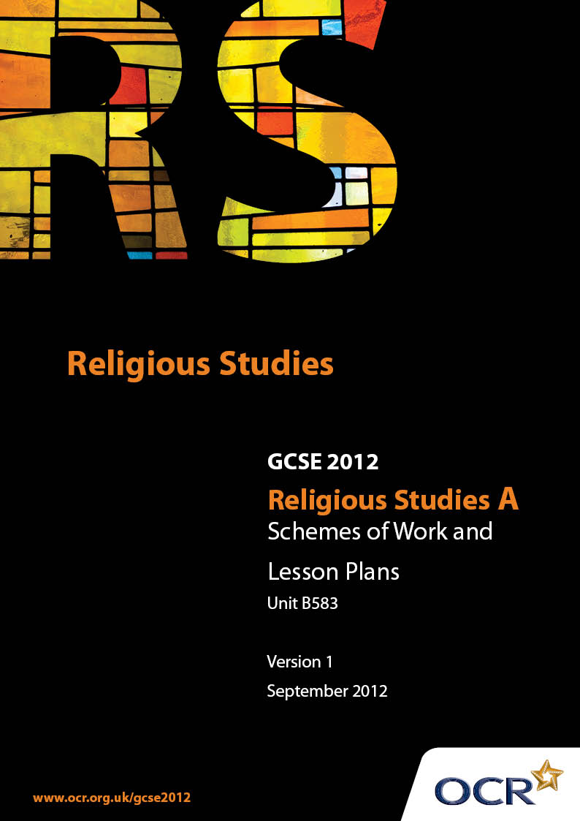

Contents
Contents 2
Introduction 3
Sample Scheme of Work:Unit B583: Christian Scriptures (Mark) 5
Sample Lesson Plan:Unit B583: Christian Scriptures (Mark) 9

Introduction

Background
Following a review of 14 – 19 education and the Secondary Curriculum Review, the Qualifications and Curriculum Authority (QCA) has revised the subject criteria for GCSEs, for first teaching in September 2009. This applies to all awarding bodies.
The new GCSEs have more up-to-date content and encourage the development of personal, learning and thinking skills in your students.
We’ve taken this opportunity to redevelop all our GCSEs, to ensure they meet your requirements. These changes will give you greater control of assessment activities and make the assessment process more manageable for you and your students. Controlled assessment will be introduced for most subjects.
From September 2012 assessment tasks may be undertaken at any point between release of the task and the examination series for which the task must be submitted. Centres must ensure that candidates undertake a task that is valid for submission in the year in which the candidate intends to submit it.
OCR has produced a summary brochure, which summarises the changes to Religious Studies A. This can be found at www.ocr.org.uk, along with the new specification.
In order to help you plan effectively for the implementation of the new specification we have produced these Schemes of Work and Sample Lesson Plans for Religious Studies A. These Support Materials are designed for guidance only and play a secondary role to the Specification.

Our Ethos
OCR involves teachers in the development of new support materials to capture current teaching practices tailored to our new specifications. These support materials are designed to inspire teachers and facilitate different ideas and teaching practices.
Each Scheme of Work and set of sample Lesson Plans is provided in Word format – so that you can use it as a foundation to build upon and amend the content to suit your teaching style and students’ needs.
The Scheme of Work and sample Lesson plans provide examples of how to teach this unit and the teaching hours are suggestions only. Some or all of it may be applicable to your teaching.
The Specification is the document on which assessment is based and specifies what content and skills need to be covered in delivering the course. At all times, therefore, this Support Material booklet should be read in conjunction with the Specification. If clarification on a particular point is sought then that clarification should be found in the Specification itself.

A Guided Tour through the Scheme of Work

= Innovative Teaching Idea
This icon is used to highlight exceptionally innovative ideas.


= ICT Opportunity
This icon is used to illustrate when an activity could be taught using ICT facilities.

Unit B583: Christian Scriptures (Mark)
SUGGESTED TEACHING TIME | 8 HOURS | TOPIC | LIFE OF JESUS THROUGH A STUDY OF MARK
TOPIC OUTLINE |  | SUGGESTED TEACHING AND HOMEWORK ACTIVITIES |  | SUGGESTED RESOURCES | POINTS TO NOTE
Jesus as Messiah  John the Baptist prepares the way (Mark 1:1-8) |  | - What would you do if you had an important person coming to stay at your house? Ttidy and clean up – John encourages people to clean up their lives to prepare for the coming of the Messiah)  - How does Mark show that John is important? Give two reasons  - Write a job description for John the Baptist |  | - Construct a job description sheet with headings
The Baptism and temptation of Jesus (Mark 1: 9-11) |  | - Use of video clip from ‘Jesus of Nazareth’ on the baptism of Jesus. Make notes on what is said and done  - The dove symbolises God’s presence – explain why. If you had to choose a symbol to represent God’s presence in you what would you choose and why?  - Discuss the importance of Elijah in Mark’s description of the baptism (2Kings 1: 8)  - What were the three things about John’s appearance and lifestyle that people would have associated with the prophet Elijah? Using the worksheet write profiles for Elijah and John the Baptist |  | - Video clip – 'Jesus of Nazareth'  - Create a worksheet for the profiles of Elijah and John the Baptist
The transfiguration of Jesus (Mark 9: 2-8) |  | - Explore the idea of Transfiguration – ‘changing appearance’  - Consider the use of white to signify heaven, and heavenliness eg: historically angels are dressed in white  - Peter thinks he should build three shelters at the Transfiguration – why? Research the Jewish festival of Sukkoth  - Imagine you are Peter. Write about what happened at the Transfiguration. How did you feel? Write the story from Peter’s point of view |  | - Use of internet to research Jewish festival of Sukkoth
The triumphal entry into Jerusalem (Mark 11: 1-11) |  | - Why is the transfiguration important for Christians today?  - This begins the last week of Jesus’ Life. Look at the prophecy in Zechariah 9: 9-19 What is important about the use of the Colt?  - Write an acrostic for the word ‘Hosanna’  - How do people today remember Jesus’ entry into Jerusalem?  - For each part of the story write down what each part tells Mark’s readers about Jesus
Jesus anointed at Bethany (Mark 14: 1-10) |  | - The Jewish soldiers did not do anything about Jesus’ entry into Jerusalem. Imagine you are the leader of the soldiers – write a response to the criticism that your soldiers let this event pass  - Perfume was used to anoint bodies after death. Why did the woman anoint Jesus?  - Research the use of perfume for anointing bodies – what is the significance of the whole bottle being used?  - What was the significance of Jesus being anointed by a woman? Would the meaning be different if the anointing was done by a man?  - Research Passover  - Re-enact the anointing at Bethany  - The woman spent a whole year’s wages on the perfume. What would you spend a year’s wages on to help someone else? Give reasons for your answer |  | - ICT opportunity – research  - ICT opportunity research

Unit B583: Christian Scriptures (Mark)
SUGGESTED TEACHING TIME | 8 HOURS | TOPIC | LIFE OF JESUS THROUGH A STUDY OF MARK
TOPIC OUTLINE |  | SUGGESTED TEACHING AND HOMEWORK ACTIVITIES |  | SUGGESTED RESOURCES | POINTS TO NOTE
Death and Resurrection  Jesus arrested (Mark 14: 43-51) |  | - Jesus has to leave his friends and die alone – how must he be feeling?  - Jesus called God ‘Abba’, what does this mean?  - Mark mentions the ‘young man’ who follows Jesus. Who do people believe he is? Why do you think Mark included him?  - Imagine you are one of the soldiers sent to arrest Jesus. Write a diary entry. How were you feeling? Did you agree with the arrest or did you feel sorry for Jesus?  - Why did Jesus not defend himself, but perform an act of kindness and healing?  - What was the significance of Judas’ kiss? Write Judas’ thoughts as he did this. Write about a time when you did something you later regretted
The Jewish trial before the Sanhedrin (Mark 14: 53-65) |  | - Imagine that you are passing by the High Priest’s House on your way home when you see Jesus being led up the steps – describe the scene  - Debate ‘This house thinks that Jesus should have been released’  - Construct a worksheet with the main characters involved in the arrest and trial, together with what they said and where – mismatch them for sorting  - Write down as many reasons as you can think of which explain why Jesus was considered a threat  - Research what the other gospels have to say about the trial  - Research Pontius Pilate |  | - Worksheet in three columns with who, what was said and where
The Roman trial before Pilate (Mark 15: 1-15) |  | - Why was Jesus taken to see Pilate after he had been found guilty?  - Imagine you are Pilate – why did you allow Jesus to be condemned to death?  - Imagine you are a juror at the trial of Jesus. What evidence can you use as reasons for condemning him?  - Use of video clip from ‘Jesus of Nazareth’  - Research Good Friday in different countries (Way of Sorrows in Jerusalem – Via Dolorosa) |  | - ICT research  - ICT opportunity | - Bible passages can be found at www.biblegateway.com for putting on screen/interactive whiteboard  - Jesus was accused of four crimes, but the things he did prior to his arrest could be used – possibility for revision of previous topics
The Crucifixion (Mark 15: 21-41) |  | - Write an eye-witness account from Simon of Cyrene when he saw Jesus carrying the cross  - Plan an assembly for Good Friday  - Imagine you are Mary, the mother of Jesus – how would you be feeling?  - Why was it necessary for Jesus to die?  - Research the Stations of the Cross in Catholic churches.  - Write a diary entry for Good Friday – Jesus, your friend is dead, how do you make sense of it all?  - Write about a time when you have been punished for something you did. How did you feel about it? What difference would it have made to your feelings if you had been innocent? How would you feel seeing someone else punished for something that you did? |  | - ICT Research | - BBC ‘Son of God’ has useful resources on crucifixion
The burial of Jesus (Mark 15:42-47) |  | - Jesus was mocked. Has there been a time when people made fun of you? What is it like to have people laughing at you? How do you think Jesus felt?  - Jesus had to be buried quickly, what were the reasons for this?  - Imagine you are one of the people involved in the death of Jesus (Mary, Pontius Pilate, Peter, Nicodemus) How do you feel the following day when you wake up and realise that Jesus is dead?  - Research special services that take place over the Easter period  - Cloze passage  - Look at Psalm 22, Psalm 69:21 and Isaiah 53. Copy out these references and next to them write the verses from Mark which are the same. Why do you think they are so close? Prophecy |  | - Internet search engine  - Put the passages on screen/interactive whiteboard or use Bibles for this research  - Pictures of the cross/crucifixion
The Resurrection (Mark 16: 1-8) |  | - Display pictures of the cross. What statement do you think each picture is making?  - Write a newspaper article about the death of Jesus. Use a headline like ‘Death of a King’, ‘Traitor dies ’or ‘Robber saved’. What implication does the headline make to the way you tell the story? |  | - ICT opportunity Internet search engine
The Lord’s Supper/Eucharist |  | - Who was the young man at the tomb? Why did the women react as they did?
Institution of the Lord’s Supper/Eucharist and centrality to Christian worship (Mark 14: 12-26) |  | - Explain why the Resurrection was so important  - Research life after death in other religions  - How is the Resurrection important to Christians today?  - Why did Jesus choose the bread and wine to remember his life? What two things would you choose to remember your life? Why?  - What is the significance of the Last Supper to Christians today?  - The Last Supper was a Covenant. What other Covenants are there in the Bible (e.g. Noah – rainbow, Abraham)?  - Find out how the Lord’s Supper/Eucharist is celebrated by other churches  - Make an acrostic using the word ‘Salvation’ to explain its meaning  - Describe what happened at the Last Supper |  | - ICT opportunity Internet search engine

Unit B583: Christian Scriptures (Mark)
SUGGESTED TEACHING TIME | 8 HOURS | TOPIC | LIFE OF JESUS THROUGH A STUDY OF MARK
TOPIC OUTLINE |  | SUGGESTED TEACHING AND HOMEWORK ACTIVITIES |  | SUGGESTED RESOURCES | POINTS TO NOTE
Jesus as Miracle Worker:  The nature of miracles  Jesus calms the storm (Mark 4:35-41) |  | - The disciples were afraid and showed a lack of trust in Jesus. Do you think this was understandable?  - Research the Sea of Galilee – do storms often occur there? In the Old Testament there was much reference to water and storms – who controlled them?  - Prepare a short play on these events. Put in the light/sound directions  - Imagine you are Jesus and you have been woken up by the frightened men. How would you initially feel? You will need to remember Jesus was human as well as divine |  | - ICT opportunity - research
Jesus feeds the five thousand (5000) (Mark 6: 30-44) |  | - This miracle shows the nature of Jesus in that he behaves as if he were God. Contrast with Elisha in 2 Kings 4: 42-44  - Discuss how the Feeding of the 5000 is interpreted today. What would a liberal Christian say? What would a fundamentalist say? What would a conservative say? Which one do you think makes the most sense?  - Imagine you were there at the Feeding of the 5000. Write an eye-witness account of what you saw and heard |  | - ICT opportunity. Research of modern miracles
Jesus walks on the water (Mark 6: 45-52) |  | - Compare the Calming of the Storm and Jesus walking on the water. How are they similar?  - What is a nature miracle? Why are nature miracles important? How do they show us that Jesus was God’s chosen one?  - Do miracles happen today? Find examples in newspaper articles/ internet research on modern miracles  - Imagine you were walking along the shore when you saw Jesus walk on the water. What did you see? How did you feel? Write an account. Did it make you believe Jesus was the Son of God?
Healings and Exorcisms  Jesus drives out an evil spirit (Mark 1: 21-28) |  | - How would we react to someone who was ‘possessed’ today? What would we say was wrong with him?  - You were present when Jesus cast out the evil spirit. Write a letter to a friend saying what happened and what you saw and heard. Explain to your friend how you felt when it was over  - How does Jesus’ authority over the evil spirit show his importance?  - Discuss whether you think demons exist today |  | - ICT opportunity. Research on houses in Jesus’ time
Jesus heals a paralytic (paralysed man) (Mark2: 1-12) |  | - Construct a storyboard for the events in this story using speech bubbles  - Research houses in Jesus’ time. How did they lower the man through the roof? Draw a diagram to explain this  - Construct a storyboard for the events in this story using speech bubbles  - Prepare a radio interview (taped) with someone who was present at this healing  - Why are healing miracles important in our understanding of the power of Jesus? Hotseating  - Both these miracles are about faith. How can we express our faith today? Prepare a PowerPoint presentation to explain to others what faith is |  | - Tape recorder and written script  - ICT opportunity – PowerPoint presentation  - ICT opportunity. Research into coma victims
A dead girl and a sick woman (Mark 5: 21-43) |  | - Both these miracles are about people who are beyond medical help for those times. How would they be treated today? Research someone who has been in a coma. (EG: Tony Bland , the Hillsborough victim)  - How does Mark show that Jesus is behaving as if he was God?  - Both these miracles are about women. Research how women were treated in the time of Jesus  - Give an example of how men mistreat and discriminate against women today  - How might Christianity today challenge people’s attitudes to women? Make a poster to explain this  - Imagine you are Jairus. Describe your thoughts from when you asked Jesus to help to when your daughter sat up and walked about. Write this as a diary entry  - Why did Jesus ask people not to say what they had seen? Why was it important that he kept his identity a secret?  - What is meant by the term ‘Messianic secret?’ |  | - ICT opportunity – Research on the role of women in Old Testament/New Testament times
The healing of a demon-possessed man (Legion) (Mark 5: 1-20) |  | - Write an eye-witness account from someone who saw the evil spirits go out of the man  - Construct a storyboard for the events |  | - Tape recorder and written script
The faith of the Syrophoenecian woman (Mark 7: 24-30) |  | - Why does the fact that this woman was a Gentile make the healing so important  - Discuss why racism is never right. Prepare a radio interview with someone who has been affected by racism  - Jesus used the analogy of ‘dogs’. Why do you think he did this?  - Why does Mark place more emphasis on what is actually said, rather than the details of the cure?
The healing of a boy with an evil spirit (Mark 9: 14-29) |  | - Construct a storyboard for the events in this miracle  - If you had to choose one miracle as being the most important, which one would you choose and why?  - Describe the exorcism of the boy with the evil spirit  - Debate – ‘This house believes that evil and bad are the same thing’  - Draw a poster with evil things on one side and bad things on the other  - How is epilepsy treated today? Research  - There is no cure for epilepsy today. How did Jesus manage to cure him?  - Why is faith so important? Draw a poster showing how people have faith  - Research places of pilgrimage where healings are said to have happened. (Lourdes) |  | - ICT opportunity –research  - ICT opportunity –research

Unit B583: Christian Scriptures (Mark)
SUGGESTED TEACHING TIME | 8 HOURS | TOPIC | LIFE OF JESUS THROUGH A STUDY OF MARK
TOPIC OUTLINE |  | SUGGESTED TEACHING AND HOMEWORK ACTIVITIES |  | SUGGESTED RESOURCES | POINTS TO NOTE
Jesus in conflict with authority  Lord of the Sabbath (Mark 2: 23-28) |  | - Look at Deuteronomy 23 :24 and the Law of Moses regarding poor people. The disciples picked corn on the Sabbath and angered the Pharisees by doing it on the Sabbath. What rules can you think about today that show things that should not be done on the Sabbath (Jewish laws on Shabbat). Produce a PowerPoint presentation to show to your class  - What did Jesus mean by ‘The Sabbath was made for the good of man; man was not made for the Sabbath’?  - Research the ‘Keep Sunday special campaign’. Is Sunday a special day for you? What do you do on a Sunday? Write a diary entry  - Debate ‘This house believes that Sunday should be a day of rest’ |  | - ICT opportunity – research on Jewish laws for Shabbat
The man with the withered (shrivelled) hand (Mark 3: 1-6) |  | - The Jewish laws about healing stated that it was only allowed if someone’s life was in danger. This man’s life was not in danger. Why did Jesus choose to heal him on the Sabbath knowing that this would get him into trouble with the Pharisees?  - Design a ‘Wanted Poster’ for Jesus from the point of view of one of the groups of people who oppose Jesus  - Who opposed Jesus? Why did they oppose him? Imagine you are a member of one of the groups. Write down how you feel about Jesus  - Main theme – the hostility of the authorities to Jesus. Jesus was a Jew and such grew up respecting the Jewish law, and the teachings. Jesus shows throughout his life that he did not believe the traditional teachings were important. How do we know this? List times when Jesus did ‘the wrong thing’ according to the authorities
Clean and unclean (Jesus answers criticism by the Pharisees) (Mark 7: 1-23) |  | - The Pharisees did not like what Jesus was doing. They said he broke the laws. When would you break a law? Give reasons and explain why  - Research Martin Luther King. He acted against the laws that discriminated against black people in the USA. How did he act?  - Research Jewish food laws. Prepare a menu for a Jew today |  | - ICT opportunity – research of Martin Luther King.  - ICT opportunity – research of Jewish food laws.

Unit B583: Christian Scriptures (Mark)

Jesus as miracle worker: The Calming of the Storm Mark 4;35-41
OCR recognises that the teaching of this qualification above will vary greatly from school to school and from teacher to teacher. With that in mind this lesson plan is offered as a possible approach but will be subject to modifications by the individual teacher.
Lesson length is assumed to be one hour.

Learning Objectives for the Lesson
Objective 1 | Students to understand why The Calming of the Storm is a miracle.
Objective 2 | Students to consider the nature of Jesus from miracles.
Objective 3 | Students to be able to analyse the significance of the miracle.

Recap of Previous Experience and Prior Knowledge
- Students to re-cap on what constitutes a miracle – an event that interferes with the laws of nature; a moment when God acts in a powerful way in the world.

Content
Time | Content
5 minutes | Quick discussion on what constitutes a miracle – pupils to give examples of what they see as a ‘modern-day’ miracle.
10 minutes | Read Mark 4:35-41. Question and answer session on The Calming of the Storm.
5-10 minutes | Pupils to draw a quick storyboard for what happened during the Calming of the Storm.
15-20 minutes | Students to write an ‘eye-witness account ‘ from one of the disciples.
10 minutes | Selected students to share their account with the class.

Consolidation
Time | Content
5 minutes | A quick fire question round: what did Jesus say to the disciples? Why did the disciples wake Jesus up? Why did Jesus ask ‘Do you still have no faith?’ etc.
5 minutes | Teacher led short discussion: hat does the miracle show about God’s love and the calm and peace that the Kingdom of God will bring? Preparation for next lesson.

