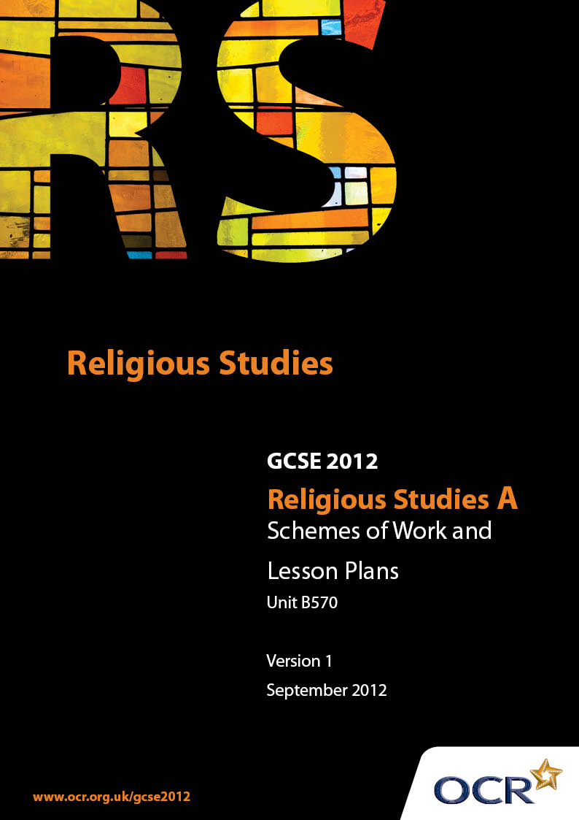

Contents
Contents 2
Introduction 3
Sample Scheme of Work: Unit B570: Buddhism 2 (Worship, Community and Family, Sacred Writings) 5
Sample Lesson Plan: Unit B570: Buddhism 2 (Worship, Community and Family, Sacred Writings) 13

Introduction

Background
Following a review of 14 – 19 education and the Secondary Curriculum Review, the Qualifications and Curriculum Authority (QCA) has revised the subject criteria for GCSEs, for first teaching in September 2009. This applies to all awarding bodies.
The new GCSEs have more up-to-date content and encourage the development of personal, learning and thinking skills in your students.
We’ve taken this opportunity to redevelop all our GCSEs, to ensure they meet your requirements. These changes will give you greater control of assessment activities and make the assessment process more manageable for you and your students. Controlled assessment will be introduced for most subjects.
From September 2012 assessment tasks may be undertaken at any point between release of the task and the examination series for which the task must be submitted. Centres must ensure that candidates undertake a task that is valid for submission in the year in which the candidate intends to submit it.
OCR has produced a summary brochure, which summarises the changes to Religious Studies. This can be found at www.ocr.org.uk, along with the new specification.
In order to help you plan effectively for the implementation of the new specification we have produced these Schemes of Work and Sample Lesson Plans for Religious Studies. These Support Materials are designed for guidance only and play a secondary role to the Specification.

Our Ethos
OCR involves teachers in the development of new support materials to capture current teaching practices tailored to our new specifications. These support materials are designed to inspire teachers and facilitate different ideas and teaching practices.
Each Scheme of Work and set of sample Lesson Plans is provided in Word format – so that you can use it as a foundation to build upon and amend the content to suit your teaching style and students’ needs.
The Scheme of Work and sample Lesson plans provide examples of how to teach this unit and the teaching hours are suggestions only. Some or all of it may be applicable to your teaching.
The Specification is the document on which assessment is based and specifies what content and skills need to be covered in delivering the course. At all times, therefore, this Support Material booklet should be read in conjunction with the Specification. If clarification on a particular point is sought then that clarification should be found in the Specification itself.

A Guided Tour through the Scheme of Work

= Innovative Teaching Idea
This icon is used to highlight exceptionally innovative ideas.


= ICT Opportunity
This icon is used to illustrate when an activity could be taught using ICT facilities.

Unit B570: Buddhism 2 (Worship, Community and Family, Sacred Writings)
Suggested teaching time | 12 hours | Topic | Places and forms of worship
Topic outline |  | Suggested teaching and homework activities |  | Suggested resources | Points to note
An introduction to the nature of traditional Buddhist holy buildings  Temples, viharas and stupas |  | - ICT internet research stimulus  - Explore the variety of examples of temples, viharas and stupas to understand size, architectural styles and locations  - Define the differences between temples as holy shrines, viharas as monasteries and stupas as burial mounds. They evaluate the reasons why some sites contain all three  - Create a ‘Wish You Were Here’ power point of the most spectacular sites with an accompanying narrative script to feature theory history and links to Buddhism |  | - Various internet sites e.g.  En.wikipedia.org/wiki/List_of_  Buddhist_temples  - The Buddhist Experience  [M Thompson]  - Introduction to the Buddhist Experience  [D.Mitchell]  - Teach Yourself Buddhism [W Owen Cole] | - Students may wish to begin by offering explanations of the purpose of holy buildings in general to compare the common elements each may offer  - Students should be in a position to describe the main features of a temple, vihara and stupa and explain the history of their development  - Students begin to link the ways in which these buildings are also holy shrines that contain relics and how they may be used as part of meditation and worship to honour the memory of the Buddha
Shrines |  | - Students create their own Buddhist shrine by researching the common elements that one might contain from the various Buddhist traditions  - The shrine might include:  - Buddha images, rupas  - Flowers incense and candles  - Offering bowls  - A bell  - A gong  - Pictures, images of the Buddha  - Create a guide booklet to the Buddhist shrine which contains an explanation of the objects displayed and how they may be used for puja  - Focus on the ways in which a Buddhist may chant mantras or meditate in silence focusing on each element of the shrine |  | - Various internet sites e.g.  www.buddhamind.info/leftside/actives/shrine.htm  www.pilgrimage-india.com/buddhist-pilgrimage/lumbini.html | - Students should begin to relate the nature of the shrine as a stimulus for the mind and body to help Buddhists to concentrate on the teachings of the Buddha  - Students understand how respect may be shown to the buddharupa and how visiting a temple, vihara or shrine may strengthen the faith of the individual Buddhist
How they might be used as a community |  | - Recap on previous lessons and the variety of buildings used as part of Buddhist worship  - Students focus on how the outside and inside of each type of building or the stupa as a simple burial mound might help the community to focus on remembering the teachings of the Buddha and focus on the values that effect their lives  - Students brainstorm how a temple and shrine may be used as part of everyday worship, rites of passage and also as part of special festivals and days  - Students feedback and consolidate their findings |  |  | - Students should focus on both the positive and negative aspects of visiting a Buddhist holy shrine or building  - Meditation may help gain merit for the Buddhist  - Attachments to earthly objects are unhelpful  - It is helpful for students if they can relate the ways in which the community uses Buddhist buildings or shrines to enhance the Buddha’s teachings and relate then to modern day issues

Unit B570: Buddhism 2 (Worship, Community and Family, Sacred Writings)
Suggested teaching time | 12 hours | Topic | Religion in the faith community and the family
Topic outline |  | Suggested teaching and homework activities |  | Suggested resources | Points to note
An introduction to the role of the monastic sangha |  | - Review the history of the Buddha and how some of his early followers became the first bhikkhus  - Evaluate the meaning of the Three Refuges and how they rely on each other for the continuation of the Buddhist faith  - Investigate the differences between the monastic sangha and the laity and how the relationship between the two was established during the Buddha’s lifetime and continue today  - List the ways in which a community can be strengthened spiritually by having access to religious teachers at all times |  | - The Buddhist Experience  [M.Thompson]  - Introduction to the Buddhist Experience  [D.Mitchell]  - Various internet websites | - Students should evaluate the ways in which the Buddhist dharma helped to enforce equality amongst his early followers  - The relevance of the caste system at the time of the Buddha and how it imposed restrictions against many who wished to lead a life learning about and teaching the scriptures to others
Lifestyles of the bhikku and bhikkhuni |  | - Stimulus: brainstorm what it is like to be a monk or nun in the religious faith most relevant to them  - Discussion: What general rules apply to those choosing to lead a monastic lifestyle and why do they apply?  - Evaluate the lifestyle of a bhikku and bhikkhuni. They should focus on the ten precepts and the monastic rules about possessions  - Design a rule guide book for Buddhists from the laity who wish to join the monastic Sangha |  | - As above | - Students should begin to develop an awareness of the everyday distractions that may impede the quest for religious fulfilment or enlightenment  - Students should link the quality of commitment to the reward of enlightenment  - Students should decide if only the monastic sangha are in a position to reach enlightenment and why?
The relationship between the laity and the monastic sangha |  | - Brainstorm the role of the monastic Sangha and the similarities and differences between the ways in which they and the laity approach puja and meditation.  - Compile a list of the physical things they would be prepared to give up in a quest to find enlightenment  - Create a duel diary describing a typical day in their life and a typical day in the life of one the monastic sangha  - Make a comparative study of how the monastic sangha and the laity rely on each other for their spiritual and physical existence |  | - As above | - Students should continue to evaluate how each refuge is dependent on the other and how not adhering to one part may affect another  - An understanding that the monastic sangha are viewed as representatives of the Buddha’s teachings and an aid to enlightenment  - That various Buddhist traditions place greater or lesser value on the role of the monastic sangha

Unit B570: Buddhism 2 (Worship, Community and Family, Sacred Writings)
Suggested teaching time | 12 hours | Topic | Sacred writings
Topic outline |  | Suggested teaching and homework activities |  | Suggested resources | Points to note
Introduction to sacred texts and why they are important to a religion |  | - Investigate the value of religious scriptures by brainstorming prior knowledge of the most relevant religious scriptures related to individual world faiths  - Examine the most common ‘rules’ related to religious teachings and how they may be relevant to the period of time during which they were produced  - Build on prior knowledge by discussing their views of other founders of faith and how their original teachings were disseminated |  | - The Buddhist Experience  [M.Thompson]  - Introduction to the Buddhist Experience  [D.Mitchell]  - There are various interpretations and translation of parts Various internet websites  - Teach Yourself Buddhism [W Owen Cole] | - Do ancient religious texts still hold relevance to modern day life?  - Can students identify which teachings from the world faith have stood the test of time and are still important today
The Pali Cannon  The ways in which the texts are used by some Buddhists |  | - ICT, internet, text book research the Pali Cannon [Tripitaka.]  - Divide the meaning of the Tripitaka into its three main areas  - Vinaya Pitaka, Sutta Pitaka and Abhidhamma Pitaka  - Evaluate which part of the Tripitaka is the most important and place them in order of significance  - Research and investigate each part of the Tripitaka. They formulate and feedback facts to the rest of the class.  - Create a set of revision cards by choosing an image prompt related to the part they heave researched with bullet point facts written on the reverse |  | - Various internet websites.  - The Buddhist Experience  [M.Thompson]  - Introduction to the Buddhist Experience  [D.Mitchell] | - When evaluating parts of the Pali canon, consider and discuss how the text may be used as evidence in response to a GCSE question
The Sutta Pitaka |  | - Stimulus: research either the Dhammapada or the Jakata Tales. They each produce a storyboard which describes/retells some of the verses of the Dhammapada linking the Buddha’s teachings to the Noble Eightfold Path or the Jakata Tales to illustrate the quest to live a moral life and the ongoing cycle of samsara |  | - Various internet websites including:  www.buddhanet.net/monkey1.htm  www.buddha-images.com  www.archive.org/details/jatakatales00tran  - There are various internet sites containing verses from the Dhammapada including an illustrated version of the verses at www.buddhanet.net/dhammapada/index.htm | - Students may wish to build a portfolio of verses and stories from the sacred texts and analyse what the Buddha is teaching.  - Can the verses be used to illustrate the Five precepts?

Unit B570: Buddhism 2 (Worship, Community and Family, Sacred Writings)

Creating a Buddhist Shrine
OCR recognises that the teaching of this qualification above will vary greatly from school to school and from teacher to teacher. With that in mind this lesson plan is offered as a possible approach but will be subject to modifications by the individual teacher.
Lesson length is assumed to be one hour.

Learning Objectives for the Lesson
Objective 1 | Students to understand the significance of a Buddharupa image and the ways in which it relates to puja.
Objective 2 | Students identify the physical aspects of the shrine and suggest ways in which they may help a Buddhist to meditate.
Objective 3 | Understand the three refuges are linked to the concept of the shrine and the ways in which it may draw upon each aspect.

Recap of Previous Experience and Prior Knowledge
- This lesson will give the opportunity for students to create the idea of their own Buddhist shrine. It will draw upon their prior knowledge of puja and meditation and will encourage them to identify the links between the Three Refuges and the practice of meditation and worship.

Content
Time | Content
5 minutes | Stimulus: Power point, internet research and text book representations of a selection of images of the Buddha.  Students focus on the similarities and differences of the representation of the Buddha. Can students identify poses, hand gestures etc?
5 minutes | Students devise a Buddhist shrine plan and focus on the necessary physical relics and resources to recreate a shrine dedicated to the Buddha and his teachings.  Students may wish to focus on  - A Buddharupa  - Photographic images and representations of the Buddha  - Offering bowels  - Flowers and incense  - A bell or gong  - Candles.
15 minutes | Students develop a set of revision cards to connect each item from their Buddhist shrine to a teaching of the Buddha. On one side of the card, the image and meaning/connection of each item to the Buddha’s teachings.  - Buddharupa - the enlightenment  - Images of the Buddha - various stages of his life and teachings.  - Offering bowls - the original Sadhu in the four sights, the life of the bhikku.  - Flowers and incense - impermanence and good deeds spreading outwards.  - A bell or gong - a call to meditation  - Candles - light, wisdom, enlightenment.
15 minutes | Students look at the meaning of the three refuges.  I go to the Buddha for refuge.  I go to the Dharma for refuge.  I go to the Sangha for refuge.  They take each image and apply which refuge might suit that part of the shrine. They write the relevant refuge [in some cases more than one] on the flipside of the card with an explanation, description or example of the links they have found.
10 minutes | Students continue to prepare their cards and feedback to the group on progress made.

Consolidation
Time | Content
5 minutes | Students attempt to define the word ‘refuge’ and discuss the ways in which each refuge is applicable to the process of puja and meditation.
 | Homework or future lesson: Create a guide booklet for a non Buddhist to explain how and why the Buddhist shrine helps to remind the Buddhist of all aspects of the Buddha’s teachings from both the sangha and the laity’s point of view.

Unit B570: Buddhism 2 (Worship, Community and Family, Sacred Writings)

The role of the monastic sangha. Dear Diary: A day in the Life of A Bhikku and Bhikkhuni
OCR recognises that the teaching of this qualification above will vary greatly from school to school and from teacher to teacher. With that in mind this lesson plan is offered as a possible approach but will be subject to modifications by the individual teacher.
Lesson length is assumed to be one hour.

Learning Objectives for the Lesson
Objective 1 | Students to understand the term Sangha as part of the three refuges.
Objective 2 | Students evaluate the lifestyle of the bhikku and bhikkhuni by  creating a diary extract to describe their typical day.
Objective 3 | Students prepare a set of interview questions for a radio audio link to their local vihara. They connect key words to their interview questions to evaluate the theory of the Buddha’s teaching to everyday practice.

Recap of Previous Experience and Prior Knowledge

Content
Time | Content
5 minutes | Stimulus: Students begin by looking at a set of key words connected to the Buddha’s teachings: PRECEPT, METTA, PUJA, MEDITATION, CRAVING, KARMA, SAMSARA, ENLIGHTENMENT and NIRVANA. They discuss their meaning and how they are connected to the teachings of the Buddha.
5 minutes | Students work in pairs to plan how their diary will reflect the duties and purpose of a typical day in the life of the bhikku and bhikkhuni.
15 minutes | Students develop a rough draft of the 24 hours in a typical day of the monastic sangha. They should include:  - The ten precepts with a description of how this might affect the life of the individual monk or nun.  - Different types of meditation and puja  - How living in the monastery might prevent craving  - The role of the sangha and the laity and how this can develop mutual metta.  - There feelings about enlightenment and the quest for nirvana.
15 minutes | Students continue with their written task, feeding back progress to the teacher.
10 minutes | Students exchange ideas for peer assessment purposes and discuss the ways in which the key words can be used to describe the different elements that make up a day in the life of a bhikku and bhikkhuni.

Consolidation
Time | Content
5 minutes | Students are asked to give a verbal account of what they would find easy/hard about becoming a monk or nun in the Buddhist tradition.
 | Homework or future lesson: Students look at the ways in which they might retreat to a quiet place when they need to reflect upon personal issues and how it might help them to solve a personal problem or reach an important decision.

Unit B570: Buddhism 2 (Worship, Community and Family, Sacred Writings)

The Tripitaka
OCR recognises that the teaching of this qualification above will vary greatly from school to school and from teacher to teacher. With that in mind this lesson plan is offered as a possible approach but will be subject to modifications by the individual teacher.
Lesson length is assumed to be one hour.

Learning Objectives for the Lesson
Objective 1 | Students understand the nature and value of sacred texts
Objective 2 | Students investigate each area of the Tripitaka giving examples of what might be found in each basket.
Objective 3 | Students create a wall display to show the nature of what is contained in some of the Buddhist sacred texts.

Recap of Previous Experience and Prior Knowledge
- This lesson is devised as a relatively easy example for students to investigate the way in which the Pali Canon is divided into ‘three baskets,’ [Tripitaka] and to give examples of what each basket may contain.

Content
Time | Content
5 minutes | Students divide into three groups, they will each take one part of the Tripitaka to investigate and recreate as part of the wall display. Students divide the workload of this project and make lists of what should be included in their basket.
5 minutes | Students appoint each person in their team to applicable research areas: ICT internet research, library, art work etc
15 minutes | Students collect information under the following titles:  - The Vinaya Pitaka- rules for monks and nuns  - The Sutta Pitaka- the Buddha’s teachings.  - The Abhidhamma Pitaka- explanations of the Buddha’s teachings.  - Students make a list of the relevant key words that might apply to each basket, the make key word cards with a written explanation for each.
15 minutes | Students seek to make their display both informative and eye catching by using narrative descriptions of the relevant facts and colourful illustrations.
10 minutes | Students continue with their research and preparations for the display.

Consolidation
Time | Content
5 minutes | Students explain to their peers why they have chosen the narrative and illustrations for their part of the display and the ways in which it may assist knowledge and understanding of the value of the Pali Canon.
 | Homework or future lesson: Student create a written account of the contents of the wall display to prepare for a speaking and listening presentation of their contribution of the display to other students.

