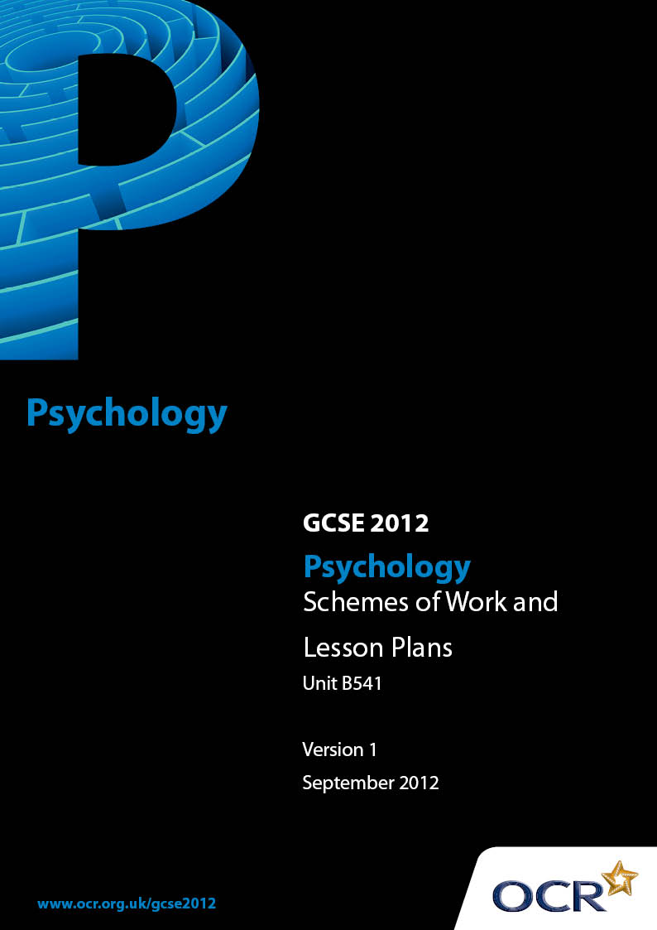

Contents
Contents 2
Introduction 3
Sample Scheme of Work: OCR GCSE Psychology Unit B541: Studies and Applications in Psychology 1 5
Sample Scheme of Work: OCR GCSE Psychology Unit B541: Studies and Applications in Psychology 1 and Unit B542: Studies and Applications in Psychology 2 14
Sample Lesson Plan: OCR GCSE Psychology Unit B541: Studies and Applications in Psychology 1 16

Introduction

Background
Following a review of 14 – 19 education and the Secondary Curriculum Review, the Qualifications and Curriculum Authority (QCA) has revised the subject criteria for GCSEs, for first teaching in September 2009. This applies to all awarding bodies.
The new GCSEs have more up-to-date content and encourage the development of personal, learning and thinking skills in your students.
We’ve taken this opportunity to redevelop all our GCSEs, to ensure they meet your requirements. These changes will give you greater control of assessment activities and make the assessment process more manageable for you and your students. Controlled assessment will be introduced for most subjects.
From 2014, candidates must take all unit examinations within the series for which the certification entry is made. Candidates who start a two year course in September 2012 will therefore take all examinations and be certificated in June 2014. There is no January series in 2014.
OCR has produced a summary brochure, which summarises the changes to Psychology. This can be found at www.ocr.org.uk, along with the new specification.
In order to help you plan effectively for the implementation of the new specification we have produced these Schemes of Work and Sample Lesson Plans for Psychology. These Support Materials are designed for guidance only and play a secondary role to the Specification.

Our Ethos
OCR involves teachers in the development of new support materials to capture current teaching practices tailored to our new specifications. These support materials are designed to inspire teachers and facilitate different ideas and teaching practices.
Each Scheme of Work and set of Sample Lesson Plans is provided in Word format – so that you can use it as a foundation to build upon and amend the content to suit your teaching style and students’ needs.
The Scheme of Work and Sample Lesson Plans provide examples of how to teach this unit and the teaching hours are suggestions only. Some or all of it may be applicable to your teaching.
The Specification is the document on which assessment is based and specifies what content and skills need to be covered in delivering the course. At all times, therefore, this Support Material booklet should be read in conjunction with the Specification. If clarification on a particular point is sought then that clarification should be found in the Specification itself.

A Guided Tour through the Scheme of Work

= Innovative Teaching Idea
This icon is used to highlight exceptionally innovative ideas.


= ICT Opportunity
This icon is used to illustrate when an activity could be taught using ICT facilities.

OCR GCSE Psychology Unit B541: Studies and Applications in Psychology 1
Suggested teaching time | 10 hours | Topic | Biological Psychology
Topic outline |  | Suggested teaching and homework activities |  | Suggested resources | Points to note
Biological Psychology  3.1.1  Sex and Gender |  | - Complete Bem’s sex role inventory to illustrate the concepts of masculinity, femininity and androgyny  - Students could write their own version of Bem’s inventory bringing it into the twenty first century  - Watch the film of Billy Elliott to show the different gender roles and aspects of masculinity, femininity and androgyny  - Exploring the biological factors in sex differences: Students could produce life size human figures (by using wallpaper and drawing round each other) and labelling each one with the appropriate sex organs, chromosomes, hormones etc for both males and females using different coloured pens or paper |  | - http://www.neiu.edu/~tschuepf/bsri.html for a copy of Bem’s sex role inventory & score sheet or it can be found on page 123 of ‘Psychology For You’ Cullis, T., Dolan,L.,Groves.,(2002) Nelson Thornes [0 7487 3627 1]  - Billy Elliott DVD | - Research activity:  Scope to conduct a questionnaire on natural differences in choice of leisure activities
- Students could write a short diagrammatic story aimed at ten year olds as an informal sex education aid to describe the roles of chromosomes, hormones and gonads etc in gender development
- Students could look for other external influences on gender such as the media. A selection of advertisements or toy catalogues could be used to illustrate the media’s influence on gender role development
- Students could produce a cartoon strip of the psychoanalytic explanation for sex/gender role development. Half the class could do the Oedipus complex and half the Electra and they could be compared

OCR GCSE Psychology Unit B541: Studies and Applications in Psychology 1
Suggested teaching time | 10 hours | Topic | Cognitive Psychology
Topic outline |  | Suggested teaching and homework activities |  | Suggested resources | Points to note
Cognitive Psychology  3.1.2  Memory |  | - Introduce the topic of memory by running a mini experiment to see how reliable your student’s memory is (see http://www.psypress.com/pip/resources/slp/flash/ch09-IA-01.swf for a mock crime clip which could be used for this exercise)  - Watch the film ‘Memento’ - This shows a good insight into what life without the ability to make new memories would be like. It makes a good introduction to the topic of memory and shows evidence for the existence of long term and short term memory stores. Or alternatively, the film ’50 first dates’ gives a light hearted take on life without memory  - Design a hanging mobile linking the stages and processes involved in memory |  | - http://faculty.washington.edu/chudler/experi.html for interactive memory experiments  - http://www.bbc.co.uk/science/humanbody/mind/surveys/memory/ an experiment to explore your short term memory  - http://www.psypress.com/pip/resources/slp/flash/ch09-IA-06.swf for an interactive exercise demonstrating the levels of processing theory. Includes an evaluation of the theory  - http://www.psypress.com/pip/resources/slp/flash/ch09-IA-02.swf for a ‘drop and drag’ test of the multi-store model. It includes a demonstration of the power of rehearsal and an evaluation of the multi model theory of memory | - Carry out a replication of Terry’s research or  - any experiment on any aspect of memory (primacy-recency, effects of organisation, cues in recall etc)  - Research activity:  Deep processing - Construct a list of words that have approximately the same frequency of usage. Prepare questions to ask that will involve deep processing (e.g., “Is this the opposite of . . . ?”) or shallow processing (e.g., “Does this word include the letter G?”). It is easier if the questions have “yes/no” answers. Divide the list in half and give each half to a naïve participant, such as a family member, and ask the questions

OCR GCSE Psychology Unit B541: Studies and Applications in Psychology 1
Suggested teaching time | 10 hours | Topic | Cognitive Psychology
Topic outline |  | Suggested teaching and homework activities |  | Suggested resources | Points to note
 |  | - Conduct online memory experiments in class to illustrate the evidence for the existence of LTM and STM, the role of attention & rehearsal, evidence for the serial position effect etc  - Design a revision leaflet aimed at GCSE students describing the most effective revision aids  - Students could work in groups each producing a memory aid of each of the topics studied. Mind maps of core theories/studies, posters using imagery, etc could be made and shared |  | - www.s-cool.co.uk has some useful exercises and revision summaries on memory processes, the multi store model and levels of processing models of memory. (NB: designed for AS level use, although appropriate for strongly abled students)  - www.psychlotron.org.uk has an interactive levels of processing experiment  - http://uk.youtube.com/watch?v=wDNDRDJy-vo for a 10 minute BBC Four programme on Clive Wearing; the Man without a Memory, and  - http://uk.youtube.com/watch?v=xCyvzI2aVUo for part b of Clive’s story  - http://www.guardian.co.uk/books/2005/jan/23/biography.features3 This is Deborah’s (Clive’s wife’s) story | Take the list away and give the participant a blank piece of paper for a free recall test. Compare the findings with those of Craik and Lockhart  - Students could conduct a survey of teaching staff across a number of curriculum areas to find out what types of memory aids they use with their students to support recall. Look for common patterns

OCR GCSE Psychology Unit B541: Studies and Applications in Psychology 1
Suggested teaching time | 10 hours | Topic | Developmental Psychology
Topic outline |  | Suggested teaching and homework activities |  | Suggested resources | Points to note
- ‘Memento’ DVD can be purchased at www.coolpsychologystuff.co.uk
- ’50 first dates’ DVD

Developmental Psychology  3.1.3  Attachment |  | - A mix and match exercise could be used, where students are required to match the key terms to their corresponding definitions  - Watch ‘Are Mothers Really Necessary’ to provide a background to the theory of attachment and to introduce Bowlby’s theories  - Use stories or case studies of children who have been separated from their attachment figures for various reasons to instigate thought about the possible effect this may have on the children. Use them to critically evaluate Bowlby’s theories, explaining the impact of his ideas |  | - http://www.psypress.com/pip/resources/slp/topic.asp?chapter=ch17&topic=ch17-sc-01 for an extensive teaching reference explaining the work of Bowlby, Ainsworth, alternative attachment theories, with links to all areas of attachment  - http://www.psychclips.co.uk/clip150.html for a BBC Horizon report on Genie – an extreme case of privation  - www.feralchildren.com for information and cases of children who have grown up with no, or minimal human contact | - Research activity:  The short-term effects of separation. Students could prepare a structured interview to carry out with their parents about their reaction to their first separation from their parents and their longest separation. Interview parents, and then pool the data with other students to identify themes and patterns
- www.s-cool.co.uk has some useful exercises and revision summaries on types of attachment, effects of deprivation, privation etc. (NB: designed for AS level use, although appropriate for strongly abled students)
- www.onlineclassroom.tv to purchase ‘Classic Studies in Psychology 1’: A DVD of classic studies including ‘The Strange Situation’, previews of the video are available
- ‘Are Mothers Really Necessary’ DVD

OCR GCSE Psychology Unit B541: Studies and Applications in Psychology 1
Suggested teaching time | 10 hours | Topic | Social Psychology
Topic outline |  | Suggested teaching and homework activities |  | Suggested resources | Points to note
Social Psychology  3.1.4  Obedience |  | - Students could watch ‘Holocaust – Shame of a Nation’, this is a three part DVD examining the extreme obedience of the Second World War. A good introduction to the topic of obedience and to show obedience in its extremity in the armed forces  - Conduct a debate, select a jury, the remainder of the class divide into two groups, one provides an argument for the effect of the situation on behaviour, the other for disposition. Jury decides  - Students could design their own experiment to test obedience. Good links with practical investigations could be made here (i.e. thinking about the ethical issues, experimental design etc)  - Students to imagine that they are running a prison and devise a list of punishments for un-orderly prisoners |  | - Students could research their own and other school’s punishment policies  - http://uk.youtube.com/watch?v=y6GxIuljT3w for Derren Brown’s re-enactment of Milgram’s famous experiment on obedience. Shows the power of the situation  - ‘Five steps to Tyranny’ – a useful recording which shows the extreme power of the situation on behaviour  - ‘Holocaust – Shame of a Nation’. A three part DVD, can be purchased at www.coolpsychologystuff.co.uk | - Research activity:  Students could conduct interviews/questionnaires to find out who students obey and why

OCR GCSE Psychology Unit B541: Studies and Applications in Psychology 1
Suggested teaching time | 10 hours | Topic | Individual Differences
Topic outline |  | Suggested teaching and homework activities |  | Suggested resources | Points to note
Individual Differences  3.1.5  Atypical behaviour |  | - The classical conditioning process can be demonstrated through the eye blink reflex. With students working in pairs, one blows carefully a puff of air across the other’s eyeball. Then pair the puff of air with a gentle tap on the back of the participant's hand. Record the number of pairings required to produce the eye blink to the tap on the hand alone  - Give hypothetical case studies of individuals experiencing different types of phobias to students. Students are required to use the process of classical conditioning to explain the onset of the phobias  - The same case studies can then be used to explain the use of systematic desensitisation, classical conditioning, flooding etc in treating phobias |  | - Teacher resource: Detailed account of Watson & Rayner can be found at: http://psychclassics.yorku.ca/Watson/emotion.htm  - Watch an interview by John Watson : http://uk.youtube.com/watch?v=xOSVxxMkFpk&feature=related  - www.coolpsychologystuff.co.uk to purchase a Pavlov’s dog finger puppet  - For fun - try conditioning Pavlov’s dogs at: http://www.simplypsychology.pwp.blueyonder.co.uk/pavlov.swf or  - Watch the conditioning process in action at: http://www.psypress.com/pip/resources/slp/flash/ch08-IA-01.swf | - Research activity :  Candidates could carry out a questionnaire into phobias (be mindful of the ethical guidelines)

OCR GCSE Psychology Unit B541: Studies and Applications in Psychology 1
Suggested teaching time | 10 hours | Topic | Individual Differences
Topic outline |  | Suggested teaching and homework activities |  | Suggested resources | Points to note
 |  | - Students could conduct an internet search on phobias, looking for ways of treating phobias – once found they could identify which theory the treatment is based. Show how the principles of classical and operant conditioning have been applied to reverse the effects  - Students could design a cartoon strip of the study by Watson & Rayner encompassing all the key stages in the conditioning process |  | - An Interactive crossword can be found at: http://www.simplypsychology.pwp.blueyonder.co.uk/behaviourism-crossword.html  - http://www.wadsworth.com/psychology_d/special_features/sniffy.html to download ‘Sniffy the rat’. An interactive game which involves using the principles of conditioning at varying levels of difficulty. Similar to Skinner’s box - (trial download is free)

OCR GCSE Psychology Unit B541: Studies and Applications in Psychology 1 and Unit B542: Studies and Applications in Psychology 2
Suggested teaching time | n/a | Topic | n/a
Topic outline |  | Suggested teaching and homework activities |  | Suggested resources | Points to note
ALL  Activities which can be used with all the core topics. |  | - Play Bingo. Make your own bingo cards. Instead of numbers, use key words from the specification. Read out definitions of the key words, students to identify which term corresponds to the definition and cross it off if they have it on their card  - At the end of a topic, students could write their own crossword puzzles, then trade with other students to solve each other’s puzzles. Teachers could also write crosswords to get students to learn key terms and their definitions. A useful revision aid  - Play 20 questions. Based on the classic 20 questions game, prepare a set of cards. Each card should have a key word/term/name of a psychologist/name of theory on etc |  | - www.dltk-cards.com/bingo/ for printable bingo cards with instructions for use and ideas for creating games  - http://www.microsoft.com/education/Crossword.mspx to download a programme which creates crosswords. Includes instructions on writing the crossword and the clues

OCR GCSE Psychology Unit B541: Studies and Applications in Psychology 1 and Unit B542: Studies and Applications in Psychology 2
Suggested teaching time | n/a | Topic | n/a
Topic outline |  | Suggested teaching and homework activities |  | Suggested resources | Points to note
- Students take it in turns to play their turn. Student takes a card and working round the class, each person has to ask a question up to a max of 20 questions. The student must only answer yes, no or sometimes. The winner is the student who guesses the correct word on the card the quickest
- Mix and Match exercises can be used to aid the learning of key terms and definitions, or stage theories. Prepare a set of definition cards and a set of cards with the correct term on. Cut them up and place in envelopes for small group work. Students to match the terms with the definitions

OCR GCSE Psychology Unit B541: Studies and Applications in Psychology 1

Biological Psychology, Sex and Gender: Gender Terms
OCR recognises that the teaching of this qualification above will vary greatly from school to school and from teacher to teacher. With that in mind this lesson plan is offered as a possible approach but will be subject to modifications by the individual teacher.
Lesson length is assumed to be one hour.
*Suggested Resources:
Series of TV adverts.
Envelopes containing pieces of paper identifying personality traits (and headings ‘masculinity’ and ‘femininity’).

Learning Objectives for the Lesson
Objective 1 | To explore the concepts of masculinity, femininity and androgyny.
Objective 2 | To understand how the terms can be defined.

Recap of Previous Experience and Prior Knowledge
It is assumed that students will have already understood the distinction between sex and gender.

Content
Time | Content
10 minutes | Teacher gives students a brief form to fill out, which asks for details including their gender. Through question and answer, teachers establishes how students have responded to the question about gender as an opportunity to distinguish between sex and gender.
20 minutes | Focusing on gender, teacher shows students a series of approximately five TV adverts. For each one, students analyse the adverts to identify whether main characters behave in a typically masculine and/or feminine way. Teacher discusses responses at the end of each advert to begin to establish what is recognised as masculine and feminine behaviour. It would be useful to include an advert where a character demonstrates atypical gender behaviour to further illustrate the distinction between sex and gender.
25 minutes | Students are placed in small groups, and each given an envelope with a list of traits plus the headings ‘Masculine’ and ‘Feminine’. As a group, they have to decide which traits are typically masculine and feminine and place under the appropriate heading. Students should be allowed to discount traits they think are neither.  Teacher gets feedback on how many masculine and feminine traits each group has, and asks about the kind of traits which caused dispute. There will be differences between groups and can be used to illustrate the subjective nature of gender (as opposed to the objective nature of sex).  Teacher then introduces the term androgyny, as a third type of gender. In their groups, students read down their lists of traits and (privately) decide how many on each list apply to them. This can be used to give a basic measure of their androgyny and further reinforces the term.

Consolidation
Time | Content
5 minutes | Teacher gets students to write a working definition of ‘masculinity’ and ‘femininity’ based on what has been learnt in this lesson. This could be shared at the beginning of the next lesson.

OCR GCSE Psychology Unit B541: Studies and Applications in Psychology 1

Biological Psychology, Sex and Gender: Core Study Diamond and Sigmundson (1997)
OCR recognises that the teaching of this qualification above will vary greatly from school to school and from teacher to teacher. With that in mind this lesson plan is offered as a possible approach but will be subject to modifications by the individual teacher.
Lesson length is assumed to be one hour.
*Suggested Resources
Video clip outlining Diamond & Sigmundson case study.
Written descriptions of the same case study.

Learning Objectives for the Lesson
Objective 1 | To develop knowledge and understanding of the Core Study Diamond and Sigmundson (1997).
Objective 2 | To consider the limitations of relying on case study evidence.

Recap of Previous Experience and Prior Knowledge
It is assumed that the students will have studied the Biological explanation of gender development.

Content
Time | Content
10 minutes | Teacher starts the lesson by asking students to consider the following question:  “Imagine boys who are ‘typical boys’. How do we know whether they were born this way or brought up this way because they are male?”  Give students time to consider the question. Through question and answer, teacher extracts the idea of experimentation – bringing up a boy as a girl to see what happens. This gives the teacher the opportunity to also discuss the practical and ethical problems of doing this kind of experiment. Teacher can use this as an introduction to the Diamond & Sigmundson case study of David Reimer, emphasising it is not an experiment but a real-life occurrence.

Time | Content
20 minutes | Teacher outlines the case of David Reimer. An outline is available on www.youtube.com where there is a 10 minute summary of the BBC’s Horizon programme on the case.  Students are given the opportunity to write down three further questions they have about the case. Teacher gets students to share these, answering relevant questions where possible. This is also a chance to distinguish between questions that are relevant and irrelevant to psychologists, and those that relate to gender development.
25 minutes | Students are given a written outline of the David Reimer case, with key extraneous variables highlighted eg parents knowledge of gender re-assignment, re-assignment at 20 months, presence of twin brother, Money’s intensive interviewing, hormone injections.  In pairs, students are asked to deduce why certain features of the case are highlighted. Through question and answer, these should be identified as factors affecting the reliability of the case.  This is another opportunity to emphasise the case study is different from an experiment otherwise these variables would be controlled.  Different pairings of students are then given a different factor/variable to elaborate on and explain how it affects the reliability of findings (there is an opportunity to differentiate here). Teacher gets feedback on each factor, using this to emphasise the problem of relying on case studies i.e. cannot generalise.  Teacher could finish by asking some students how many similar cases they would want to be convinced that findings were reliable.

Consolidation
Time | Content
5 minutes | Teacher asks students to write down five key points about the Diamond & Sigmundson case study. Teacher could do same, and see how many of each student’s points match theirs.

