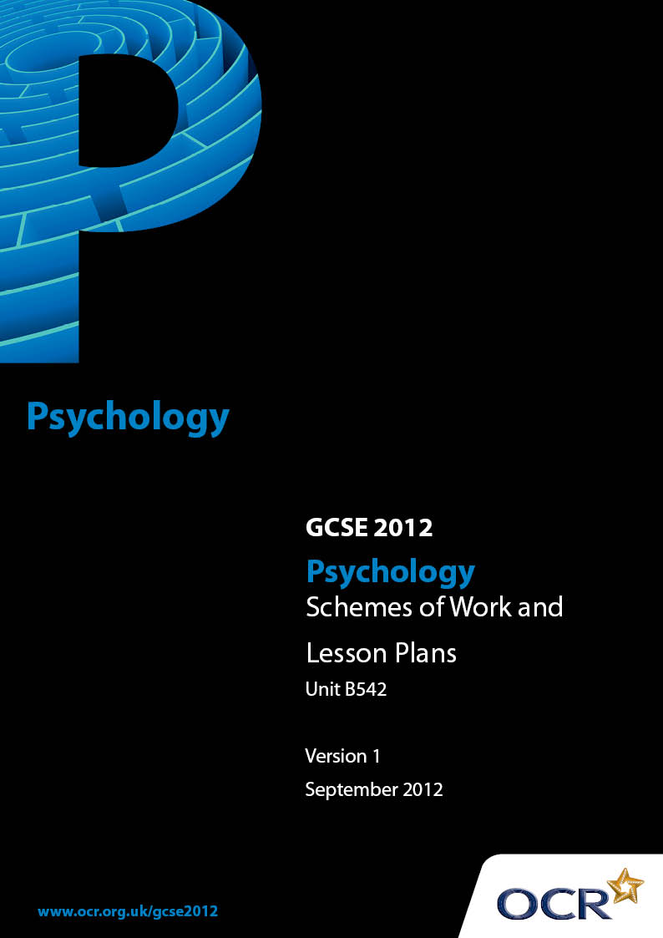

Contents
Contents 2
Introduction 3
Sample Scheme of Work: OCR GCSE Psychology Unit B542: Studies and Applications in Psychology 2 5
Sample Scheme of Work: OCR GCSE Psychology Unit B541: Studies and Applications 1 and Unit B542: Studies and Applications in Psychology 2 15
Sample Lesson Plan: OCR GCSE Psychology Unit B542: Studies and Applications in Psychology 2 17

Introduction

Background
Following a review of 14 – 19 education and the Secondary Curriculum Review, the Qualifications and Curriculum Authority (QCA) has revised the subject criteria for GCSEs, for first teaching in September 2009. This applies to all awarding bodies.
The new GCSEs have more up-to-date content and encourage the development of personal, learning and thinking skills in your students.
We’ve taken this opportunity to redevelop all our GCSEs, to ensure they meet your requirements. These changes will give you greater control of assessment activities and make the assessment process more manageable for you and your students. Controlled assessment will be introduced for most subjects.
From 2014, candidates must take all unit examinations within the series for which the certification entry is made. Candidates who start a two year course in September 2012 will therefore take all examinations and be certificated in June 2014. There is no January series in 2014.
OCR has produced a summary brochure, which summarises the changes to Psychology. This can be found at www.ocr.org.uk, along with the new specification.
In order to help you plan effectively for the implementation of the new specification we have produced these Schemes of Work and Sample Lesson Plans for Psychology. These Support Materials are designed for guidance only and play a secondary role to the Specification.

Our Ethos
OCR involves teachers in the development of new support materials to capture current teaching practices tailored to our new specifications. These support materials are designed to inspire teachers and facilitate different ideas and teaching practices.
Each Scheme of Work and set of Sample Lesson Plans is provided in Word format – so that you can use it as a foundation to build upon and amend the content to suit your teaching style and students’ needs.
The Scheme of Work and Sample Lesson Plans provide examples of how to teach this unit and the teaching hours are suggestions only. Some or all of it may be applicable to your teaching.
The Specification is the document on which assessment is based and specifies what content and skills need to be covered in delivering the course. At all times, therefore, this Support Material booklet should be read in conjunction with the Specification. If clarification on a particular point is sought then that clarification should be found in the Specification itself.

A Guided Tour through the Scheme of Work

= Innovative Teaching Idea
This icon is used to highlight exceptionally innovative ideas.


= ICT Opportunity
This icon is used to illustrate when an activity could be taught using ICT facilities.

OCR GCSE Psychology Unit B542: Studies and Applications in Psychology 2
Suggested teaching time | 10 hours | Topic | Biological Psychology
Topic outline |  | Suggested teaching and homework activities |  | Suggested resources | Points to note
Biological Psychology  3.2.1  Criminal behaviour |  | - The case study of Charles Whitman (A Sniper in the Tower) can be used as a starting point for discussion about the possible role of brain dysfunction in criminal behaviour  - The powerful television advertisement called ‘Children see. Children do’ could be used to open discussion of the role of observation and imitation. Link to key concepts of the social leaning approach (http://www.psychblog.co.uk/children-see-children-do-312.html for a copy of the advert, it can also be seen on YouTube)  - Candidates could draw a criminal face and then build their design into a model face using paper mache |  | - www.onlineclassroom.tv to purchase ‘Classic studies in psychology 1’: A DVD of classic studies including ‘Bandura’s Bobo Doll experiment’, previews of the video are available  - http://www.guardian.co.uk/uk/2003/feb/06/bulger.ukcrime An account of the Jamie Bulger case – it examines a variety of potential causes for the crime, including copy cat crime from violent video games  - http://www.popsubculture.com/pop/bio_project/charles_whitman.html for the biographical notes of Charles Whitman | - Possible link to the use of correlations as a research method  - Students could score participants viewing of violence and plot it against a score for violence tendencies (be mindful of the ethical guidelines)
 |  | - Produce a blank diagram of the human brain. Students to label each area that has been linked to violence/aggressive behaviour. Use to illustrate the biological basis of criminal behaviour (good link with the Charles Whitman case)  - Using case studies or newspaper articles of copy cat crimes (such as the Jamie Bulger case), students could consider how the social learning approach would explain the criminal behaviour  - Hypothetical case studies could be written outlining various different crimes and students could be asked to apply the theories of crime to explain the behaviour |  | - http://www.psychblog.co.uk/children-see-children-do-312.html A psychblog article examining the influence of role models on behaviour

OCR GCSE Psychology Unit B542: Studies and Applications in Psychology 2
Suggested teaching time | 10 hours | Topic | Cognitive Psychology
Topic outline |  | Suggested teaching and homework activities |  | Suggested resources | Points to note
Cognitive Psychology  3.2.2  Perception |  | - Use visual illusions to describe the difference between perception and sensation  - Use posters or landscape pictures to explain depth cues (relative size, texture gradient etc) or students could design and draw their own pictures or illusions to illustrate the depth cues  - Students could build a replication of Gibson & Walk’s visual cliff using cardboard boxes etc  - Students could design and make a cot mobile for an infant using the shapes and patterns Fantz identified as the ones babies most preferred to look at |  | - www.coolpsychologystuff.co.uk to purchase distortion goggles (severely disrupt normal perceptual cues) and for depth perception testing apparatus  - http://faculty.washington.edu/chudler/chvision.html for interactive visual perception activities | - Research activity:  Students could investigate perceptual set by using an experiment to prime participants (using a series of images) and then present an ambiguous image to see if perception of the ambiguous image is influenced by the images which came before it

OCR GCSE Psychology Unit B542: Studies and Applications in Psychology 2
Suggested teaching time | 10 hours | Topic | Cognitive Psychology
Topic outline |  | Suggested teaching and homework activities |  | Suggested resources | Points to note
- Show students a pre-prepared selection of advertisements and use them to explain how subliminal advertising, perceptual set etc has been used to change customer’s perception of brands
- Students could design their own advert incorporating their knowledge of motivation and context in perceptual set etc. They could even make a film of the advert and show it to the rest of the class

OCR GCSE Psychology Unit B542: Studies and Applications in Psychology 2
Suggested teaching time | 10 hours | Topic | Developmental Psychology
Topic outline |  | Suggested teaching and homework activities |  | Suggested resources | Points to note
Developmental Psychology  3.2.3  Cognitive development |  | - Students could build their own version of the 3 mountain experiment using paper, cardboard, tubes etc or design a more modern version  NB. For ethical reasons students are NOT expected to then use this on young children  - Physically demonstrate the experiments into the conservation of liquid, number and mass using the students as your participants. Students could re-enact Piaget’s experiments using each other to role play on  - Using a toy catalogue, students could find toys that are appropriate to Piaget’s ideas. For example, they could look for toys that support his ideas of discovery learning, and toys that facilitate the development of conservation, abstract thought etc. They could then make a poster display ‘advertising’ their toy selection |  | - Piaget, J. (1952) The child’s conception of number, London: Routledge | - Research activity:  Students could conduct a structured questionnaire with their parents asking them which of the characteristics of Piaget’s stages they showed and at what age. They could provide examples of their behaviour which illustrate the key concepts of each stage (eg ego-centricity, animism etc). The data could be pooled to identify themes and patterns
- Set students the task of working for ‘Ofsted’ for the day. Their task is to prepare a report for a recently opened day care centre offering childcare to children aged three months to five years. They are required to make appropriate suggestions to the centre on what materials and toys should be made available to the children to enhance their development. (For example, they may suggest a water table with measuring cups – for conservation)
- Students could imagine they are primary school teachers and their task is to prepare a twenty minute activity to do with their pupils based on one of Piaget’s ideas, they could then present this to the rest of the class

OCR GCSE Psychology Unit B542: Studies and Applications in Psychology 2
Suggested teaching time | 10 hours | Topic | Developmental Psychology
Topic outline |  | Suggested teaching and homework activities |  | Suggested resources | Points to note
- Have students plan an infant day care program based on Piaget’s theory of sensori-motor development. What behaviours and abilities develop during this time period? What activities might help to promote the development of these behaviours and abilities? What décor might be facilitating?
- Students could prepare a handbook aimed at new parents to give them some insight into Piaget’s theories about how children think and learn and to give parents some ideas for using Piagetian-type activities and games in the home
- Group work – students could make a poster showing the procedures and results for Piaget’s original experiments and those of the critical research, showing how they differ and why

OCR GCSE Psychology Unit B542: Studies and Applications in Psychology 2
Suggested teaching time | 10 hours | Topic | Social Psychology
Topic outline |  | Suggested teaching and homework activities |  | Suggested resources | Points to note
Social Psychology  3.2.4  Non-verbal communication |  | - Play a TV recording (advert or clip from a programme) in silence and ask candidates to interpret what is happening. Use to illustrate examples of body language as a form of non-verbal communication  - Watch the expressions and body language used by a deaf individual when they are communicating. There are various television programmes that could be used for this exercise  - Working in small groups, candidates could take digital photographs of each other wearing differing facial expressions. Show to other groups & see if they can guess the meaning behind the expression |  | - http://www.bbc.co.uk/science/humanbody/ to ‘spot the fake smile’, this is a good exercise to illustrate whether we use the eyes to help us determine the expression. Good to use alongside Yuki’s research  - www.physorg.com/pdf96297525.pdf provides a summary of the influence of culture in determining facial expressions  - www.teachervision.fen.com/vocabulary/printable/39805.html A printable cartoon facial expressions chart | - Research activity:  Students could design and carry out a questionnaire or an experiment to replicate Yuki’s research – perhaps looking for differences between gender rather than cultures

OCR GCSE Psychology Unit B542: Studies and Applications in Psychology 2
Suggested teaching time | 10 hours | Topic | Social Psychology
Topic outline |  | Suggested teaching and homework activities |  | Suggested resources | Points to note
- Students could work in small groups and act out a piece of role play using body language and facial expressions only. The rest of the class have to interpret the content of what is being acted
- Provide students with a page full of blank face outlines, students to draw as many different facial expressions as they can, incorporating all aspects of the face
- Give students a copy of all the symbols that are used to denote different facial expressions in texts, get them to describe the expression meant by each symbol, (for example ;-) is a wink and could be described as cheeky)

OCR GCSE Psychology Unit B542: Studies and Applications in Psychology 2
Suggested teaching time | 10 hours | Topic | Individual Differences
Topic outline |  | Suggested teaching and homework activities |  | Suggested resources | Points to note
Individual Differences  3.2.5  The Self |  | - Ask students to write ‘Who am I?’ at the top of a page and then ask them to answer it 20 times. Analyse the answers for physical descriptions, social roles, personal traits and existential statements. (This exercise is known as the Twenty Statements test (TST))  - Students could build model of Maslow’s hierarchy of needs. They could build the pyramid using paper mache straws, or similar materials. They could personalise the model relating each stage to themselves  - Role play client-centred therapy. One student could present with a ‘problem’, the other could adopt humanistic concepts to ‘treat’ it. Then students swap |  | - http://www.angelfire.com/or3/tss2/tst.html for detailed instructions on how to take the Twenty Statements Test (TST) | - Research activity:  Carry out a questionnaire investigating the positive influence of pet ownership

OCR GCSE Psychology Unit B541: Studies and Applications 1 and

Unit B542: Studies and Applications in Psychology 2
Suggested teaching time | n/a | Topic | n/a
Topic outline |  | Suggested teaching and homework activities |  | Suggested resources | Points to note
ALL  Activities which can be used with all the core topics. |  | - Play Bingo. Make your own bingo cards. Instead of numbers, use key words from the specification. Read out definitions of the key words, students to identify which term corresponds to the definition and cross it off if they have it on their card  - At the end of a topic, students could write their own crossword puzzles, then trade with other students to solve each other’s puzzles. Teachers could also write crosswords to get students to learn key terms and their definitions. A useful revision aid  - Play 20 questions. Based on the classic 20 questions game, prepare a set of cards. Each card should have a key word/term/name of a psychologist/name of theory on etc |  | - www.dltk-cards.com/bingo/ for printable bingo cards with instructions for use and ideas for creating games  - http://www.microsoft.com/education/Crossword.mspx to download a programme which creates crosswords. Includes instructions on writing the crossword and the clues

OCR GCSE Psychology Unit B541: Studies and Applications 1 and

Unit B542: Studies and Applications in Psychology 2
Suggested teaching time | n/a | Topic | n/a
Topic outline |  | Suggested teaching and homework activities |  | Suggested resources | Points to note
- Students take it in turns to play their turn. Student takes a card and working round the class, each person has to ask a question up to a max of 20 questions. The student must only answer yes, no or sometimes. The winner is the student who guesses the correct word on the card the quickest
- Mix and Match exercises can be used to aid the learning of key terms and definitions, or stage theories. Prepare a set of definition cards and a set of cards with the correct term on. Cut them up and place in envelopes for small group work. Students to match the terms with the definitions

OCR GCSE Psychology Unit B542: Studies and Applications in Psychology 2

Biological Psychology Criminal Behaviour: Measuring Crime
OCR recognises that the teaching of this qualification above will vary greatly from school to school and from teacher to teacher. With that in mind this lesson plan is offered as a possible approach but will be subject to modifications by the individual teacher.
Lesson length is assumed to be one hour.
* Suggested Resources
Crime statistics from www.statistics.gov.uk
BCS data from www.homeoffice.gov.uk
Current newspaper articles on crime
Large sheets of paper & marker pens
Wipeboards & pens

Learning Objectives for the Lesson
Objective 1 | To consider limitations of official crime statistics.
Objective 2 | To interpret tables and graphs of statistics and draw comparisons.
Objective 3 | To analyse and summarise written material.
Objective 4 | To understand the distinction between quantitative and qualitative data.

Recap of Previous Experience and Prior Knowledge
It is assumed that students will have been introduced to the concept of criminal behaviour and its possible definitions.

Content
Time | Content
5 minutes | Teacher displays three criminal offences and asks students to estimate the percentage of criminal acts each accounts for (current data can be accessed on www.statistics.gov.uk). Students could use wipeboards as a quick means of displaying estimates. A wide range of guesses will probably be elicited allowing an opportunity to discuss the ‘public perceptions’ and the reality of crime.
15 minutes | Teacher asks question: how reliable are official statistics? Through question and answer, teacher establishes the idea that there are problems achieving an accurate record of criminal offences. One problem is crimes going unreported.  In groups, students given a large sheet of paper and pen to record, in 1 minute, as many reasons that they can think of why crimes go unreported.
Time | Content
Then, for another minute each group is allowed to send out a spy (or one spy at a time) to have free access to other groups’ ideas. The spy/spies can memorise what they see, or return to their own groups to tell others what they have seen.
However, nothing is to be written down until the minute has passed.
Give groups another minute to add any further ideas, including those based on what the spies have seen.
Groups then count up all of their ideas, and the highest scoring group starts by feeding back (teacher may want to reward this group). Other groups can add comments as appropriate.
15 minutes | Teacher outlines use of British Crime Survey as a means of uncovering unreported crime.  In groups, students are given official statistics and data from British Crime Survey to compare. Students asked to identify three differences and feedback.
20 minutes | Teacher identifies crime statistics/BCS data as quantitative, and asks how crime data can be qualitative.  Teacher offers newspaper reports as an example of a qualitative measure of crime. Groups of students given different current newspaper articles to analyse how different newspapers report on crime. Each group summarises the main points of their article onto a poster, which they then display on wall for other students to peruse.

Consolidation
Time | Content
5 minutes | Teacher concludes that neither quantitative data nor qualitative data give an accurate measure of crime and are open to interpretation.

OCR GCSE Psychology Unit B542: Studies and Applications in Psychology 2

Biological Psychology Criminal Behaviour: Facial Features of Criminals
OCR recognises that the teaching of this qualification above will vary greatly from school to school and from teacher to teacher. With that in mind this lesson plan is offered as a possible approach but will be subject to modifications by the individual teacher.
Lesson length is assumed to be one hour.
*Suggested Resources
Gallery of criminal faces and non-criminal faces (possibly on PowerPoint)
Computers with access to Internet or file of faces
Wipeboards & pens

Learning Objectives for the Lesson
Objective 1 | To develop awareness of facial features associated with criminals.
Objective 2 | To outline the relationship between genetic theory and criminal facial features.
Objective 3 | To consider the reliability and validity of research suggesting criminals are identifiable by facial features.

Recap of Previous Experience and Prior Knowledge
It is assumed that students have been introduced to the concept of criminal behaviour, and possibly the Biological theory of crime (although this is not essential).

Content
Time | Content
10 minutes | On wipeboards or similar, teacher asks students to draw the head and shoulders of a typical criminal (or a mugshot). Students show their drawings to the class, and teacher identifies similarities between pictures but especially those that relate to facial features typical of criminals e.g. large jaws, crooked noses, etc.  Teacher takes this as an opportunity to list criminal features on the board, and relate to biological/genetic theory of criminal behaviour.
20 minutes | Teacher uses projector to display a gallery of faces – some known/convicted criminals, others non-criminals. The students task is to identify the criminals from the collection of faces, using the listed features of the guide.  Teacher later reveals the ‘real’ criminals (e.g. by highlighting faces) and uses to initiate a class discussion on whether it is possible to identify criminals from facial features. How reliable is the biological/genetic theory in this respect?
Time | Content
25 minutes | Using computers, and possibly a prepared file of faces, students then individually create a criminal face using editing/publishing software. In other words, they put together a ‘photofit’ of a typical criminal using the facial features identified earlier in the lesson. This could be printed off the create a ‘rogues gallery’ for display.  Teacher asks question: how likely is it that criminals really look like this?

Consolidation
Time | Content
5 minutes | Teacher asks question: is genetic theory right when it says criminals can be identified by facial features alone? Students vote on the validity of the theory by showing 5, 4, 3, 2 or 1 fingers.

