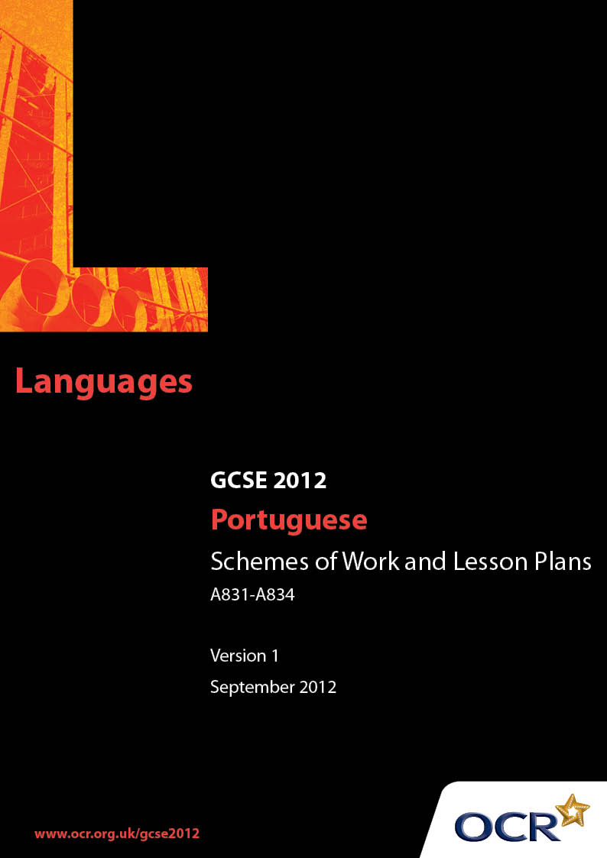

Contents
Contents 2
Introduction 3
Sample Scheme of Work: OCR GCSE Portuguese
Units A831-A834: Listening, Speaking, Reading and Writing 5
Sample Lesson Plan: OCR GCSE Portuguese
Units A831-A834: Listening, Speaking, Reading and Writing 13

Introduction

Background
OCR has produced a summary brochure, which summarises the changes to Portuguese. This can be found at www.ocr.org.uk, along with the new specification.
In addition and in response to reforms announced by the Government and in response to Ofqual mandated changes to GCSEs, unitised assessment of this qualification is being replaced by linear assessment from September 2012. This means that candidates commencing a two year course from September 2012 will take all of their GCSE units at the end of the course in June 2014.
In order to help you plan effectively for the implementation of the new specification we have produced these Schemes of Work and Sample Lesson Plans for Portuguese. These Support Materials are designed for guidance only and play a secondary role to the Specification.

Our Ethos
OCR involves teachers in the development of new support materials to capture current teaching practices tailored to our new specifications. These support materials are designed to inspire teachers and facilitate different ideas and teaching practices.
Each Scheme of Work and set of sample Lesson Plans is provided in Word format so that you can use it as a foundation to build upon and amend the content to suit your teaching style and students’ needs.
The Scheme of Work and sample Lesson plans provide examples of how to teach this unit and the teaching hours are suggestions only. Some or all of it may be applicable to your teaching.
The Specification is the document on which assessment is based and specifies what content and skills need to be covered in delivering the course. At all times, therefore, this Support Material booklet should be read in conjunction with the Specification. If clarification on a particular point is sought then that clarification should be found in the Specification itself.

A Guided Tour through the Scheme of Work

= Innovative Teaching Idea
This icon is used to highlight exceptionally innovative ideas.


= ICT Opportunity
This icon is used to illustrate when an activity could be taught using ICT facilities.

OCR GCSE Portuguese Units A831-A834: Listening, Speaking, Reading and Writing
Suggested teaching time | 10 hours | Topic | Holiday and Exchanges (Topic Area 4)
Topic outline |  | Suggested teaching and homework activities |  | Suggested resources | Points to note
1. Holiday Destinations  (speaking revision with written reinforcement) |  | - Starter activity, revising familiar vocabulary  - Introduce new vocabulary  - Revision of present tenses - using mainly first person forms - e.g. eu vou/nós vamos; eu gosto/nós gostamos  - Revise/teach names of a variety of countries and cities, with appropriate prepositions e.g. a Londres; ao Brasil  - Write labels for a variety of holiday destinations - or other reinforcement activity  - Look through the keyhole - using only part of each picture, the students guess the destination |  | - OCR Portuguese vocabulary list – for any new words  - PowerPoint vocabulary with icons or pictures  - List or textbook with common verbs in present tense  - Visuals of countries, famous cities and places such as seaside, mountains, countryside etc.  - Worksheet with pictures and a word bank (FT students) or just pictures to label (HT)  - Magazine or textbook texts with questions requiring non-verbal responses – for extension work | - Include countryside, mountains, seaside etc. and different countries, particularly those where Portuguese is spoken  - Much of this material should already be familiar. FT students may need reinforcement activities and HT students may be encouraged to explore extra vocabulary and read appropriate texts
2. Holiday Accommodation  (speaking, writing and reading or listening) |  | - Revise/introduce vocabulary, using visuals and/or textbook  - Starting with a model phrase to express an opinion and a reason, e.g. eu gosto do apartamento porque é grande, brainstorm simple opinions and reasons in groups or as a class  - Using a text from a magazine or the textbook as model, encourage students to write a short paragraph about holiday accommodation, including opinions and reasons |  | - Visuals of hotel, campsite, youth hostel, holiday apartment and villa  - OCR Portuguese vocabulary list  - Textbook  - Text, e.g. magazine article and/or extract from a video/dvd, requiring short answers in English | - Groups or whole class produce sentences with pictures  - Encourage HT students to include more complex opinions and reasons  - Students may respond positively to working in pairs or small groups and then presenting their ideas to the class
3. Booking Accommodation and Asking Questions  (speaking, reading, writing) |  | - Advise on writing a formal letter  - Revise/teach vocabulary related to facilities e.g. com banheiro/casa de banho and dates  - Revise/teach ways of asking questions  - Revise/teach appropriate information e.g. para duas noites,  - Use visuals of types of accommodation and facilities to encourage students to brainstorm questions  - In pairs, or small groups, students to choose one type of accommodation and write a series of questions about it  - Formal letter or email to be written or word processed |  | - Textbook, word list, model questions  - Visuals of types of accommodation and facilities | - Encourage variety of questions by using visuals in different combinations e.g. visual of an apartment with balcony and visual of restaurant  - Encourage the students to vary the questions they ask by giving them a role - either on behalf of a family or a group of friends  - FT students may write an email and HT students a longer letter
4. Travel and Transport  (speaking, listening, writing) |  | - Starter activity, revising familiar transport vocabulary using visuals  - Teach/revise means of transport with correct prepositions e.g. de comboio/de trem  - In pairs, produce,a variety of sentences e.g. eu ando de bicicleta. One starts with a verb and the other finishes the sentence with an appropriate noun or longer phrase. FT students may prefer to use a word bank  - Write sentences linked with travel and transport e.g. eu gosto de viajar de avião porque é rápido |  | - Visuals of means of transport, introducing new vocabulary as required  - Text book or word list of other vocabulary and phrases | - Display sentences with appropriate pictures (writing/drawing or ICT)  - Make PowerPoint vocabulary list, using all vocabulary covered so far. Use one of the animation schemes, e.g. Unfold or Credits, to encourage speed of recognition  - Teach European and Brazilian Portuguese variants of common words e.g. comboio/ trem
5. Holiday Plans  (sentence building, using 1-4 above, and differentiated consolidation or extension activities. Speaking and reading, with written consolidation) |  | - Revise/teach use of immediate future e.g. eu vou passar um mês em Portugal  - Comprehension of written text  - Students work in pairs or small groups to add additional material as appropriate  - Presentations to whole class  - Write a short text for a leaflet advertising a place to visit for a holiday. Mention one special feature which makes the place interesting |  | - Adverts of holiday offers  - Short holiday brochures  - Choice of appropriate texts in textbook or magazine article with questions requiring either non-verbal responses or responses in simple Portuguese | - Internet research  - Students imagine they are a sports star or film star when making plans.  They can imagine a really exotic  holiday and use more extensive vocabulary  - Students word process the star’s holiday plans, with pictures for display
6. Holiday Activities  (speaking, listening, writing) |  | - Revise/teach past tenses - imperfect and preterite in particular  - Brainstorm vocabulary for holiday activities e.g. ir à praia; fazer equitação  - Listening comprehension about a recent holiday, with non-verbal responses  - Students prepare a short description of a recent holiday, using past tenses  - Individual or small group presentation to class |  | - Imperfect and preterite tenses of common verbs - textbook or whiteboard or PowerPoint  - Recording of someone talking about a recent holiday. Written questions requiring non-verbal responses | - Extension activities may involve revising other past tenses (perfect and pluperfect) and incorporating them into an imaginary holiday where everything went wrong  - Internet research for holiday activities to lend authenticity to presentation
7. Consolidation  (reading and listening) |  | - Revision of vocabulary and grammar, using PowerPoint, textbook or whiteboard  - Students listen to an extract/extracts about holidays in a Portuguese-speaking country. Comprehensions with non-verbal responses and/or short answers in English or Portuguese  - Independent research – collect items/articles about holidays in preparation for speaking presentation and writing tasks |  | - Textbook, whiteboard, word list, PowerPoint revision  - Extract on video/dvd or appropriate past listening paper from legacy specification 1923  - Text from magazine, textbook or appropriate past reading paper from legacy specification 1923  - http://www.visitportugal.com/Cultures/pt-PT/default.html  - http://www.brasilturismo.com | - Encourage students to discuss any difficulties they have and incorporate appropriate activities into future lessons  - In a mixed ability class, the questions may be used for differentiation  - Independent research may take place on the Internet
8. Speaking Presentation about a Recent Holiday  (speaking) |  | - Revise past tenses of appropriate verbs  - Revise weather, using past tenses e.g. choveu;fazia sol  - Students build more complex clauses, revising grammar and vocabulary  - Students prepare a short presentation about a recent holiday, using vocabulary and grammar already learnt. They should include when, where, with whom, how long, impressions, activities, weather and any other appropriate information  - Pair or group work: each student delivers a presentation to the group or to a fellow student. Other student(s) should ask some questions |  | - Textbook, whiteboard or PowerPoint with relevant verbs  - Visuals of weather  - Visuals of general holiday vocabulary | - Students should use more complex clauses and include opinions and reasons  - Students should be encouraged to reduce their written notes to a cue card of short notes and up to five visuals  - Presentations may be recorded to prepare students for the experience in the exam
9. Exchange Visit  (reading and writing) |  | - Revise/teach the conditional tense and/or imperfect tense used as conditional e.g. eu gostaria/eu gostava  - Students use details supplied about an exchange partner  - Students write an introduction about themselves and describe plans for the activities that they would like to do on the exchange  - Students write an account of their visit for the exchange partner’s school magazine, expressing opinions with reasons |  | - Textbook, whiteboard or PowerPoint presentation of conditional tense  - Details of a student or students from Internet, textbook or past paper  - Information about the town or area where the exchange partner lives | - Teacher may like to provide a list of headings and encourage students to supply details of a fictional exchange partner and work in pairs as a speaking task first  - Adult learners should be encouraged to use their imagination and enter into the spirit of being sixteen again  - Remind students to use more complex clauses and include opinions and reasons
10. Revision of Holidays and Exchanges  (reading and listening) |  | - Explore previous exam questions on this topic |  | - Relevant past papers from legacy specification 1923  - Listening papers may need differentiated questions | - Offer students guidance on using textbook and other materials for revision, including websites, and encourage them to read further about this topic

OCR GCSE Portuguese Units A831-A834: Listening, Speaking, Reading and Writing

Holiday Activities
OCR recognises that the teaching of this qualification above will vary greatly from school to school and from teacher to teacher. With that in mind this lesson plan is offered as a possible approach but will be subject to modifications by the individual teacher.
Lesson length is assumed to be one hour.

Learning Objectives for the Lesson
Objective 1 | Students to understand and use a variety of vocabulary relevant to the topic
Objective 2 | Students to listen to an extract and identify the main points, details and opinions related to the topic
Objective 3 | Students to use a variety of different tenses or time frames in speaking and writing presentations

Recap of Previous Experience and Prior Knowledge
- Brain-storming activity. Students to be given 90 seconds to write down vocabulary they can remember related to the topic. The time could be sub-divided into 30 seconds for means of travelling, 30 seconds for accommodation and facilities abroad and 30 seconds for holiday activities.

Content
Time | Content
5 minutes | - Student brain-storming activity  - Teacher reviews and adds any extra vocabulary relevant to this topic, using visuals
20 minutes | - Teacher introduces or revises past tenses - preterite and imperfect - of relevant verbs, using textbook, whiteboard or PowerPoint.  - Students work in pairs or small groups to compose sentences about holiday activities, using a variety of verbs in past tenses  - Teacher asks questions to assess pronunciation and quality of language, stretching and challenging more able students with unexpected questions
15 minutes | - Students listen to someone describing a recent holiday. Extract may be from a course, recorded by the teacher or an OCR past paper  - Students listen again and complete a handout with gaps for answers, or answer questions requiring non-verbal responses  - Teacher feeds back answers and reviews with the whole class

10 minutes | - Students write a short paragraph about a recent holiday, including opinions about the activities  - Activities to stretch and challenge students may involve using other past tenses and imagining a holiday when everything went wrong

Consolidation
Time | Content
5 minutes | - Individual or small group presentation to class

