Solar System Multiple Choice

1. A light year is a measure of:

A. Time B. Speed C. Distance D. Brightness

2. If the force of gravity between two bodies is 200 000 N when they are 1 million km apart, what is the force between them when they are ½ million km apart?

A. 50 000N B. 100 000N C. 400 000N D. 800 000N

3. How long does it take a geostationary satellite to complete one orbit?

A. 1 hour B. 1 day C. 1 week D. 1 year

4-7. The diagram below shows the orbit of a comet. Choose letters from the diagram which best match the statements below.

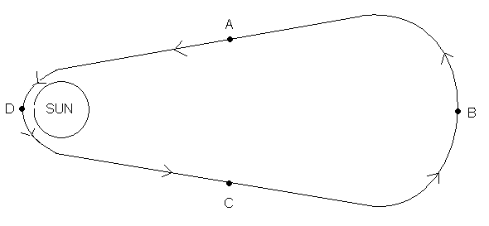

4. At this point in its orbit, the comet is decelerating

5. At this point in its orbit, the comet is moving fastest

6. At this point in its orbit, the gravitational force on the comet is increasing

7. At this point in its orbit, the comet is most likely to be visible from Earth

8. Which of the following combinations is given in order of increasing size?

A. Comet; Star; Planet; Galaxy; Solar System; Universe

B. Universe; Galaxy; Solar System; Star; Planet; Comet

C. Comet; Planet; Star; Galaxy; Solar System; Universe

D. Comet; Planet; Star; Solar System; Galaxy; Universe

9-11. The diagram below shows the inner planets of the Solar System, labelled A, B, C, and D. Match a letter to each statement below.

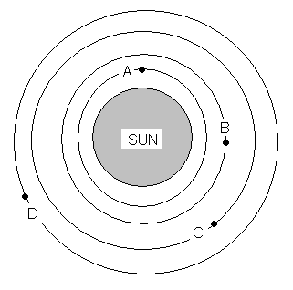

9. This planet orbits the Sun in the shortest time.

10. This planet has a gravitational field strength of 10N/kg.

11. There is evidence that this planet may once have had water and supported life.

12. How does a star produce light?

A. Fission B. Fusion C. Combustion D. Electricity

13-16. Below are the names of some stages in a star’s life, numbered 1-8. Use the numbers to answer the questions below.

1. Red giant
2. White dwarf
3. Protostar
4. Supernova
5. Main sequence star
6. Black hole
7. Neutron star
8. Cloud of gas and dust

13. Which of the following sequences shows the life cycle for a star with mass at least one hundred times the mass of the Sun?

A. 8 3 1 5 4 7

B. 8 3 5 1 2

C. 8 3 5 4 6

D. 8 3 5 1 4 6

14. Which of the following sequences shows the life cycle for a star like our Sun?

A. 8 3 5 1 2

B. 8 3 5 4 2

C. 8 3 5 1 4 2

D. 8 3 5 1 4 7

15. Which of the stages is described in the statement below?

“Astronomers detect these by monitoring X-rays.”

A. 8 B. 7 C. 6 D. 4

16. Which of the stages is described in the statement below?

“This stage occurs when the outward force due to heat from fusion reactions is larger than the inward force due to gravity.”

A. 1 B. 3 C. 4 D. 5

17. Many scientists believe that all matter in the universe was once compressed into one place. What is this theory called?

A. Steady state theory B. Expansion theory

C. Big bang theory D. Explosion theory

18. Why was the Hubble telescope put into orbit around the Earth rather than being set up on the ground?

A. It is cheaper to keep it in space

B. It is so big there wasn’t space for it on Earth

C. It is closer to the stars it is used to study

D. It can get clearer pictures from outside the Earth’s atmosphere

19. Which of the following is true of the work of SETI?

A. They send radio signals into space to communicate with alien life

B. They listen for radio signals coming from beyond our solar system

C. They send probes out to seek microbes on other planets

D. They look for distant planets

20. The largest element which can be formed during the main sequence and red giant phase of a star is:

A. Helium

B. Carbon

C. Iron

D. Uranium

Answers
1. C
2. D
3. B
4. C
5. D
6. A
7. D
8. D
9. A
10. C
11. D
12. B
13. D
14. A
15. C
16. A
17. C
18. D
19. B
20. C

