Revision requirements for the Test on the Waves Section of the Year 9 Syllabus

THE ELECTROMAGNETIC SPECTRUM

Electromagnetic radiations are disturbances in an electric field. They travel as waves and move energy from one place to another. They can all travel through a vacuum and do so at the same speed. The waves cover a continuous range of wavelengths called the electromagnetic spectrum. The uses and hazards of the radiations in different parts of the electromagnetic spectrum depend on their wavelength and frequency.

Boys should be able to evaluate the possible hazards associated with the use of different types of electromagnetic radiation and to evaluate methods to reduce exposure to different types of electromagnetic radiation.

The electromagnetic spectrum is continuous but the wavelengths within it can be grouped into types of increasing wavelength and decreasing frequency:
− gamma rays, X-rays, ultraviolet rays, visible light, infra red rays, microwaves and radio waves.

Different wavelengths of electromagnetic radiation are reflected, absorbed or transmitted differently by different substances and types of surface. When radiation is absorbed the energy it carries makes the substance which absorbs it hotter and may create an alternating current with the same frequency as the radiation itself.

Different wavelengths of electromagnetic radiation have different effects on living cells. Some radiations mostly pass through soft tissue without being absorbed, some produce heat, some may cause cancerous changes and some may kill cells. These effects depend on the type of radiation and the size of the dose. The uses and the hazards associated with the use of each type of radiation in the electromagnetic spectrum.

Radio waves, microwaves, infra red and visible light can be used for communication. Microwaves can pass through the Earth’s atmosphere and are used to send information to and from satellites and within mobile phone networks. Infra red and visible light can be used to send signals along optical fibres and so travel in curved paths.
Oscillations
An oscillation is a vibration, i.e. a movement back and forth (or up and down etc) about a fixed (or rest, or equilibrium, or mean) point.
Amplitude is defined as the maximum displacement of an oscillating particle from the mean rest position
Period is the time it takes for a vibrating particle to complete on oscillation. Symbol T, unit second (s)
Frequency (symbol f, unit Hz) is the number of oscillations per second. For example, Mains frequency is 50 Hz, and a grandfather clock has a pendulum that oscillates at 1 Hz (which also means it has a period of 1 second too)

What are wavse? (Waves transfer energy from a source to other places without any matter being transferred and are a series of oscillations)

Transverse Wave Motion (In transverse waves the oscillations are at right angles to the direction in which the wave is travelling. All e-m waves are transverse)

Longitudinal Wave Motion (In longitudinal waves the oscillations are back and forth along the direction that the wave is travelling. Sound (and ultrasound) are longitudinal waves.)
Waves can be represented using ray diagrams. Rays must be drawn with a pencil and ruler and must have arrows to represent the direction in which the wave is travelling.

Separate boys will deal with the images formed by reflectors formally in Year 11
REFLECTION

You should understand and be able to use the terms plane mirror, incident ray, reflected ray, angle of incidence and angle of reflection.

The normal is a construction-line perpendicular to the reflecting surface at the point of incidence.

The angle of incidence is equal to the angle of reflection.

Light, sound and ultrasound waves can be reflected (as above).

REFRACTION
You should know that waves can be represented by rays or by wavefronts.

Wavefronts can help us explain why there is a change in direction when there is a change in speed.

Boys should recognise the normal (as a dotted line at right angles to the boundary), the angle of incidence and the angle of refraction.
Brighter boys can discuss refraction related to splitting light into spectrum with prism.

Waves travelling across the surface of water can also be refracted. The change in the speed of water waves when they cross the boundary between two different depths causes a change in their direction (refraction), unless the direction of travel of the waves is along a normal.

Rays of light change direction (are refracted) when they cross the boundary between one transparent substance and another, unless they meet the boundary at right angles (along a normal).

Sounds are also refracted, i.e. their direction is changed when they cross the boundary between two different substances at an angle other than a right angle.

This behaviour of waves suggests that light and sound:
- also travel as waves
- and are refracted because they travel at different speeds in different substances (media).
DIFFRACTION
When a wave moves through a gap, or past an obstacle, it spreads out from the edges. This is called diffraction. Electromagnetic radiation and sound are also diffracted which supports the idea that they travel as waves. Because of diffraction:
• sounds can sometimes be heard in the shadow of buildings;
• radio signals can sometimes be received in the shadow of hills.
Waves having a longer wavelength are more strongly diffracted.

The Electromagnetic Spectrum
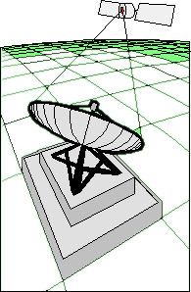
Electromagnetic radiation is all around you. Your senses can only detect visible light, but there are other, invisible radiations passing through you and around you right now. They all travel at 300 million m/s – the speed of light, and all of them can be reflected and refracted by suitable objects.

One type is infra-red (IR), which is emitted by any hot object, including you. Electric bar fires produce IR radiation to keep you warm; grills, ovens and cookers produce it to heat food. Whenever an object absorbs any type of radiation, the object is heated, and we use this in infra-red grills. Infra-red is also used by remote controls for TVs and VCRs.


Microwaves also heat substances when they are absorbed, but this only works well for certain substances such as water and fats. This is because water molecules and fat molecules absorb microwave frequencies particularly well, and the energy they absorb ends up as kinetic energy when they vibrate – in other words, heat. This is why microwaves can be dangerous, because we are mainly made of water and fats. Microwaves can also cause “cataracts”, a clouding of the cornea in the eye. Microwaves cook things from the inside, whereas “normal” cooking involves heating the outside of the food.
Microwaves are also used for radar, and by mobile phones. Holding a microwave transmitter to the side of your head for long periods can’t be a good idea!

Microwaves will induce currents in metals, which is why we must not use metal containers to heat food in microwave ovens – the metal will get very hot, and may also give off sparks and wreck the oven. Having said that, some foods come in special containers with metal foil pieces especially to make use of this effect and help to cook the food. Can you think of an example?
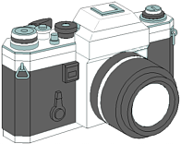
Visible light is, obviously, used for seeing things. We can refract it using lenses, and make images in cameras and in our eyes. Light is not only used for seeing but can also be sent along optical fibres, for example, in endoscopes used by doctors to see inside patients' bodies.

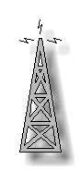
When light travels down an optical fibre, all the light may stay inside the fibre until it emerges from the other end. This is because light travels down optical fibres by repeated total internal reflection. More information can be carried using optical fibres than by sending electrical signals through cables of the same diameter. There is also less weakening of the signal in optical fibres.

Radio waves are used to transmit radio and TV programmes between different points on the Earth's surface. Longer wavelength radio waves are reflected from an electrically charged layer in the Earth's upper atmosphere, called the ionosphere. This enables them to be sent between distant points despite the curvature of the Earth's surface.

Ultraviolet radiation is used in sunbeds. Special coatings that absorb ultraviolet radiation and emit the energy as light are used in fluorescent lamps and security coding. Ultra violet radiation can pass through skin to deeper tissues. The darker the skin, the more ultra violet it absorbs and the less reaches into deeper tissues;

X-radiation is used to produce shadow pictures of materials which X- rays do not easily pass through including bones and metals. Gamma radiation is used to kill harmful bacteria in food, sterilise surgical instruments, and kill cancer cells. X-radiation and gamma radiation mostly pass through soft tissues, but some is absorbed by the cells.

High doses of ultra violet radiation, X-radiation and gamma radiation can kill normal cells.
Lower doses of these types of radiation can cause normal cells to become cancerous.

- Name all the sources of infra-red radiation mentioned on this sheet. Write down at least two other sources of infra-red radiation
- Infra-red radiation is absorbed by our skin and felt as heat. Use the ideas of molecules vibrating and of absorption to explain how this happens.
- Infra-red has a higher frequency than microwave radiation, so it transfers more energy. Yet microwaves cook food faster – why should this be?
- Why should we not use metal containers in microwave ovens?
- What are the effects of different doses of UV, X-rays and gamma rays on living cells?

Year 9 Waves

A wave is something which transfers energy from one place to another without transferring any matter. There are two types of wave – transverse and longitudinal. In transverse waves, the vibrations are perpendicular to the direction of energy transfer. Water waves and light waves are transverse.

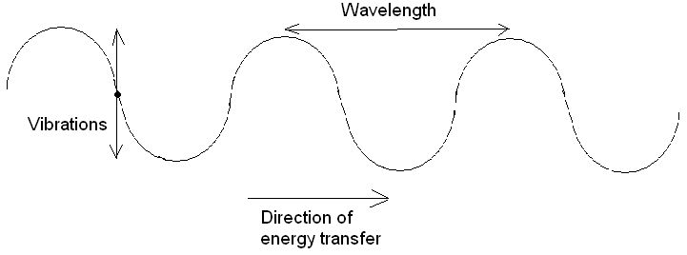

In longitudinal waves, the vibrations are parallel to the direction of energy transfer. Sound waves are longitudinal.

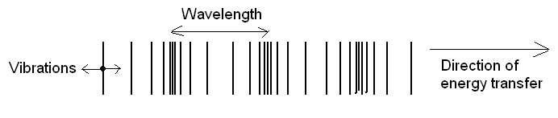

All waves can be described in terms of their wavelength (the distance between two adjacent peaks or troughs), and their frequency (the number of waves passing a point each second).

The Electromagnetic Spectrum

Light is an electromagnetic wave, and forms part of the electromagnetic spectrum. Other waves in the spectrum are (starting with the longest wavelength/lowest frequency):
Radio; Micro; Infra-red; Light; Ultra-violet; X-ray; Gamma

All electromagnetic waves are transverse. They are all able to travel through a vacuum. They all travel at the same speed (300 000 000m/s). The only difference between the different types of wave is their wavelength and frequency, but this gives the waves very different properties and uses.

Type | Uses | Other
Radio | Communications and radio/TV broadcasts | Range from 50cm to 10km wavelength. Longer wavelengths are reflected by the ionosphere (charged layer in Earth’s atmosphere) so are able to travel around the curvature of the Earth. Pass through humans without being absorbed.
Micro | Satellite communications, mobile phones, cooking | Microwaves are able to pass through the Earth’s atmosphere so are used to send information to satellites. They also cause water molecules in food to vibrate and heat up, cooking the food. They are not very dangerous to humans although prolonged exposure should be avoided and they may cause cataracts.
Infra-red | Toaster and grills, remote controls, heat vision, optical communications | Infra-red waves are emitted by all objects but more when the object is hotter. They can cause burns on human skin. Used to carry signals down optical fibres.
Light | Seeing things, lasers, optical communications, CD players etc | The only part of the E-M spectrum detectable by the human eye. White light can be split into different wavelengths which have different colours (between red and violet). Used to carry signals down optical fibres.
Ultra-violet | Security markings, fluorescence, sun beds | Exposure to UV can cause sun burn and skin cancer as it is absorbed by and damages skin cells. Fluorescence is where chemicals absorb UV light (invisible) and re-emit it as visible light so the chemical can be seen in UV light.
X rays | X rays | Can cause cancer in deep tissues with over exposure. X rays can penentrate flesh but are absorbed by bone, so an image can be built of bones.
Gamma | Treating cancer, tracers, sterilisation. | Emitted by some radioactive substances. Can be used to kill cancerous cells and harmful bacteria, but can also cause cancer when over exposed.

Reflection

All waves can be reflected from surfaces, and they obey the Law of Reflection. This states that the angle of incidence is equal to the angle of reflection. The angles are measured between the wave and the normal, which is a line drawn at 90º to the surface where the wave is incident. The diagram below illustrates the Law of Reflection.

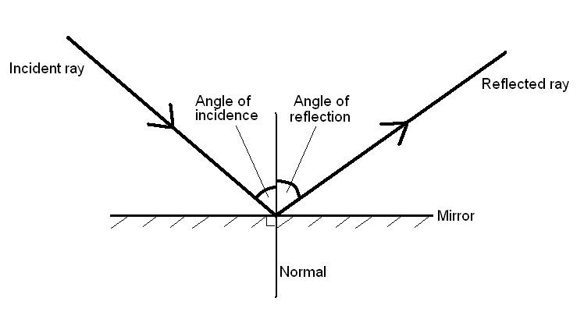
Refraction

All waves can be refracted. When a wave moves to a different medium (e.g. passing from air to glass), it will change speed. This change in speed causes the wave to change direction (unless the wave is travelling along the normal to the boundary). If the wave slows down (e.g. when light moves from air to glass), it will bend towards the normal, so the angle of incidence will be greater than the angle of refraction. If the wave speeds up (e.g. when light moves from glass to air) it will bend away from the normal, so the angle of incidence will be smaller than the angle of refraction.
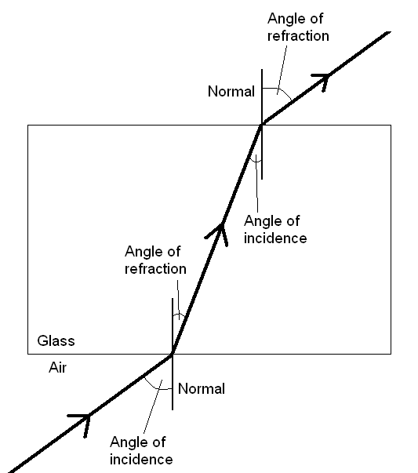

When a wave slows down, its wavelength decreases, so the wavefronts get closer together. This can be observed when water waves refract which happens when the water they are travelling in changes depth. They travel slower in shallower water.

Diffraction

Diffraction is the spreading out of the edges of waves as they pass through a gap or past an obstacle. Diffraction occurs more strongly when the size of the gap is similar to the wavelength of the wave. Diffraction is the reason why radio broadcasts can sometimes be received in the shadow of a hill.

