Optical Devices Summary Questions
In all questions please use pencil and ruler, and label diagrams carefully

1a. The diagram below shows a converging lens being used. Add the appropriate rays to the diagram to show how an image is formed. In the space below the diagram, describe the nature of the image and calculate the magnification.

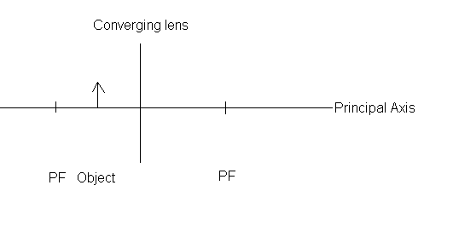
………………………………………………………………………………………….

………………………………………………………………………………………….

………………………………………………………………………………[7 marks]

1b. Draw a second diagram to illustrate what happens to the image when the object is moved more than two focal lengths away from the lens. [4 marks]
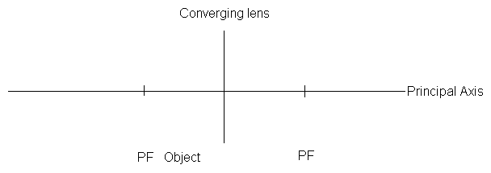
1c. Suggest reasons why the image formed in part a could not be used to create a picture with a camera while the image in part b could.

………………………………………………………………………………………

………………………………………………………………………………………

…………………………………………………………………………[3 marks]
2. A diverging lens is shown in the diagram below. Label the key features of the diagram. Complete the paths of the rays and determine the nature and magnification of the image.

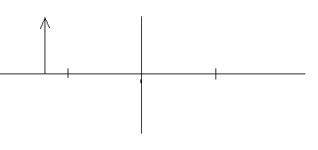
………………………………………………………………………………………….

………………………………………………………………………………………….

………………………………………………………………………………………….

………………………………………………………………………………[9 marks]

3. The diagram below shows a concave mirror being used. Add the appropriate rays to the diagram to show how an image is formed. In the space below the diagram, describe the nature of the image and calculate the magnification.

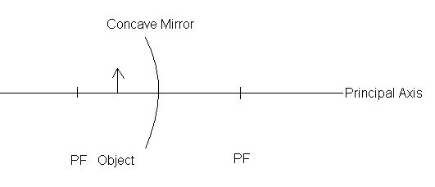
…………………………………………………………………………………………

…………………………………………………………………………………………

…………………………………………………………………………………………

…………………………………………………………………………….. [7 marks]

4. In the space below, draw diagrams to illustrate that the image formed by a convex mirror will always be virtual, upright and diminished, no matter where the object is in relation to the mirror. [8 marks]

5. Complete the table below:

Type of lens/mirror | Distance of object from lens / mirror (in terms of focal length, f) | Real / virtual | Magnified / diminished | Upright / inverted
Converging lens | Less than f
Converging lens | Between f and 2f
Converging lens | Greater than 2f
Diverging lens | Any
Concave mirror | Less than f
Concave mirror | Greater than f |  | Magnified or diminished
Convex mirror | Any

[7 marks]

