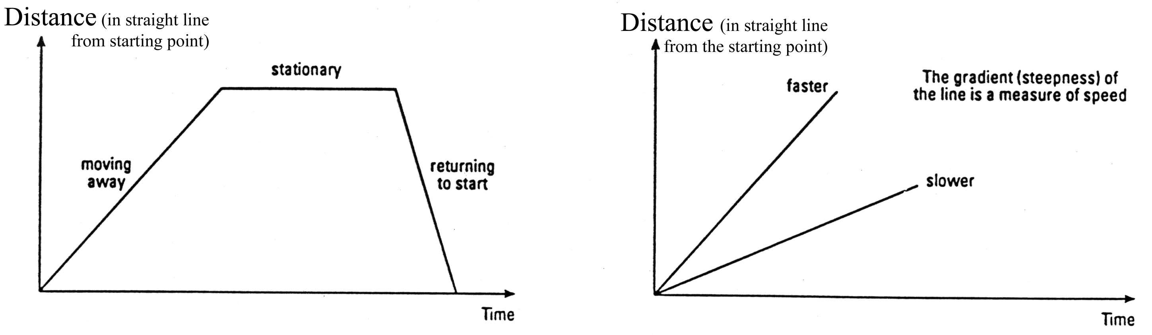
HOW FAR? HOW FAST?
It is often easier to understand what numbers are telling us by using a graph. This is particularly true for information about movement. We usually plot motion data as a graph and join the points with straight (or smoothly curved) lines.

To do
- Copy the five graphs below, and choose the correct beginnings and endings to label each graph.
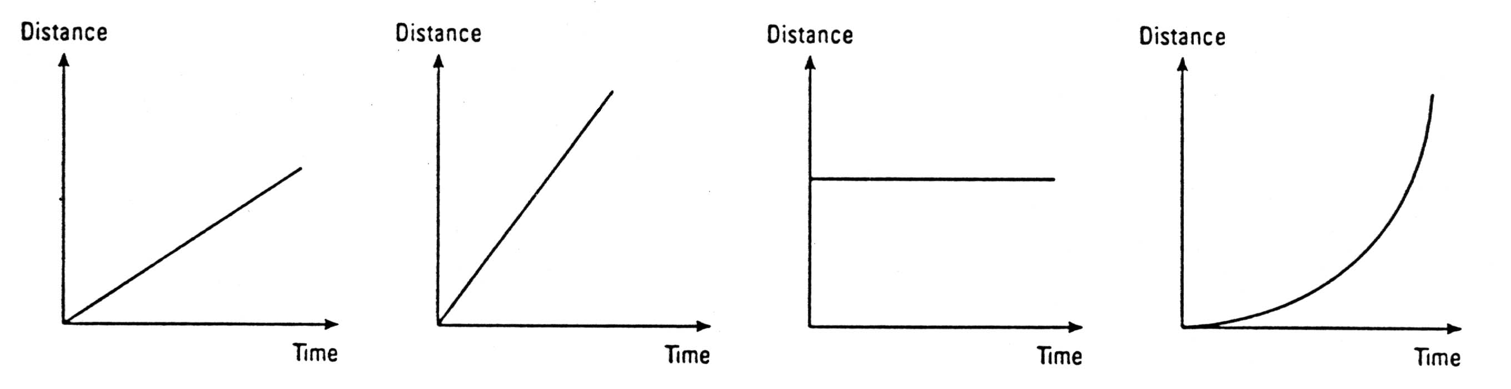
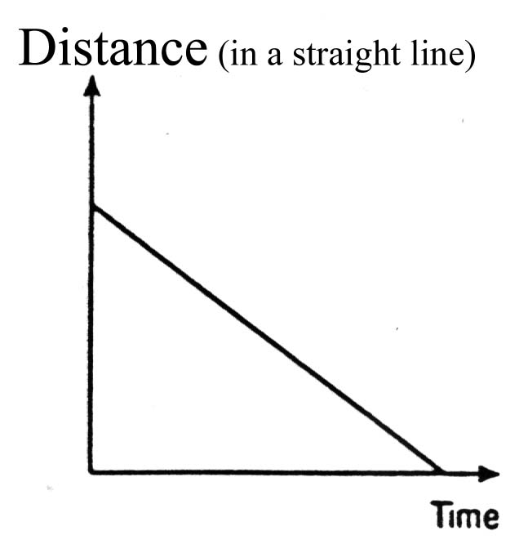

At the beginning
Moves off at a steady (slowish) speed
At rest
Returns to the start
Speeding up

Moving fast
At the end
Accelerating to a very fast speed as the gradient gets steeper
Maintains a (fast) steady speed
Remains at rest
Because the gradient is shallow
Because the gradient is negative

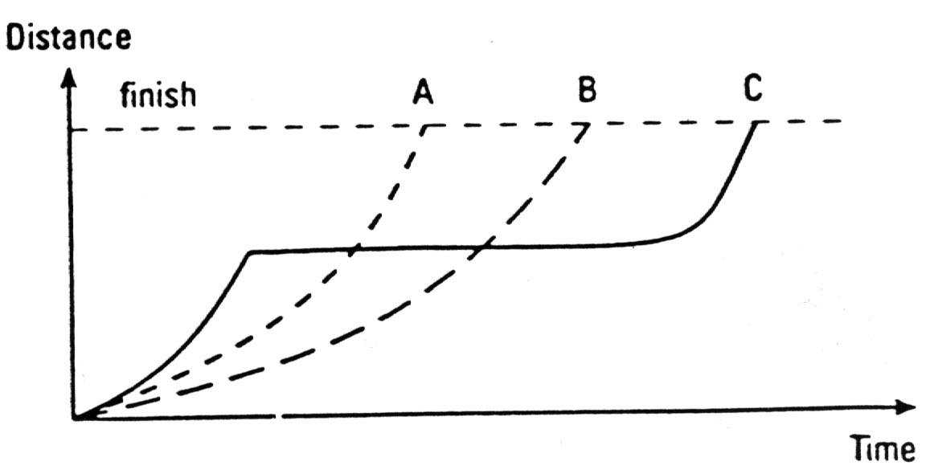

2. This graph shows how three hurdlers performed in the 110 m race on their school sports day.
- Which hurdler started fastest?
- Which hurdler fell part way through the race?
- Which hurdler won the race?

