VELOCITY AND SPEED
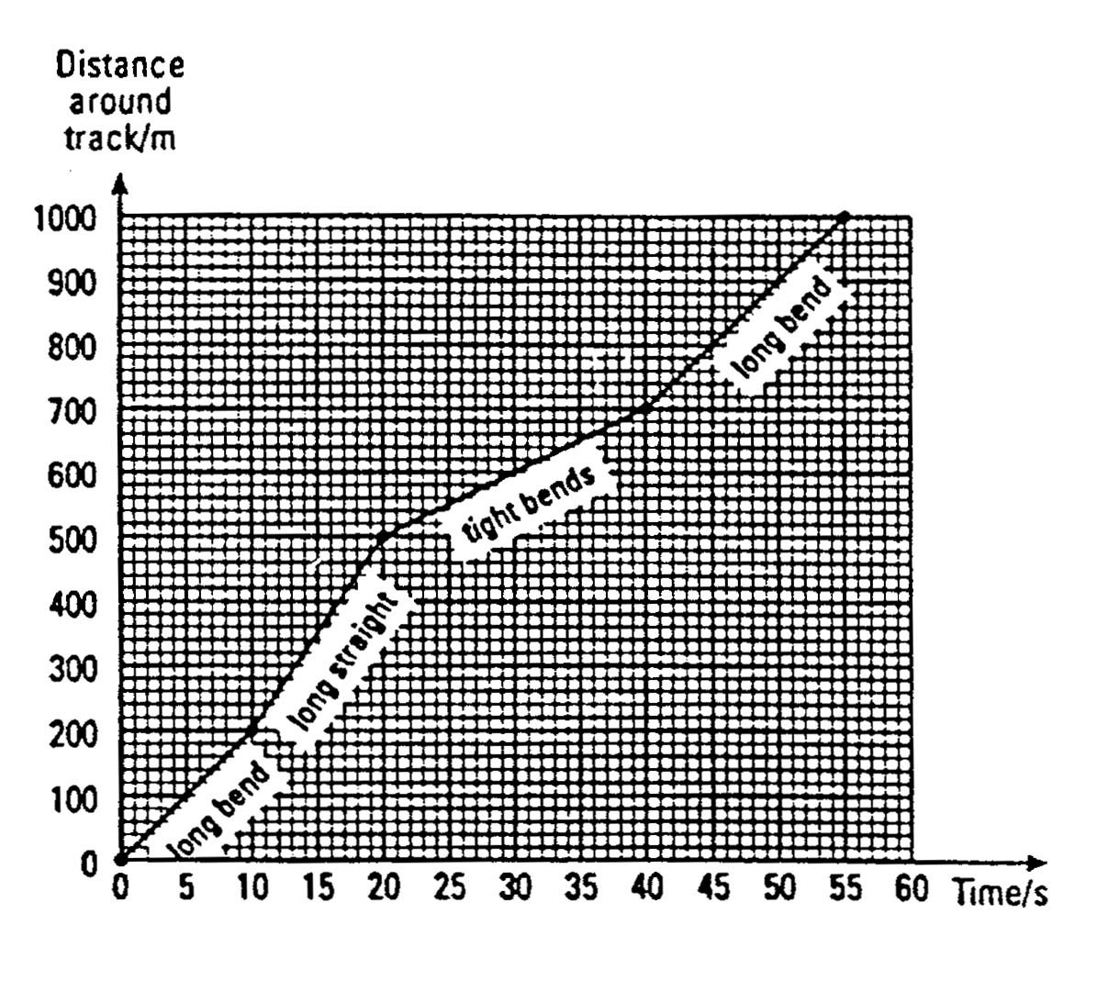
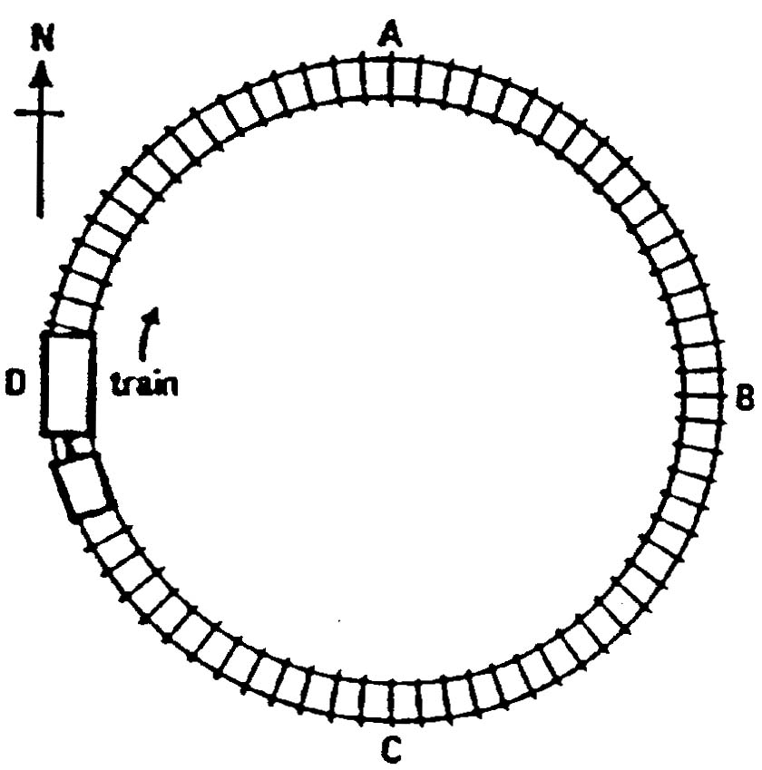

In physics we do not use the word speed very often. Speed may tell us how fast or slow an object is moving, but it does not tell us in which direction the object is moving. If we wish to include the direction we should use the term velocity.
Velocity is speed in a stated direction.

If two cars, both moving at 60 km/h, passed each other travelling in opposite directions on a road, they would have the same speed but different velocities.

The velocity of one car might be 60 km/h due north and the velocity of the other 60 km/h due south.

Velocity and distance-time graphs

We can use a distance-time graph to find the velocity.

The gradient of the line = the velocity.
Questions
- A cycling team is trying to improve its rider's performance round the Grand Prix track. They have recorded the time the cyclist takes to reach different points on the track.
The graph shows their measurements for one circuit of the track.
a. How long is the full circuit of the track?

b. Over which section of the track does the cyclist travel fastest?

c. How long does the cyclist take to travel round the tight bends? What is the distance around the tight bends? Calculate the cyclist's speed over this section.

d. Write a description of the cyclist's lap of the track. State the cyclist's speed on each section of the track.

e. If the cyclist could cut the total time for one circuit by 5 seconds, what would be the average speed?
2 a. What is the difference between velocity and speed?
b. A model train travels at a constant speed of 3 cm/s around its track. What is the train's velocity at points A, B, C and D?

