Stopping Distance and Energy

The graph below shows the motion of a car (of mass 750kg) from the moment when the driver sees a pedestrian step out in front of him, to the moment he stops.
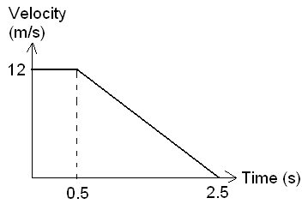

a. What is the driver’s reaction time? (1)

b. Use the graph to calculate his thinking distance. (3)

c. Use the graph to calculate his braking distance. (3)

d. What is the overall stopping distance? (1)

e. Use the graph to calculate the deceleration of the car whilst braking. (4)

f. Hence find the force applied by the brakes. (4)

g. Find the initial kinetic energy of the car. (Hint: ke = ½ mv²) (3)

h. Show that the work done by the brakes in slowing the car down is equal to the kinetic energy. (Hint: Work done = Force applied x distance moved in direction of force while it is applied) (3)

i. If the work done by the brakes is equal to the kinetic energy of the car, show theoretically that doubling the speed of the car will quadruple the braking distance if all other factors remain constant. (3)

j. If the car had been travelling at only 6m/s, draw on the axes what the graph would have looked like. (Assume the brakes apply the same force). What is the braking distance in this case? (5)

