Dear Head of GCSE Physical Education,

Re: Update on GCSE Physical Education full course (5PE01) and short course (3PE01) examination from Summer 2013

We recently contacted you regarding the examination papers for the above qualifications to inform you that the supporting bullet points in the final questions on the question papers will be removed. The notice is available here:

http://www.edexcel.com/quals/gcse/gcse09/pe/pages/viewNotice.aspx?notice=2713

Along with many other GCSEs, PE will become linear from September 2012, first assessment in Summer 2014. Whilst reviewing the specification we have made some additional minor changes to the examination papers on both qualifications.

To support centres through this change we have prepared updated sample assessment materials and mark schemes on the GCSE PE homepage of our website and copies have been included with this letter.

The written examination paper will still contain multiple choice, short answer and long answer responses. However, from Summer 2013, there will be some minor changes to question types used to assess candidate responses. The changes are outlined below.

Unit 1 – Full Course (5PE01)

- We have made a small reduction in the number of single word response questions, and have replaced these with short answer questions that are marked out of 3 or 4 marks.
- As per the changes in Summer 2012, the longer answer questions will not contain supporting bullets.

Unit 3 – Short Course (5PE03)

- We have reduced the number of multiple choice questions and will no longer use the ‘whether two linked statements are true and/or false’ multiple choice question type.
- We have also made a small reduction in the number of single word response questions and replaced these with short answer questions that are marked out of 3 or 4 marks.
- As per the changes in Summer 2012, the longer answer question will not contain supporting bullets.

The total number of marks available for the written examination paper for both full and short course remains the same, and there will still be common questions between the full and short course written examination papers. There have been no changes to the controlled assessment unit. The content and topics in the specification remain the same.

Please continue to prepare your candidates for these papers as described in the GCSE 2012 linear specification for first assessment in 2014 and the 2013 sample assessment material.
If you have any questions about this, please email the Physical Education Assessment Team at physicaleducation@pearson.com or contact the Subject Advisor, Penny Lewis, at TeachingPEandSport@pearson.com or by calling 0844 576 0036 (+44 (0)1204 770696 for centres outside the UK).
Yours sincerely
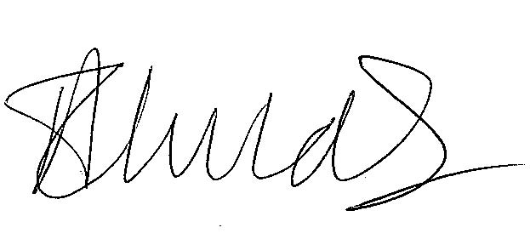
Abena Childs
Qualification Delivery and Award Manager
Physical Education

