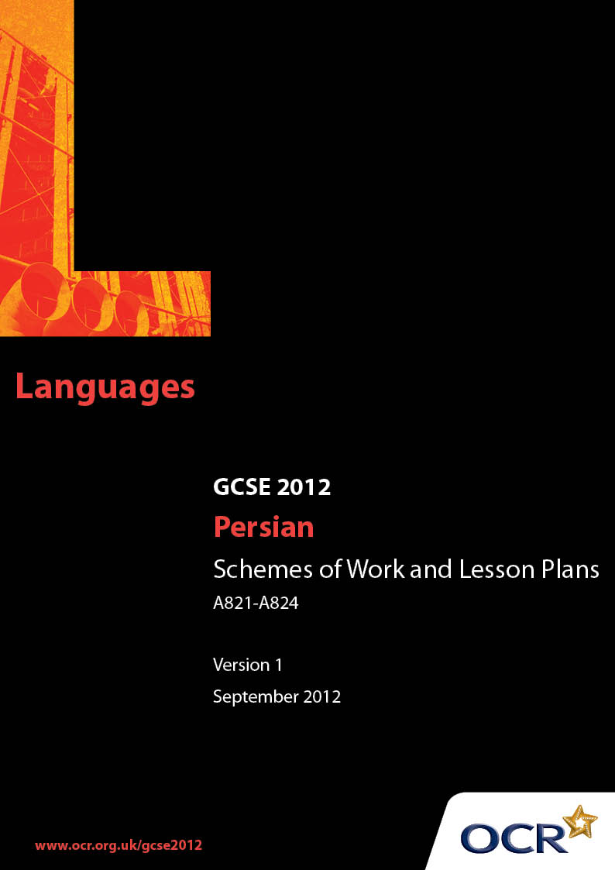

Contents
Contents 2
Introduction 3
Sample Schemes of Work:
OCR GCSE Persian Unit: Listening 4
OCR GCSE Persian Unit: Speaking 5
OCR GCSE Persian Unit: Reading 7
OCR GCSE Persian Unit: Writing 8
Sample Lesson Plans:
OCR GCSE Persian Unit: Listening 9
OCR GCSE Persian Unit: Speaking 10
OCR GCSE Persian Unit: Reading 11
OCR GCSE Persian Unit: Writing 12

Introduction

Background
OCR has produced a summary brochure, which summarises the changes to Persian. This can be found at www.ocr.org.uk, along with the new specification.
In addition and in response to reforms announced by the Government and in response to Ofqual mandated changes to GCSEs, unitised assessment of this qualification is being replaced by linear assessment from September 2012. This means that candidates commencing a two year course from September 2012 will take all of their GCSE units at the end of the course in June 2014.
In order to help you plan effectively for the implementation of the new specification we have produced these Schemes of Work and Sample Lesson Plans for Persian. These Support Materials are designed for guidance only and play a secondary role to the Specification.

Our Ethos
OCR involves teachers in the development of new support materials to capture current teaching practices tailored to our new specifications. These support materials are designed to inspire teachers and facilitate different ideas and teaching practices.
Each Scheme of Work and set of sample Lesson Plans is provided in Word format so that you can use it as a foundation to build upon and amend the content to suit your teaching style and students’ needs.
The Scheme of Work and sample Lesson plans provide examples of how to teach this unit and the teaching hours are suggestions only. Some or all of it may be applicable to your teaching.
The Specification is the document on which assessment is based and specifies what content and skills need to be covered in delivering the course. At all times, therefore, this Support Material booklet should be read in conjunction with the Specification. If clarification on a particular point is sought then that clarification should be found in the Specification itself.

OCR GCSE Persian Unit: Listening
Suggested teaching time | 8 hours | Topic | Travel And The Wider World
Topic outline |  | Suggested teaching and homework activities |  | Suggested resources | Points to note
Listening |  | - Teacher to issue students with cards containing cut up information based on the account being read to the class  - Teacher to read out/give the account  - Students to process the information & match it with the pictures  - Teacher checking the answers (group activity) |  | - Teacher will have to produce the cards to match the account read to the class  - Maps, pictures of cities, people travelling (airports, bus and railway stations), people in local costume, etc
 |  | - Students to listen to a tape/watch a video comparing travel in a Farsi-speaking country with another country, mentioning similarities & differences & to make notes  - Teacher to give a table to students to complete while listening to the tape for the second time  - Teacher to check & correct answers |  | - Teacher would need to make the tape  - Books that could be used as reference:  Colloquial Persian (Rafiee, A. Routledge) Modern Persian (Farzad, N.)  Teach Yourself Modern Persian/Farsi (McGraw-Hill)
Consolidation |  | - Teacher to put on the board one list of words & a 2nd list containing meanings & synonyms. Students to match lists
Homework |  | - Teacher to suggest to students to watch a Persian programme, listen to the news & feed back to the class what they have understood. |  | - BBC Persian news on the internet  - Various Persian TV programmes.

OCR GCSE Persian Unit: Speaking
Suggested teaching time | 8 hours | Topic | Travel And The Wider World
Topic outline |  | Suggested teaching and homework activities |  | Suggested resources | Points to note
Speaking |  | - Teacher to bring to class postcards, pictures of a few Iranian cities, map of the country, travel brochures with pictures of sites in those cities; 2 sets of cue cards: one with some information about the cities in question and one with questions to be asked:  When did you go? What city did you visit? How long did you stay? Where did you stay? What did you do there? What sites did you visit?  - Teacher to set the scene by dividing the class into two groups: those who have visited Iran & those who are interviewing them. Pair activity  - Students ask questions & teacher makes suggestions  - Students change group. The interviewers become interviewees  - Teacher issues next set of questions & answers about what the person’s feelings/ fears/ joys/ likes/ dislikes were during their visit  - Students continue the interview  - Teacher answers questions & makes suggestions  - Teacher introduces more pictures to the group of Iranians going about their daily life, eg shopping, eating, walking in the street  - Teacher asks for a volunteer to come to the front of the class & answer questions  - Students take turns in asking the teacher about the dress code, customs, what is acceptable/unacceptable in Iran |  | - Maps, brochures, pictures, postcards, leaflets, pamphlets available in Iran & publicity material available from Iranian & Afghani shops in England  - Pictorial descriptions of Cities in Iran available in Persian bookshops  - Farhangsara book shop has a vast collection of books, CDs, tapes & sells through the internet  - Internet material  - Iranian newspapers (Keyhan, Nimrooz), magazines published in England  - Iranian Niazmandiha (Yellow Pages)  - Cards to be devised by teachers
Consolidation |  | - Teacher rounds up the lesson, answers questions & offers explanations if needed
Homework |  | - Teacher gives lists of Persian-speaking businesses students could visit and gives examples of information students could collect & feed back to the class in the next session

OCR GCSE Persian Unit: Reading
Suggested teaching time | 8 hours | Topic | Travel And The Wider World
Topic outline |  | Suggested teaching and homework activities |  | Suggested resources | Points to note
Reading |  | - Teacher to issue students with copies of a tour operator’s brochure for trips advertised to Farsi-speaking countries  - Students to read the text and do a multiple choice exercise  - Students to compare answers  - Teacher to give the correct answers  - Teacher to give students an article/text written by two students for the school news letter |  | - Brochures, pictures, map of Iran  - Google Search for pictures & information on cities in Farsi-speaking countries  - www.tourismiran.ir/en  - www.irpedia.com  - Worksheets devised by the teacher based on the information in the brochure  - An article devised by the teacher to incorporate the required vocabulary  - An exercise devised by the teacher | - Unfortunately there are no texts in general to cater for students at this level. All texts will have to be adapted by the teacher  - Teacher should be aware of difficult words and explain meaning to students.
 |  | - Students to do a task, eg matching phrases & completing sentences. Pair activity  - Teacher to go round the class & check students’ answers as they are writing them |  | - Worksheet devised by teacher.
Consolidation |  | - Teacher to ask students to choose a word they have learnt in the lesson & use it in a sentence orally. Group activity
Homework |  | - Students to take away a worksheet with sentences to complete by using words from the given list. Students to read around an agreed subject & feed back.

OCR GCSE Persian Unit: Writing
Suggested teaching time | 8 hours | Topic | Travel And The Wider World
Topic outline |  | Suggested teaching and homework activities |  | Suggested resources | Points to note
Writing |  | - Teacher to bring to class brochure of air /train journeys to & around Iran, train/air tickets & timetables, price lists, hotel brochures, maps etc.  - Teacher to set the scene, eg an English friend is planning to visit Tehran & Keesh & needs some information  - Teacher to give students the following list:  Price of air travel to Iran, length of journey, name of airport, price ticket to Keesh, price of single room in hotel in Tehran & Keesh, situation of hotels/proximity to town centres, bus & taxi fares  - Students working in pairs to extract information & take notes from each source available  - Students to check and write up their notes  - Students to write an e-mail to the friend giving them the information requested |  | - Travelling brochures, plane/train timetables, tickets, plans of cities, maps. Some available from travel agents, some from the internet, some need to be devised by the teacher  - Travel & Tourism guide on the internet in Persian:  www.tourismiran.ir  www.irpedia.com  - Information also available under country/city names via Google search | - In addition to the simple & past tenses, the subjunctive will need to be practiced in the course of this session  - Teacher should be aware of difficult words and explain meaning to students
Consolidation |  | - Teacher to check the written work & highlight the appropriate way of beginning & ending an e-mail message
Homework |  | - Teacher to set as homework a reply to the e-mail

OCR GCSE Persian Unit: Listening

Travelling in Different Countries
OCR recognises that the teaching of this qualification above will vary greatly from school to school and from teacher to teacher. With that in mind this lesson plan is offered as a possible approach but will be subject to modifications by the individual teacher.
Lesson length is assumed to be 50 minutes.

Learning Objectives for the Lesson
Objective 1 | Students to listen to someone’s account of planning a holiday & process the information
Objective 2 | Students to listen to a tape for gist
Objective 3 | Students to listen again & extract details from the conversation & arrange the information in a table

Recap of Previous Experience and Prior Knowledge
- Elicit vocabulary relevant to planning trips in their families: Where do they go? Who decides? What role do they play?

Content
Time | Content
10 minutes | Warm up activity: Teacher provides 4 pictures of people & reads an account of how they planned their holiday  Students arrange the cards given to them with pieces of information, according to each name, while listening to the account. Pair activity
5 minutes | Teacher checks the answers by going round the class
5 minutes | Students listen to a telephone conversation mentioning similarities & differences of travelling to Iran & another country & take notes
10 minutes | Students given a table to complete while listening to the tape a second time for detail. Pair activity
5 minutes | Teacher checks/corrects the answers by going round the class

Consolidation
Time | Content
10 minutes | Recap the vocabulary: The teacher puts on the board a list of new words in one column & meanings/ synonyms in another  Students volunteer to choose a word from the 1st column & match it with a word from the 2nd column
5 minutes | Homework: Agree on an activity, eg watching a Persian programme/ listening to the news, preparing to feed back to the class what they have understood in the next session

OCR GCSE Persian Unit: Speaking

Getting to know about Iran
OCR recognises that the teaching of this qualification above will vary greatly from school to school and from teacher to teacher. With that in mind this lesson plan is offered as a possible approach but will be subject to modifications by the individual teacher.
Lesson length is assumed to be one hour.

Learning Objectives for the Lesson
Objective 1 | Students to understand Persian in the context of travelling & visiting
Objective 2 | Students to carry out dialogues effectively in Persian in the context of travelling & visiting
Objective 3 | Students to develop understanding & awareness of customs in Iran

Recap of Previous Experience and Prior Knowledge
- Ask the class to mention the differences they have noticed between Iranian & English cultures

Content
Time | Content
5 minutes | Teacher issues postcards, pictures, map etc. & gives out cue cards with questions & answers on them. The group is divided into interviewers & interviewees
10 minutes | Students interview each other using the information on the cards
15 minutes | Students change group & interviewees interview the other group using the new set of questions
5 minutes | Teacher answers questions arising from the activity
10 minutes | One student volunteers to be interviewed by the rest of the class. Students take turns in asking questions about the dress code, customs, what is acceptable & unacceptable in Iran (cards to be available to help with the questions & answers in this context)

Consolidation
Time | Content
5 minutes | Teacher consolidates the terminology introduced & answer questions
10 minutes | Homework: Teacher gives out list of Persian-speaking businesses & asks students to gather information ready to feedback to the class in the next session

OCR GCSE Persian Unit: Reading

Student article on a visit to Iran
OCR recognises that the teaching of this qualification above will vary greatly from school to school and from teacher to teacher. With that in mind this lesson plan is offered as a possible approach but will be subject to modifications by the individual teacher.
Lesson length is assumed to be one hour.

Learning Objectives for the Lesson
Objective 1 | Students to read a text from a brochure & give non-verbal responses to multiple choice questions
Objective 2 | Students to read & extract details of a text and complete sentences in Persian accordingly

Recap of Previous Experience and Prior Knowledge
- Warm up exercise: asking students who has recently travelled (Where to? When?) to elicit relevant vocabulary

Content
Time | Content
10 minutes | Students read a tour-operator’s itinerary of a tour to Iran
10 minutes | Students complete a multiple choice exercise & provide answers to: When? How? How many days? Which cities? Which sites? etc.
5 minutes | Students compare answers  Teacher gives students the correct letters to the answers
10 minutes | Students read an article written by two students for the school newsletter with an account of arriving at an airport terminal, going through customs, filling forms & answering questions, their impressions, feelings & emotions etc.
10 minutes | Students do a task, eg completing sentences by matching phrases from two given lists. Pair activity  Teacher corrects answers

Consolidation
Time | Content
10 minutes | Students focus on new vocabulary: identify one word/ expression learned in the course of the lesson & use it in a sentence
5 minutes | Homework: To consolidate the vocabulary, students are asked to take away a worksheet with incomplete sentences to be completed with words from the list given. Agree on a subject for students to read about & to feed back next time

OCR GCSE Persian Unit: Writing

Writing an e-mail
OCR recognises that the teaching of this qualification above will vary greatly from school to school and from teacher to teacher. With that in mind this lesson plan is offered as a possible approach but will be subject to modifications by the individual teacher.
Lesson length is assumed to be one hour.

Learning Objectives for the Lesson
Objective 1 | Students to communicate information in written form
Objective 2 | Students to be able to write in appropriate register using appropriate terminology
Objective 3 | Students to choose appropriate format for their writing

Recap of Previous Experience and Prior Knowledge
- Quick set of questions round the class to find out how students communicate with their friends, eg letters, phone calls, e-mail messages

Content
Time | Content
10 minutes | Teacher sets the scene & provides the information required by an English friend who is going to travel to Tehran & Keesh
10 minutes | Students study brochures, train/ plane timetables, tickets, hotel brochures etc. to extract information and take notes
15 minutes | Students write an e-mail to the friend & include the information requested
10 minutes | Teacher invites students to read out their sentences & correct them

Consolidation
Time | Content
10 minutes | Teacher consolidates the vocabulary learnt and draws attention to the appropriate opening and closing format for e-mails
5 minutes | Homework: Students to reply to the e-mail from the friend

