
Sample Schemes of Work and Lesson Plans
GCSE Methods in Mathematics
OCR GCSE in Methods in Mathematics: J926
Unit: B391/01
This Support Material booklet is designed to accompany the OCR GCSE Methods in Mathematics specification for teaching from September 2010.

Contents
Contents 2
Introduction 3
Sample Scheme of Work OCR GCSE Methods in Mathematics Unit: B391/01 4
Sample GCSE Lesson Plan 1 OCR GCSE Methods in Mathematics Unit B391/01 36
Sample GCSE Lesson Plan 2 OCR GCSE Methods in Mathematics Unit B391/01 51
Sample GCSE Lesson Plan 3 OCR GCSE Methods in Mathematics Unit B391/01 53

Introduction
In order to help you plan effectively for the implementation of the new specification we have produced sample schemes of work and lesson plans for Methods in Mathematics. These support materials are designed for guidance only and play a secondary role to the specification.
Each scheme of work and lesson plan is provided in Word format – so that you can use it as a foundation to build upon and amend the content to suit your teaching style and learners’ needs.
This booklet provides examples of how to structure the teaching of this unit; the teaching hours are suggestions only.
The specification is the document on which assessment is based and specifies what content and skills need to be covered in delivering the course. At all times, therefore, this support material booklet should be read in conjunction with the specification. If clarification on a particular point is sought then that clarification should be sought in the specification itself.

OCR GCSE Methods in Mathematics J926 Unit: B391/01
Suggested teaching time | N/A | Topic | F1A – General problem solving skills
Topic outline |  | Suggested teaching and homework activities |  | Suggested resources | Points to note
1 – Solve problems using mathematical skills  - select and use suitable problem solving strategies and efficient techniques to solve numerical problems  - identify what further information may be required in order to pursue a particular line of enquiry and give reasons for following or rejecting particular approaches  - break down a complex calculation into simpler steps before attempting to solve it and justify their choice of methods  - use notation and symbols correctly and consistently within a problem  - use a range of strategies to create numerical representations of a problem and its solution; move from one form of representation to another in order to get different perspectives on the problem  - interpret and discuss numerical information presented in a variety of forms  - present and interpret solutions in the context of the original problem  - review and justify their choice of mathematical presentation  - understand the importance of counter-example and identify exceptional cases when solving problems  - show step-by-step deduction in solving a problem  - recognise the importance of assumptions when deducing results; recognise the limitations of any assumptions that are made and the effect that varying those assumptions may have on the solution to a problem |  | - These skills should be integrated within the other content areas in the context of different areas of maths within both more open ended and closed questions/problems

OCR GCSE Methods in Mathematics J926 Unit: B391/01
Suggested teaching time | 9-12 hours | Topic | F1B – Number
Topic outline |  | Suggested teaching and homework activities |  | Suggested resources | Points to note
1 – Add, subtract, multiply and divide any number  - understand and use positive numbers and negative integers, both as positions and translations on a number line  - add, subtract, multiply and divide integers and then any number  - multiply or divide any number by powers of 10  - multiply or divide any positive number by a number between 0 and 1  - multiply and divide by a negative number  - recall all positive integer complements to 100  - recall all multiplication facts to 10 × 10, and use them to derive quickly the corresponding division facts  - develop a range of strategies for mental calculation; derive unknown facts from those they know  - add and subtract mentally numbers with up to two decimal places  - multiply and divide numbers with no more than one decimal place, using place value adjustments, factorisation and the commutative, associative, and distributive laws, where possible  - add and subtract integers and decimals understanding where to position the decimal point  - perform a calculation involving division by a decimal (up to two decimal places) by transforming it to a calculation involving division by an integer |  | - Best to introduce in real life contexts eg temperature and have a number line visible  - Negative number puzzle  - MyMaths.co.uk - negatives1  - BODMAS: Positive and negative numbers  - MyMaths.co.uk - negatives2  - Multiplying and dividing by powers of 10.  - Use My maths to deliver Tp’s and activities MyMaths.co.uk - decimalx10x100  - Multiply positive and negative numbers  - MyMaths.co.uk - Sky Solver - Add 100  - MyMaths.co.uk - Introducing Multiplication  - MyMaths.co.uk - DecimalAdding  - MyMaths.co.uk - Decimal multiplying1  - MyMaths.co.uk - Decimal multiplying2  - MyMaths.co.uk - DecimalDividing |  | - Number Line Bounce - NLVM  - Tarsia – negative numbers at SmartBoard Notepad files for teaching mathematics  - Waldomaths - operations with negative numbers  - VTC - KS4 - Maths - Number  - SmartBoard Notepad files for teaching mathematics – multiplication puzzle, mental mathematics  - Base Blocks Decimals - NLVM  - nrich.maths.org :: Mathematics Enrichment :: Forgot the Numbers  - nrich.maths.org :: Mathematics Enrichment :: Route Product | - Incorporate reasoning questions eg explain why = 40 cannot be correct
2 – Approximate to a specified or appropriate degree of accuracy  - use previous understanding of integers and place value to deal with arbitrarily large positive numbers  - estimate answers to problems involving decimals  - use a variety of checking procedures, including working the problem backwards, and considering whether a result is of the right order of magnitude  - round to the nearest integer, to any number of decimal places specified or appropriate, and to any number of significant figures  - give solutions in the context of the problem to an appropriate degree of accuracy, and recognise limitations on the accuracy of data and measurements |  | - MyMaths.co.uk - rounding10  - Rounding and estimation hangman  - MyMaths.co.uk - roundingDecimal  - MyMaths.co.uk - Decimal Places  - MyMaths.co.uk - Significant Figures  - MyMaths.co.uk - Estimatingintro  - MyMaths.co.uk - Estimating |  | - Approximation  - Rounding and estimation hangman  - VTC - KS4 - Maths - Number | - Write 13 066 using words and to the nearest 100  - Round 345.46 to the nearest integer, 1 decimal place, 2 significant figures  - Know that 3.5 on a calculator means 3.50 in money context  - Know that 3.66666667 on a calculator is a recurring decimal
3 – Understand and use Venn diagrams and set notation to solve problems  - use ‘two circle’ Venn diagrams including in contexts other than number  - understand and use set notation, and be able to solve related problems |  | See separate document covering additional content

OCR GCSE Methods in Mathematics J926 Unit: B391/01
Suggested teaching time | 1-2 hours | Topic | F1C – Hierarchy of operations
Topic outline |  | Suggested teaching and homework activities |  | Suggested resources | Points to note
1 – Hierarchy of operations  - use brackets and the hierarchy of operations |  | - MyMaths.co.uk - Operations Order |  |  | Calculate $\frac{{\left(6+8\right)}^{2}}{2⋅5^{2}−1⋅5^{2}}$

OCR GCSE Methods in Mathematics J926 Unit: B391/01
Suggested teaching time | 2-3 hours | Topic | F1D – Factors, multiples and primes
Topic outline |  | Suggested teaching and homework activities |  | Suggested resources | Points to note
1 – Factors, multiples and primes  - use the concepts and vocabulary of factor (divisor), multiple, common factor, common multiple, highest common factor, least common multiple, prime number and prime factor decomposition  - find the prime factor decomposition of positive integers  - understand that the number of factors of a number can be derived from its prime factorisation |  | - Happy numbers activity – find numbers where sum of factors is equal to number  - Use factor tree software to illustrate use of prime factors in finding LCM/HCF after definitions have been established  Class activity: Identify a number from a description of its properties, for example, which number less than 50 has 3 and 5 as factors and is a multiple of 9? Students make up their own descriptions and test one another.  - Multiples prison cell game  - Use factor trees/factor staircase  - Goldbach’s conjecture (counter example search) |  | - Tarsia puzzle – factors and multiples at SmartBoard Notepad files for teaching mathematics  - Sieve of Eratosthenes - NLVM  - Factors of Numbers - Waldomaths  - Finding prime numbers - The Sieve of Eratosthenes 1 - Waldomaths  - Factor Tree - NLVM  - Factor Tree - NLVM | - Write down a multiple of 7, a prime number and a factor of 104 that lie between 25 and 30  - Write 96 as a product of prime factors using indices  - Counter example problems could be bought in here  eg Are all primes odd?  - Emphasise 1 not a prime and factor trees should not contain 1s

OCR GCSE Methods in Mathematics J926 Unit: B391/01
Suggested teaching time | 8-10 hours | Topic | F1E – Fractions, decimals and percentages
Topic outline |  | Suggested teaching and homework activities |  | Suggested resources | Points to note
1 – Calculate with fractions  - calculate a given fraction of a given quantity, expressing the answer as a fraction  - express a given number as a fraction of another  - add and subtract fractions by writing them with a common denominator  - convert a simple fraction to a decimal  - multiply and divide a fraction by an integer and by a unit fraction  - understand and use unit fractions as multiplicative inverses⁽¹⁾  - use efficient methods to calculate with fractions, including cancelling common factors before carrying out a calculation |  | - MyMaths.co.uk - Fractions1  - MyMaths.co.uk - Adding fractions  - MyMaths.co.uk - FractoDec  - MyMaths.co.uk - Mult Div Fractions  - MyMaths.co.uk - Multiplying Fractions  - MyMaths.co.uk - Dividing Fractions  - MyMaths.co.uk - Calculations with Mixed Numbers  - MyMaths.co.uk - Reciprocal |  | - SmartBoard Notepad files for teaching mathematics – lots of tarsia puzzles to download on fractions and processes  - Fractions - Adding - NLVM  - Fractions review  - Adding and subtracting fractions  - Worksheet: Fraction addition  - nrich.maths.org :: Mathematics Enrichment :: The Greedy Algorithm – unit fraction investigation  - Mixed numbers and improper fractions  - Follow me cards: Calculating fractions  - nrich.maths.org :: Mathematics Enrichment :: Peaches Today, Peaches Tomorrow....  - nrich.maths.org :: Mathematics Enrichment :: Fractions in a Box  - VTC - KS4 - Maths - Number | ⁽¹⁾ Multiplication by is equivalent to division by 5
2 – Order rational numbers  - order integers  - order fractions  - order decimals |  | - MyMaths.co.uk - Comparing Fractions  - MyMaths.co.uk - DecimalOrdering |  | - Ordering fractions  - Ordering decimals
3 – Understand equivalent fractions  - understand equivalent fractions and simplify a fraction by cancelling all common factors |  | - MyMaths.co.uk - Equivalent fractions  - MatchingFractions  - FractionPairs |  | - SmartBoard Notepad files for teaching mathematics – fractions activities  - Simplifying fractions  - Matching equivalent fractions  - Fractions - Equivalent - NLVM | - nrich.maths.org :: Mathematics Enrichment :: Fractions Jigsaw
4 – Relationship between fractions and decimals  - use decimal notation and recognise that each terminating decimal is a fraction⁽¹⁾  - distinguish between fractions with denominators that have only prime factors of 2 and 5 (which are represented by terminating decimals), and other fractions |  | - MyMaths.co.uk - Fdp Intro |  | - Percentages puzzle  - SmartBoard Notepad files for teaching mathematics – fracts/dec/% tarsia puzzles and % puzzles  - Match fractions decimals and percentages  - nrich.maths.org :: Mathematics Enrichment :: Matching Fractions Decimals Percentages | ⁽¹⁾ 0.137 = $\frac{\text{137}}{\text{1000}}$

OCR GCSE Methods in Mathematics J926 Unit: B391/01
Suggested teaching time | 4-6 hours | Topic | F1F – Indices and surds
Topic outline |  | Suggested teaching and homework activities |  | Suggested resources | Points to note
1 – Indices in common use  - use the terms ‘square’, ‘positive square root’, ‘negative square root’, ‘cube’ and ‘cube root’  - recall integer squares from 11 × 11 to 15 × 15 and the corresponding square roots  - recall the cubes of 2, 3, 4, 5 and 10 |  | - MyMaths.co.uk - SquareTriangle  - MyMaths.co.uk - SquareNumbers  - MyMaths.co.uk - SquarePairs  - MyMaths.co.uk - Cubepairs  Extension activity: 121 is a palindromic square number (when the digits are reversed it is the same number). Write down all the palindromic square numbers less than 1000. |  | - Concentration squares game  - Numbersearch: Powers of 2 and 3  - Square numbers starter  - Opportunities for counter example work – are all squares odd etc?
2 – Use index notation  - use index notation for squares, cubes and powers of 10  - use index notation for simple positive integer powers  - use index laws for multiplication and division of integer powers  - use index laws to simplify, and calculate the value of, numerical expressions involving multiplication and division of integer powers |  | - MyMaths.co.uk - IndicesPart1  - MyMaths.co.uk - IndiciesPart2  - (not fractional indices) |  | - SmartBoard Notepad files for teaching mathematics – Tarsia – Index notation 1 and 2  - Basic index notation worksheet  - Indices rules  - nrich.maths.org :: Mathematics Enrichment :: Power Crazy

OCR GCSE Methods in Mathematics J926 Unit: B391/01
Suggested teaching time | N/A | Topic | F1G – Algebra
Topic outline |  | Suggested teaching and homework activities |  | Suggested resources | Points to note
1 – Symbols and notation  - distinguish the different roles played by letter symbols in algebra, using the correct notational conventions for multiplying or dividing by a given number  - know that letter symbols represent definite unknown numbers in equations⁽¹⁾, and defined quantities or variables in formulae⁽²⁾  - know that in functions, letter symbols define new expressions or quantities by referring to known quantities⁽³⁾ |  |  |  |  | ⁽¹⁾ 5x + 1 = 16  ⁽²⁾ V = IR  ⁽³⁾ y = 2x

OCR GCSE Methods in Mathematics J926 Unit: B391/01
Suggested teaching time | 2-3 hours | Topic | F1H – Coordinates
Topic outline |  | Suggested teaching and homework activities |  | Suggested resources | Points to note
1 – Use the conventions for coordinates in the plane  - use the conventions for coordinates in the plane; plot points in all four quadrants  - understand that one coordinate identifies a point on a number line and two coordinates identify a point in a plane, using the terms ‘1D’ and ‘2D’  - use axes and coordinates to specify points in all four quadrants  - locate points with given coordinates⁽¹⁾ |  | - Coordinates in one quadrant  - Plotting coordinates  - Flash game: Plotting coordinates  - Coordinate code breaking  - Points and lines  - Coordinate problems  - MyMaths.co.uk - Coord midpoint |  | - Geoboard - Goordinate - NLVM  - MyMaths.co.uk - Flippyneck  - MyMaths.co.uk - Flippynecktwo  - nrich.maths.org :: Mathematics Enrichment :: Cops and Robbers  - nrich.maths.org :: Mathematics Enrichment :: Coordinate Patterns | ⁽¹⁾ Plot (3, 6) and (2, -4) on a grid

OCR GCSE Methods in Mathematics J926 Unit: B391/01
Suggested teaching time | 1-2 hours | Topic | F1I – Sequences and formulae
Topic outline |  | Suggested teaching and homework activities |  | Suggested resources | Points to note
1 – Understand and use formulae  - substitute numbers into formulae⁽¹⁾ |  | - MyMaths.co.uk - Formulae  - Formula Pairs game  Class activity: Investigate the difference between simple algebraic expressions which are often confused, for example, find the difference between 2x, 2 + x and x² for different values of x.  Spider diagram activities – different expressions on the legs with a value in the body  - MyMaths.co.uk - Substituting  - MyMaths.co.uk - Substituting Further  - Starter problem: Substitution into BMI formula |  | - Happy planet index - functional  - Happy planet index - data support sheets  - Fitness calculator  - Fitness support sheets  - Reading age formulae  - Reading age formulae support  - Reading age fomulae lesson plan | ⁽¹⁾ For area of a triangle or a parallelogram, area enclosed by a circle, volume of a prism

OCR GCSE Methods in Mathematics J926 Unit: B391/01
Suggested teaching time | 4-6 hours | Topic | F1J – Linear equations
Topic outline |  | Suggested teaching and homework activities |  | Suggested resources | Points to note
1 – Manipulate algebraic expressions  - understand that the transformation of algebraic expressions obeys and generalises the rules of arithmetic⁽¹⁾  - manipulate algebraic expressions by collecting like terms⁽²⁾, by multiplying a single term over a bracket, and by taking out common factors⁽³⁾  - use index laws in algebra |  | - Try algebra pyramids for collecting like terms; matching games – expression with answer; odd ones out  - MyMaths.co.uk - SimplifyingExpressions  - MyMaths.co.uk - FactoriseExpressions  - Expanding brackets  - Tarsia and Easiteach resources: Algebra – select from these resources |  | - Tarsia puzzle – simplifying at SmartBoard Notepad files for teaching mathematics  - MyMaths.co.uk - SimplifyPairs  - MyMaths.co.uk - Simplify Pairs 2  - Algebra Tiles - NLVM  - Tarsia – expanding brackets at SmartBoard Notepad files for teaching mathematics | - Collecting like terms  - Expanding brackets  - Factorising by removing common factors  ⁽¹⁾ a(b + c) = ab + ac  ⁽²⁾ x + 5 – 2x – 1 = 4 – x  ⁽³⁾ 9x – 3 = 3(3x – 1) or x² – 3x = x(x – 3)
2 – Set up and solve simple equations  - set up simple equations⁽¹⁾  - solve simple equations⁽²⁾ by transforming both sides in the same way  - solve linear equations, with integer coefficients, in which the unknown appears on either side or on both sides of the equation |  | - MyMaths.co.uk - Equations Simple  - Flowchart method to begin to consolidate inverse operations leading to the balance method  - MyMaths.co.uk - solving Equations |  | - Algebra Balance Scales - NLVM  - Solving simple linear equations - Waldomaths  - Tarsia puzzle – solving equations at SmartBoard Notepad files for teaching mathematics  - Simple Equations 2 - Waldomaths  - Algebra Balance Scales - Negatives - NLVM | ⁽¹⁾ Richard is x years, Julie is twice as old and their combined age is 24 years. Write an equation to show this information  ²⁾ 11 – 4x = 2; 3(2x + 1) = 8;  2(1 – x) = 6(2 + x);  3x² = 48; 3 =

OCR GCSE Methods in Mathematics J926 Unit: B391/01
Suggested teaching time | 2-3 hours | Topic | F1K – Functions and graphs
Topic outline |  | Suggested teaching and homework activities |  | Suggested resources | Points to note
1 – Recognise and plot equations that correspond to straight-line graphs in the coordinate plane  - plot graphs of functions in which y is given explicitly or implicitly in terms of x, where a table and/or axes are provided and where no table or axes are given  - read off values of x- or y-coordinates where two lines cross, where a line meets an axis, or where one coordinate is given |  | - MyMaths.co.uk - PlottingGraphs  - MyMaths.co.uk - Equationofline  - Tarsia and Easiteach resources: Algebra |  | - VTC - KS4 - Maths - Algebra  - Drawing straight line graphs  - nrich.maths.org :: Mathematics Enrichment :: Translating Lines  - nrich.maths.org :: Mathematics Enrichment :: Diamond Collector  - y = mx + c  - nrich.maths.org :: Mathematics Enrichment :: Parallel Lines  - nrich.maths.org :: Mathematics Enrichment :: Perpendicular Lines | - Know that the lines represented by y = 5x and y = 3 + 5x are parallel, each having gradient 5  - Know that the line with equation y = is perpendicular to these lines and has gradient
2 – Use geometric information to complete diagrams on a coordinate grid  - use geometric information about shapes, or parallel or perpendicular lines⁽¹⁾, to complete diagrams on a coordinate grid |  |  |  |  | ⁽¹⁾ Know that the lines represented by y = 5x and y = 3 + 5x are parallel, each having gradient 5

OCR GCSE Methods in Mathematics J926 Unit: B391/01
Suggested teaching time | 2-3 hours | Topic | F1L – Angles and properties of shapes
Topic outline |  | Suggested teaching and homework activities |  | Suggested resources | Points to note
1 – Lines and angles  - recall and use properties of angles at a point, angles at a point on a straight line (including right angles), perpendicular lines, and vertically opposite angles  - distinguish between acute, obtuse, reflex and right angles; estimate the size of an angle in degrees |  | - Anglesums  - MyMaths.co.uk - Angler |  | - Angles at a point  - Calculating missing angles  - Categorising angles  - Acute or Obtuse?  - Angle properties  - nrich.maths.org :: Mathematics Enrichment :: Right Time
2 – Properties of shapes  - use angle properties of equilateral, isosceles and right-angled triangles  - recall the essential properties and definitions of special types of quadrilateral, including square, rectangle, parallelogram, trapezium, kite and rhombus  - classify quadrilaterals by their geometric properties  - recall the definition of a circle and the meaning of related terms, including centre, radius, chord, diameter, circumference, tangent, arc, sector and segment  - understand that inscribed regular polygons can be constructed by equal division of a circle |  | - Anglesums  - MyMaths.co.uk - Angle Reasoning  - Use diagonal from one vertex and angle of triangles to demonstrate  - MyMaths.co.uk - Angle Proofs  - MyMaths.co.uk - LinesQuads  - Practical activity – stick the labels on parts of the circle  - Card sort game – terms with pictures  - Use compasses and protractor to construct regular pentagons; hexagons; octagons etc  - Simple angle related angle calcs involving angle at centre of polygon and isosceles triangles |  | - Angles in triangles  - Angles in quadrilaterals  - Click on the shape to view its properties  - Properties of quadrilaterals  - True or False? – quiz on shape facts

OCR GCSE Methods in Mathematics J926 Unit: B391/01
Suggested teaching time | 6-8 hours | Topic | F1M – Transformations
Topic outline |  | Suggested teaching and homework activities |  | Suggested resources | Points to note
1 – Transformations of 2D shapes  - recognise and visualise rotations⁽¹⁾, reflections⁽²⁾ and translations, including reflection symmetry of 2D and 3D shapes, and rotation symmetry of 2D shapes  - understand that rotations are specified by a centre and an (anticlockwise) angle  - understand that reflections are specified by a mirror line, at first using a line parallel to an axis, then a mirror line such as y = x or y = −x  - understand that translations are specified by a vector  - transform triangles and other 2D shapes by translation, rotation and reflection and by combinations of these transformations⁽³⁾  - recognise that these transformations preserve length and angle, and hence that any figure is congruent to its image under any of these transformations  - understand from this that any two circles and any two squares are mathematically similar, while, in general, two rectangles are not  - understand that enlargements⁽⁴⁾ are specified by a centre  - describe and transform enlargements of shapes using positive scale factors  - distinguish properties that are preserved under particular transformations  - identify the scale factor of an enlargement as the ratio of the lengths of any two corresponding line segments and apply this to triangles  - understand and use vector notation for translations |  | - MyMaths.co.uk - Reflection  - MyMaths.co.uk - Rotation  - nrich.maths.org :: Mathematics Enrichment :: Hex  - MyMaths.co.uk - Rotation  - MyMaths.co.uk - Reflection  See separate document covering additional content  - VTC - KS4 - Maths - Shape, space and measure  - MyMaths.co.uk - Translation  - MyMaths.co.uk - Transformations  - nrich.maths.org :: Mathematics Enrichment :: Transformation Game  - MyMaths.co.uk - Enlargement – ignore neg scale factor pages  - MyMaths.co.uk - Transformations |  | - nrich.maths.org :: Mathematics Enrichment :: Hidden Meaning  - Rotations  - Transformations - Rotation - NLVM  - Transformations - Reflection - NLVM  - Reflections  - nrich.maths.org :: Mathematics Enrichment :: Clocks  - nrich.maths.org :: Mathematics Enrichment :: Mirror, Mirror...  - Transformations - Translation - NLVM  - Translation game  - nrich.maths.org :: Mathematics Enrichment :: Decoding Transformations  - nrich.maths.org :: Mathematics Enrichment :: Combining Transformations  - Transformation game  - MyMaths.co.uk - TransformGame  - Enlargements  - nrich.maths.org :: Mathematics Enrichment :: Who Is the Fairest of Them All?  - Scale factors  - Worksheet: Enlargement | ⁽¹⁾ Includes the order of rotation symmetry of a shape  ⁽²⁾ Includes reflection in the x-axis or y-axis or in a given mirror line  ⁽³⁾ Includes the single transformation equivalent to a combination of transformations  ⁽⁴⁾ Includes enlarging a shape on a grid and enlarging a shape by a scale factor given the centre of enlargement

OCR GCSE Methods in Mathematics J926 Unit: B391/01
Suggested teaching time | 2-3 hours | Topic | F1N – Area and volume
Topic outline |  | Suggested teaching and homework activities |  | Suggested resources | Points to note
1 – Perimeter, area and volume  - find areas of rectangles, recalling the formula, understanding the connection to counting squares and how it extends this approach  - find the area of a parallelogram and a triangle  - work out the surface area of simple 3D shapes composed of triangles and rectangles  - calculate perimeters and areas of shapes made from triangles and rectangles  - find volumes of cuboids, recalling the formula and understanding the connection to counting cubes and how it extends this approach |  | - MyMaths.co.uk - Area of a Rectangle  - MyMaths.co.uk - Area of a Parallelogram  - MyMaths.co.uk - Area of a Triangle |  | - KS4 Shape – tarsia and puzzles on area/vol  - House design: Area and perimeter  - Worksheet: Area, perimeter, volume  - Area and perimeter cross number  - nrich.maths.org :: Mathematics Enrichment :: Tangram  - nrich.maths.org :: Mathematics Enrichment :: Hidden Dimensions  - nrich.maths.org :: Mathematics Enrichment :: Pick's Theorem  - Perimeter and area problem | Could involve inverse calculations – find the length of an edge given the volume and two other edges  - After skills work emphasise functional aspects eg design a patio with area 60 m² – How many paving stones will you need? – What will be the cost?  - eg You have 100 m of fencing, what is the maximum area that can be enclosed?

OCR GCSE Methods in Mathematics J926 Unit: B391/01
Suggested teaching time | 4-6 hours | Topic | F1O – Probability
Topic outline |  | Suggested teaching and homework activities |  | Suggested resources | Points to note
1 – Probability  - understand and use the vocabulary of probability and the probability scale⁽¹⁾  - understand and use theoretical models of probabilities including the model of equally likely outcomes⁽²⁾  - understand and use estimates of probability from relative frequency  - use sample spaces for situations where outcomes are single events and for situations where outcomes are two successive events⁽³⁾  - identify different mutually-exclusive and exhaustive outcomes and know that the sum of the probabilities of these outcomes is 1⁽⁴⁾  - understand that if they repeat an experiment, they may (and usually will) get different outcomes, and that increasing sample size generally leads to better estimates of probability⁽⁵⁾  - compare experimental data to theoretical probabilities, and make informal inferences about the validity of the model giving rise to the theoretical probabilities  - understand and use set notation to describe events and compound events  - use Venn diagrams to represent the number of possibilities and hence find probabilities |  | - MyMaths.co.uk - ProbIntro  - MyMaths.co.uk - Prob Simple  - MyMaths.co.uk - Listoutcomes  - MyMaths.co.uk - RelativeFrequency  - MyMaths.co.uk - Probfair  - Use data to check for possible bias – could use dice/coin experiments  See separate document covering additional content  See separate document covering additional content |  | - SmartBoard Notepad files for teaching mathematics – probability tarsia file  - Probability game  - Probability card game: Higher or Lower  - Probability interactive page  - MyMaths.co.uk - Playcards  - Stick or Switch - NLVM  - nrich.maths.org :: Mathematics Enrichment :: Which Spinners?  - nrich.maths.org :: Mathematics Enrichment :: Three Spinners | ⁽¹⁾ Use impossible, certain, evens, likely, unlikely  ⁽²⁾ Associate 0, 0·5, 1 with impossible, evens and certain, and position events on a probability scale  ⁽³⁾ Use a sample space or list combinations systematically eg for 2 dice  ⁽⁴⁾ Given P(A) find P(not A), and given P(A) and P(B) find P(not A or B)  ⁽⁵⁾ Compare the dice experiment results to theoretical and comment on possible bias

OCR GCSE Methods in Mathematics J926 Unit B391/01

Geometry and Measures – Rotation and Reflection
OCR recognises that the teaching of this qualification above will vary greatly from school to school and from teacher to teacher. With that in mind this lesson plan is offered, as a possible approach but will be subject to modifications by the individual teacher.
Lesson length is assumed to be one hour.

Learning Objectives for the Lesson
Objective 1 | Understand that rotations are specified by a centre and an (anticlockwise) angle
Objective 2 | Understand that reflections are specified by a mirror line, at first using a line parallel to an axis eg y = 2, x = ⁻3 , then a mirror line such as y = x or y = ⁻x
Objective 3 | Describe simple transformations involving rotation and reflection, and understand how marks are awarded in exams for these descriptions

Recap of Previous Experience and Prior Knowledge
Students will have already covered translations and understand simple column vector notation; they will also have done some rotation and reflection work when covering line and rotation symmetry. This will have included reflecting in horizontal and vertical mirror lines as well as ones at 45 degrees but not on a coordinate grid.

Content
Time | Content
5 minutes | Capital letters of alphabet starter (see below) – which letters have line and rotation symmetry?  Have the letters on a whiteboard for students to look at – allow 5 minutes only to link into this topic.
5 minutes | Rotating about a centre through a multiple of 90 degrees – discuss terms clockwise/anticlockwise and 90/180/270.  Play short PowerPoint (separate document entitled “B391/01 - Lesson Plan - PowerPoint Presentation”).
15 minutes | Students attempt rotation consolidation work on “Rotations 2” worksheets provided – content is also available through the link: Rotations courtesy of NGFL Cymru. Allow 15 minutes maximum – students choose which one they wish to try – could use cooperative learning model in pairs for AFL.
5 minutes | Plenary – review on whiteboard – ask students to demo a couple of examples.

10 minutes | Reflections – have whiteboard prepared with three grids labelled –4 to 4 for both axes.  Describing mirror lines – draw on first grid three horizontal lines one of which is y = 0; discuss with students the names for these lines and why they are named this way.  Repeat for second grid but with vertical lines; discuss with students the names for the lines and why.  On the final grid draw y = x and y = –x and discuss why lines are named this way.  Provide handout for students of the labelled lines – blank grids provided on additional sheet.  Emphasise the importance of learning these ‘coded’ mirror lines.
15 mins | Reflections exercise – “Reflections 2” worksheets provided and content is also available through the link: Reflections courtesy of NGFL Cymru.  Again allow the students to choose which they try – encourage all to attempt the diagonal mirror lines (from Q5 onwards).
5 mins | Plenary – review on whiteboard – ask students to demo a couple of examples – assess progress.  Homework is to attempt two more examples of rotations and two more examples of reflections from the worksheets provided.

Starter
A B C D E F G H I J K L M N
O P Q R S T U V W X Y Z
Which of the letters above have
1) line symmetry,
2) rotation symmetry?
For those that have rotation symmetry what is the order for each of them?
What do you think a point of symmetry means?
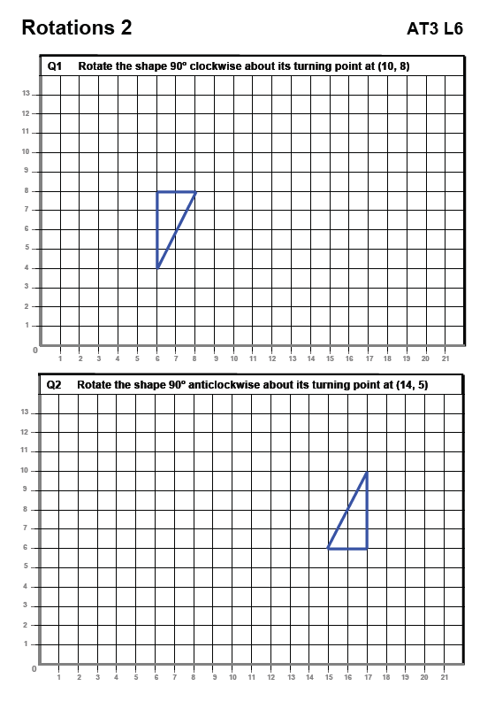
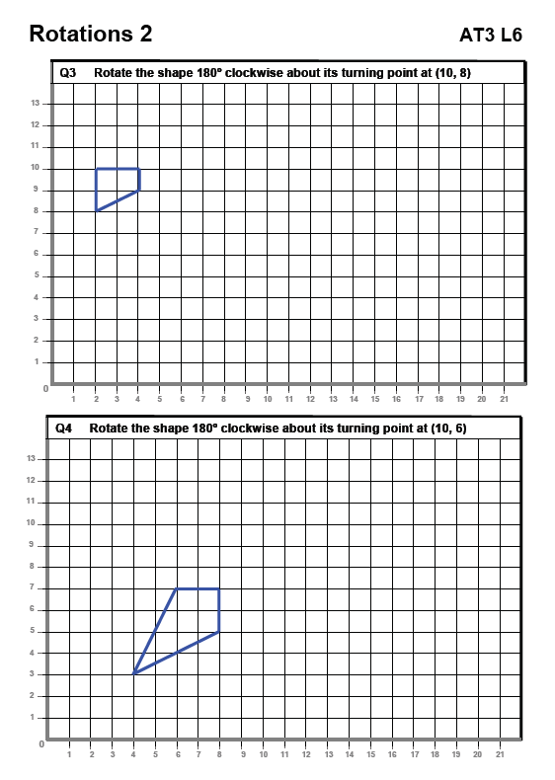
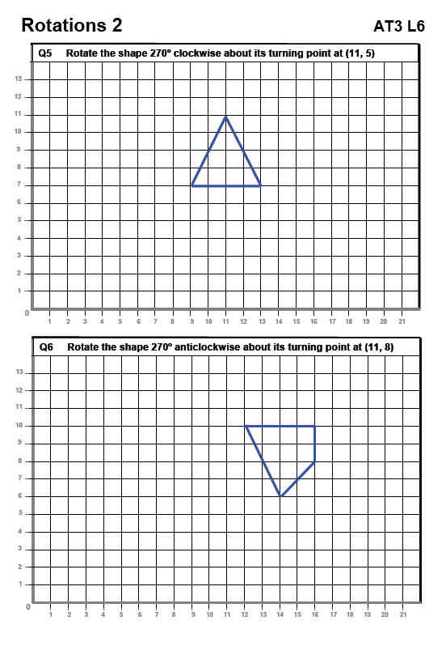
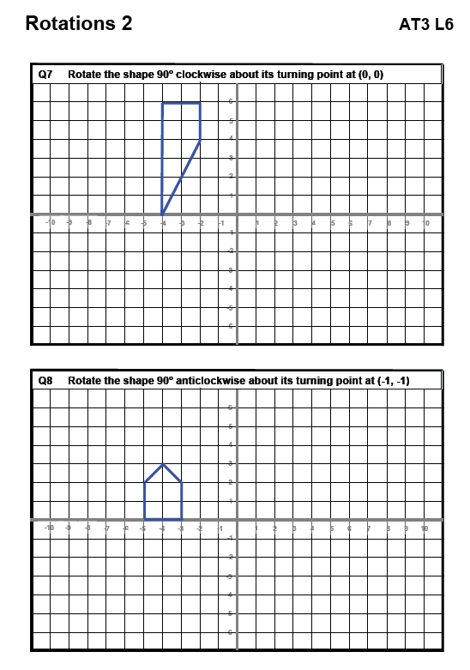
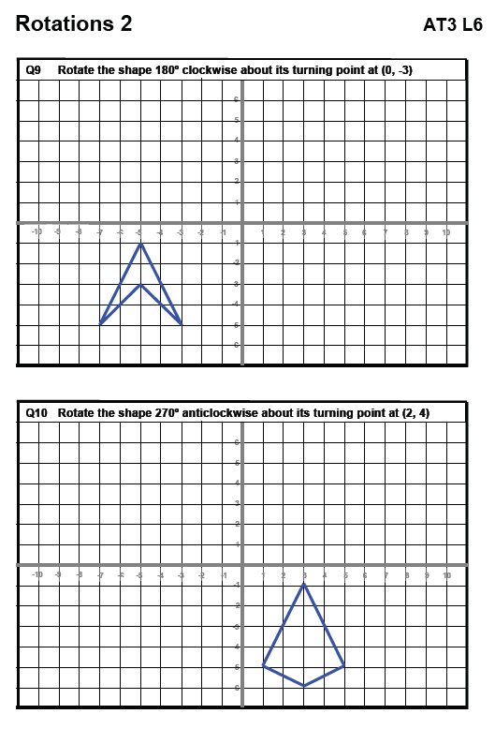
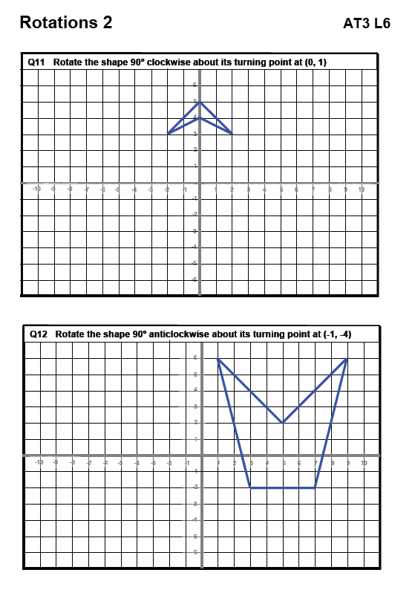
Blank grids for “coded names for the mirror lines” activity – adapt this handout to your needs.
0
-4
-3
-2
-1
-4
-3
-2
- 1
1
2
3
4
1
2
3
4
x
y

0
-4
-3
-2
-1
-4
-3
-2
- 1
1
2
3
4
1
2
3
4
x
y

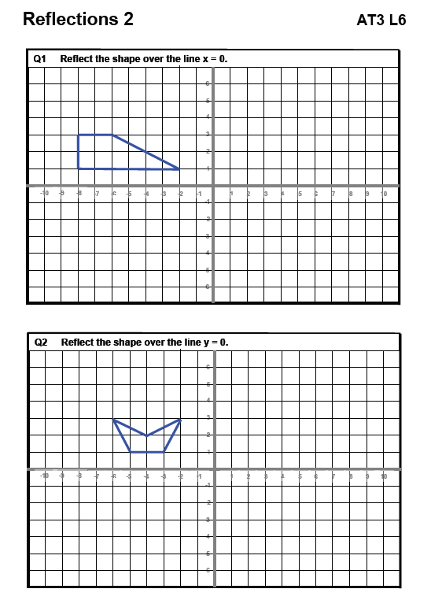
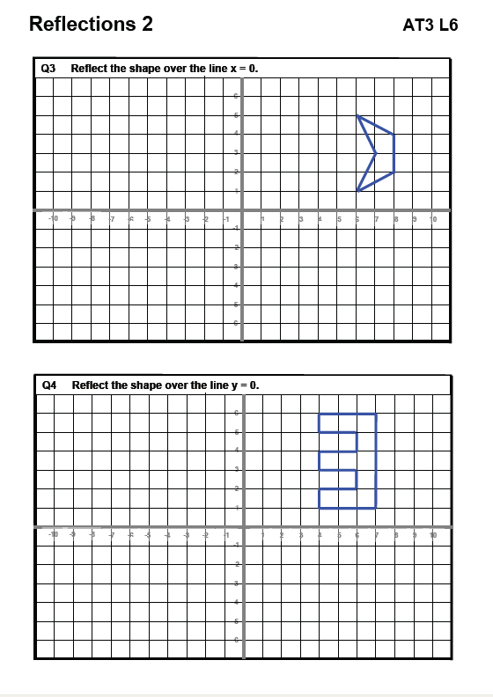
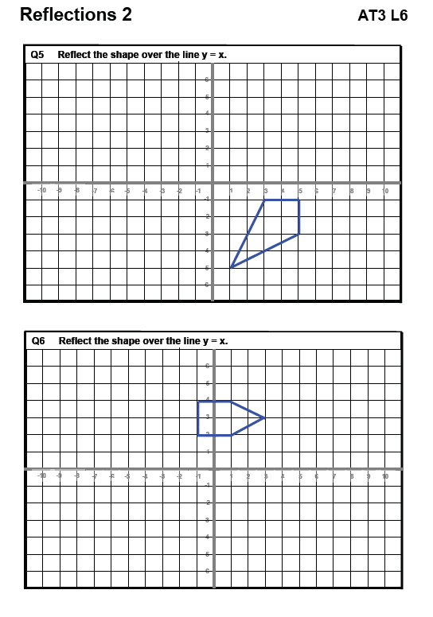
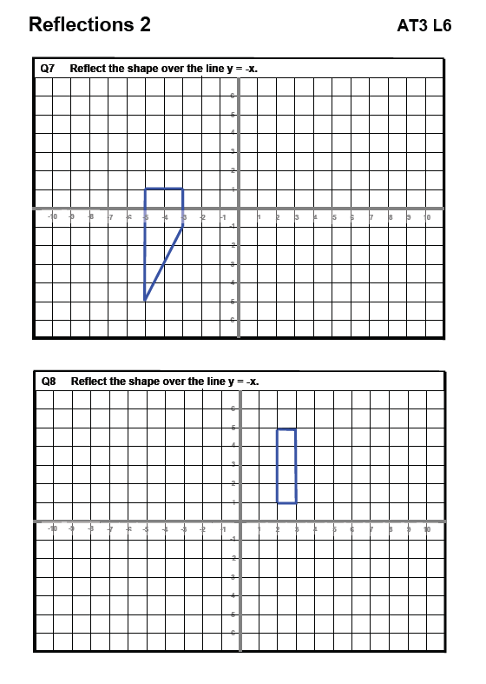
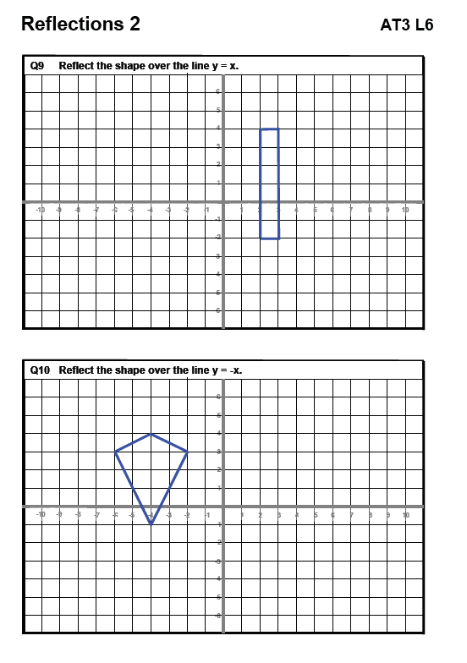
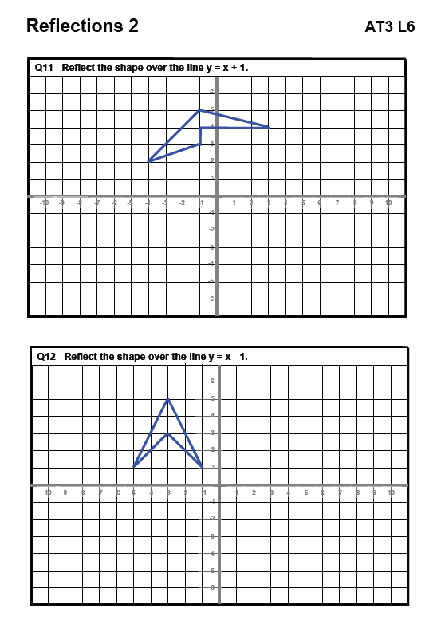

OCR GCSE Methods in Mathematics J926 Unit B391/01

Number – Primes; Prime Factors; LCM and HCF
OCR recognises that the teaching of this qualification will vary greatly from school to school and from teacher to teacher. With that in mind this lesson plan is offered as a possible approach but will be subject to modifications by the individual teacher.
Lesson length is assumed to be one hour.

Learning Objectives for the Lesson
Objective 1 | To understand the importance of the counter-example in mathematics
Objective 2 | To break down any number into a product of prime factors
Objective 3 | To use prime factors to find the HCF of two numbers developing to LCM
Objective 4 | PLTS – Team workers, effective participators, creative thinkers

Recap of Previous Experience and Prior Knowledge
Students will have a basic understanding of primes; factors and multiples through previous work.

Content
Time | Content
10-15 minutes | Starter activity – series of questions about primes and factors to familiarise with terminology and develop idea of a counter-example.  Mini plenary to discuss issues and solutions.
15 minutes | Teacher exposition on methodology for breakdown of numbers into prime factors and recording as products. Use NLVM site Factor Tree - NLVM and encourage factor tree approach – involve students in exposition.  Encourage use of index notation at this stage in the products.  Notes for notebook with a couple of examples to try.
20–25 minutes | Development – work in pairs on Tarsia puzzle (see link below) to consolidate writing numbers as a product of primes – PLTS objectives on team work, leadership and perseverance also developed.  Extension activity is for more able students to access MyMaths.co.uk MyMaths.co.uk - HCF and look at the lesson on highest common factors – which develops on this understanding of prime factors.  The NVLM applet will also develop the prime factors work to HCF and LCM – select the 2 option. Practice questions can be provided from endorsed text.

Time | Content
10 minutes | Plenary – students demonstration of learning – use examples from the puzzle. Key questions and AFL.  Next lesson – HCF/LCM using prime factors – extend to 3 values.
Starter
Work in pairs.
Decide which of the following statements are true – give a reason for your answer – try to find an example that does not fit the statement.
- All multiples of 6 are even
- There are 5 factors of 20
- A number squared is always even
- All prime numbers are odd
- All odd numbers are prime
- One is a prime number
- Prime numbers have only two factors.
Tarsia software can be downloaded for free from www.emaths.co.uk/tarsia.htm . Tarsia allows you to create your own puzzles, including jigsaws, dominoes and card sorting activities.

OCR GCSE Methods in Mathematics J926 Unit B391/01

Handling Data – Probability and Relative Frequency
OCR recognises that the teaching of this qualification will vary greatly from school to school and from teacher to teacher. With that in mind this lesson plan is offered as a possible approach but will be subject to modifications by the individual teacher.
Lesson length is assumed to be one hour.

Learning Objectives for the Lesson
Objective 1 | Understand that repeating an experiment can result in different outcomes
Objective 2 | Understand that increasing sample size leads to more reliable results
Objective 3 | Compare experimental data to theoretical probabilities. Know the meaning of relative frequency
Objective 4 | Work collaboratively on an experiment, gathering, representing and drawing conclusions from data

Recap of Previous Experience and Prior Knowledge
Students will have prior knowledge that probabilities can be represented as fractions, decimals or percentages.

Content
Time | Content
10 minutes | Introduction/Starter (see below) – simple probabilities quiz to revise prior learning and address any misconceptions. Which probabilities can be given exactly? How can the others be found or estimated?
10-15 minutes | Teacher exposition – set up Drawing pin experiment (see below) and base it on question 7 of the Starter and the discussion from the Starter. Allow only 10 minutes initially. Students work in pairs and are provided with 10 drawing pins each. Task is to find the probability of a drawing pin landing pin up when it is dropped. Allow free choice for pairs on how they do this.
10 minutes | Feedback on results.  Key questions:  - How did you record your results?  - How reliable are your results?  - How many times does the experiment need to be done?  - Will your answer be the same as everyone else’s?  Refine the experiment now. Discuss a writing/recording framework eg tabulate results, show the stages, keep a running total, graph of the staged results.  Define the term RELATIVE FREQUENCY as experimental probability.
15 minutes | Use the refined model to repeat the experiment – short plenary after 15 minutes.
10 minutes | Guess the colour of the counters (see below) – fun experiment linked to previous work.  This activity is likely to run over and next lesson could begin with a review of the key points from this lesson.  Homework to consider the Sample examination questions (see below) – introduce the term bias.  OR use NRICH PUZZLE – three spinners nrich.maths.org :: Mathematics Enrichment :: Three Spinners
Starter
Find the probabilities of
1 Rolling the number 1 on a fair dice.
2 Picking a red disc from a bag with 5 red discs, 4 blue discs and one green disc.
3 Picking an ace from a pack of 52 cards.
4 Flipping 2 coins and have both land on heads.
5 A red car passes the school in the next 5 minutes.
6 It will rain tomorrow.
7 Dropping a drawing pin and it landing pin up.
Drawing pin experiment
After initial free choice for drawing pin experiment:
Suggest refined model for drawing pin experiment – hopefully these points will come out of the mini-plenary.
Tabulate results – template could be provided.
Number of trials | 10 | 20 | 30 | 40 | 50 | 60 | 70 | 80 | 90 | 100
Pin-up
Probability/relative frequency
Decimal value
Graphing the results – could provide the template again – leave the students to scale.
Relative Frequency
Ask students to make two observations about the graph and to try to answer the question.
The best estimate of the probability of the drawing pin landing pin up occurs after _______ throws,
because _______________________________________________________________________

Number of trials
Guess the colour of the counters
Students work in pairs.
One student selects 10 counters of 3 different colours to be placed in an envelope eg 7 red, 2 yellow, 1 green.
Other student has to deduce the colour of the counters by experiment.
Rules
You may draw one counter at a time only.
You can do this as many times as you wish.
You have one guess only and you score:
10 points for guessing all numbers of colours correctly
3 points for guessing one number of colour correctly
Swap over with partner.
Sample examination questions
1 A record was kept of a train’s arrival times for one month.
Here are the results.
Arrival | more than 5 minutes early | up to 5 minutes early | on time | up to 5 minutes late | between 5 and 10 minutes late | more than 10 minutes late
Frequency | 1 | 3 | 12 | 9 | 4 | 2

What is the experimental probability that the train will be on time?

_________________ [2]
2 Randeep makes a spinner numbered from 1 to 4.
To test the spinner, he spins it 200 times.
Here are his results.

Number | 1 | 2 | 3 | 4
Frequency | 49 | 77 | 22 | 52

(a) Is the spinner fair?
Explain your answer.
____________ because ________________________________________________________
__________________________________________________________________________ [2]

(b) Use the table to estimate the probability of getting
(i) 2,
(b)(i)_________________ [1]
(ii) an odd number.
(ii)_________________ [2]
3 Paul has a spinner numbered 1, 2, 3, 4 and 5.

He spins it 300 times and records the numbers the spinner lands on.
His results are shown in the table.

Number | 1 | 2 | 3 | 4 | 5
Frequency | 79 | 53 | 22 | 109 | 37

(a) Use the table to estimate the probability that the spinner lands on 4.

(a)_________________ [2]

(b) Paul says ‘The results show that the spinner is biased.’
Is he correct?
Explain your answer.

____________ because ________________________________________________________
__________________________________________________________________________ [2]

4 (a) Mike has a biased six-sided dice.
The relative frequency of the dice showing the numbers 1 to 5 is given in this table.

Number on dice | 1 | 2 | 3 | 4 | 5 | 6
Relative frequency | 0·15 | 0·25 | 0·18 | 0·12 | 0·10

(i) Complete the table.
[2]

(ii) Mike is going to throw the dice 400 times.
About how many times would he expect the dice to show a 2?

(a)(ii)_________________ [1]

(b) Mary has an ordinary, unbiased six-sided dice.
Whose dice is more likely to show a 5?
Explain your answer.

____________ dice is more likely to show a 5 because_____________________________
_____________________________________________________________________________
__________________________________________________________________________ [2]

