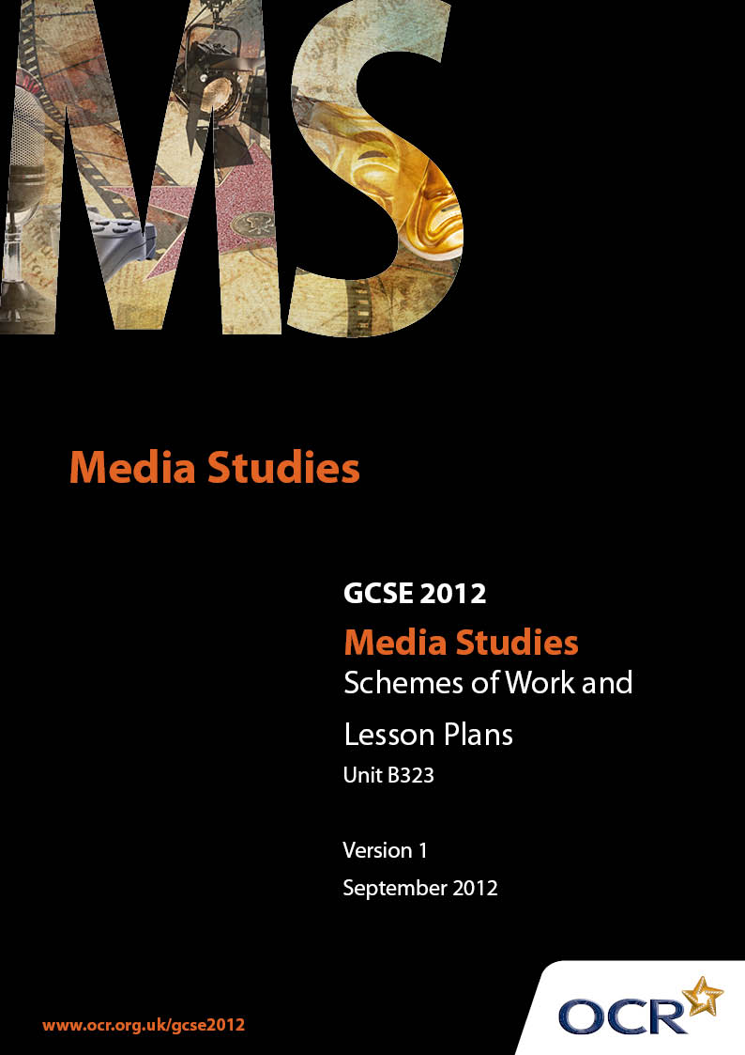

Contents
Introduction 3
Sample Scheme of Work: OCR GCSE Media Studies J526 Unit B323:
Textual Analysis and Media Studies Topic (Print) 5
Sample Lesson Plan: OCR GCSE Media Studies J526 Unit B323:
Textual Analysis and Media Studies Topic (Print) 23

Introduction

Background
Following a review of 14 – 19 education and the Secondary Curriculum Review, the Qualifications and Curriculum Authority (QCA) has revised the subject criteria for GCSEs, for first teaching in September 2009. This applies to all awarding bodies.
The new GCSEs have more up-to-date content and encourage the development of personal, learning and thinking skills in your students.
We’ve taken this opportunity to redevelop all our GCSEs, to ensure they meet your requirements. These changes will give you greater control of assessment activities and make the assessment process more manageable for you and your students. Controlled assessment will be introduced for most subjects.
From September 2012 assessment tasks may be undertaken at any point between release of the task and the examination series for which the task must be submitted. Centres must ensure that candidates undertake a task that is valid for submission in the year in which the candidate intends to submit it.

OCR has produced a summary brochure, which summarises the changes to Media Studies. This can be found at www.ocr.org.uk, along with the new specification.
In order to help you plan effectively for the implementation of the new specification we have produced these Schemes of Work and Sample Lesson Plans for Media Studies. These Support Materials are designed for guidance only and play a secondary role to the Specification.

Our Ethos
OCR involves teachers in the development of new support materials to capture current teaching practices tailored to our new specifications. These support materials are designed to inspire teachers and facilitate different ideas and teaching practices.
Each Scheme of Work and set of sample Lesson Plans is provided in Word format – so that you can use it as a foundation to build upon and amend the content to suit your teaching style and students’ needs.
The Scheme of Work and sample Lesson plans provide examples of how to teach this unit and the teaching hours are suggestions only. Some or all of it may be applicable to your teaching.
The Specification is the document on which assessment is based and specifies what content and skills need to be covered in delivering the course. At all times, therefore, this Support Material booklet should be read in conjunction with the Specification. If clarification on a particular point is sought then that clarification should be found in the Specification itself.

A Guided Tour through the Scheme of Work

= Innovative Teaching Idea
This icon is used to highlight exceptionally innovative ideas.


= ICT Opportunity
This icon is used to illustrate when an activity could be taught using ICT facilities.

OCR GCSE Media Studies J526 Unit B323: Textual Analysis and Media Studies Topic (Print)
Suggested teaching time | 28 hours | Topic | Textual analysis and media studies topic
Topic outline |  | Suggested teaching and homework activities |  | Suggested resources | Points to note
Genre (8 hours)  conventions |  | - Explain meaning of genre. Use examples from range of media.  - Using a selection of consumer magazines (or print outs of various front covers) ask small groups to categorise them by putting them into groups. Discuss how those decisions were made. Expect categories that are divided by target audience, format, publication frequency as well as genre  - Idea is to show that there are obvious categories like sport, gossip, homes and interiors etc  - In groups of 2/3 thought-shower what has to be in the magazines in order for them to be in a particular category  - Class feeds back and lifestyle magazines are focused upon.  - Using either several copies of the text, or copies of the contents page, ask students to complete a learning grid that looks at the conventions of a lifestyle magazine.  - They should identify which articles correspond with each convention.  - Create a contents page that has a selection of articles that fulfil the conventions of a lifestyle magazine. |  | Copies of:  - Homes and Garden, House and Home, Amateur Gardener ,Match, Kingpin, Bike, Redline, Custom PC, Gamesmaster, Kerrang, Arena, Company, Red, Essentials, Men’s Health, Esquire and GQ etc..  - Major lifestyle magazine publishing companies:  - www.ipcmedia.com  - www.natmags.co.uk  - www.condenast.co.uk (useful media packs on its publications including GQ and Vogue)  - www.emap.com  - www.magforum.com has an extensive list of magazines and case studies of various genres.  - Copies of several months’ editions or photocopies of contents pages from Company, She, Esquire and GQ magazines needed.  Worksheet with lifestyle generic topic headings will be needed:  - Celebrity  - Fashion  - Health  - Beauty  - Sex  - Advice  - Astrology  - Fiction | - A large selection of publications (not just lifestyle magazines), for the students to analyse and use as research material, will be needed for this and other sections of the SOW. Students could bring in examples of publications and build up the resource.  - www.magazineweek.net/browse/search  - Has a drop down menu that includes lifestyle as a topic choice.  - www.mediaedu.co.uk/magazines /researchactivites.php  is an excellent research activity  - www.mediaedu.co.uk  is an excellent site for student friendly information on magazines.  - ‘The Language of Magazines’ by Linda McLoghlin. Routledge pg 28 has a useful list of Marie Claire’s contents page structure.
How conventions are shared with other texts |  | - Return to the selection of magazines that were originally used. Students analyse the conventions of lifestyle magazines that are in other genres: advice in Gardening magazines, health in Kingpin and extreme sport magazines, fiction in Bike  - If possible, students should explore the websites of some of the magazines and compare the online content with that of the print publication. This should then be expended to examine the similarities of differing genres eg. Teen magazines and lifestyle magazines. ITC |  | - Several copies of different publications needed.  - Similarities chart would be needed that compares features.  Useful teen magazines sites include:  - www.sugarscape.com  - www.blissmag.co.uk | - Caution needs to be exercised in the choice of publication. Several magazines have explicit sexual content: Cosmopolitan, Nuts, Loaded etc and discretion and professional judgement should be used in the selection of texts to be used.
Mixing genres |  | - Teacher led activity on hybridity (mixing of genres: Arena mixes music and fashion, Grazia mixes gossip and fashion). Students suggest possible reasons for this: to broaden audience appeal, to compete in a different market, such as Grazia and weekly gossip magazines  - Students create a new magazine title that mixes genres to illustrate understanding. They could create a synopsis of the magazine’s content/genre status similar to the ones found on www.magforum.com  - Homework – to write up comparison of lifestyle generic conventions with two other existing magazines  - Assessment task: Discuss generic conventions of lifestyle magazines with reference to two titles.  - 20 minutes writing task. |  | - Use copies of Arena and Grazia magazines.  - Comparison chart could be provided as an alternative for differentiation.  - It may be necessary to provide a writing frame for some students that offers bullet points, or even ask questions, to prompt a response. | - Caution needs to be exercised in the choice of publication. Several magazines have explicit sexual content: Cosmopolitan, Nuts, Loaded etc and discretion and professional judgement should be used in the selection of texts to be used.
Media Language (10 hours)  Layout  House style  Symmetrical/asymmetrical  Use of columns and boxes  Ratio of copy/photography/space  Headline  Caption  Strapline  Standfirst |  | - In pairs students make a list of things they would expect to see on the front cover of a particular magazine title like Match, Sugar, Cosmo Girl; a genre of magazine they are likely to read. Students feedback expectations. Teacher led explanation of house style with handout listing elements of a house style.  - Pairs game that asks the students to match pictures of front covers with the titles blanked out. This will require them to spot similarities which will lead to discussion about house style.  - Students play spot the similarity with a selection of several different months/editions of the same magazine. They should be encouraged to see the similarities in the construction of the magazine’s contents pages and editorials. They should also be drawn to observe the way in which the articles use similar fonts, language patterns (metaphors/ similes, colloquialisms) to create consistency.  - ITI students create a ‘jigsaw’ of a front cover. Play with moving elements of the ‘jigsaw’. Ask students to say whether it looks ‘right’? Teacher to lead them to discussion of balance symmetry.  - Students measure up a double page spread. Discuss measurements and size of columns and boxes. Teacher to lead discussion of why regular sizing is necessary in publishing.  - Using the measurements they have taken students use ratio formula to assess Students could then contrast/compare this to a different magazine title.  - Look at differences of text/image /space ratio of GQ and compare to She magazine.  - Students use template to create a mock up of a double page spread. They should demonstrate their understanding of the use of space  - Students will analyse where the headings, captions and straplines are positioned. Previous knowledge, relating to ratio of text, image and space can be applied.  - Students can work in small groups to make connections between the headline, caption and strapline.  - Teacher to give students an article cut into sections. Students can put article together and closer analysis of standfirst can ensue.  Assessment:  - Annotated analysis of the layout of a particular double page article from a lifestyle magazine.  - Allow 20 minutes for this task |  | - The Economist (although not a lifestyle magazine) has a useful style guide that should be adapted for use with GCSE students.  - www.economist.com/research /StyleGuide/  - A worksheet that has some suggestions of headings like; what style would the font be? What sorts of words would you expect on the front cover?  - Several copies of lifestyle magazines of a particular title.  - www.magforum.com has a useful collection.  - Set of pairs cards that are front covers of magazines with the title covered up.  - Several copies of magazines of the same title from different months.  - Create either an online VLE template or photocopy a cover and cut out the different elements of the front cover.  - Double page spread article from a lifestyle magazine photo copied onto A3. Rulers.  - Blank templates (graph paper) will be needed.  - Blank shapes to be provided (similar to the jigsaw) to represent columns, boxes for images etc.  - More able students could create their own.  - Selection of articles from She and Esquire magazines.  - A worksheet will be needed. Perhaps a flow chart that records the connections students make between the articles.  - A selection of articles from Company and Men’s Health.  - Photocopies of a double page article.  - Use A3 copy which allows students to annotate straight onto the article. | - This unit will require some fore planning in the collection of materials; several subscription deals are available. Asking colleagues to save magazines is also useful.  - There are several opportunities to include numeracy objectives in this element of the SOW. Using ratio formula, measurements, column inches etc  - www.journalism.co.uk/36/54/  has a concise glossary of terms.
Typography--  Serif/ sans serif typeface  Specialist typeface  Fontsize/italics/bold |  | - Teacher to introduce the technical terms and definitions.  - Students use word document to change the font style of a chosen heading or strapline and discuss the connotations of the font style. Students can analyse a selection of article headings and discuss connotations of specialist typefacing.  - Same task can be done to illustrate the use of font sizing.  - Connotations of use of italics dicussed as a class, as well as the use of bold type. Use students own practice in texting/email etiquette to prompt discussion.  Assessment:  - Annotated analysis of the layout of a particular double page article from a lifestyle magazine.  - Allow 20 minutes for this task |  | - Power point with some examples of serif and sans serif type face needed.  - Handout with definitions and space for students to add examples.  - Could be a homework task.  - Copies of straplines/headings from a selection of lifestyle magazines.  - Photocopies of a double page article.  - Use A3 copy which allows students to annotate straight onto the article.
Use of language  Formal/ informal register  Direct mode of address  Puns/ colloquialisms/  slang |  | - Analysis of the use of formal and informal register. Students write headlines in a formal and informal style  - Using editorials from lifestyle magazines teacher led activity on direct mode of address;  - Use of personal pronoun, verb usage, etc. Students could then analyse an editorial and then swap with a partner to peer assess their work.  - Students analyse use of puns.  - Pairs work on a cloze exercise that has a range of phrases and words that have a colloquial term.  - Teacher models analysis of front cover.  Assessment:  - Annotated analysis of the use of language on a lifestyle magazine front cover.  - Allow 20 minutes for this task |  | - Students will need an activity sheet based on pg 6-7 ‘The Language of Magazines’ by Linda McLoghlin. Routledge  - Copies of editorials from a variety of magazines: Company, Elle, GQ and Men’s Health etc. needed.  - ‘The Language of Magazines’ by Linda McLoghlin. Routledge pg 74-80 this exercise could be adapted to be accessible for GCSE students  - A selection of headings that illustrate the use of word play in magazines.  - A cloze exercise that has either been created by the teacher or could be done by the more able students.  - PowerPoint presentation or copies of handouts of a front cover to be analysed by class, modelled by teacher.  - Copies of a front cover from Essentials magazine | - ‘The Language of Magazines’ by Linda McLoghlin. Routledge pg 21-24 has a very useful list of linguistic tools that magazines use. An engaging activity could be created using these.  - Caution should perhaps be exercised with some groups seeing a potential to gat carried away with this task! Phrases that have been selected for use by the teacher would be best for some students.
Use of images  Camerawork and mise-en-scène in photography  Depth of field  Digital manipulation  Graphics |  | - Teacher led presentation of mise-en-scène using power point.  - Teacher led deconstruction of a front cover looking at mise-en-scène.  - Students attempt their own analysis of a given front cover.  - Teacher uses same PowerPoint images to discuss use of camera.  - Students apply analysis to their own covers.  - Teacher uses a double page spread article from lifestyle magazine to show depth of field and use of focus. It is also a good point to look at mise-en-scène in more detail, discussing the use of props and scenery/setting as background.  - Once again teacher to lead presentation of digital manipulation techniques. Could start from discussion about the ‘reality’ of some images on front covers and images accompanying articles: flawless skin, slim perfectly proportioned bodies.  - Students also need to analyse a fashion/makeup/product page and discuss use of cropping, selection, filters etc.  - Students look at computer magazines and discuss use of graphics. Pairs can compare use of graphics on front cover of lifestyle magazines. Class discuss use of graphics and connotations of use in different genres.  Assessment:  - Annotated analysis of the use of image on a lifestyle magazine front cover.  - Allow 20 minutes for this task |  | - www.mediaedu.co.uk/magazines /misenscene.php  - PowerPoint will be needed that analyses the different image aspects of a particular front cover.  - Copies of front cover of lifestyle magazine such as She and Esquire.  - ‘The Language of Magazines’ by Linda McLoghlin. Routledge pgs 9-14 has a useful selection of lifestyle magazine front covers and an activity that questions how the image and verbal text interact.  - PowerPoint or booklet of images that illustrate the transformation of an image from the original to the finished, manipulated, stage.  - Photoshop or similar digital manipulation software.  Front cover of Vogue magazine(or similar) | - Key Concepts and Skills for Media Studies V. Clarke, J. Baker, E. Lewis pp18-20 has a glossary of camerawork definitions and illustrations.  - Students should be encouraged to take photographs of themselves using a variety of camera angles/positions.  - Students can take their photographs of themselves and upload them onto a computer. Using Photoshop, or similar image manipulation software they can use the cloning tool, lasso tool.
Use of colour  House style  Colour saturation  Choice of colour |  | - Students create colour connotations chart to illustrate understanding of connotations of colour using ICT.  - Using copies of same magazine titles as students to find the house style in terms of colour. Direct them to note on house style lessons from earlier in SOW  Assessment:  - Annotated analysis of the use of colour on a lifestyle magazine front cover.  - Allow 10 minutes for this task  Assessment:  - Using the extracts provided analyse the use of media language in the following areas.  - Layout  - Typography  - Use of Language  - Use of Images  - Allow 30 minutes for this task. |  | - Colour connotation chart will need to be provided if ICT unavailable  - Copies of several months of editions of She (or similar).  - Several copies of lifestyle magazines of a particular title.  - www.magforum.com has a useful collection.  - Copy of a front cover, the contents page and the editorial letter page of a lifestyle magazine. | - Students could use image manipulation software to play with colour filter on an image of front cover.
Representation (8 hours)  Stereotyping of people, places and/or events  Age ,gender, ethnicity, body types, class, region, nationality.  Anti stereotyping/ subversion  Why social groups are present or absent from the text  Exclusion from group due to stereotyping  Construction of a world that makes sense to an audience  What is valued and celebrated by that world |  | - Teacher puts series of images of people, places and events and invites comments from class about the personality/ common preconceived ideas and stereotyping of the groups.  - Class discuss understanding of the term stereotype. Discuss reasons for why the media use it.  - Teacher to stick pictures from Vogue and Men’ Health magazine on the walls around the room. Students should use the stimuli to create discussion about use of body image in fashion pages of lifestyle magazines.  - Case study in representation using gender to illustrate the ways in which media stereotype.  - Students compare the images used on the front cover of Vogue and She magazine and discuss the representation of body image, looking at differences and the idelolgy of the magazines.  - Different groups can look at a different stereotype and research the representation of those groups within lifestyle magazines. Each group can then present findings to rest of class via PowerPoint, written report, oral presentation. Each group should create a handout for the rest of the class  - Teacher led discussion on subversion/challenging of stereotypes. Include discussion of why social groups are present or absent.  - Students create a new lifestyle magazine title that challenges stereotypes.  - Analysis of construction of a world: using knowledge of media language draw conclusions about the ideology of a specific lifestyle magazine. Compare students’ observations with the magazine’s rationale.  - Homework: design a front cover for the new magazine clearly showing the ideology through media language choice.  Assessment:  - Using the extracts for reference discuss the representations of males/females/ethnicity/different body types/nationality (delete as appropriate) and how they have been created.  - Allow 30 minutes for this task. |  | - A PowerPoint or booklet of still images will be needed. Choose a range of images that relate to the different representative groups.  - Images from Vogue and Men’s Health  - Worksheets could be adapted from this unit: ‘The Language of Magazines’ by Linda McLoghlin. Routledge unit 7  - Copies of She magazine.  - Copies of Vogue  - www.ebonyjet.com  - www.marieclaire.co.uk  - www.northernlife.co.uk  - Instructions on requirements for presentation, a writing frame may be needed.  - Use profile of Esquire reader from www.condenast.co.uk  - (useful media packs on its publications including GQ and Vogue)  - www.magforum.com has a selection of magazine rationales.  - Copy of a front cover, the contents page and the editorial letter page of a lifestyle magazine. | - www.magazineweek.net/browse/search  - Has a drop down menu that includes lifestyle as a topic choice.  - Daniel Chandler’s site www.aber.co.uk/media has some interesting articles on representation, but only for information and adaptation as it is a university site and of a higher order than is necessary for GCSE .  This task can be repeated with extracts from different magazines to explore the representation of different groups:  - Gender – GQ/Men’sHealth/Esquire/Red  /Marie Claire  - Age – She/Cosmopolitan/Woman’sOwn  - Ethnicity – Ebony  - Body types - She/Vogue  - Region – Any regional lifestyle magazine  - Class – Vogue/More  - Nationality – This England

OCR GCSE Media Studies J526 Unit B323: Textual Analysis and Media Studies Topic (Print)

Investigating generic conventions of Lifestyle Magazines
OCR recognises that the teaching of this qualification above will vary greatly from school to school and from teacher to teacher. With that in mind this lesson plan is offered as a possible approach but will be subject to modifications by the individual teacher.
Lesson length is assumed to be one hour.

Learning Objectives for the Lesson
Objective 1 | To gain knowledge and understanding of generic conventions in lifestyle magazines
Objective 2 | To analyse lifestyle magazine content pages for generic conventions.
Objective 3 | To explore how generic conventions are applied in different lifestyle magazine titles.

Recap of Previous Experience and Prior Knowledge
- This is the second lesson in this unit. Students have understood the concept of genre within magazines and have seen some examples of various titles within the genre of lifestyle magazines.

Content
Time | Content
5 minutes | Starter: Prediction exercise. Students brainstorm ideas of what they think are the generic conventions of a lifestyle magazine onto IWB (or large piece of paper).
10 minutes | Teacher introduces task: to analyse generic conventions of lifestyle magazines.  Teacher shares list with class compare with class predictions.  Discussion of expectations and any differences between the lists.  Use list adapted from ‘The Language of Magazines’ by Linda McLoghlin. Routledge pg 28 and information from www.mediaedu.co.uk to show students the generic conventions of lifestyle magazines.
15 minutes | Students to work in pairs.  Using worksheet with lifestyle generic topic headings Celebrity/Fashion/Health/Beauty/Sex/Advice/Astrology/Fiction students sort contents page listings from a selection of magazines into different conventions.  Different groups could be given different magazines titles to analyse.
10 minutes | Pairs join up and share analysis with another pair.
5 minutes | Feedback to class. Discuss how contents pages of different lifestyle magazines share generic conventions.

Consolidation
Time | Content
10 minutes | Create a contents page that has a selection of articles that fulfil the conventions of a lifestyle magazine.
5 minutes | Class shares pages in a peer assessment exercise.

