Revision Topic 6: Loci and Constructions

Constructions
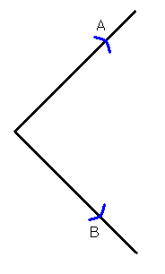
Bisecting an angle

N.B. To bisect an angle means to cut it in half.

(1) Use your compasses to mark points A and B which are the same distance from the point (or vertex) of the angle.

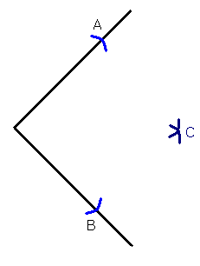

(2) Without changing the settings of the compasses, put the compass point on A and draw an arc in the middle. Then put the compass point on B and draw an arc in the middle which crosses the first.

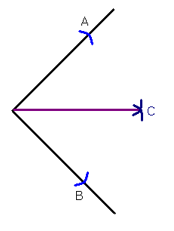
(3) This new point C will be in the middle of the angle. So we can draw a line from the point of the angle to C and we will have split the angle in two.

Perpendicular bisector of a line
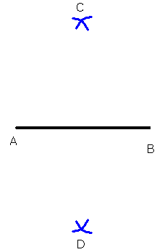
A line which cuts a straight line in half at right angles is called a perpendicular bisector.

(1) Draw a line AB.

(2) Open your compasses to just over half the distance of the length AB.

(3) Put your compasses on A and draw an arc above and below the line. Then put your compasses on B and draw more arcs above and below the line. These arcs will cross over at two points C and D.

(4) Join up points C and D with a straight line. This is then the perpendicular bisector of the line AB.

Constructions such as bisecting angles or lines can be used for making scale drawings where conditions have to be met.
Example
A water tap is to be put in a garden
but it must meet these conditions:
1. It must be the same distance
from the two greenhouses, A and
B.
2. It must be the same distance from
the grape line wires as from the
Greenhouse
hedge.
Where must the tap be placed?

To meet condition 1 you
draw the perpendicular
bisector of the line BA.
This line is the locus of
all points equidistant from
B and A.
To meet condition 2 you
bisect the angle BAD.
This line is the locus of all points that are equidistant from the lines BA
and AD.

Where the two loci intersect
Tap
Both conditions are met, so
the tap must be at this point.

Examination Question 1: A B
The diagram shows a rectangular field ABCD.
The side AB is 80m long.
The side BC is 50m long.
Draw the diagram using a scale of 1cm to 10m.
Treasure is hidden in the field.
D C
a) The treasure is equidistant from the sides AB and
AD. Construct the locus of points for which this is true.
b) The treasure is 60m from corner C. Construct the locus of points for which this is true.
c) Mark with an X the position of the treasure.

Examination Question 2:
The map shows an island with three main towns, Alphaville, Betaville and Gammaville.
The map is drawn to a scale of 1 cm: 10 km.
A radio transmitter is to be installed.

Scale 1cm : 10km

Gammaville
x

x
Alphaville

x Betaville

The transmitter must be equidistant from Alphaville and Betaville.
The transmitter must be between 35km and 50 km from Gammaville.
Mark on all the possible sites that the transmitter may be drawn.

Examination Question 3:
Draw the locus of all points that are 2.5 cm away from the line AB.

A B

Examination Question 4:
On the diagram, draw the locus of the points outside the rectangle that are 3cm from the edge of this rectangle.

Points to remember

* To construct an angle of 90 degrees, draw a line and construct its perpendicular bisector. By bisecting this angle you can construct an angle of 45 degrees.

* To construct an angle of 60 degrees, construct an equilateral triangle. By bisecting this angle you can construct an angle of 30 degrees.

* When you are asked to construct something, do not rub out the construction lines.

Examination Question 5.
The diagram shows a penguin pool at a zoo. It consists of a right-angled triangle and a semi-circle.
The scale is 1 cm to 1 m.
A safety fence is to be put up around the pool. The fence is always 2m from the pool. Draw accurately the position of the fence on the diagram.

Examination Question 6:
Two straight roads are shown on the diagram.
A new gas pipe is to be laid from Bere equidistant from the two roads.
The diagram is drawn to a scale of 1cm to 1 km.
a) Construct the path of the gas pipe on the diagram.
b) The gas board needs to construct a site depot. The depot must be equidistant from Bere and Cole. The depot must be less that 3 km from Alton. Draw loci on the diagram to represent this information.
c) The depot must be nearer the road through Cole than the road through Alton. Mark on the diagram, with a cross, a possible location for the site depot that satisfies all these conditions.

Alton o

o
Cole
Bere

