Revision Topic 18: Trigonometry

Trigonometry connects the length of sides and angles in right-angled triangles.

Some important terms
Opposite O
In a right-angled triangle, the side opposite the right angle is called the hypotenuse. The hypotenuse is the longest side in a right-angled triangle.
Hypotenuse H
The side opposite the angle of interest is called the opposite.
x
The third side (which is next to the angle of interest) is called the adjacent.
Adjacent A

Sin, cos and tan
Three important formulae connect the lengths of O, A and H with the angle x:

$\text{sin}x=\frac{O}{H}$ $\text{cos}x=\frac{A}{H}$ $\text{tan}x=\frac{O}{A}$.

You need to learn these formulae! It sometimes helps to remember them as SOHCAHTOA.

Finding an angle
Trigonometry can be used to find angles in right-angled triangles.

Example 1:  x  14 cm  H  10 cm A  O  Start by labelling the triangle H, O and A.  We then have to decide whether to use sin, cos or tan  SOHCAHTOA  Since we know the values of A and H, we use cos:  $\begin{aligned}\text{cos}x=\frac{A}{H} \\ \text{cos}x=\frac{\text{10}}{\text{14}}=0\text{.}\text{7143}\end{aligned}$  To find the angle x, you have to press SHIFT cos 0.7143.  You get:  x = 44.4˚  Note: Write down several calculator digits in your working. | Example 2:  20 cm A  x  9cm  H O  We start by labelling the triangle.  This time we will need to use tan as we know O and A:  SOHCAHTOA  $\begin{aligned}\text{tan}x=\frac{O}{A} \\ \text{tan}x=\frac{9}{\text{20}}=0\text{.}\text{45}\end{aligned}$  To find angle x, you press SHIFT tan 0.45.  You get:  x = 24.2˚ | Example 3:  11.2m  H 7.3 m  O  θ  A  The triangle is labelled H, O and A.  Because we know O and H, we need to use sin this time:  SOHCAHTOA  So,  $\begin{aligned}\text{sin}θ=\frac{O}{H} \\ \text{sin}θ=\frac{7\text{.}3}{\text{11}\text{.}2}=0\text{.}\text{6518}\end{aligned}$  To recover angle θ, you press SHIFT sin 0.6518.  The answer is:  θ = 40.7˚.
Examination Question 1:
A
x
Calculate the angle marked x.
Give your answer correct to one decimal place.

12 m 15m

B C
Examination Question 2:
B
x
Work out the size of the angle marked x.
20 m

A 30 m C

Finding a side
Trigonometry can also be used to find sides in right-angled triangles if you know one of the angles.

Example 1:  37˚  24 cm  H  A  xcm  O  Start by labelling the triangle H, O and A.  We then have to decide whether to use sin, cos or tan  SOHCAHTOA  Since we want to find O and we know H, we use sin:  $\begin{aligned}\text{sin}\text{37}=\frac{O}{H} \\ \text{sin}\text{37}=\frac{x}{\text{24}} \\ 0\text{.}\text{6018}=\frac{x}{\text{24}}\end{aligned}$  So, x = 24 × 0.6018 = 14.4 cm.  Remember to put a unit on the answer!! | Example 2:  6.8 cm A  65˚  xcm  H O  We start by labelling the triangle.  This time we will need to use tan as we know A and want O:  SOHCAHTOA  $\begin{aligned}\text{tan}\text{65}=\frac{O}{A} \\ \text{tan}\text{65}=\frac{x}{6\text{.}8} \\ 2\text{.}\text{1445}=\frac{x}{6\text{.}8}\end{aligned}$  So, x = 2.1445 × 6.8 = 14.6 cm. | Example 3:  0.85 m  H O  52˚  y A  The triangle is labelled H, O and A.  Because we know H and want A, we need to use cos this time:  SOHCAHTOA  So,  $\begin{aligned}\text{cos}\text{52}=\frac{A}{H} \\ \text{cos}\text{52}=\frac{y}{0\text{.}\text{85}} \\ 0\text{.}\text{61566}=\frac{y}{0\text{.}\text{85}}\end{aligned}$  So,  y = 0.85 × 0.61566 = 0.523 m.

Examination Question 3:
R Angle Q = 90 degrees, angle P= 32 degrees and PR = 2.6 m.
2.6 cm Calculate the length of QR. Give your answer in metres to 3 significant figures.
32˚

P Q
C

Examination Question 4:
Triangle ABC is shown on the right.
a) Calculate the length of the side BC.
b) Calculate the length of the side AC.
69˚

A 6cm B

Finding the length of sides (continued)
Some side lengths are harder to calculate – they appear on the denominator of the fractions.
Consider the following example:

Example:
40˚
Find the length x cm in this triangle:
A x cm
SOHCAHTOA 18cm H

O
The triangle is labelled H, O and A as normal. Since we know A and want to find H we use cos.
$\text{cos}\text{40}=\frac{A}{H}\text{so}\text{cos}\text{40}=\frac{\text{18}}{x}\text{so}0\text{.}\text{7660}=\frac{\text{18}}{x}$
The side we wish to find appears on the denominator. There are two methods that we could use to find the value of x:

Method 1:  Write both sides as fractions: $\frac{0\text{.}\text{7660}}{1}=\frac{\text{18}}{x}$  Invert both sides: $\frac{1}{0\text{.}\text{7660}}=\frac{x}{\text{18}}$  Work out the left hand side: 1.305 = $\frac{x}{\text{18}}$  Therefore x = 18 × 1.305 = 23.5 cm | Method 2:  Rearrange the equation by first getting rid of the fraction (multiply by x): x × 0.7660 = 18  Get x on its own by dividing by 0.7660:  $x=\frac{\text{18}}{0\text{.}\text{7660}}=\text{23}\text{.}5$cm.

We can check our answer – since we are finding the hypotenuse, it should be the longest side in the triangle.
Example 2:
C
Calculate the length of AB.

We need to use tan: SOHCAHTOA
$\text{tan}\text{39}=\frac{\text{Opp}}{\text{Adj}}$
$\begin{aligned}\text{tan}\text{39}=\frac{\text{12}\text{.}5}{x} \\ 0\text{.}\text{8098}=\frac{\text{12}\text{.}5}{x}\end{aligned}$
As x appears on the bottom, we need to use one of the methods used in the previous example.
Eg:
$\begin{aligned}\frac{1}{0\text{.}\text{8098}}=\frac{x}{\text{12}\text{.}5} \\ \text{So}, x=\text{12}\text{.}5×\frac{1}{0\text{.}\text{8098}}=\text{15}\text{.}4\text{cm}\end{aligned}$

12.5cm Hyp
Opp

39˚

A Adj B

Examination Question 5:
The triangle ABC has a right angle at B. B 8.3 cm C
Angle BAC = 50 degrees and BC = 8.3 cm.
Calculate the length of AC.

50

A

Examination Question 6:
B
6cm

8cm C

40˚

A D

ABCD is a quadrilateral. Angle BDA = 90˚, angle BCD = 90˚, angle BAD = 40˚.
BC = 6 cm, BD = 8cm.
a) Calculate the length of DC. Give your answer correct to 3 significant figures. [Hint: use Pythagoras’ theorem!]
b) Calculate the size of angle DBC. Give your answer correct to 3 significant figures.
c) Calculate the length of AB. Give your answer correct to 3 significant figures.
Trigonometry: Harder Questions:

Example:
B
16.4 cm
AB = 19.5 cm, AC = 19.5 cm and BC = 16.4 cm.
Angle ADB = 90 degrees.
BDC is a straight line.
Calculate the size of angle ABC. Give your answer correct to 1 decimal place.
19.5 cm

D A

19.5 cm

C

Because triangle ABC is isosceles we can just consider the top triangle BDA. Length BD would be half of 16.4 cm, i.e. 8.2 cm.
B
x
8.2 cm 19.5 cm H
A

D O A

Examination Question 7:
$$\begin{aligned}\text{cos}x=\frac{A}{H} \\ \text{cos}x=\frac{8\text{.}2}{\text{19}\text{.}5}=0\text{.}\text{4205} \\ x=\text{SHIFT} \text{cos} 0\text{.}\text{4205}=\text{65}\text{.}1^{∘}\end{aligned}$$

C

148 cm
AB and BC are two sides of a rectangle.
AB = 120 cm and BC = 148 cm.
D is a point on BC.
Angle BAD = 15 degrees.

Work out the length of CD. Give your answer to the nearest centimetre.
D

15˚

A 120cm B
Trigonometry and Bearings

Recall that bearings measure direction. They are angles that are measured clockwise from a north line. Bearings have three digits.

Example:
The diagram shows the path of a jet-ski from P to Q to R.

Q 160˚
700m

500m
P

R
N
Q is 700m from P on a bearing of 070 degrees.

R is 500m from Q on a bearing of 160˚.

Calculate the bearing of P from R.

N

070˚

First it is important to realise that triangle PQR is a right-angled triangle (with the right angle at Q):
The blue angles are alternate (Z angles) so are equal.
The red angles add up to 180 degrees as they make a straight line.
Therefore angle Q is a right angle.

Q 160
700m 70 20

70 500m

20
P x
R
We can therefore find angle x using trigonometry:
$\begin{aligned}\text{tan}x=\frac{O}{A}=\frac{\text{700}}{\text{500}}=1\text{.}4 \\ x=\text{SHIFT} \text{tan}1\text{.}4=\text{54}\text{.}{\text{46}}^{∘}\end{aligned}$
The angle of P from R is the clockwise angle measured from R to P. It is
360˚ - 20 - 54.46 = 285.54˚.
So the bearing is 286˚ (to nearest degree).

Examination Question
Ballymena is due west of Larne.
Woodburn is 15 km due south of Larne.
Ballymena is 32 km from Woodburn.
a) Calculate the distance of Larne from Ballymena, correct to 1 decimal place.
b) Calculate the bearing of Ballymena from Woodburn.
Ballymena Larne

N
32 km 15 km

Woodburn
Angle of elevation

Worked examination question
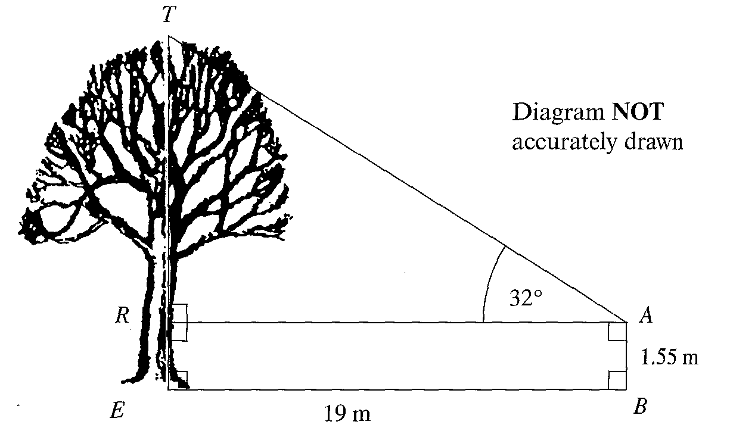
Abbi is standing on level ground, at B, a distance of 19 metres away from the foot E of a tree TE.
She measures the angle of elevation of the top of the tree at a height of 1.55 metres above the ground as 32˚.
Calculate the height TE of the tree. Give your answer correct to 3 significant figures.

Solution:
First find the length TR using trigonometry, specifically using tan:
$\begin{aligned}\text{tan}\text{32}=\frac{O}{A}=\frac{\text{TR}}{\text{19}} \\ 0\text{.}\text{6249}=\frac{\text{TR}}{\text{19}} \\ \text{TR}=\text{19}×0\text{.}\text{6249}=\text{11}\text{.}\text{87} \text{metres}\end{aligned}$
So, to get the height of the tree you need to add Abbi’s height to this distance.
Therefore, height of tree = 11.87 + 1.55 = 13.4 metres (to 3 s.f.)

