Revision Topic 16: Statistics 2

Time Series and Moving Averages

A time series is a set of readings taken at time intervals.
Time series measurements can be plotted on a line graph – this can be used to see if there are any seasonal variations.
Moving averages can be calculated to smooth out the seasonal variations so that trends can be spotted.

Example:
The table shows the number of units of electricity used each quarter by a householder over a period of 3 years.

Year | 1999 |  |  |  | 2000 |  |  |  | 2001
Quarter | 1 | 2 | 3 | 4 | 1 | 2 | 3 | 4 | 1 | 2 | 3 | 4
Units used | 680 | 810 | 470 | 740 | 640 | 850 | 420 | 750 | 970 | 880 | 490 | 760

a) Plot these values on a line graph.
b) Calculate a 4-point moving average.
c) Plot the moving averages on your line graph. Draw in the trend line.
d) Comment on the trend in the units of electricity used.

Solution:
a)
First moving average plotted over the middle of the interval to which it corresponds
Q1 Q2 Q3 Q4 Q1 Q2 Q3 Q4 Q1 Q2 Q3 Q4
b) The first 4-point moving average is calculated as the mean of the 4 values from 1999. The mean of 680, 810, 470 and 740 is 675.
The second 4-point moving average is calculated as the mean of the Q2, Q3 and Q4 values from 1999 and the Q1 value from 2000. The mean of 810, 470, 740 and 640 is 665.
The 3rd 4-point moving average is the mean of Q3 and Q4 from 1999 and Q1 and Q2 from 2000. This moving average is 675.

Units used | 680 | 810 | 470 | 740 | 640 | 850 | 420 | 750 | 970 | 880 | 490 | 760

Moving average 675 665 675 662.5 665 747.5 755 772.5 775

c) The moving averages have been added to the graph in (a). Each moving average is plotted above the middle of the interval from which it was calculated. The trend line is drawn through the middle of the points.

d) The trend line shows that electricity usage is increasing over time. There is a seasonal pattern to the usage, with Quarter 3 seeing the least electricity used.

Examination Style Question
Lizzie has the following information about the oil bills for her home over the period from 2001 to 2002.

Year | 1st quarter | 2nd quarter | 3rd quarter | 4th quarter
2001 | 222 | 120 | 58 | 172
2002 | 234 | 128 | 64 | 182

(a) Plot these quarterly bills as a time series.
(b) Work out the four-point moving averages.
(c) On the same axes as the time series, plot the moving averages and draw the trend line.
(d) Make three comments about the variations in Lizzie’s oil bills from 2001 to 2002.

Stem-and-leaf diagrams

Stem-and-leaf diagrams are used to represent data in its original form. Each piece of data is split into two parts.
The numbers in the leaves should be written in numerical order and you should include a key on your diagram.

Example
The data below show the highest November temperature recorded in several European countries last year:
10, 7, 14, 17, 14, 9, 21, 22, 14, 19, 11, 20, 13, 18, 22.
(a) Draw a stem-and-leaf diagram to illustrate the data.
(b) What is the modal temperature?
(c) Find the range of these temperatures.

Solution
(a) Each number has two parts to it – a tens digit and a units digit. We will write the tens digits on the stem and the unit digits as the leaves:

 |  |  |  |  | 0 | 7 | means 7˚C  Write stems in order
0 | 7 | 9
1 | 0 | 4 | 7 | 4 | 4 | 9 | 1 | 3 | 8
2 | 1 | 2 | 0 | 2
 |  |  |  |  | 0 | 7 | means 7˚C
0 | 7 | 9
1 | 0 | 1 | 3 | 4 | 4 | 4 | 7 | 8 | 9
2 | 0 | 1 | 2 | 2
(b) From the stem-and-leaf diagram we can see that the mode is 14˚C (as it occurs more times than the other values).

(c) The highest temperature is 22˚C and the lowest is 7˚C . The range therefore is 22 – 7 = 15˚C .

Box-and-whisker plots
We can use a stem-and-leaf diagram to find the values of the median as well as the upper and lower quartiles.
In the above example there were 15 temperatures recorded.
The median is the $\frac{n+1}{2}$th temperature i.e. the $\frac{\text{15}+1}{2}=8$th temperature. From the stem-and-leaf diagram this is 14˚C .
The lower quartile is in position $\frac{n+1}{4}=\frac{\text{15}+1}{4}=4$. From the stem-and-leaf diagram this is 11˚C .
Likewise, the upper quartile is in position $\frac{3(n+1)}{4}=\frac{3(\text{15}+1)}{4}=\text{12}$. The upper quartile therefore is 20˚C .
We can put these values on a box-and-whisker plot.

Examination Style Question
The stem-and-leaf diagram shows the weights, in grams, of letters posted by an office.
 |  | 1 | 5 | means 15g
1 | 5 | 8
2 | 0 | 4 | 5 | 6 | 8 | 8
3 | 1 | 2 | 3 | 5 | 7
4 | 2 | 5

(a) How many letters were posted?
(b) What is the median weight of on of the letters?
(c) Find the lower and upper quartile for the weights.
(d) Draw a box-and-whisker diagram to show the data.

Examination Style Question
The box plots illustrate the distribution of weights for a sample of eating apples and a sample of cooking apples.

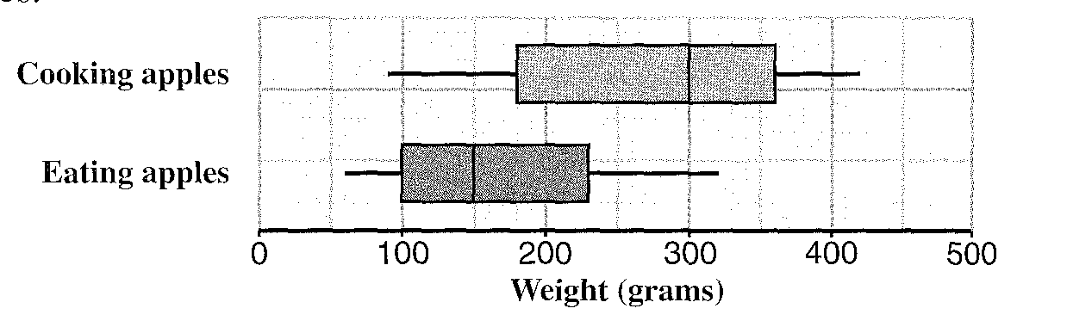
a) What is the range in the weights of the eating apples?
b) What type of apple has the higher median weight?
c) What is the interquartile range for cooking apples? [Hint: the interquartile range is the difference between the upper and lower quartiles. It can also be thought of as the width of the box in a box-and-whisker plot].
d) Compare and comment on these distributions. [Hint: when you compare two distributions you should comment on which type of apple is generally heavier and also on which type of apple has the greater spread of weights – spread is measured by the interquartile range].
Questionnaire design

A questionnaire is a set of questions that are used to collect data for a survey. Questionnaires should:
1. use simple language;
2. ask short questions which can be answered precisely;
3. provide tick boxes;
4. avoid open-ended questions;
5. avoid leading questions.

Example of poor question | Reason why question is poor | Improved question
How much sleep did you get last night?  Less than average  About average  More than average | The question is not clear- different people are likely to have different ideas of what is meant by average! | How much sleep did you get last night?  Less than 8 hours  About 8 hours  More than 8 hours
Do you agree that we need at least 8 hours of sleep each night? | This is a leading question – the question is leading people to answer yes. | Do you think that we need at least 8 hours sleep each night?  Yes  No  Not sure
What do you sleep on? | This question is ambiguous: it could have more than one meaning. The question is meant to be about sleeping position, but could be answered “a bed”! | What do you usually sleep on?  Back  Front  Side

Examination Style Question
a) Write down a reason why the following question would be unsuitable for use in a questionnaire:
“What films do you watch?”
b) Write an improved version of this question.

