November 2004 Paper 5 answers

Question 1 (3 marks)
07/5 = 14, so Cheese 28, Topping 42

Question 2 (3 marks)
$\text{12}\frac{1}{2} ÷ \frac{5}{8}=\frac{\text{25}}{2}×\frac{8}{5}=\text{20}$
Question 3 (3 marks)
(a) pq - p³ (b) 5p + 16

Question 4 (4 marks)
(a) 4 × 10⁷ and 0.000 03 (b) 1.2 x 10³

Question 5 (5 marks)
(a) $\frac{\text{180}−x}{2}$ (b) p = 4 and q = -1

Question 6 (2 marks)
360 ÷ 6 = 60º

Question 7 (3 marks)
You need to show these steps:
(a) Construct right angle at A (using compass)
(b) Bisect the right angle (using compass)
(c) Label the correct angle

Question 8 (4 marks)
½ × 4 × 3 × 7 = 42 cm³

Question 9 (8 marks)
(a) x⁴ and y¹² (b) t² +2t – 8
(c) -2, –1, 0, 1, 2, 3 (d) 1/6 and 9
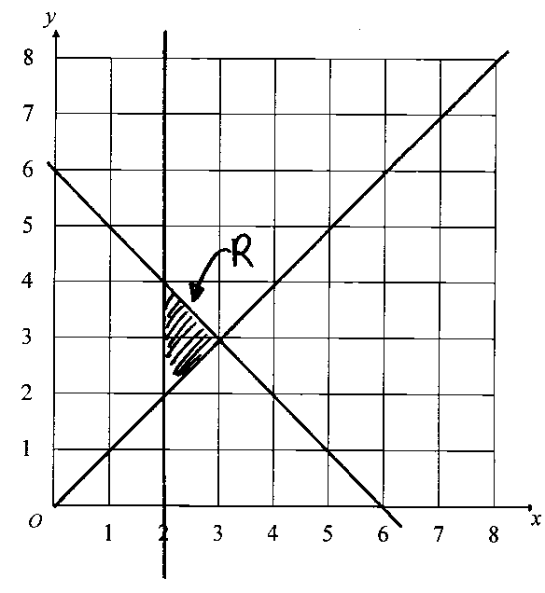
Question 10 (5 marks)
See diagram.

Question 11 (2 marks)
$$\frac{D−{\text{kt}}^{2}}{t}$$

Question 12 (8 marks)
(a) 44, 100, 134, 153, 160
(b) See diagram.
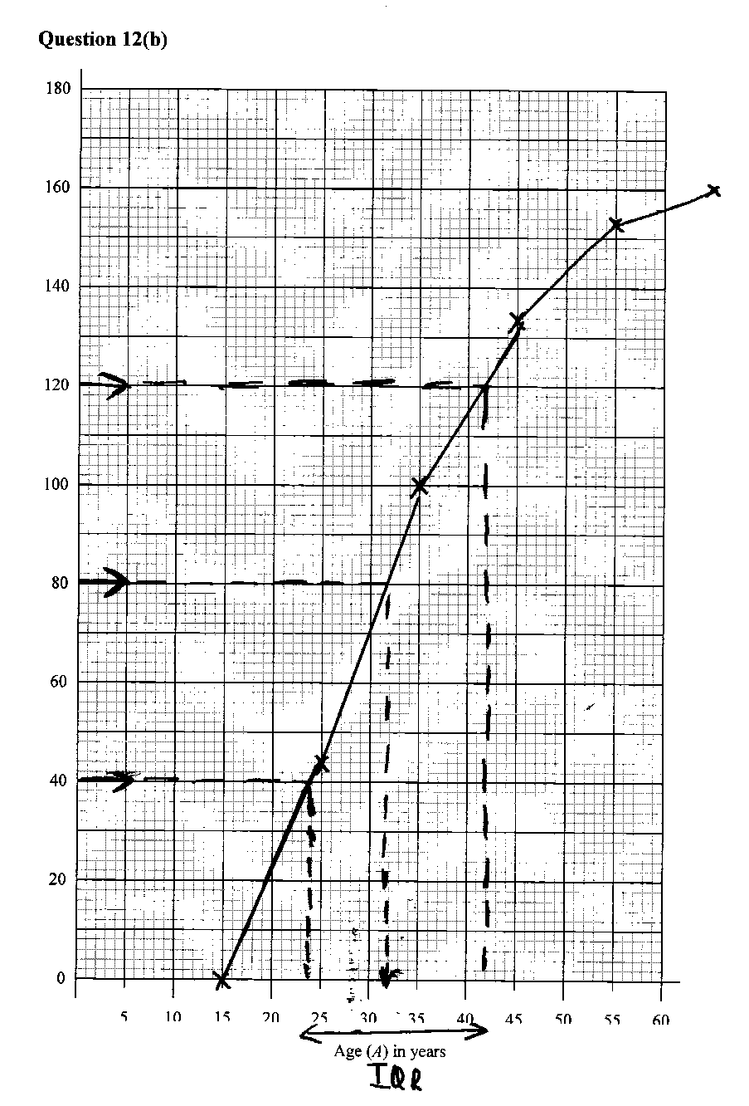
(c) Median about 30-32,
IQR about 16-18
(d) See diagram.

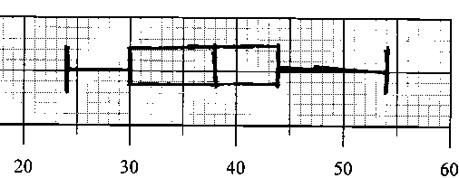
Question 13 (5 marks)
(a) 90 –35 = 55º using angle in a semi-circle = 90º
(b) 90 – 55 = 35
(c) 180 - 2×35= 110º

Question 14 (3 marks)
By Pythagoras: x² + (2x)² = 25² so 5x² = 625 and x² = 125
x = √125 giving A = √125 × 2√125 = 250cm².

Question 15 (5 marks)
(a) Common side SQ
Side SP same length as side RQ
Side PQ same length as side SR
∴ Congruent by SSS rule.
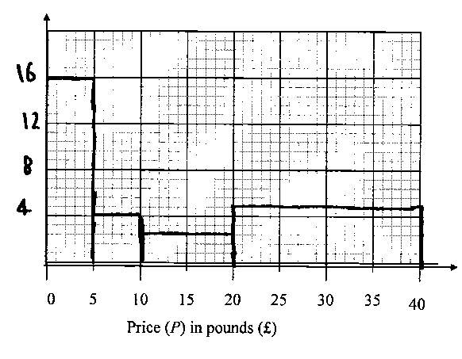
(b) In a cyclic quadrilateral, opposite angles add up to 180. Here SPQ and SQR are both over 90, so they cannot add up to 180.

Question 16 (5 marks)
(a) 40, 60, 56, 32
(0.8 = height of one
little square)
(b) See diagram:

Question 17 (4 marks)
(a) $\frac{6}{\sqrt{2}}$×$\frac{\sqrt{2}}{\sqrt{2}}$ = $\frac{6\sqrt{2}}{2}$ =$3\sqrt{2}$
(b) $\frac{1}{2}$ ×$\frac{6}{\sqrt{2}}$×$\frac{6}{\sqrt{2}}$ = $\frac{\text{36}}{4}$ = 9

Question 18 (2 marks)
1-D, 2-A, 3-B, 4-C

Question 19 (6 marks)
(a) 5n
(b) 5n + 5(n±1) = 10n ± 5 = 5(2n ± 1)
Both 5 and 2n ± 1 are odd so result is odd.
(c) 5n × 5(n±1) = 25n(n±1). 25 is odd, one of n or n ± 1 is odd, so odd × even × odd = even

Question 20 (6 marks)
(a) a = 2,b = -1
(b) 0,234,360,594,720 (allow $±$$5°$on 234 and 594)
(c) 2 – ( 0 – 1) = 3

Question 21 (5 marks)
(a) PS = ½ (q – p) so OS = p + ½ (q – p) = ½ (p + q)
(b) RS = RP + PS, so RS = ½ p + ½( q – p) = ½ q
OQ = q
Therefore RS is parallel to OQ (and half as long)

Question 22 (4 marks)
2(x - 1) + 3(x + 1) = 5 ∴ 2x – 2 + 3x + 3 = 5
5x +1 = 5 ∴5x = 4 and x = 0.8

Question 23 (5 marks)
(a)(i) $\frac{1}{3}{πx}^{2}$ (ii) $\frac{2}{3} πx$
(b) 1/3π × (1/3x)² × h = 3 × 1/3 πx²
so π h x² = πx² and h = 27
27

