June 2004 GCSE Paper 5 (Higher level)
Time: 2 hours – No calculator
Answer ALL of the questions. You must write down all stages in your working.

Question 1 (4 marks)
(a) Use the information that 13 x 17 = 221 to write down the value of:
(i) 1.3 x 1.7 (ii) 22.1 ÷ 1700
(b) Use the information that 13 x 17 = 221 to find the Lowest Common Multiple of 39 and 17.

Question 2 (3 marks)
The table shows some expressions in which the letters a, b, c and d represent lengths. π and 2 are numbers that have no dimensions. Three of the expressions could represent areas. Which ones are they?

$$\frac{π\text{abc}}{2d}$$ | πa³ | 2a² | πa² + b | π(a + b) | 2(c² + d²) | 2ad²

Question 3 (4 marks)
The probability that a biased dice will land on a four is 0.2. Pam is going to roll the dice 200 times.
(a) Work out an estimate for the numbers of times the dice will land on a four.
The probability that the biased dice will land on a six is 0.4. Ted rolls the biased dice once.
(b) Work out the probability that the biased dice will land on either a four or a six.

Question 4 (4 marks)
(a) Express 108 as the produce of powers of its prime factors.
(b) Find the Highest Common Factor (HCF) of 108 and 24.

Question 5 (2 marks)
On the answer sheet, use rule and compasses to construct the perpendicular to the line segment AB that passes through the point P. You must show all of your construction lines.

Question 6 (3 marks)
The diagram shows a wedge in the shape of a triangular prism. The cross section of the prism is shown as a shaded triangle. The area of the triangle is 15 cm². The length of the prism is 10cm. Work out the volume of the prism.

Question 7 (9 marks)
(a) Simplify k⁵ ÷ k²
(b) Expand and simplify:
(i) 4(x + 5) + 3(x – 7)
(ii) (x + 3y)(x + 2y)
(c) Factorise (p + q)² + 5(p+ q)
(d) Simplify (m⁻⁴)⁻²
(e) Simplify 2t² x 3r³t⁴
Question 8 (2 marks)
Each side of a regular pentagon has a length of 101mm, correct to the nearest millimetre.
(a) Write down the least possible length of each side.
(b) Write down the greatest possible length of each side.

Question 9 (5 marks)
The area of the square is 18 times the area of the triangle. Work out the perimeter of the square.

Question 10 (7 marks)
The line with the equation 6y + 5x = 15 is drawn on the grid on the answer sheet.
(a) Rearrange the equation to make y the subject.
(b) The point (-21,k) lies on the line. Find the value of k.
(c) (i) On the grid, shade the region of points whose coordinates satisfy the four inequalities:
y > 0, x > 0, 2x < 3, 6y + 5x < 15
Label your region with an R.
(ii) P is a point in the region R. The coordinates of P are both integers. Write down the coordinates of P.
Question 11 (5 marks)
In the diagram, ABCD is a rectangle. A is the point (0,1) and C is the point (0,6). The equation of the straight line through A and B is y = 2x + 1.
(a) Find the equation of the line through D and C.
(b) Find the equation of the line through B and C.
(c) It is always possible to draw a circle which passes through all four vertices of a rectangle. Explain why.

Question 12 (3 marks)
On the answer sheet, enlarge the triangle by a scale factor of 1½, centre P.

Question 13 (1 mark)
40 boys each completed a puzzle. The cumulative frequency graph gives information about the times it took them to complete the puzzle.
(a) Use the graph to estimate the median time.
For the boys, the minimum time to complete the puzzle was 9 seconds, and the maximum time was 57 seconds.
(b) Use this information and the cumulative frequency graph to draw a box-plot on the answer sheet showing information about the boys’ times.
The second box-plot on the answer sheet shows information about the times taken by 40 girls to complete the puzzle.
(c) Make two comparisons between the boys’ times and the girls’ times.

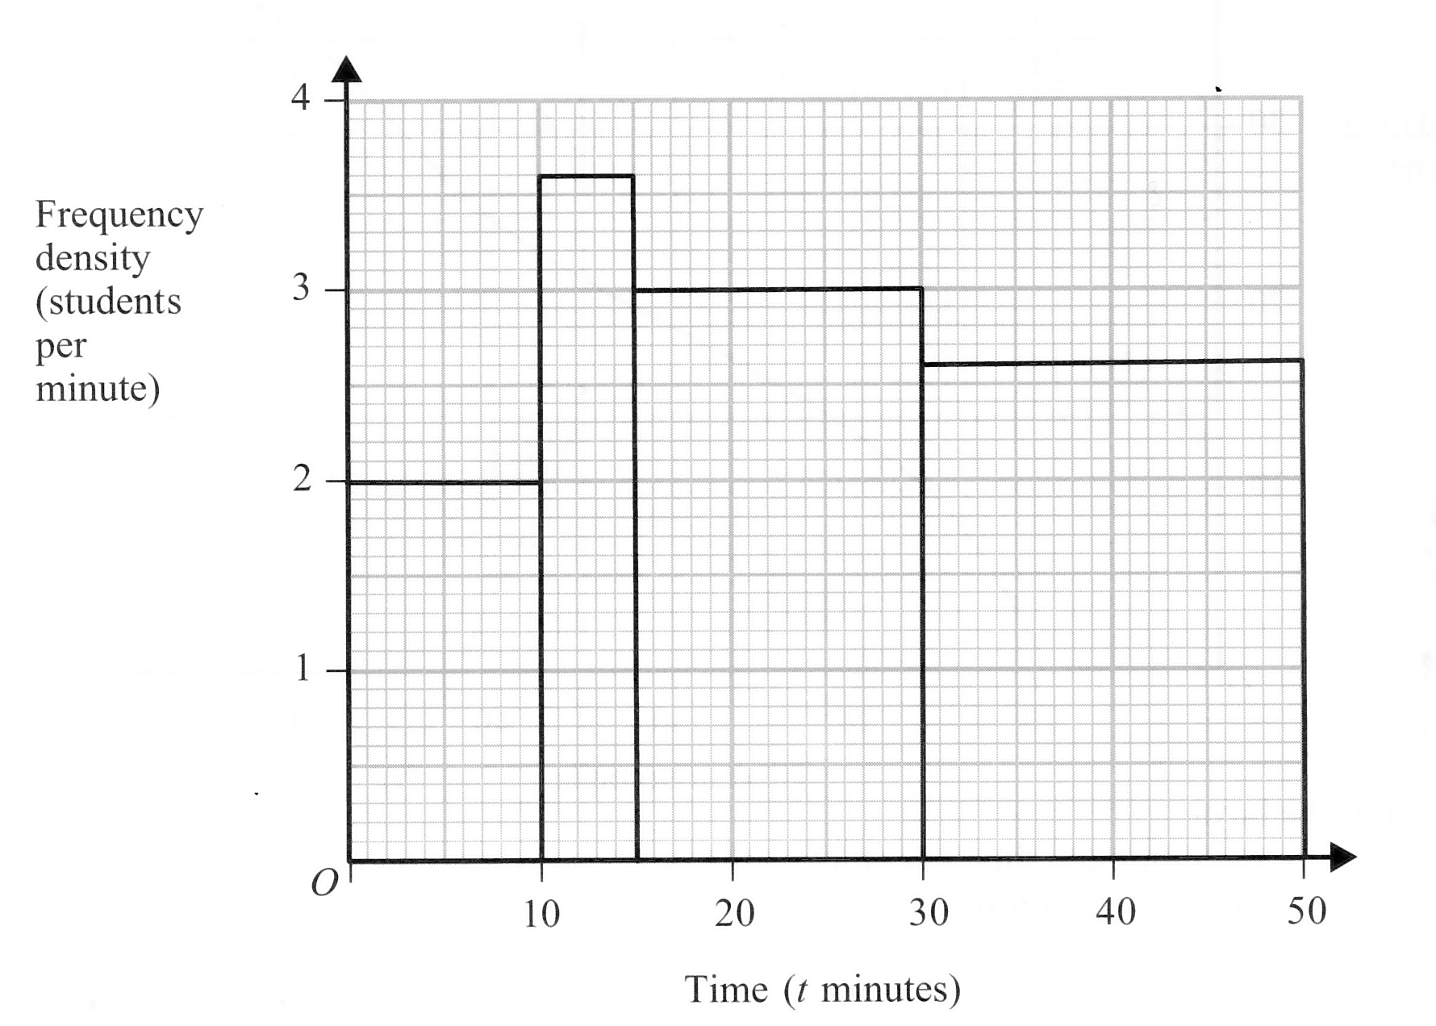
Question 14 (2 marks)
The histogram gives information about the times, in minutes, 135 students spent on the Internet last night. Use the histogram to find the missing values in the table.
Time (t minutes) | Frequency
0 < t ≤ 10
10 < t ≤ 15
15 < t ≤ 30
30 < t ≤ 50
TOTAL | 135

Question 15 (5 marks)
The value of a car on 1st January 2000 was £1600. The value of the same car on 1st January 2002 was £400. The sketch graph shows how the value, £V, of the car changes with time. The equation of the sketch graph is V = pq^{t}, where t is the number of years after 1st January 2000 and p and q are positive constants.
(a) Use the information on the graph to find p and q.
(b) Using your values of p and q, find the value of
the car on 1st January 1998.

Question 16 (7 marks)
A, B, and C are three points on the circumference of a circle.
Angle ABC = Angle ACB.
PB and PC are tangents to the circle from the point P.
(a) Prove that the triangle APB and the triangle APC are congruent.
(b) Angle BPA = 110 degrees. Find the size of angle ABC.

Question 17 (5 marks)
OABC is a parallelogram. P is the point on AC such that AP = 2/3 AC. Also, OA = a, and OC = c.
(a) Find the vector OP. Give your answer is terms of a and c.
(b) The midpoint of CB is M. Prove that OPM is a straight line.
Question 18 (6 marks)
(a) Find the value of 16^{1/2}.
(b) Given that √40 = k√10, find the value of k.
(c) A large rectangular piece of card is √5 + √20 cm long and √8 cm wide. A small rectangle √2 cm long and √5 cm wide is cut out of the piece of card. Express the area of the card that is left as a percentage of the area of the large rectangle.

Question 19 (13 marks)
(a) (i) Factorise 2x² – 35x + 98.
(ii) Solve the equation 2x² – 35x + 98 = 0.
(b) A bag contains (n+7) tennis balls: n of the balls are yellow and the other 7 balls are white. John will take at random a ball from the bag. He will look at its colour and then put it back into the bag.
(i) Write an expression in terms of n for the probability that John will take a white ball.
Bill states that the probability that John will take a white ball is 2/5.
(ii) Prove that Bill’s statement cannot be correct.
(c) After John has put the ball back into the bag, Mary will then take at random a ball from the bag. She will note its colour. Given that the probability that John and Mary will take balls of different colours is 4/9, prove that 2n² – 35n + 98.
(d) Using your answer to part (a)(ii) or otherwise, calculate the probability that John and Mary will both take white balls.
Question 20 (5 marks)
A sketch of the curve y = sin x for 0 ≤ x ≤ 360 is shown in the diagram on the right.
(a) Using this sketch, or otherwise, find the equations of each of the two curves below.

Curve 1 Curve 2

(b) Describe fully the sequence of two transformations that maps the graph of y = sin x onto the graph of y = 3 sin 2x.

END OF EXAM

TOTAL 100 MARKS

