June 2003 GCSE Paper 5 (Higher level)
Time: 2 hours – No calculator
Answer ALL TWENTY FOUR questions. You must write down all stages in your working.

Question 1 (3 marks)
Using the information that 97 x 123 = 11,931 write down the values of:
- 9.7 x 12.3
- 0.97 x 123,000
- 11.931 ÷ 9.7

Question 2 (3 marks)
Ben bought a car for £12,000. Each year the value of the car depreciated by 10%. Work out the value of the car two years after he bought it.

Question 3 (2 marks)
Solve 7r + 2 = 5(r – 4)

Question 4 (5 marks)
- x is an integer and - 2 < x ≤ 1. Write down all the possible values of x.
- x and y are integers and - 2 < x ≤ 1 and y > -2 and y < x+1. On the grid on the answer sheet, mark with a cross each of the six points which satisfies all of these three inequalities.

Question 5 (2 marks)
- Here are the first 5 terms of an arithmetic sequence: 6, 11, 16, 21, 26.
Find an expression, in terms of n, for the n^{th} term of the sequence.

Question 6 (4 marks)
Look at the diagram on the answer sheet.
Shape A is rotated 90 degrees anticlockwise, centre (0,1) to Shape B.
Shape B is rotated 90 degrees anticlockwise, centre (0,1) to Shape C.
Shape C is rotated 90 degrees anticlockwise, centre (0,1) to Shape D.
- Mark the position of Shape D.
- Describe the single transformation that takes Shape C to Shape A.

Question 7 (3 marks)
The diagram on the answer sheet represents a triangular garden ABC. The scale of the diagram is 1cm represents 1m. A tree is to be planted in the garden so that it is:
• nearer to AB than to AC
• within 5m of point A
On the diagram, shade the region where the tree may be planted.

Question 8 (3 marks)
The table on the answer sheet shows some expressions. The letters x,y and z represent lengths. Place a tick in the appropriate column for each expression to show whether it can be used to represent a length, an area or a volume, or none of these.
Question 9 (4 marks)
Mr Beeton is going to open a restaurant. He wants to know what type of restaurant people like. He designs a questionnaire.
- Design a suitable question he could use to find out what type of restaurant people like.
He asks his family “Do you agree that pizza is better than pasta?” This is not a good way to find out what people who might use the restaurant like to eat.
(b) Write down two reasons why this is not a good way to find out what people who might use the restaurant like to eat.

Question 10 (5 marks)
A spaceship travelled for 6 x 10² hours at a speed of 8 x 10⁴ km/h.
- Calculate the distance travelled by the spaceship. Give your answer in standard form.
One month an aircraft travelled 2 x 10⁵ km. The next month it travelled 3 x 10⁴ km.
- Calculate the total distance travelled by the aircraft in the two months. Give your answer as an ordinary number.

${\left(x+y\right)}^{2}$Question 11 (4 marks)
(a) Expand and simplify
$3\text{.}{\text{47}}^{2}+2×3\text{.}\text{47}×1\text{.}\text{53}+1\text{.}{\text{53}}^{2}$(b) Hence or otherwise find the value of

Question 12 (4 marks)
In the diagram, A, B and C are points on the circle, centre O. Angle BCE = 63 degrees. FE is a tangent to the circle at point C.
- Calculate the size of angle ACB. Give reasons for your answer.
- Calculate the size of angle BAC. Give reasons for your answer.

Question 13 (3 marks)
Simplify fully
${\left(p^{3}\right)}^{3}$(i)

$\frac{3q^{4}×2q^{5}}{q^{3}}$(ii)

Question 14 (5 marks)
Mary recorded the heights, in centimetres, of the girls in her class. She put the heights in order:
132 144 150 152 160 162 162 167
167 170 172 177 181 182 182

- Find the lower quartile
- Find the upper quartile
- On the grid on the answer sheet, draw a box plot of this data.

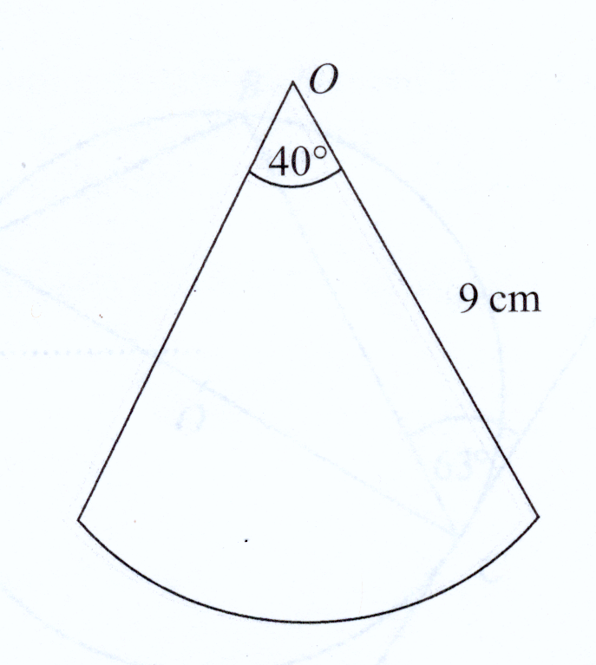
Question 15 (4 marks)

The diagram shows a sctor of a circle, centre O. The radius of the circle is 9cm. The angle at the centre of the circle is 40°.
Find the perimeter of the sector. Leave your answer in terms of π.

Question 16 (3 marks)
Work out
$4^{0}$(i)

$4^{−2}$(ii)

${\text{16}}^{\frac{3}{2}}$(iii)

Question 17 (6 marks)
The force, F, between two magnets is inversely proportional to the square of the distance, x, between them. When x=3, F=4
- Find an expression for F in terms of x.
- Calculate F when x=2
- Calculate x when F=64

$\frac{\left(5+\sqrt{3}\right)\left(5−\sqrt{3}\right)}{\sqrt{\text{22}}}$Question 18 (3 marks)
Work out the following, giving your answer in its simplest form.

Question 19 (4 marks)
The incomplete table and histogram on the answer sheet give some information about the ages of people who live in a village.
- Use the information in the table to complete the frequency table.
- Complete the histogram.

Question 20 (7 marks)

Simplify fully
$2\left(3x+4\right)−3\left(4x−5\right)$(a)
${\left(2{\text{xy}}^{3}\right)}^{5}$
(b)
$\frac{n^{2}−1}{n+1}×\frac{2}{n−2}$
(c)

Question 21 (3 marks)
Using the diagram on the answer sheet, enlarge triangle A by scale factor –1.5, centre O.

Question 22 (5 marks)
A bag contains 3 black beads, 5 red beads and 2 green beads. Gianna takes a bead at random from the bag, records its colour and replaces it. She does this two more times.
Work out the probability that, of the three beads Gianna takes, exactly two are the same colour.

Question 23 (7 marks)

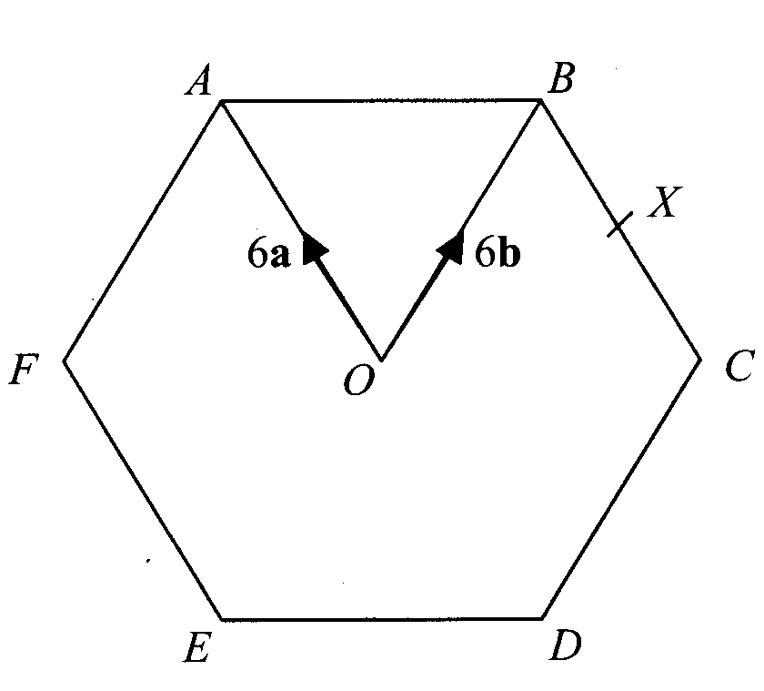
$\overset{→}{\text{OB}}=6b$The diagram shows a regular hexagon ABCDEF with centre O.
- $\overset{→}{\text{OA}}=6a$Express in terms of a and/or b
$\overset{→}{\text{AB}}$$\overset{→}{\text{EF}}$
(i) (ii)

X is the midpoint of BC.
$\overset{→}{\text{EX}}$
- Express in terms of a and/or b

Y is the point on AB extended, such that AB:BY = 3:2
- Prove that E, X and Y lie on the same straight line.

Question 24 (8 marks)
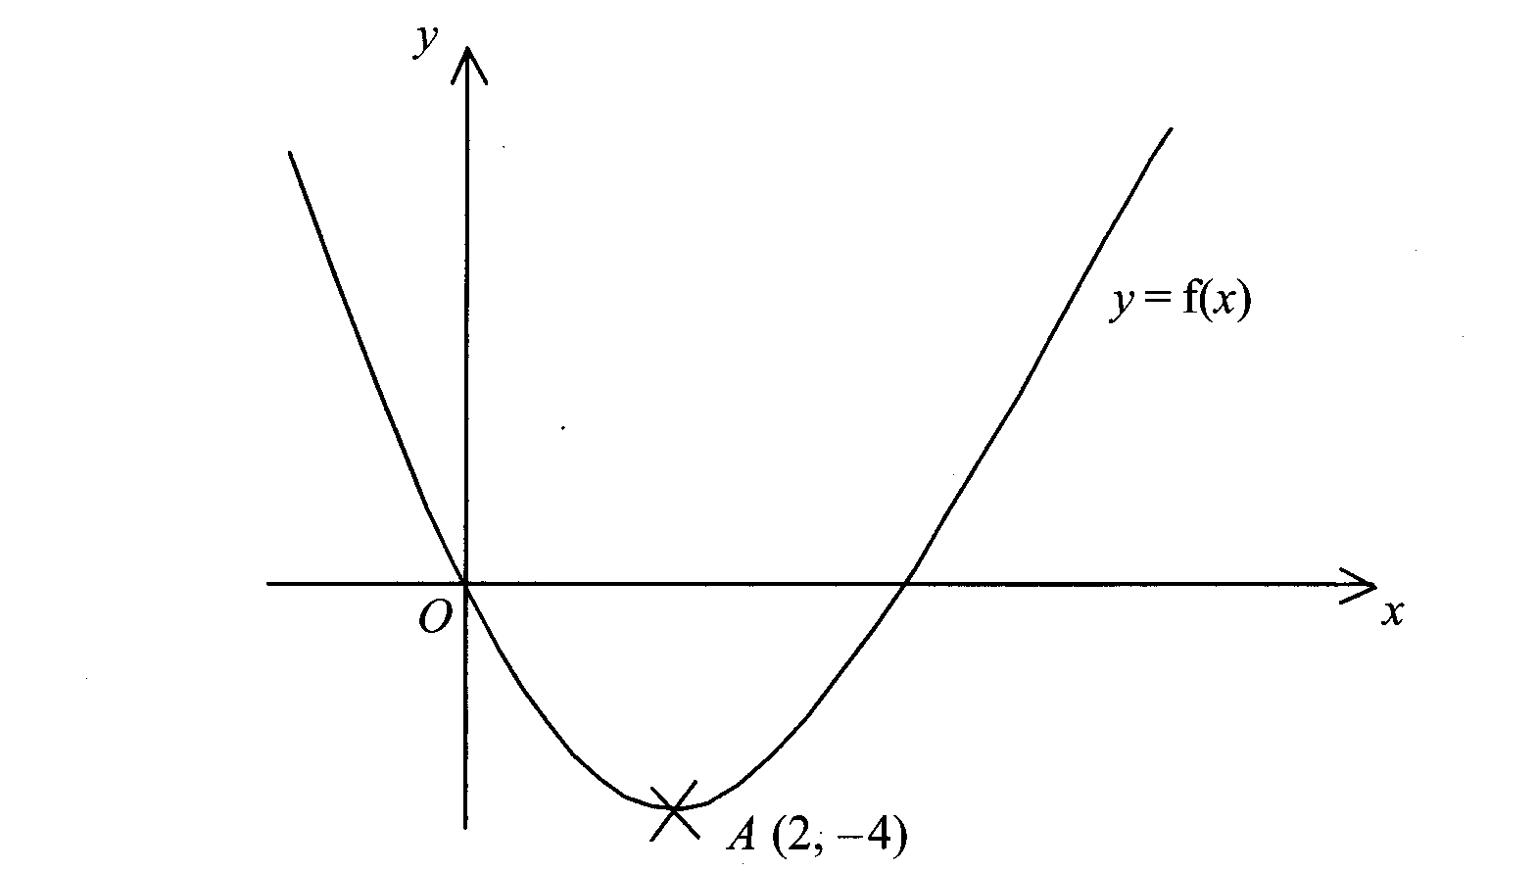
This is a sketch of the curve with equation
y = f(x). It passes through the origin O.

The only vertex of the curve is at A (2, -4)
- Write down the coordinates of the vertex of the curve with equation
- y = f(x-3)
- y = f(x) – 5
- y = - f(x)
- y = f(2x)

$y=x^{2}$The curve with equation has been translated to give the curve y = f(x).

- Find f(x) in terms of x.

END OF TEST

TOTAL 100 MARKS

