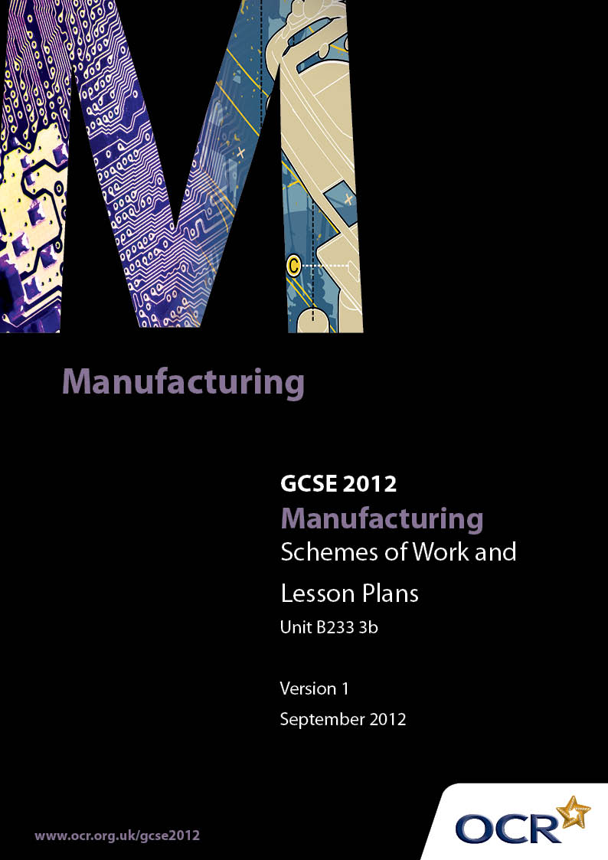

Contents
Contents 2
Introduction 3
Sample Scheme of Work: Manufacturing J510: Making a Manufactured Product B233: 3B 5
Sample Lesson Plan: Manufacturing J510: Making a Manufactured Product
B233: 3B 13

Introduction

Background
OCR has produced a summary brochure, which summarises the changes to Manufacturing. This can be found at www.ocr.org.uk, along with the 2012 specification.
In order to help you plan effectively for the implementation of the new specification we have produced these schemes of work and sample lesson plans for Manufacturing. These support materials are designed for guidance only and play a secondary role to the specification.

Our Ethos
OCR involves teachers in the development of new support materials to capture current teaching practices tailored to our new specifications. These support materials are designed to inspire teachers and facilitate different ideas and teaching practices.
Each scheme of work and set of sample lesson plans are provided in Word format to be used as a foundation to build upon and amend the content to suit your teaching style and students’ needs.
The scheme of work and sample lesson plans provide examples of how to deliver these units and suggested teaching hours which could be applicable to your teaching.
The specification is the document on which assessment is based and specifies what content and skills need to be covered in delivering the course. At all times, therefore, this support material booklet should be read in conjunction with the specification. Any clarification should be found in the specification.

A Guided Tour through the Scheme of Work

= Innovative Teaching Idea
This icon is used to highlight exceptionally innovative ideas.


= ICT Opportunity
This icon is used to illustrate when an activity could be taught using ICT facilities.

Manufacturing J510: Making a Manufactured Product B233: 3B
Suggested teaching time | 20 hours | Topic | Using Appropriate Materials, Components, Processes, Tools and Equipment.
Topic outline |  | Suggested teaching and homework activities |  | Suggested resources | Points to note
Selection and use of a range of appropriate materials, parts or components |  | - Working as part of a team, explore alternative materials for batch producing a product selected from OCR list in the specification.  - Discuss in groups and write up justified choices as individuals  - Possibly conduct simple tests on sample materials  - Homework – research materials that similar products are made from  - Homework – Collect suitable evidence of the above process and assemble in folder for assessment |  | - Samples of different materials  - Simple technical specification sheets to assist in choice  - Ring binders or other suitable folders for collecting evidence  - ICT facilities for recording evidence electronically | - Wherever possible, candidates should make choices themselves.  - However, teachers should oversee choices and intervene at an early stage if wholly inappropriate materials are selected.  - It is recommended that candidates collect assessment evidence as they go along and resist the temptation to press on with the manufacture and then trying to collect all the evidence at the end.  - Please note that any work submitted for assessment must be completed under controlled conditions and not as a homework activity
Selection and use of a range of appropriate processes, tools and equipment |  | - Teams discuss production processes and the most appropriate tools and equipment to use to make their product.  - Using the appropriate tools and equipment, each candidate should manufacture at least one item of the selected product.  - Homework – recording evidence collected during practical work and assembling it in assessment folder |  | - Facilities appropriate to effective and safe use of chosen tools, materials and processes.  - Wherever practical, equipment should be available in sufficient quantities to allow all candidates to use the equipment they need within a reasonable time.  - Possible use of digital video camera (or mobile phone) to record short pieces of video evidence of manufacturing processes  - Processes could include  - Processing metals:  - Casting  - Forming  - Welding and joining  - Material removal  - Processing ceramics  - Pressing, drawing and blowing  - Clay Forming  - Processing polymers:  - Moulding such as injection, compression, blow and rotational  - Textiles:  - Pattern making  - Industrial sewing  - Printing  - Spinning | - Wherever possible, this should be the candidate’s own work. Where assistance from the teacher or other adult is required for health and safety or other reasons this should be recorded when the work is assessed.  - Where resources and equipment are scarce, it may be necessary to carefully schedule their use and possibly restrict the choices made by teams.  - Need to keep evidence to minimum necessary and be mindful of health and safety at all times.  - Please note that any work submitted for assessment must be completed under controlled conditions and not as a homework activity

Manufacturing J510: Making a Manufactured Product B233: 3B
Suggested teaching time | 10 hours | Topic | Apply Health, Safety and Hygiene and Quality Standards
Topic outline |  | Suggested teaching and homework activities |  | Suggested resources | Points to note
Candidates should be able to fully contribute and detail the team’s application of Health and Safety Procedures |  | - Health and safety issues will vary greatly from process to process.  - Generic health and safety principles should be taught, emphasising that the safety and well -being of self and others is paramount.  - Homework – candidates write an account of health and safety issues relating to each of the processes used in the manufacture of their product.  - Homework – candidates write a description of health and safety issues relating to their product in use. |  | - Health and safety fact sheets  - Sheets giving simple descriptions of health and safety issues. | - Need to ensure the evidence collected in this part is relevant to the individual candidate’s product and not simply generic material used indiscriminately.  - Evidence could include:-  - Details of Health and Safety issues that relate to the application of the Quality Control procedures of the product  - Details of safety systems used during the manufacture of the product
Candidates should be able to fully contribute and detail the team’s application of quality control techniques |  | - Quality control techniques will vary from product to product.  - Generic principles of quality control and quality assurance should be taught to the class, emphasising that nothing can ever be perfect and that manufactured items are normally made to a tolerance.  - Homework – investigate evidence of quality control in the real world eg packing slips saying ‘checked by’  - The team then apply this theory to their product by considering each process in turn and quality check in terms of implementation, desired outcome, and overall effectiveness.  - Homework – Collect and assemble evidence of quality control techniques they used for their team’s product |  | - Handout summarising main aspect associated with quality control  - Various examples of quality control evidence to help them | - Evidence could include:  - Details of all Quality Control procedures used during the manufacture of the products  - Details of tests carried out during the manufacture of the product  - Details of any gauges, templates, quality samples, or other methods of measuring quality aspects of the products  - Need to ensure this work is individual, even though it is based on the team’s performance  - Please note that any work submitted for assessment must be completed under controlled conditions and not as a homework activity

Manufacturing J510: Making a Manufactured Product B233: 3B
Suggested teaching time | 10 hours | Topic | Consider Production Details and Constraints
Topic outline |  | Suggested teaching and homework activities |  | Suggested resources | Points to note
Individual candidates should fully consider and explain production details and constraints |  | - Key features should be explained to candidates who then work individually, but with teacher guidance, to apply generic key features to their product.  - Homework- candidates to write up and/or evidence the production details and constraints relating to their product |  | - Sheet with examples of ‘typical’ production details  - Sheet with examples of common constraints | - Key features could include:-  - Styling aesthetics  - Intended Markets  - Ergonomics  - Maintenance  - Scale of Production  - Relevant regulations and legislation  - Please note that any work submitted for assessment must be completed under controlled conditions and not as a homework activity
Individual candidates should fully consider and explain the application of quality standards |  | - Candidates should be taught about TQM, quality assurance and quality control. Explain significance of IS9000 and what it means for a manufacturing company.  - Explain typical quality standards and necessary measurements  - Homework- candidates to write up and/or evidence the production details and constraints relating to their product |  | - Handouts on TQM, QC and QA  - Summary of IS9000  - Sheet listing typical elements of Quality Control | - Reference could be made to one or more of the following:-  - Which relevant standard should be met and how this should be measured / evaluated  - The numbers or percentage of products to be checked in a batch is identified (sampling)  - How failure / non conformance is reported to quality supervisors / management  - The remedial action is highlighted i.e. rework or scrap  - Troubleshooting with guidance on how to improve production if the process is failing  - How automated and statistical measurements systems are integrated and monitored  - Please note that any work submitted for assessment must be completed under controlled conditions and not as a homework activity (see section 5.3 in the specification).

Manufacturing J510: Making a Manufactured Product B233: 3B
Suggested teaching time | 10 hours | Topic | Analysis and Evaluation of Product and How it could be modified in Real World Production
Topic outline |  | Suggested teaching and homework activities |  | Suggested resources | Points to note
Candidates individually analyse and evaluate the product in terms of equipment |  | - After brief explanation of what is required, candidates work in teams and individually to analyse and evaluate their product.  - Homework – write up analysis for inclusion in folder of evidence |  | - Form to encourage candidates to list and evaluate equipment | - Candidates may benefit from using the following framework:-  - Clear reasoning why equipment and processes were used in all the aspects of manufacture  - Identification of all production constraints that relate to the manufacture of their product, including tools, equipment and processes  - Please note that any work submitted for assessment must be completed under controlled conditions and not as a homework activity .
Candidates individually analyse and evaluate the product in terms of the tools and processes that have been used |  | - After brief explanation of what is required, candidates work in teams and individually to analyse and evaluate their product.  - Homework – write up analysis for inclusion in folder of evidence |  | - Form to encourage candidates to list and evaluate the tools and processes they used | - Candidates may benefit from using the following framework:-  - Clear reasoning why equipment and processes were used in all the aspects of manufacture  - Identification of all production constraints that relate to the manufacture of their product, including tools, equipment and processes
Candidates individually analyse and evaluate the product in terms of how these would be modified in real-world manufacturing |  | - After brief explanation of what is required, candidates work in teams and individually to analyse and evaluate how the manufacture of their product would need to change in a real-world scenario.  - Homework – write up analysis for inclusion in folder of evidence |  | - Company visits  - Research on the internet.  - For example the British Plastics Federation website containing short animations to demonstrate polymer processing. Visit the website on www.bpf.co.uk.  - www.Nikebiz.com has some useful information on the technology involved in producing sporting equipment such as the latest generation of running shoes.  - Specialist CDs and DVD.  - An example is ‘Polestar’ for introducing the technology involved in today’s printing industry.  - Television programmes  - Many programmes on television have excellent technical information - Top Gear (BBC), Mega-structures (Channel 5) and the Gadget Show (Channel 5) are all good examples. | - Candidates may benefit from using the following framework:-  - A clear explanation of how the product would be produced in the same batch size using “real world “ techniques and processes  - A clear explanation of how the product would be produced in large quantities using “real world “ techniques and processes  - A clear explanation of how tools and equipment used would be modified if the product was to be produced in large quantities  - Please note that any work submitted for assessment must be completed under controlled conditions and not as a homework activity

Manufacturing J510: Making a Manufactured Product B233: 3B

Applying Quality Standards
OCR recognises that the teaching of this qualification above will vary greatly from school to school and from teacher to teacher. With that in mind this lesson plan is offered as a possible approach but will be subject to modifications by the individual teacher.
Lesson length is assumed to be one hour.

Learning Objectives for the Lesson
Objective 1 | To understand the importance of quality standards in real-world manufacturing
Objective 2 | To be able to apply simple quality standards to a product being made in batch by the candidate’s team

Recap of Previous Experience and Prior Knowledge
Candidates should already have some experience of quality and have specified the quality control techniques they are planning to use when making the batch of products with their team.

Content
Time | Content
5 minutes | Explain that the purpose of the lesson is to be able to apply quality standards to their product.  Ask candidates to tell about items they have bought which have gone wrong.  Ask why they think things cannot be made perfectly  Refer them back to the quality control techniques they have already specified for their team’s product.
10 minutes | Ask if anyone can think of how quality standards are applied in school. (eg Ofsted or OCR examinations)  Explain the main features of a Total Quality Management system.  Give out the handout on Quality Systems  Ask if anyone has any experience of an organisation that applies quality management. Be prepared to prompt them. Holiday jobs, voluntary work etc. Examples need only be very basic eg supervisor checks work that has been done etc.
5-10 minutes | Ask individuals to think about how quality standards can be applied to their product. Ask them to make brief notes
15 minutes | Working in production teams, discuss each persons ideas for applying quality standards to the team’s product.  Reach a team consensus and record how the team agrees to apply the quality standards
10 minutes | Teams feed back their thoughts  General group discussion on the different approaches

Consolidation

Time | Content
5 minutes | Summarise main points covered
10 minutes | Remind candidates of need to keep their folder of evidence up to date.  Explain that homework is to write up how they will apply quality standards to their product. Remind them to base it on the discussions they have had today and on the fact sheet they have been given. Also remind them that they may need to amend their notes in light of feedback from others following the final plenary session.

