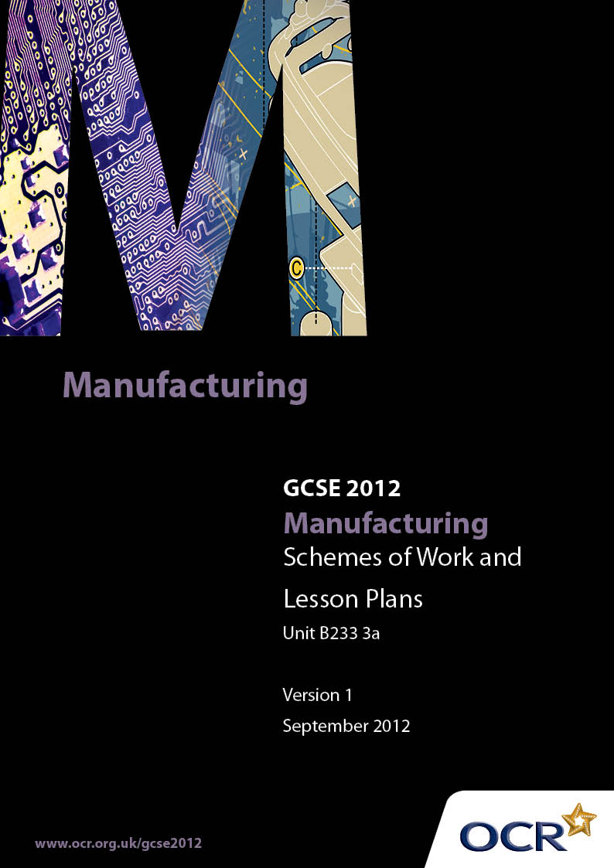

Contents
Introduction 3
Sample Scheme of Work: OCR GCSE Manufacturing J510 Unit B233: Real World Manufacturing 3A 5
Sample Lesson Plan: OCR GCSE Manufacturing J510 Unit B233: Real World Manufacturing 3A 10

Introduction

Background
OCR has produced a summary brochure, which summarises the changes to Manufacturing. This can be found at www.ocr.org.uk, along with the 2012 specification.
In order to help you plan effectively for the implementation of the new specification we have produced these schemes of work and sample lesson plans for Manufacturing. These support materials are designed for guidance only and play a secondary role to the specification.

Our Ethos
OCR involves teachers in the development of new support materials to capture current teaching practices tailored to our new specifications. These support materials are designed to inspire teachers and facilitate different ideas and teaching practices.
Each scheme of work and set of sample lesson plans are provided in Word format to be used as a foundation to build upon and amend the content to suit your teaching style and students’ needs.
The scheme of work and sample lesson plans provide examples of how to deliver these units and suggested teaching hours which could be applicable to your teaching.
The specification is the document on which assessment is based and specifies what content and skills need to be covered in delivering the course. At all times, therefore, this support material booklet should be read in conjunction with the specification. Any clarification should be found in the specification.

A Guided Tour through the Scheme of Work

= Innovative Teaching Idea
This icon is used to highlight exceptionally innovative ideas.


= ICT Opportunity
This icon is used to illustrate when an activity could be taught using ICT facilities.

OCR GCSE Manufacturing J510 Unit B233 3A: Real World Manufacturing
Suggested teaching time | 7 hours | Topic | Stages In Manufacturing A Product
Topic outline |  | Suggested teaching and homework activities |  | Suggested resources | Points to note
Students gain an understanding of the various stages in manufacturing a product |  | - For a particular product lead a group discussion around the identification of all manufacturing processes used to make the product  - Identify and list processes that would be used to produce the product in quantity  - Explain of the differences between manufacturing prototypes and producing in quantity |  | - Product list provided by OCR in the Specification. | - When presenting their evidence of this work, students should always be encouraged to relate any processes discussed to the product. General downloads from the Internet or general written descriptions of processes are not sufficient.
 |  | - Provide a handout listing the main generic stages in manufacturing a product. Students spend time working in pairs to determine how the list relates to the product they have chosen.
- Homework – Research further details about stages in manufacture of their individual product choice using the internet and reference/text books
- Collect evidence and assemble in portfolio folder for assessment

OCR GCSE Manufacturing J510 Unit B233 3A: Real World Manufacturing
Suggested teaching time | 7 hours | Topic | Production Details and Constraints
Topic outline |  | Suggested teaching and homework activities |  | Suggested resources | Points to note
Students should fully consider the identified product giving details and justification of all Materials, Components and/or ingredients.  Students should identify constraints through their availability, form and supply. |  | - A centre generated bank of questions to be asked during disassembly / reverse engineering activities, industrial visits, technical and other videos experienced by students should be designed to encourage an analytical interest in Manufactured products.  - An open ended method to suit the centre that enables students to establish what things are made from, how they are made and why was that process used should form the basis of this unit.  - Natural extensions of the impacts of the products and production methods (including materials) should be built in.  - Students should expect to become analytical by nature and seek to ask questions themselves and obtain answers making value judgements as to their quality and relevance.  - Group Product Analysis is both permissible and desirable for non-controlled assessment work.  - The course should be structured in an integrated way to avoid students being presented with disjointed activities. |  | Other resources:  - Image bank and useful links at http://gcsemanufacturing.com  - GCSE Manufacturing by Neil Godfrey and Steve Wallis  - GCSE Manufacturing by Steven Cushing | - Teachers are encouraged to capitalise on local industries, personal knowledge, students’ interests, topical events or sporting events.

OCR GCSE Manufacturing J510 Unit B233 3A: Real World Manufacturing
Suggested teaching time | 7 hours | Topic | Systems and Control Technology
Topic outline |  | Suggested teaching and homework activities |  | Suggested resources | Points to note
Students should identify and fully explain the systems and control technology used to organise, monitor and control production of the product |  | - Summarise what is meant by Systems and Control technology explaining typical applications  - Use DVD and/or Industrial Visits to show how systems and control technology is used in an industrial production environment.  - Possible opportunities to use IT packages for simulating the organisation of production. Eg students develop process flow diagrams on MS Visio.  - Possible opportunities to learn through modelling simple monitoring and control systems using technology modelling systems eg Lego  - Basic monitoring devices such as go/no-go gauges can allow first hand experience of monitoring. |  | - Local industry is the best provider of resources for this Unit.  - Firms are very different in their approach to industrial visits. Sometimes a large company, although providing students with an insight into state of the art production techniques, is not as beneficial as a visit to a smaller concern where students have better opportunities to speak with staff and witness the end-to-end process at close quarters.  - Technical construction kits can be useful for modelling production control systems and can significantly aid the learning of dynamic processes.  - Various simple monitoring devices can be used by students to develop first hand experience of monitoring temperature, size, acidity etc. The properties being monitored will vary with the product selected. | - This topic is best taught based on an industrial visit.  - Some pre-visit activity can usefully prepare students for seeing technology in use in the Real World.  - Summary exercises and group discussion after a visit helps ‘internalise’ and understand what has been seen.

OCR GCSE Manufacturing J510 Unit B233 3A: Real World Manufacturing
Suggested teaching time | 9 hours | Topic | The Impact of Modern Technologies
Topic outline |  | Suggested teaching and homework activities |  | Suggested resources | Points to note
Students should identify and fully explain the impact of modern technologies when manufacturing the product |  | - Much of this topic, and previous topics in this Unit, can be very effectively studied through real life experiences such as industrial visits or work experience.  - However, effective research may also be carried out using centre-based resources.  - Teaching activities for this unit should be fairly informal and should mainly consist of supporting students in their research and helping them apply what they have learnt to their chosen product.  - Homework – In addition encouraging further research activity, homework can also be used by students to collate and present evidence for assessment in an appropriate way in their assessment portfolio. |  | - Local companies.  - DVD or internet material such as:-  - Animations to demonstrate polymer processing. Visit the website on www.bpf.co.uk.  - www.Nikebiz.com has some useful information on the technology involved in producing sporting equipment such as the latest generation of running shoes.  - Textbooks, magazines and journals.  - Specialist CDs and DVD.  - Eg ‘Polestar’ for introducing the technology involved in today’s printing industry.  - Television programmes  - Many programmes on television have excellent technical information – Top Gear (BBC), Mega-structures  - (Channel 5) and the Gadget Show (Channel 5) are all good examples. | - This activity can be evidenced through traditional means such as writing up notes afterwards.  - However, alternatives such as digital photographs and short video or audio recordings should also be considered.  - Students should be reminded of the importance of always seeking permission beforehand when making recordings of any sort.

OCR GCSE Manufacturing J510 Unit B233 3A: Real World Manufacturing

Preparing for and Industrial Visit
OCR recognises that the teaching of this qualification above will vary greatly from school to school and from teacher to teacher. With that in mind this lesson plan is offered as a possible approach but will be subject to modifications by the individual teacher.
Lesson length is assumed to be one hour.

Learning Objectives for the Lesson
Objective 1 | To prepare students so that they can gain maximum benefit from an Industrial Visit
Objective 2 | To increase understanding of the stages in manufacturing a product

Recap of Previous Experience and Prior Knowledge
- Students should already have some experience of many stages in the manufacturing cycle but not necessarily the complete cycle.

Content
Time | Content
5 minutes | Introduction – Explain that an industrial visit to chocolate factory has been arranged for next week and deal with the necessary outstanding administrative arrangements. Explain that today’s lesson is designed to help them get the best out of the visit.
10 minutes | Explain that the stages of manufacturing a product simply describe the order in which the product is designed, produced and assembled. The amount of technology varies as it moves through the different stages but the description of each stage is common to all sectors  Write the stages on the board in no particular order. Discuss, as a class, what each one is and then agree the correct sequence for carrying them out. Re-write the list in order (better done on Power Point or interactive whiteboard)
20 minutes | Show PowerPoint slide show of end-to-end manufacture of a food product similar, but not identical to, one made by the company the students are planning to visit. Identify what is happening at each stage of the process.  Ask how the process is managed ie how the product passes between stages at the right time. Discuss workflow documentation, use of computers, team-work and the role of a production manager.  Discuss ‘wait time’ when work is not available from the previous stage and why stock needs to be kept low (economic). Mention that ICT such as a database can be used to monitor and control material stock levels. Ordering new stock can be carried out using e-mail or the on-line via secure company websites

15 minutes | Introduce students to the ‘visit recording form’ and discuss it in light of the manufactured product analysed earlier in the lesson.  Explain how it will be used during the visit and how it will later be used to provide evident for assessment of the Unit.  Give an example of what could go in each box of the ‘Stages of Manufacturing’ form and ask the class for one or two more ideas.  Then, give an example of what could go in each box of the ‘Communication and Quality’ form and ask the class for one or two more ideas.  Tell the students that they will be required to complete similar forms during and after their visit next week.

Consolidation
Time | Content
10 minutes | Summarise main points covered above including checking the stages in manufacture and communication and management in particular
5 minutes | Remind students of the arrangements for the visit next week. Stress that it is imperative that health and safety instructions are obeyed without question and emphasise the importance of recording as much as possible during and after the visit, as this will be used in the final assessment portfolio.
Points to note
Collaboration control: Candidates must complete and/or evidence all work individually. With reference to collaboration control, all assessment evidence will be provided by the individual candidate. Where group work is undertaken it is vital to be able to identify the unique individual contribution made by each candidate.

