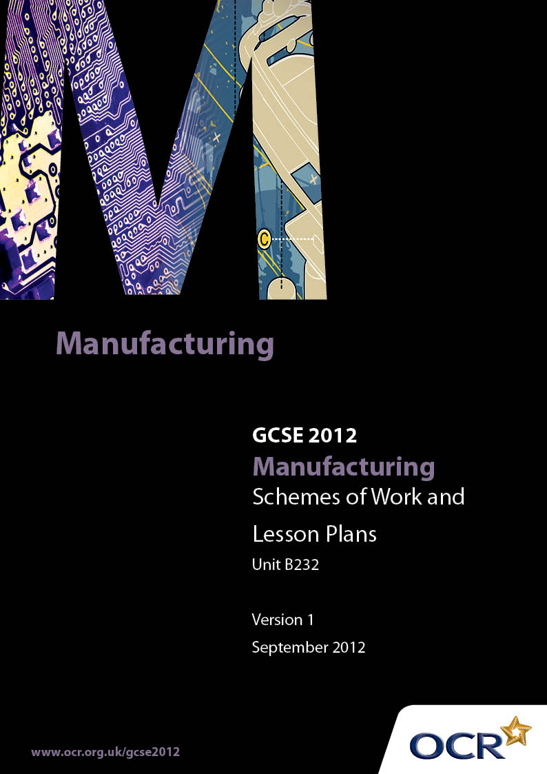

Contents
Introduction 3
Sample Scheme of Work: OCR GCSE Manufacturing J505 J510 Unit B232:
Manufacturing Processes 5
Sample Lesson Plan: OCR GCSE Manufacturing J505 J510 Unit B232:
Manufacturing Processes 12

Introduction

Background
OCR has produced a summary brochure, which summarises the changes to Manufacturing. This can be found at www.ocr.org.uk, along with the 2012 specification.
In order to help you plan effectively for the implementation of the new specification we have produced these schemes of work and sample lesson plans for Manufacturing. These support materials are designed for guidance only and play a secondary role to the specification.

Our Ethos
OCR involves teachers in the development of new support materials to capture current teaching practices tailored to our new specifications. These support materials are designed to inspire teachers and facilitate different ideas and teaching practices.
Each scheme of work and set of sample lesson plans are provided in Word format to be used as a foundation to build upon and amend the content to suit your teaching style and students’ needs.
The scheme of work and sample lesson plans provide examples of how to deliver these units and suggested teaching hours which could be applicable to your teaching.
The specification is the document on which assessment is based and specifies what content and skills need to be covered in delivering the course. At all times, therefore, this support material booklet should be read in conjunction with the specification. Any clarification should be found in the specification.

A Guided Tour through the Scheme of Work

= Innovative Teaching Idea
This icon is used to highlight exceptionally innovative ideas.


= ICT Opportunity
This icon is used to illustrate when an activity could be taught using ICT facilities.

OCR GCSE Manufacturing J505 J510 Unit B232: Manufacturing Processes
Suggested teaching time | 20-30 hours | Topic | Manufacturing processes
Topic outline |  | Suggested teaching and homework activities |  | Suggested resources | Points to note
Unit Overview: This unit will be assessed by a one-hour computer-based test or a one-hour written examination. Questions will be a mix of short answer and free response styles, and will require candidates to demonstrate practical application of knowledge related to products and manufacturing environments they have studied.
Where possible, links should be made with a manufacturing company to allow candidates access and exposure to ‘real-life’ manufacturing practice. Candidates should concentrate on one of the manufacturing sectors listed below and should study a range of products within that sector.
Candidates will demonstrate knowledge and understanding of the following:  Production methods in common use:  - materials and components, material selection appropriate to process;  - available technology, consider cost and timing;  - labour requirements (skills, training and experience);  - health, safety and hygiene;  - quality standards;  - market needs.  Materials, components and/or ingredients including modern and smart materials:  - Selection and reason for use; their availability, form and supply;  - their properties, characteristics and performance;  - their cost;  - health, safety and hygiene requirements;  - handling and storage  - Impact and use of modern and smart materials and components.  Modern Technologies used in Manufacture:  - Impact and use of modern materials upon design, production and manufacture;  - Impact and use of information, communication and digital technologies;  - Impact and use of systems and control technology to organise, monitor and control production - basic control systems and technology in terms of Input/Output (IO) and feedback  The stages in the design of a product - analysing client design briefs for manufactured products:  - Producing, using and modifying design specifications for manufactured products  - Considering material details and constraints  - Considering production details and constraints  - Applying quality standards  - Developing design ideas  - Presenting a design solution for manufactured products  - Modifying design solutions.  The stages in the manufacture of a product - The process of making a prototype from a design solution:  - Selecting and using:  - A range of appropriate materials, parts and components  - Appropriate processes  - Appropriate tools and equipment  - Applying health and safety procedures and quality control techniques  - Producing a batch of a product from a design solution as a member of a team  - Analysing and evaluating the product in terms of the equipment, tools and processes, which have been used, and detailing how these would be modified in real world manufacturing. |  | - It is suggested that the SOW for this unit has two parts.  Part A: the topic content is fully interwoven with that of unit B231 parts A and B if candidates are taking the Single Award and B231 parts A and B, plus B233 parts A and B for candidates undertaking the Double award. For these candidates, integration of some of the necessary preparation for B234 may also be included.  Part B: will consist of the “top up” topic content which, for each centre, has not been covered in their individual Part A.  - A centre based structured plan, building on students existing experience gained at KS3, should be prepared by each centre and orientated to either the Single Award J505 or the Double Award J510.  - These plans will differ depending on the teacher(s) delivering the specification, the centre resources and arrangements (e.g. links with other establishments) and the centres actual timetables and teacher contact times.  - It is anticipated that, rather than “theory” sessions dealing with each of the topics in turn, many centres will naturally link together to gradually complete a matrix of taught content. For example a lesson when some reverse engineering (the process of learning how a product is made by taking it apart and examining it) on a component or a simple artefact could draw together a number of the taught topics in a natural and holistic way. ❶  - Areas where knowledge is new (i.e. has not been covered during previous teaching or candidates’ controlled assessment activity) should include: demonstrations, media support – CD-ROMs, videos, industrial visits – and be re-enforced with a practical or visual duplication of information. ❷  - Ideally the majority of the topics will be addressed at least once during the “controlled assessment” activities and those activities which precede them. ❸  - Support can also be gained by linking directly with activities in Unit B231 A Study of an Manufactured Product where the work students are engaged in has this unit in mind. ❹  - Support can also be gained by linking directly with activities undertaken in Unit B231B Manufacturing a Product: Acquisition of practical skills ❺ with teachers naturally extending their teaching input to encompass the topics needing to be covered by this unit and checked off against the centre mapping.  - It is strongly suggested that centres produce some form of mapping, possibly a spreadsheet, with sector specific “topic content” cross referenced to:  the practical pre-“controlled assessment” activities students will undertake  KS3 experiences  controlled assessment activities, B231 Parts A and B, for Single Award students and also B233 Parts A and B for the Double Award students  - This will then reveal any topic areas which have not been covered and which may need specific “theory” inputs for final examination preparation.  - Sample Assessment materials should be used initially, and then past papers as they become available following each examination sitting,❼ as a template for centres generating their own worksheets and homework sheets for fortnightly exposure to all students. It is recommended that the structure of the questions should be copies and should not be changed. A range of different mark responses should be incorporated to give all students regular experience of what the papers will look and feel like and the types of things they will be asked to respond to.  - If centres generate sector specific questions for preparation to this unit they should be given the style and feel of the sample assessment materials and past papers which is an important “familiarisation” exercise and one which should not be underestimated.  - Where these work sheets and homework sheets are used, there should be group and/or individual feedback on the responses made by students to identify:  - Common misunderstandings  - Gaps in the teaching group’s knowledge  - Types of questions which students respond to poorly  - Use of the “un-rewardable” generic responses ❽  - Examination techniques e.g. mark allocations in brackets [4] ❾  - Time management  - Reading the whole question paper through before starting to answer  - Legibility  - Use of technical terms  - Quality of written communication  - Understanding and use of the Computer based assessment software if appropriate.  - Remedial input for any of the areas identified should then be incorporated into the SOW and form part of the preparatory content for any subsequent SOW |  | - Resources will vary greatly from Manufacturing sector to Manufacturing sector.  - Sample Assessment materials are available for this qualification at http://www.ocr.org.uk/Data/publications/assessment_materials/GCSE_Manufacturing_SAM_Unit_B232.pdf  - Past papers from examination sittings in this qualification when available  - OCR Manufacturing for GCSE. John Hill ISBN 9780340985090 | - Care should be taken by centres to ensure they correctly prepare students for the specification content for either the Single Award J505 or the Double Award J510. Unit contents are specific to each award.  - It is expected that preparation for this unit will be an on-going activity and not a final “theory” input immediately prior to the examination.  - Where possible, links should be made with a Manufacturing company to allow candidates access and exposure to ‘real-life’ Manufacturing practice.  - Candidates could concentrate on one Manufacturing sector and should study a range of products. Some examples are given below:  Chemical and pharmaceutical:  - Asthma medication  - Saccharin tablets  - Soap.  Clothing and textiles:  - Denim jeans  - High heel shoes  - Nurse’s uniform.  Electrical:  - Torch  - Electric kettle  - Alarm clock.  Food and drink:  - Tea bags  - Christmas cake  - Freeze-dried vegetables.  - Alternative Products: Candidates may well be fully exposed to all of the topic areas required by investigating products not listed. However, centres are advised that students would benefit from investigating the products which are indentified in the list on page 16 of the specification as there may well be assessment questions specifically about these.  - Sample Assessment Material is available which can be used during teaching by centres.  - Study of additional products in the sector may significantly advantage candidates but they must be sure to respond to the questions set and relate their responses to the product asked about, not a different product which they might have studied.  - Some questions will be asked in a generic way which will allow candidates the opportunity to respond accordingly with information based on their individual studies  - ❿There is some overlap of content with the Double Manufacturing Award (B234)  - However centres can expect different questions in each sitting for any overlap content. i.e. the questions will not be the same for the Single Award B232 paper and the Double Award B234 paper for the common content.  - ❹ A centre generated bank of questions to be asked during disassembly or “reverse engineering” (the process of learning how a product is made by taking it apart and examining it) activities, industrial visits, technical and other videos experienced by students should be designed to encourage an analytical interest in Manufactured products.  - ❺…a series of short, highly focused “teaching by demonstration activities” with immediate student’s “hands on” practice activities. It is not important that the practical activities result in the production of a Manufactured product or part of a product but that the process is experienced, understood and recorded by the student.  - ❽ In written examinations, candidates should be advised to avoid responses such as:  cheap / very cheap / cheaper, strong / stronger / very strong, light / very light / lighter, tough / very tough / tougher, unless they are qualified in some way.  - ❾ Guidance should be given as to the length and breadth of responses expected in an examination question. For example if a question has three marks [3] there is an expectation of three “bits” to their response. This might be two different points with some extension of a point or one point with several points of extension / explanation.

OCR GCSE Manufacturing J505 J510 Unit B232: Manufacturing Processes

Textiles and their Properties
OCR recognises that the teaching of this area will vary greatly from school to school and from teacher to teacher. With that in mind, this lesson plan is offered as a possible approach but will be subject to modifications by the individual teacher.
Lesson length is assumed to be one hour.

Learning Objectives for the Lesson
Objective 1 | Students to understand the terms Textiles
Objective 3 | Students to understand the general properties of Textiles
Objective 4 | Students to know a range of natural and synthetic Textiles
Objective 5 | Students to be able to identify a number of Textiles

Recap of Previous Experience and Prior Knowledge
Textiles: Known fabrics irrespective of category
Knowledge of any properties of those fabrics
Uses of: Students recall and apply knowledge and understanding of known uses of given fabrics
Identification: Students describe colouring, weight, strength and feel for the known fabrics

Content
Time | Content
5 minutes | Explanation of proposed lesson structure: Today we are going to widen our knowledge of Manufacturing materials. By the end of this lesson you will all know more about the main types of fabric in common use and some of their properties.  What we are going to do to start is you are going to tell me which fabrics you actually know at the moment. I’m going to write them down on the chalk board / white board / laptop as you tell me what you know. But… you need to watch where I write them down okay. You’ll see what I mean as we go through.
5 minutes | Student Activity: Students, in controlled, measured fashion indicate the textiles that they know. As they do the teacher writes them down, spelt correctly in one of three columns. The columns do not have headings on them. This is important!  As the students identify each of the known textiles the teacher will categorise them in columns of natural or synthetic.
10 minutes | Define the term Textiles, and synthetic and natural.  Mention that early textiles were made from natural materials such as wool, cotton and linen. Advances in the mid 20th Century led to the use of synthetic materials such as nylon and polyester. Today textiles continue to be used in clothing manufacture but are also used widely in aerospace, defence and medicine. Kevlar, as protective clothing is now well known, but was unheard of 20 years ago.  The concept that some textiles are a mixture of the two is then introduced and explained. In this way there are just 3 headings / categories for students to remember.
10 minutes | Practical Activity: Students examine and test the range of Fabric samples. They should give a visual description of the materials as well as describing any thing else they can discern from the tests. They record their findings on a sheet provided. Possibility of team work in pairs exists here.
10 minutes | Give out the work sheet below. Ask students to fit the name of the textile with the description by drawing an arrow between the two.  Nylon Fibre A natural material involving processes such as shearing, spinning and dying.  Thermochromic material  A highly stiff, flameproof material often used as bullet-proof vests.  Cotton A polymer based textile with good, strength and resistance to wrinkling.  Wool These materials can be described as those whose colour changes as a result of reaction to heat. Often dyes are used especially through the application of dyes whose colours change at particular temperatures.  Kevlar A natural material which can be described as having soft white fibres.
5 minutes | Tidying up, reforming into teaching positions with individual work sheets at the ready.
10 minutes | A pre-prepared worksheet will then gradually be unveiled by the teacher (ideal use of ICT) comparing the teacher information (previously obtained) to students’ findings in the above two exercises. They can tick them off, change their responses to get a correct copy of the necessary data, and are basically “marking” the accuracy of their findings.

Consolidation
Time | Content
5 minutes | Home work: To collect and/or identify two Manufactured components or artefacts made from fabric using the agreed list of fabrics identified during the lesson.

