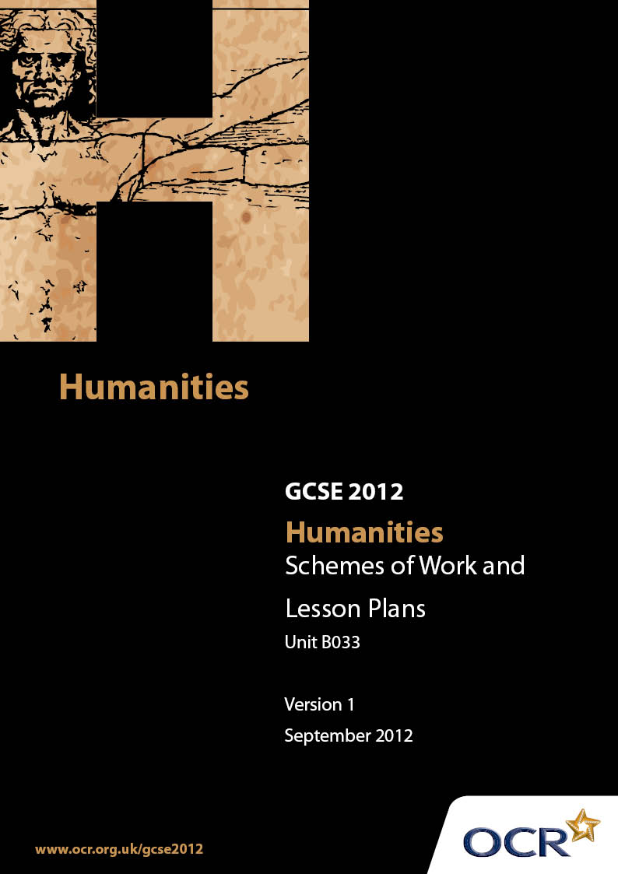

Contents
Contents 2
Introduction 3
OCR GCSE Humanities Scheme of Work Unit B033: Controlled Assessment 5
OCR GCSE Humanities Lesson Plan Unit B033: Controlled Assessment 8

Introduction

Background
Following a review of 14 – 19 education and the Secondary Curriculum Review, the Qualifications and Curriculum Authority (QCA) has revised the subject criteria for GCSEs, for first teaching in September 2009. This applies to all awarding bodies.
The new GCSEs have more up-to-date content and encourage the development of personal learning and thinking skills in your students.
We’ve taken this opportunity to redevelop all our GCSEs, to ensure they meet your requirements. These changes will give you greater control of assessment activities and make the assessment process more manageable for you and your students. Controlled assessment will be introduced for most subjects.
From September 2012 assessment tasks may be undertaken at any point between release of the task and the examination series for which the task must be submitted. Centres must ensure that candidates undertake a task that is valid for submission in the year in which the candidate intends to submit it.
OCR has produced a summary brochure, which outlines the changes to Humanities. This can be found at www.ocr.org.uk, along with the new specification.
In order to help you plan effectively for the implementation of the new specification we have produced these Schemes of Work and Sample Lesson Plans for Humanities. These support materials are designed for guidance only and play a secondary role to the Specification.

Our Ethos
OCR involves teachers in the development of new support materials to capture current teaching practices tailored to our new specifications. These support materials are designed to inspire teachers and facilitate different ideas and teaching practices.
Each Scheme of Work and set of sample Lesson Plans is provided in Word format – so that you can use it as a foundation to build upon and amend the content to suit your teaching style and your students’ needs.
The Scheme of Work and sample Lesson plans provide examples of how to teach this unit and the teaching hours are suggestions only. Some or all of it may be applicable to your teaching.
The Specification is the document on which assessment is based and specifies what content and skills need to be covered in delivering the course. At all times, therefore, this Support Material booklet should be read in conjunction with the Specification. If clarification on a particular point is sought then that clarification should be found in the Specification itself.

A Guided Tour through the Scheme of Work

= Innovative Teaching Idea
This icon is used to highlight exceptionally innovative ideas.


= ICT Opportunity
This icon is used to illustrate when an activity could be taught using ICT facilities.

OCR GCSE Humanities Unit B033: Controlled Assessment
Suggested teaching time | 15 hours | Topic | People work just to earn money to live with
Topic outline |  | Suggested teaching and homework activities |  | Suggested resources |  | Points to note
Initial introduction to actual enquiry |  | Brainstorm reasons  - Why do people work?  - What is the point of working?  - If you are using a focus, include this here.  - Add information on different types of industry  - Add information on why work is important for people  - HMK individuals should come up with an first draft of an outline plan to bring to the next lesson taking into account what they already know |  | - See scheme of work B032  - Use the Humanities Independent Enquiry Guidelines  - Learners should spend the lesson looking at the teaching of 3.2.3 and working out how they are going to approach the enquiry  - A proforma sheet with outline plan and deadlines relating to the enquiry should be given to the learners |  | - It is important at this point that the learners have completed 3.2.1 Different types and forms of evidence, 3.2.2 Using and evaluating evidence 3.2.3 Managing an enquiry and Communicating the results of an enquiry  - It is also assumed that prior to the start of the actual controlled assessment the methods of data collection will have been discussed and completed with the learners, e.g. they have a questionnaire, interview and observation sheet if needed
Discussion of enquiry set up |  | - Place learners in groups and get them to share and discuss the enquiry and the problems they can see  - Discuss/produce a research plan with whole class to make sure everyone is aware of the task ahead |  | - Learners should bring the completed proforma with them to the lesson  - The Unit B033 contains a controlled assessment guide which could be easily adapted for individual schools  - The hints on Coursework Methods are particularly useful here |  | - This is the point where learners need to become aware that teacher led lessons will soon cease  - Teachers need to be aware that from now on the learners need to take control. It is therefore vital that the methodology of enquiry is well understood before this section begins
Data collection |  | - Learners should go on work experience with a clear idea of what information they are expected to collect |  | - Some form of data collection manual should be included in the work experience pack |  | - The final form of the questions should be decided by the learner
Write up of Controlled Assessment. |  | - Learners need to be given clear guidelines which encourage candidates to look at their hypothesis and present findings in a variety of methods  - Learners should then be allowed to carefully read the mark scheme which they should be familiar with  - Time now needs to be made available for the candidates to complete the Controlled Assessment with little further input from the teachers. The time frame is now quite strict and the final document cannot be taken home to work on. It is therefore vital that candidates come to lesson prepared and ready to concentrate on completing the assessment |  | - A copy of the mark scheme should be available for the candidates to see where the marks are awarded. This should be discussed in some detail  - Learners must get into the habit earlier in the school curriculum of sitting down at a computer for a purpose. All too often time is wasted through lack of preparation and organisation  - It is suggested that the individual candidates’ time on the computer is logged so that they are aware of how much time they have right from the word go  - Being organised prior to sitting down becomes an absolute necessity and should improve the learners’ focus  - The learner should also have been shown how to organise an enquiry in the guidelines to B033. This cannot be used in the final Controlled Assessment |  | - Tables, graphs and spreadsheets may be produced using appropriate ICT. These should be inserted into the report at the appropriate place  - Any copied material must be suitably acknowledged  - Quotations must be clearly marked and a reference provided wherever possible  - Work submitted for moderation or marking must be marked with the: centre number; – centre name; – candidate number; – candidate name; – unit code and title; – assignment title  - The new guidelines might seem a bit excessive. However, they can be seen as an opportunity
Critical assessment and final checking |  | - Learners should be given a briefing on the purpose of a critical evaluation and encouraged to point out mistakes and come up with ways to improve the presentation  - The difference between evaluation and conclusion should be reinforced to the candidates. Ideally this should have been incorporated into the earlier teaching |  |  | - A copy of “Setting out your Controlled Assessment” could be used here as a final checklist  - Little can be given out at this point. The main focus is on how individuals manage to complete what they have learned themselves | - Please be aware that the moderators will be looking for examples of excessive similarity in coursework samples. It is vital that individual candidates complete their own work  - It is important to note that the process for completing the Controlled Assessment is the main focus here. Using the B033 guidelines is recommended to teach learners the process in detail, prior to attempting the final enquiry

OCR GCSE Humanities Unit B033: Controlled Assessment
OCR recognises that the teaching of this qualification above will vary greatly from school to school and from teacher to teacher. With that in mind this lesson plan is offered as a possible approach but will be subject to modifications by the individual teacher.
Lesson length is assumed to be one hour.

Learning Objectives for the Lesson
Objective 1 | Outline in detail the Controlled Assessment process
Objective 2 | Ensure learners have clear idea of what is needed.
Objective 3 | Give candidates a timetable and a framework to complete the tasks
Objective 4 | Begin the process of designing an outline plan

Recap of Previous Experience and Prior Knowledge
- Prior to beginning this section it is advised that the learners have completed a detailed run through of an investigation, based on a task which uses some form of structure similar to the B033 Guidelines.
- It is also advised that learners complete the Scheme of Work for B032 or something similar, including the lesson plan, prior to setting out on this work.

Content
Time | Content
5 minutes | Introduce the learners to the overall task, going over title and framework. “People work just to earn money”. Give out a proforma sheet with the outline and deadlines for the work.
10 minutes | Brainstorm reasons  - Why do people work?  - What is the point of working?  - If you are using a focus, include this here.  - Add information on different types of industry.  - Add information on why work is important for people.  At the end of section quickly cover the main areas to make sure all learners understand the issues.
5-10 minutes | Ask learners to come up with methods of enquiry which could be used to investigate the title “People work just to earn money”. It may also be useful here to reinforce the difference between questionnaires and interviews. Discuss this briefly as a whole class.

15 minutes | Learners could be broken down into small groups and given the task of coming up with an outline plan to answer the question. Individual groups should report back to the whole class. (It may be useful to ask for teaching assistant support for the less able in this lesson, to help ensure all learners are aware of what is needed).
10 minutes | Learners should be given a sheet with the main outline issues for the enquiry. As individuals they should now begin to fill in the outline plan

Consolidation
Time | Content
5 minutes | It is important that the teacher at this point outlines the process of the Controlled Assessment drawing attention to the main issues outlined in the guidelines.
10 minutes | If the learners can begin to set down their ideas in more detail, homework can be set as a completion of the outline plan to bring to next lesson, where issues and problems which may result from implementing the plan an be discussed.

