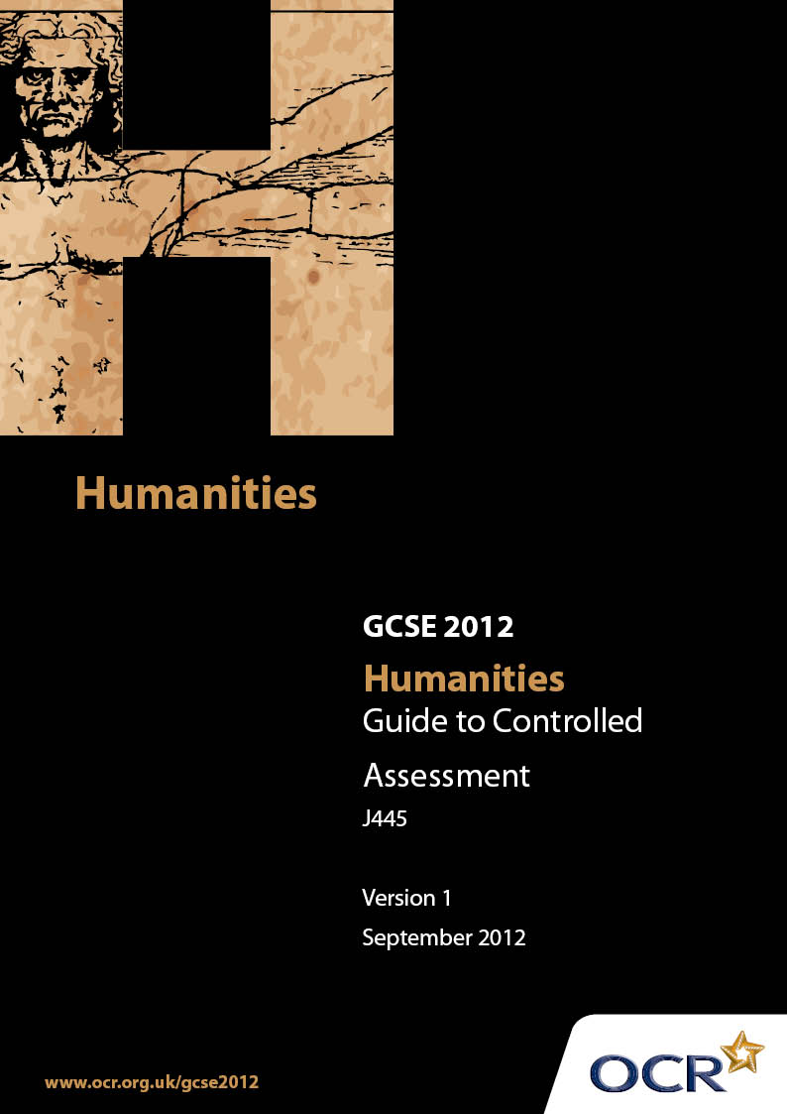
Contents

1 Introduction 3

1.1 What is Controlled Assessment? 3
1.2 What does ‘control’ actually mean? 3
1.3 What is the purpose of this Guide? 3

2 Summary of the Controlled Assessment unit 5

Unit B033: Humanities Independent Enquiry 5
2.1 The major changes 6
2.2 Humanities GCSE Controlled Assessment Issues Aims and learning outcomes 8

Marking Criteria for Controlled Assessments 15

3 Teacher guidance on how to plan Controlled Assessment 33

3.1 Controlled Assessment delivery flow chart 33
3.2 Guidance on the release of Controlled Assessment tasks to candidates 34
3.3 Guidance on research/data collection 34
3.4 Guidance on the production of the outcome 35

4 Controlled Assessment student guidelines 37

4.1 | Task setting | 37
4.2 | Task taking | 37
5 Teacher guidance on task marking 41

5.1 Generic guidance on how to mark Controlled Assessment tasks 41
5.2 Unpacking assessment objectives in Controlled Assessment tasks 42
5.3 Interpretation of the Controlled Assessment marking criteria 42
5.4 Authentication of Controlled Assessment outcomes 42
5.5 Internal Standardisation of Controlled Assessment 43
5.6 Moderation of Controlled Assessment 43
5.7 Minimum requirements for Controlled Assessment 43
5.8 Submission date for Controlled Assessment 43

6 FAQs 44

7 Guidance on downloading Controlled Assessment tasks from Interchange 46

Before you start 46
Step 1 – Log into Interchange 47
Step 2 – Navigate to Controlled Assessment materials area 48
Step 3 – Search for materials 49
Step 4 – Open materials 50
Step 5 – Troubleshooting 51

8 Guidance for the production of electronic Controlled Assessment 54
1 Introduction

1.1 What is Controlled Assessment?

High, medium or limited control levels are set for each of the Controlled Assessment processes: task setting, task taking and task marking. For each stage, the level of control will ensure reliability and authenticity, and make assessments more manageable for teachers and candidates.

Weighting of Controlled Assessments is defined by QCA subject criteria and, depending on the subject, will be 25% or 60% of the total assessment.

In response to reforms announced by the Government and in response to Ofqual mandated changes to GCSEs, unitised assessment of this qualification is being replaced by linear assessment.

This means that candidates commencing a two year course from September 2012 will take all of their GCSE units at the end of the course in June 2014.

1.2 What does ‘control’ actually mean?

QCA has produced a Glossary of terms for Controlled Assessment regulations. The levels of controls are defined as follows:

• Formal supervision (High level of control) – the candidate must be in direct sight of the supervisor at all times. Use of resources and interaction with other candidates is tightly prescribed.

• Informal supervision (Medium level of control) – questions/tasks are outlined, the use of resources is not tightly prescribed and assessable outcomes may be informed by group work. Supervision is confined to (i) ensuring that the contributions of individual candidates
are recorded accurately, and (ii) ensuring that plagiarism does not take place. The supervisor may provide limited guidance to candidates.

• Limited supervision (Limited level of control) – requirements are clearly specified, but some work may be completed without direct supervision and will not contribute directly to assessable outcomes.

1.3 What is the purpose of this Guide?

This Guide provides detailed information for teachers about how to manage Controlled Assessment. Some of the information applies to all GCSE subjects and some information provides subject specific guidance. It is important to make the point that this Guide plays a secondary role to the Specification itself. The Specification is the document on which assessment is based and specifies what content and skills need to be covered in delivering the course. At all times,
therefore, this teacher support document should be read in conjunction with the Specification. If clarification on a particular point is sought then that clarification should be found in the Specification itself.

Teaching of this qualification will vary greatly from school to school and from teacher to teacher. With that in mind, this Guide is offered as guidance but may be subject to modifications by the individual teacher.
2 Summary of the Controlled Assessment unit

Unit B033: Humanities Independent Enquiry

This unit represents 25% of the total assessment and has a maximum of 50 marks.

Each year OCR will set a choice of ten tasks, two on each of the five content areas identified for Unit B031. Each candidate undertakes one task, with a word limit of about 2,000 words. Candidates at a Centre can do the same or different tasks. This is a Centre decision, based on what is manageable within the Centre. Note however that tasks have a shelf-life of one year.

This unit is internally assessed, applying the principles of Controlled Assessment. Controls are set within the assessment in each of the stages of the assessment process:

Task setting: high level of control in relation to the setting of tasks.

Task taking: this stage is divided into 2 different stages, each with a different level of control:
- Research/data collection: limited level of control
- Analysis and evaluation: high level of control

Task marking: medium level of control.

More information about each stage of the process is provided in the following sections of this
Guide.
2.1 The major changes

The coursework is now called a Controlled Assessment Unit; candidates undertake an enquiry which leads to the production of a written report with a word limit of about 2,000 words. (See Section 8 for details of submission format)

A new set of Enquiry questions will be set by OCR for each session. The same OCR Controlled Assessment task must NOT be used as practice material and then as the actual live assessment material. It is however, recommended that the candidates have a clear idea of investigation methodology prior to completing the live assessment material. Centres should devise their own practice material using the OCR specimen Controlled Assessment task as guidance.

NB A previous year’s task may NOT be re-submitted in the following year.

Each year OCR will set a choice of ten tasks, two on each of the five content areas identified for Unit B031. Teachers can select from these the tasks they wish to do: it is anticipated that candidates will have a very limited choice of tasks available to them. The list of ten tasks will be changed each year. Centres with fixed programmes such as work experience will be catered for but the focus of the investigation will change each year within the work experience framework.

The set tasks will provide scope for candidates to develop the methodological skills necessary in an investigative enquiry, leading to an evaluation of the validity of the enquiry process and the problems associated with it. It is suggested that in addition to a practise run through, the candidates complete Unit B032 prior to embarking on the live assessment material.

NB It is here that the main change in terms of former teaching practice takes place. In the past it has been possible, and indeed often the case, that candidates combined learning methodology and completing coursework at the same time. The controlled assessment cannot be done in this way. Candidates need to know the investigation process in detail prior to embarking on the assessment.

It is anticipated that candidates will spend a total of about 15 hours in producing the work for this unit. The control of the candidates at various stages of the task will be at one of three levels: limited, medium and high. It is suggested that assessment might be divided into the following stages. Timings are approximate; actual time allocations will depend on the task concerned. Timings are for guidance only. The main control is through word limit.

Introduction to the task (teacher led) 1–1.5 hours

This is by definition high authenticity as it is teacher led. It includes: choice of tasks, identifying specific methods from the possible approaches and sources of evidence, time allocations, programmes of work and deadlines, methods of working, control requirements. The provision of model answers is not allowed.

Research/collection of evidence 3–4 hours

This is classed as limited authenticity as some of the work, by its very nature, may be undertaken outside the centre, eg research work, fieldwork, etc. Work outside direct supervision of the teacher might include, for example, working in the library or homework club but NOT at home. It also may include fieldwork, internet- or paper-based research, questionnaires, etc. Details of sources and evidence collected should be retained for inclusion in portfolio. The teacher provides
guidance on any Health and Safety issues and ensures control requirements are met. There is some scope for candidates to work collaboratively in the collection of evidence. Candidates can be given support and guidance during the research/data collection phase of task taking. Centre staff can explain the task, advise on how the task could be approached, advise on resources and alert the candidate to key things that must be included in their evaluation and analysis of findings. It should be remembered that candidates are required to reach their own independent judgements and conclusions.

Production of enquiry report 5–6 hours followed by redrafting 2-3 hours

This is classed as high authenticity as using or applying the collected material for analysis and evaluation of findings will be undertaken under direct teacher supervision. In all cases, the teacher must be able to authenticate the work and there must be acknowledgement and referencing of any sources used. If writing up is carried out over several sessions, work must be collected in between sessions. In these sessions the candidate produces a first draft of the enquiry report. The teacher may provide verbal feedback and should ensure throughout the process of production that all control requirements are met. Candidates are given the opportunity to check, edit and redraft their work prior to submission.

Task completion/submission 1–2 hours

This is classed as high authenticity as candidates need to ensure that their work is complete and complies with control requirements concerning acknowledgement of sources etc and is ready for final submission. Candidates must observe certain procedures in the production of Controlled Assessments.

Tables, graphs and spreadsheets may be produced using appropriate ICT. These should be inserted into the report at the appropriate place.

Any copied material must be suitably acknowledged.

Quotations must be clearly marked and a reference provided wherever possible. Work submitted for moderation or marking must be marked with the:
centre number; – centre name; – candidate number; – candidate name; – unit code and title; –
assignment title.

Work submitted on paper for moderation or marking must be secured by treasury tags. The teacher goes through the work with the candidate to ensure that it is suitable for formal authentication and signs off necessary documentation.

The new guidelines might seem prescriptive. However, they can be seen as an opportunity. Candidates must get into the habit earlier in the school curriculum of sitting down at a computer for a purpose. All too often time is wasted through lack of preparation and organisation. It is suggested that the candidates’ time on the computer is logged so that they are aware of how much time they have right from the word go. Being organised prior to sitting down becomes an absolute necessity and should improve the candidates’ focus. The following framework for the practice material is a possible format to outline how almost any enquiry could be approached.
NB The candidates cannot use the following framework in its entirety for the live enquiry. It does, however, make a very valuable teaching aid.

2.2 Humanities GCSE Controlled Assessment Issues Aims and learning outcomes

The rationale of this Humanities GCSE is that it is the Humanities area enquiry methodology that sets it apart from individual subjects; as such the controlled assessment is a central part of the specification. Specifically the Humanities GCSE is very well placed to fulfil the learning outcomes appropriate for controlled assessment, these are to:

a) carry out an investigation/research/enquiry and draw conclusions
b) analyse and evaluate sources of evidence and interpretations in the context of an enquiry c) apply knowledge and understanding to produce extended narratives, explanations and
analyses, including comparative analyses

d) apply knowledge and understanding to new contexts and real issues e) undertake practical and ICT based tasks
f) develop knowledge and understanding of the locality and contemporary events or issues.

2.2.1 Investigative Methodology

In terms of task setting:

The awarding body delimits 10 areas of investigation each year by setting a range of tasks designed to allow candidates to access all the levels of the marking criteria.

An example of a task might be:

“Is work experience a valid way of finding out about the world of work?”

The teacher chooses the task to fit a specific enquiry which suits the school best.

The awarding body, by strictly defining the methodology of enquiry and criteria for enquiry assessment, provides a very high level of reliability.

There are tight guidelines covering the way in which the enquiry is undertaken and the results should be analysed in the context of the enquiry methodology.
The teacher input enables the task to be tailored to the circumstances and experiences of the candidates, to take advantage of local preferences and avoid formulaic and predictable tasks.
Candidate’s Guide: A worked example of a Controlled Assessment Task

Social Research – Conducting an Enquiry

General Topic
Decide on a general topic for investigation. Ours
is ‘The World of Work’

Narrow your Topic Down

We will narrow down this very wide topic because it’s too big. The teacher will select relevant tasks from the list produced by the Awarding Body, that fall within this area.

Hypothesis

This is the specific question (from the list of tasks set by the Awarding Body) which your enquiry will be based around. You will attempt to prove or disprove it. For this example it is
“Work experience is a valid way of finding out about the world of work”
Methods and Techniques

You need to decide which research methods you will use. Try to have a balanced approach, so use between two and four different methods.

Conduct Your Research

This is the active bit! Both secondary and primary sources of information can be used, both qualitative and quantitative data displayed

Write your Enquiry

Try to use a variety of information and methods of presenting it.
Neat, clear, attractive, interesting and relevant.

Critical Assessment

Remember to include a critical commentary of how you worked. Even the mistakes are important. You’ll need to write about how it could be improved next time!
Setting up the Enquiry

In your controlled assessment set up, the following questions will need to be addressed, before you attend work experience.

• Who do you want to sample? Which group of people are you trying to find out about? Is it all types of people or a specific group?

• What exactly do you want to find out about? (This will be narrowed down and specified in your hypothesis).

• Which research methods are appropriate and which will you use? Have between two and four. Use your own primary research, but also make use of other sources of secondary data.

• As for primary data, you should look for quantitative and qualitative data and display it in various forms in your finished enquiry.

• What kind of primary quantitative data will you research? (structured questionnaires/non- participant observation)?

• What kind of primary qualitative data will you research?
(in-depth interviews – for example with local people, a council official, a local pressure group).
Setting Out Your Controlled Assessment

Title Page | Have an interesting and appealing title page. It should have your name, class, subject and controlled assessment title on it.
Hypothesis | This is a specific question about the topic which your enquiry will be based around. You will attempt to prove or disprove it.
Introduction | Explain the general topic of your coursework. Mention the research methods you used and why you chose them. You can also include here any thanks you might wish to give to anybody who was especially helpful.
Evaluation | Evaluate your research methodology in a ‘critical commentary’. The evaluation/critical commentary is your judgements about the way the research was handled and carried out, and how it could be improved. Also note what went well; evaluations aren’t necessarily all negative. You should also justify your choice of research method and explain why you used the methods you did.
Findings | Here you set out your findings. Annotate and explain any diagrams, pictures, charts or graphs. Captions should be used to give further explanation where necessary. Findings should be displayed using appropriate, interesting and detailed methods, these should be clearly explained to the reader.
Conclusions | Your conclusions are what can be said about the results you’ve managed to gather. You should always say that your conclusions are tentative (not certain, not absolutely definite for all time) and could change if further research was done.
Notes | If you use secondary research or quote from other sources in your findings, you must have your numbered notes (references) here. You should also acknowledge any other help you had. For example, if your questionnaire was done in a small group you must say this and name the other group members.
Bibliography | This is simply a list of all the secondary sources used (books, websites etc.). You should include the title, author, publisher and date of publication.
Appendix/ Appendices | You may not need an appendix. It can be used to include anything that doesn’t really fit into the main body of the enquiry. For example, if you wrote to someone for information and they replied to you, you could include the whole letter as an appendix. You wouldn’t copy it all completely into your work but you may quote from it. If you did, in your ‘note’ you could also say “see appendix”.

How your Controlled Assessment will be marked

When your teacher marks your work, he or she will be looking to see how well you have done on the five items below. This is called a mark scheme. Your teacher will use it to decide how many marks to give you.

Before you start your timed write up it is vital that you understand exactly what you are going to do and how long each section is going to take.

Have a clear research strategy AO3 (a)

Anyone reading your enquiry is able to learn a lot about the subject of your research strategy. You use correct terms clearly in explaining what you found out and how you did it. (Up to 10 marks).

Choose a suitable subject for your research. Find useful evidence and organise it properly.
AO3 (b)

Anyone reading your enquiry knows why you chose your subject and what you are doing. You find suitable information and choose the most useful pieces. You say why you have chosen them and explain where you obtained your information. (Up to 10 marks).

Record and present your findings AO3 (c)

You present your findings clearly. You help people to understand your findings by using diagrams, tables, graphs or pictures. Anyone reading your enquiry is able to follow your argument clearly and can understand what you are saying. (Up to 10 marks).

Explain how you could have improved your research AO3 (d)

You describe what was good about your research and what went wrong. You explain how it could have been improved. (Up to 10 marks).

Interpret and evaluate your findings AO2 (c)

You show clearly what your evidence means. You say how reliable it is. You say whether any of it is subject to bias and compare different pieces of evidence. You use evidence well to back up your conclusions. Your evidence convinces anyone reading your enquiry. (Up to 10 marks).
Marking Criteria for Controlled Assessments

 | AO2 [10 marks] | AO3 [40 marks]
Marks | Reach reasoned conclusions based on a range of evidence  AO2c | Apply appropriate research methodology  AO3a | Locate, select and organise material relevant to the enquiry  AO3b | Record and present findings in a coherent and purposeful form  AO3c | Evaluate the research methodology employed in the enquiry  AO3d
0 | No evidence  submitted or response does not address the question | No evidence submitted or response does not address the question
1–2 | The candidate  reaches a conclusion linked loosely to some information in the enquiry | The candidate submits  some concrete ideas described in an easily understandable way | The candidate locates  some appropriate information | The candidate presents some relevant  information. Written work is clear  enough to allow an understanding of the general focus of the enquiry. The candidate has either written relatively little or it is of some length but the content is not focussed on the task(s). Text is difficult to read with poor spelling and grammar and little punctuation | The candidate describes the  research methods adopted
3–4 | The candidate reaches an  acceptable conclusion that is  linked to evidence | The candidate’s enquiry has an implicit research  strategy underpinning it | The candidate locates some relevant information  from which selections are made | The candidate uses some appropriate methods to present findings relevant to  the research subject. Written communication is clear and uses simple  conventions of grammar and  punctuation with reasonable accuracy. The meaning is largely clear. The work of the candidate lacks precision and succinctness, but the work presented still does not exceed the prescribed word limit | The candidate describes the research methods  accurately and identifies at least one problem with the  methods chosen

 | AO2 [10 marks] | AO3 [40 marks]
Marks | Reach reasoned conclusions based on a range of evidence  AO2c | Apply appropriate research methodology  AO3a | Locate, select and organise material relevant to the enquiry  AO3b | Record and present findings in a coherent and purposeful form  AO3c | Evaluate the research methodology employed in the enquiry  AO3d
5–6 | The candidate reaches an acceptable conclusion that draws on specific evidence | The candidate’s enquiry is well organised with an explicit and coherent research strategy | The candidate locates selects and organises relevant information in a coherent way | The candidate records and presents their findings clearly and accurately, using specific methods, showing an understanding of why some presentation methods are more appropriate than others. Written communication is clear with grammar and punctuation used with reasonable accuracy. The candidate has written with precision or succinctness and has not exceeded the prescribed word limit | The candidate describes the research methodology fully and accurately giving reasons for their choice, mentioning some strengths and weaknesses
7–8 | The candidate reaches an  acceptable and relevant conclusion  that uses a selection  from evidence within the enquiry to support it | The candidate produces a well-organised enquiry that  is logical and coherent. It has an obvious research-  based structure. The  content and commentary form a clear picture of what is being recounted | The candidate locates and selects relevant information  and shows an understanding of  appropriate techniques for  collecting different types of information | The candidate records and presents their findings showing a well-founded  understanding of appropriate methods, applied in a clear, accurate and well-  ordered fashion, using technical  language in context. Written communication is clear with mostly accurate grammar and punctuation. The candidate has written with some precision and succinctness, but has not exceeded the prescribed word limit | The candidate describes the research methodology  fully and accurately giving reasons for their choice.  Strengths and weaknesses  are discussed, with some suggestions of alternatives that could be used

16 © OCR 2009
Guide to Controlled Assessment in Humanities

 | AO2 [10 marks] | AO3 [40 marks]
Marks | Reach reasoned conclusions based on a range of evidence  AO2c | Apply appropriate research methodology  AO3a | Locate, select and organise material relevant to the enquiry  AO3b | Record and present findings in a coherent and purposeful form  AO3c | Evaluate the research methodology employed in the enquiry  AO3d
9–10 | The candidate reaches an acceptable and relevant conclusion that is based on a thorough evaluation of the range of evidence presented in the enquiry | The candidate’s enquiry is detailed and coherent. An explicit methodology has been applied appropriately. Separate sections are related to the general direction of the enquiry | The candidate shows a good understanding of the techniques used to collect different types of information. The selection of sources shows an awareness of the need for comparison | The candidate records and presents their findings in a most appropriate way, paying attention to reader accessibility, with a close relationship to the subject of research and the evidence collected. The enquiry is organised in a coherent and effective manner, consistently applied throughout. Written communication is very clear and precise, using accurate  grammar and punctuation. The candidate has written with precision and succinctness, so that the candidate does not exceed the prescribed word limit | The candidate describes and evaluates the research methodology employed, deficiencies are discussed, with suggestions for positive improvements or the use of  alternative valid methodologies

“Work experience is a valid way of finding out about the world of work”

You have to test this idea/hypothesis using your work experience as your primary source of data. You should not rely just on your own experience – use the experience of others and secondary sources (things other people have written) this will give your research more validity.

Your controlled assessment is worth 25% of your final grade

You can test your school-learned perception of work against the reality of the workplace.

How do I get good marks?

• You will be given a mark scheme. This is the exam board’s one. You should use this when planning your work to make sure you pick up as many marks as possible

• Gather information in a variety of ways and justify why you have chosen these methods

• Ask appropriate and relevant questions

• Interpret and analyse the information that you gather

• Present your findings using, for example, graphs, tables and written accounts

• Check your spelling, punctuation and grammar.

Introduction

• Why do people work?

• What is the point of working?

• If you are using a focus, include this here

• Add information on different types of industry

• Add information on why work is important for people

• Discuss/produce research plan.

Methodology

• What methods are there?

• What methods are you choosing and why? Remember to give any disadvantages of possible limitations of this method. Say how you plan to overcome these eg by using a combination of methods

• Which methods are you rejecting and why?

• Include a copy of your questionnaires/interview schedule.
Presentation of evidence

(1) Secondary evidence

What did you already know about work experience and work placement? Use technical terms to describe your placement eg primary/secondary/tertiary employment sectors, manual/non- manual work. You could use these sources: government guidance, teachers, books, Internet, the experiences of relatives and friends.

(2) Primary evidence

a) Your experience of work – this will be using interviews/questionnaires and participant observation and everyone should use these methods, unless you have a very strong reason for rejecting it. You can use a diary. Remember to focus on the hypothesis – are you gaining a valid insight into the world of work?

b) Present the findings from your other methods of research (eg questionnaires, interview).

• Remember that this research should only focus on the hypothesis

• Present your findings appropriately – graphs, tables, charts, written accounts, photos, drawings, diagrams, and plans. There are lots of marks for this so use a variety of methods

• You must analyse all of your results – say how each finding relates to the question. What does it tell you about hypothesis? If you do this for each finding eg graph, this will help you enormously when you come to the conclusion

• Produce separate sections for each research method.

In all this section you could highlight the differences and the similarities between the work you were doing and the work of others in your work placement. You can use these topics to see how typical your experience of work was:

• Tasks undertaken

• Structure of the working day

• Working conditions

• Facilities you were able to use

• Skills you needed.

You should also see if there are any patterns amongst the employees. For example, do younger employees undertake a different range of tasks from older employees? Interview staff at the workplace and/or other classmates and analyse this. When you do this, think about these indicators.

Think about:

• How long they’ve been there

• Age
• Educational qualification

• Levels of responsibility

• Gender

• Ethnicity.

If you are using a focus, you should include some discussion of it here.

c) Compare your results and those of others in your class. Putting together yours and other students’ questionnaires should be done to see if your experience is similar or different to others. This information can also be used to produce a much larger questionnaire survey.
Controlled Assessment writing up guidance
NB This can only be used in the practice enquiry. Suggestions for candidates: Writing up the methods used

Introduction

In this section I will explore all the research methods that I can use to research my hypothesis. I have completed some secondary research. I obtained my information from… The advantages of this type of information are… and the disadvantages are…

For the methods you are going to use:

• I have decided to use… This means…

• I have chosen to use this method because…

• The main strengths of this method are… Furthermore… Moreover…

• However, I know that this method has weaknesses, for example…

• I plan to overcome these weaknesses by… (Write this for each method used.)

For the methods you are going to reject:

• I have decided not to use… This means…

• I have decided not to use this method because..

• I know that this method has strengths, for example… Furthermore…Moreover…

• However, I am also aware of weaknesses, for example… Additionally… (Write this for each method rejected.)

Sampling:

• I know that my sample needs to be representative. I have chosen to use… method of sampling because…

• I have chosen to reject… method(s) of sampling because…

Justification for choice of methods

• Recap:

− Which methods you have decided to use and why (the most important reason)
− Which methods you have decided to reject and why.

• Explain why you have chosen to use a combination of methods (triangulation).

READ THIS !!!
You should include a detailed research plan ie what research you plan to do before going on work experience, what research you plan to do while on work experience and what research you plan to carry out when you finish work experience. It is worth several marks.
Writing up questionnaires

This is only designed to give you ideas about how to write up a questionnaire; obviously you need to use your own common sense!

I/we sampled…

• Give the overall number of people sampled, try to combine your work with others to increase the overall sample size

• Explain how you went about gathering the questionnaires.

Put the answers into graphs as described below…

Graphs basically tell you about one of two things (if you can’t link your question to one of these, then it is a bad question!):

• Your sample

• Your hypothesis.

You need to describe what each of your graphs tells you, for example:

Simple graphs interpretations

Graph 1 shows me that everyone in the sample is in employment. This means that I have a knowledgeable sample as people are all capable of answering the questions, since they are familiar with the research topic.

Graph 2 shows that I interviewed roughly equal numbers of males and females. This will mean that
I have a representative sample. OR
Graph 2 shows me that I interviewed more males than females. This may mean that my sample is not representative because it will be biased towards the point of view of males. This may affect my results. Later in my research study, I will counter this bias by interviewing some more females to help balance the opinions.

Hypothesis type graphs

Graph 5 shows that most interviewees did/did not do tasks similar to work experience students. This supports/does not support my hypothesis that work experience gives a valid insight into the world of work.

Graph 8 does/does not support the hypothesis because it suggests that older interviewees undertake very different tasks from work experience students. However, the sample was rather small and may not truly represent what people actually do.

Don’t forget!!
When you have finished describing all your graphs, you need to write a conclusion which sums up what you have learnt. eg Overall, my questionnaire does/does not support the hypothesis because…

Overall, this does/does not support my hypothesis because… If you can, try to explain these differences – suggest possible reasons for them.
Writing up interviews

This is only designed to give you ideas about how to write up an interview; obviously you need to use your own common sense!

I interviewed…

• Don’t mention names but do give sampling details (eg a 26-year old white female)

• Explain if it is a formal or informal interview

• Describe when you interviewed them and how you chose them (did you think about the sample?)

(S)he told me that…

• Describe the information they gave you eg their work placement/the jobs they did etc.

• Explain if you had to ask any additional questions eg I asked him/her to explain in more detail and (s)he said…

(S)he felt that…

• Include details from their body language to back up your points eg he smiled when he said…

Overall, this does/does not support my hypothesis because… Comparison of interviews
If you are doing a number of interviews then it is a good idea to compare your results. Try using phrases like:

• The majority of my interviewees felt…

• A minority felt…

• Most people…

• In comparison…

• Similarly…

• In contrast…

• However…

If you can, try to explain these differences – suggest possible reasons for them.
Writing up a Participant Observation/Work Experience Diary

This is only designed to give you ideas about how to write up a participant observation/work experience diary, obviously you need to use your own common sense!

I worked at…

On my first day I had to…

• Explain what time you arrived

• Describe what you had to do

• How did you feel?

• How did the other employees treat you?

• Did you have any problems?

Most days I had to

• Describe a typical day.

I particularly enjoyed it when…

• Describe a day/activity/incident that you particularly enjoyed.

I did not like…

• Describe the aspects of the job that you didn’t like.

The other employees…

• Describe how you were treated

• Were you treated the same as other employees? Same hours? Same tasks?

I feel that I learnt…

• What skills did you learn? Try to give examples to back up what you are saying.

• What did you learn about the world of work? Eg have to be in on time etc.

I would have gained a more valuable insight into why people work if…

• What would have made your work experience more valuable?

Overall, I think that my participant observation does/does not support the hypothesis because…
Tip: Include technical worlds eg filing/database and explain what they mean.

READ THIS !!

A very large number of marks are given to the evaluation and conclusion of your work to check you have understood the processes in an enquiry. Basically you have to say what you have found out and back this up with evidence from your enquiry. You then have to look at your methods and decide what worked and what didn’t, if you can offer some ideas of how you would do the enquiry better if you did it again, do so.
Conclusion

This is where you consider the hypothesis. You must say how accurate you think the hypothesis is. You need to summarise your findings and evidence. You should establish if there are any patterns between your own and others’ experiences.

You should use these questions to help you in this work. This will enable you to answer the hypothesis.

• Can a week be long enough to get an insight into the world of work?

• Were you given the same task as others?

• Were you treated the same as other employees?

• Would your experience be different in another type of placement?

• Do you think your experiences would have been different if it had been your first week of full time employment?

• Did you have to do any menial task irrelevant to the job?

• What did you experience that was meaningful?

• Can you make a generalisation about the world of work on the basis of this piece of research?

Method of organisation to be considered when writing the conclusion

In this section, I will comment on each of the points in the result section of my work to show which parts support and which parts do not support the hypothesis.

Firstly from my secondary evidence – as you can see, on pages … to … this does/does not support the hypothesis because…

Next from my observation evidence – as you can see, on pages … to … this does/does not support the hypothesis because…

Additionally, from my questionnaire evidence – as you can see, on pages … to … this does/does not support the hypothesis because…

Furthermore, from my interview evidence – as you can see, on pages … to … this does/does not support the hypothesis because…

Finally, from my class survey evidence - as you can see, on pages … to … this does/does not support the hypothesis because…

From all of this discussion, I can make an overall decision about the hypothesis. Work experience does/does not give a valid insight into the world of work.
OR
Work experience does/does not give some valid insights, the exception to this is… OR
Work experience does/does not give a lot of valid insights, the exception to this is…

Remember you responses should be justified where possible using evidence you have collected.

THE WHOLE IDEA IS TO ANSWER THE QUESTION – IS THE HYPOTHESIS ACCURATE?
Evaluation

a) Your evaluation is where you decide how successful your research has been.

Consider:

• What went well? How successful were the methods you used?

• What went wrong if anything? Were there any unforeseen problems?

• Which methods were most reliable?

• Were your methods valid?

b) Suggest any ways in which you could have improved your research. Method of organisation to be considered when writing the evaluation In this section, I will comment on how effective my research has been.
The things that went well are…

The methods I used were totally successful/mostly successful/not successful at all. The reasons for this are…

As for things going wrong or unforeseen problems…. Examples could include –

•      Questionnaire poorly designed

•      Questionnaire not handed out in time

•      Questionnaire not completed

•      Lateness or absence

•      I was badly treated

•      I did not collect sufficient secondary evidence

•      People did not turn up for my interviews

As for my methods’ reliability and validity: I feel that (choose a method) was reliable because… but its reliability could have been strengthened in this way…

Secondly… Next…
I feel that (choose a method) was valid because… but its validity could have been strengthened in this way…
Secondly… Next…
If I was to do this research again the things I would have liked to done differently are… Examples could include, give out more questionnaires, find out more secondary evidence.
Bibliography

List any articles, books, programmes, websites that you have used to get secondary information. Include title, author, date, type of information.

eg In this section I have written a list of all documents I have used to help me with this research. This includes articles, books, computer programmes and websites.

Title Author Date of publication Type (eg book or website)
3 Teacher guidance on how to plan
Controlled Assessment

3.1 Controlled Assessment delivery flow chart

OCR set tasks

Teacher Guidance/ Feedback
Candidates Work in Progress
Research
Data collection
Planning

Candidates Produce Outcome for Assessment
Analysis and evaluation
of findings under controlled conditions

Timetabled
Lessons

Anticipated that students will spend about 15 hours producing work for this unit

See Scheme of work for Unit B033

Evaluation/ Review

Teacher Assessment and Submission to OCR for Moderation by specified deadlines
Submission of marks to moderator by
15 May

3.2 Guidance on the release of Controlled Assessment tasks to candidates

3.2.1 Choice of Controlled Assessment task

OCR will assume a high level of control in relation to the setting of tasks. Ten Controlled Assessment tasks will be available from OCR for the Controlled Assessment unit. These tasks will be changed each year. These tasks have been designed to enable candidates to meet the full assessment requirements of the unit. Candidates will need to take part in a planned learning programme that covers the underpinning knowledge and skills of the unit in addition to completing the evidence requirements of the designated assessment task.

Controlled Assessment tasks may be contextualised by centres in ways which will not put at risk the opportunity for candidates to meet the Assessment criteria, including the chance to gain marks at the highest level.

3.2.2 How to give Controlled Assessment tasks to students

Controlled Assessment tasks will be available from Interchange.

Centres should refer to BO33 Scheme of work and Lesson Plan for suggestions on how to plan and deliver this Unit.

3.3 Guidance on research/data collection

There is a limited level of supervision for this phase of the process.

a) Authenticity control: For the GCSE in Humanities, OCR will assume a limited level of control for research/evidence collection. In this context, some of the work, by its very nature, may be undertaken outside the centre, eg research work, fieldwork, etc. Work outside direct supervision of the teacher might include, for example, working in the library or homework
club but NOT at home. A high level of control will apply for using or applying this material and
for analysis and evaluation of findings, which will be undertaken under direct teacher supervision. In all cases, the teacher must be able to authenticate the work and there must be acknowledgement and referencing of any sources used. If writing up is carried out over several sessions, work must be collected in between sessions.

b) Feedback control: Candidates can be given support and guidance during the research/data collection phase of task taking. Centre staff can explain the task, advise on how the task could be approached, advise on resources and alert the candidate to key things that must be included in their evaluation and analysis of findings. It should be remembered that
candidates are required to reach their own independent judgements and conclusions. When supervising tasks, teachers are expected to:

• exercise continuing supervision of work in order to monitor progress and to prevent plagiarism
• exercise continuing supervision of practical work to ensure essential compliance with
Health and Safety requirements

• ensure that the work is completed in accordance with the specification requirements and can be assessed in accordance with the specified marking criteria and procedures.

Teachers must not provide templates, model answers or feedback on drafts. Candidates must work independently to produce their own enquiry in the task production stage.

c) Collaboration control: In the research stage, the work of individual candidates may be informed by working with others. In task production, candidates must complete and/or evidence all work individually.

d) Resource control: Access to resources will be limited to those appropriate to the task and as required by the unit. Candidates will need to be provided with the most appropriate materials and equipment to allow them full access to the marking criteria. This is the responsibility of the centre, in line with any guidance from OCR.

3.4 Guidance on the production of the outcome

3.4.1 Controls for the production of the outcome

There is a high level of supervision for this phase of the process.

Teachers must keep live Controlled Assessment tasks secure and confidential at all times whilst in their possession. For example, candidates may collect the results of any research or investigations undertaken in a research folder which must be handed in to the teacher before the writing up sessions begin. In such circumstances, it is the responsibility of the teacher to keep the research folders secure between the writing up sessions and ensure that candidates do not have access to these folders outside of the allotted sessions.

Word Control: About 2,000 words in total. Include within this word count any headings within the body of the material presented by the candidate but not footnotes, figures, tables, diagrams, charts and appendices. Tasks will be set within a broader learning programme which will allow the acquisition of subject specific knowledge and the development of appropriate practical skills.

Candidates should be allowed sufficient time to complete the tasks. It is suggested that evidence is produced in several sessions, each focussing on a specific step within the overall task or scenario. Suggested steps and timings are included in section 2. These may be interspersed with opportunities to learn relevant knowledge and develop appropriate practical skills

Candidates must be guided on the use of information from other sources to ensure that confidentiality and intellectual property rights are maintained at all times. It is essential that any material directly used from a source is appropriately and rigorously referenced.
3.4.2 Controlled Assessment task security

It is the responsibility of the centre to ensure that downloaded Controlled Assessment Tasks and candidates’ scripts are stored securely. Any breach in security must be reported to OCR as soon a possible by submitting a written report (a blank report form is available on Interchange) from Head of Centre to the Qualifications Manager detailing the circumstances, the candidates concerned and any action taken.

Candidates’ scripts for all completed Controlled Assessment tasks must be stored securely and they should be available for moderation. It is suggested that they are destroyed after the last date for result enquiries following the examination series in which entries for the units concerned are made.

Candidate absence at the time of assessment

If a candidate is absent from a centre when an assessment is carried out, the Controlled Assessment task may be set at an alternative time provided that the centre is satisfied that security has been maintained by keeping all materials secure.

Unexpected circumstances

If an unexpected problem (such as a fire alarm or other circumstances beyond the teachers’ control) occurs while a Controlled Assessment task is taking place, the task may be resumed subsequently provided the teacher ensures that no candidate is likely to have been advantaged or disadvantaged by doing so.

3.4.3 Presentation of work

Candidates must observe certain procedures in the production of Controlled Assessments.

• tables, graphs and spreadsheets may be produced using appropriate ICT. These should be inserted into the report at the appropriate place

• any copied material must be suitably acknowledged

• quotations must be clearly marked and a reference provided wherever possible

• work submitted for moderation must be identified with the:

- centre number
- centre name
- candidate number
- candidate name
- unit code and title
- task title.

Work submitted on paper for moderation or marking must be secured by treasury tags. Work submitted in digital format (CD or online) must be in a suitable file structure as detailed in Appendix C of the Specification.
4 Controlled Assessment student guidelines

4.1 Task setting

The tasks for this subject are set by OCR and changed every year. However you may be able to contextualise the task set by choosing which type of evidence or resources you are going to use to do your research/data collection. This should be done in consultation with your teacher.

4.2 Task taking

4.2.1 What can I do in relation to research, data collection and planning?

Once you have been given the task (or choice of tasks), you will have time to do the research/fieldwork, collect information and make notes which you will use later when you write up the task. Your teacher will tell you how much time you will have (probably several weeks) and will give you advice on how and where you will gather data (for example on a field trip) and/or where you will find resources (for example the library or the internet).

Things to think about/remember:

• think about how you will approach the task. (You can discuss this with your teacher)

• make a plan of how you will spend the time you have for research/data collection. This way, you can make sure that you have time to cover everything you want to do. This plan may be useful to refer back to you when you are writing up the task

• make sure that you keep a record of where all the information you want to use comes from.
This will allow you to include references and a bibliography when you write up the task

• think about how you will use your research or the data that you have collected to respond to the task. It maybe helpful to make a basic plan so that you can check you have all the information that you need

• remember, you will not have access to resources other than your notes when you write up the task, so you need to make sure that you have all the information that you need in your notes.

During research/data collection, you can talk to your teacher about the task and ask them for advice. You can also work with other students and share ideas about the task with them. With out- of-classroom fieldwork, group data collection is allowed on health and safety grounds. However
you must be aware of all the data collection methods used as you will need to write about these later.

4.2.2 How much teacher support can I expect?

During your work for Controlled Assessment you must produce work/evidence independently but your teacher will be able to give you some advice, support, guidance and feedback but the amount will vary depending upon the type of task you are doing.

You must make your own judgements and draw your own conclusions but your teacher will:

• offer advice about how best to approach a task

• offer guidance on the way you work in groups so that you all have an opportunity to tackle your tasks

• offer advice to help your research, possibly arranging visits to place of interest, if this is appropriate

• monitor your progress to make sure your work gets underway in a planned and timely manner

• ensure that your work meets the Specification requirements.

The support given by your teacher will be to make sure you understand what it is you have to do. Your teacher will not be allowed to provide model responses for you or work through your responses or outcomes in detail.

4.2.3 What can I expect in the supervised sessions?

This is where you will complete the task by analysing and evaluating the data that you have collected and the research that you have done. Depending on the type of task, this analysis/evaluation of findings may take a variety of forms (for example essays, audio reports, film etc). You will have already discussed with your teacher which format is suitable for the task that you are doing.

This part of the task has to be completed under controlled supervised conditions. This means that all of this stage of the task has to be completed within school time and supervised by your teacher or another invigilator.

Things to think about/remember:

• the analysis/evaluation of findings is the part of the task that you will be assessed on

• make sure that you include all the relevant information from your notes

• remember that it must be your own work

• remember that if you quote from another source (for example a book or the Internet) you must acknowledge this properly
• at this stage your teacher will not be able to give you further detailed feedback on the task.
You must work independently to produce your own judgements and conclusions.

You will have access to all the notes that you made during the research/data collection period. You will not be allowed to take in a template or final version of your analysis and evaluation however,
as this part of the task needs to be completed under controlled conditions.

It will probably take several hours to write up your findings, but you will not have to do this all in one go. At the end of each session your teacher will collect in your work and your notes. They will give these back at the start of the next session.

OCR set tasks

Teacher Guidance/ Feedback
Candidates Work in Progress
Research Data collection Planning

Candidates Produce Outcome for Assessment
Analysis and evaluation
of findings under controlled conditions

Timetabled
Lessons

Anticipated that students will spend about 15 hours producing work for this unit

See Scheme of Work for Unit B033

Evaluation/ Review

Teacher Assessment and Submission to OCR for Moderation by specified deadlines
Submission of marks to moderator by
15 May

5 Teacher guidance on task marking

5.1 Generic guidance on how to mark Controlled Assessment tasks

The starting point for marking the tasks is the marking criteria. These contain levels of criteria for the skills, knowledge and understanding that the candidate is required to demonstrate.

The assessment task(s) for each unit should be marked by the teacher according to the given marking criteria within the relevant unit using a ‘best fit’ approach. For each of the assessment objectives/criteria, one of the six band descriptors provided in the marking grid that most closely describes the quality of the work being marked should be selected.

Marking should be positive, rewarding achievement rather than penalising failure or omissions. The award of marks must be directly related to the marking criteria.

Teachers use their professional judgement in selecting the band descriptor that best describes the work of the candidate.

To select the most appropriate mark within the band descriptor, teachers should use the following guidance:

• where the candidate’s work convincingly meets the statement, the highest mark should be awarded

• where the candidate’s work adequately meets the statement, the most appropriate mark in the middle range should be awarded
• where the candidate’s work just meets the statement, the lowest mark should be awarded. Centres should use the full range of marks available to them; centres must award full marks in any
band for work which fully meets that descriptor. This is work which is ‘the best one could expect
from candidates working at that level’. Where there are only two marks within a band the choice will be between work which, in most respects, meets the statement and work which just meets the statement.

Only one mark per assessment objective/criteria will be entered. The final mark for the candidate for the Controlled Assessment unit is out of a total of 50 and is found by totalling the marks for each of the marking objective/criteria strands.
5.2 Unpacking assessment objectives in Controlled Assessment tasks

See section 2 Summary of Controlled Assessment Units: How your Controlled Assessment Unit will be marked.

5.3 Interpretation of the Controlled Assessment marking criteria

See section 2 Summary of Controlled Assessment Units: How your Controlled Assessment Unit will be marked.

5.4 Authentication of Controlled Assessment outcomes

Teachers/course tutors must be confident that the work they mark is the candidate’s own. This does not mean that a candidate must be supervised throughout the completion of all work but the teacher/course tutor must exercise sufficient supervision, or introduce sufficient checks, to be in a position to judge the authenticity of the candidate’s work.

Wherever possible, the teacher/course tutor should discuss work-in-progress with candidates. This will not only ensure that work is underway in a planned and timely manner but will also provide opportunities for assessors to check authenticity of the work and provide general feedback.

Candidates must not plagiarise. Plagiarism is the submission of another’s work as one’s own and/or failure to acknowledge the source correctly. Plagiarism is considered to be malpractice and could lead to the candidate being disqualified. Plagiarism sometimes occurs innocently when candidates are unaware of the need to reference or acknowledge their sources. It is therefore important that centres ensure that candidates understand that the work they submit must be their own and that they understand the meaning of plagiarism and what penalties may be applied. Candidates may refer to research, quotations or evidence but they must list their sources. The rewards from acknowledging sources, and the credit they will gain from doing so, should be emphasised to candidates as well as the potential risks of failing to acknowledge such material. Candidates may be asked to sign a declaration to this effect. Centres should reinforce this message to ensure candidates understand what is expected of them.

Please note: Centres must confirm to OCR that the evidence produced by candidates is authentic. The Centre Authentication Form includes a declaration for assessors to sign.
5.5 Internal Standardisation of Controlled Assessment

It is important that all internal assessors, working in the same subject area, work to common standards. Centres must ensure that the internal standardisation of marks across assessors and teaching groups takes place using an appropriate procedure.

Centres are advised to hold preliminary meetings of staff involved to compare standards through cross-marking a small sample of work. After most marking has been completed, a further meeting at which work is exchanged and discussed will enable final adjustments to be made.

5.6 Moderation of Controlled Assessment

All work for Controlled Assessment is marked by the teacher and internally standardised by the centre. Marks are then submitted to OCR, after which moderation takes place in accordance with OCR procedures: the date for submission of the marks to OCR is 15 May. The purpose of moderation is to ensure that the standard of the award of marks for work is the same for each centre and that each teacher has applied the standards appropriately across the range of candidates within the centre.

The sample of work which is presented to the Moderator for moderation must show how the marks have been awarded in relation to the marking criteria defined in Appendix B of the Specification.

Each candidate’s work should have a cover sheet attached to it with a summary of the marks awarded for the task. If the work is to be submitted in digital format, this cover sheet should also be submitted electronically within each candidate’s files.

5.7 Minimum requirements for Controlled Assessment

There should be clear evidence that work has been attempted and some work produced.

If a candidate submits no work for an internally assessed component, then the candidate should be indicated as being absent from that component on the mark sheets submitted to OCR. If a candidate completes any work at all for an internally assessed component, then the work should
be assessed according to the internal assessment objectives and marking instructions and the
appropriate mark awarded, which may be zero.

5.8 Submission date for Controlled Assessment

Candidates marks must be despatched to the Moderator and to OCR by 15 May.
6 FAQs

When can Controlled Assessments be taken?

Controlled Assessment is a form of internal assessment and so there is not a specified date in which Controlled Assessment has to be taken.

Controlled assessment tasks may be undertaken at any point between release of the task by the centre and the examination series for which the task must be submitted. Each controlled assessment task will be valid for submission in a single examination series only. Centres must ensure that candidates undertake a task that is valid for submission in the year in which the candidate intends to submit it.
The series in which each task can be submitted will be clearly marked on the front cover of each task. Tasks will not be valid for submission in any examination series other than that indicated.

It is up to the centre to decide when Controlled Assessment will be taken: remember however that tasks are only valid for one year.

How can teachers and candidates access the material?

Controlled Assessment tasks will be available from Interchange.

Tasks change every year and it is the responsibility of centres to make sure that candidates are submitting the correct task. Tasks will be taken off Interchange on 15 May every year for this subject.

Can any preparation work be done out of the classroom?

Yes. Controls are set at the level of task setting, task taking and task marking. Preparation work comes into the task taking level, under Research and Data Collection, which have a limited level of control ie work can be carried out without direct supervision. More guidance on this can be found can be found in Section 5.3.2 of the specification.

Is there a minimum or maximum time that can be spent on the assessments?

The suggested time is about 15 hours. See section 2.1 of this guide: the major changes.

Where can the Controlled materials be accessed and by whom?

Controlled Assessment tasks and other documents are accessed via Interchange.

Centre access to the Interchange Controlled Assessment area will be available to the registered Centre User (normally the Examinations Officer). However, the Centre User can set access permissions to others within their centre, eg HODs, subject leaders or subject teachers.

How long is each assessment valid for, ie, can we use last year’s assessment this year?

Tasks change every year and it is the responsibility of centres to make sure that candidates are submitting the correct task. Tasks will be taken off Interchange on 15 May every year for this subject.

Where can the Mark Schemes for controlled assessment be accessed?

Marking criteria are included in the specification and can also be accessed from the OCR website. Mark Schemes are attached at the end of each piece of Sample Assessment Material, and are included in this guide.

Do we have to take the Controlled Assessment under exam conditions/teacher supervision?

Yes, but only for task taking, ie the last part of Controlled Assessment when candidates are producing their final piece of work – note that this can be over more than one supervised session. More guidance on this can be found in section 2.1 of this guide.

Will candidates be able to re-enter units?
Yes. Control assessment units can be carried forward with the moderator mark from one session to the next i.e. June 2014 to June 2015. There is a separate ‘carry over’ code to re-enter the unit.

Centres have the responsibility to ensure that the correct tasks are used for a Controlled
Assessment resit.

Are materials sent based on estimated entries or can we download them from Interchange?

Tasks will only be available as downloads from Interchange: they will not be sent in hard copy to centres.

Do we mark them or do OCR?

Controlled Assessment tasks for ALL subjects are internally marked by centres and externally moderated by OCR.

How will the change to controlled assessment affect the teaching of the enquiry?

The collection of information and the types of studies completed by the learners should be similar to those used for the old specification.

The criteria used to assess the controlled assessment are largely untouched; they have merely been updated to iron out some areas of overlap.

The main difference is the level of supervision in the final completion of the work. This will need to be taken account of in the curriculum planning. The task completion gives a finite and robust structure to candidates’ work in an area where this may have been lacking in the past.

The methodology now needs to be taught before the learners embark on their final piece of controlled assessment.
7 Guidance on downloading Controlled
Assessment tasks from Interchange

Before you start

Controlled Assessment materials will be available to download from OCR Interchange from June
2009.

In order to use Interchange for the first time, you just need to register your centre by returning the Interchange Agreement. This can be downloaded from the OCR website at http://www.ocr.org.uk/interchange

If your centre already has an Interchange user account, you will need to be assigned the ‘Tutor / teacher’ Interchange role to access Controlled Assessment materials. Your Interchange Centre Administrator can assign this for you.
Step 1 – Log into Interchange

Click on the following link https://interchange.ocr.org.uk

Enter your log in details

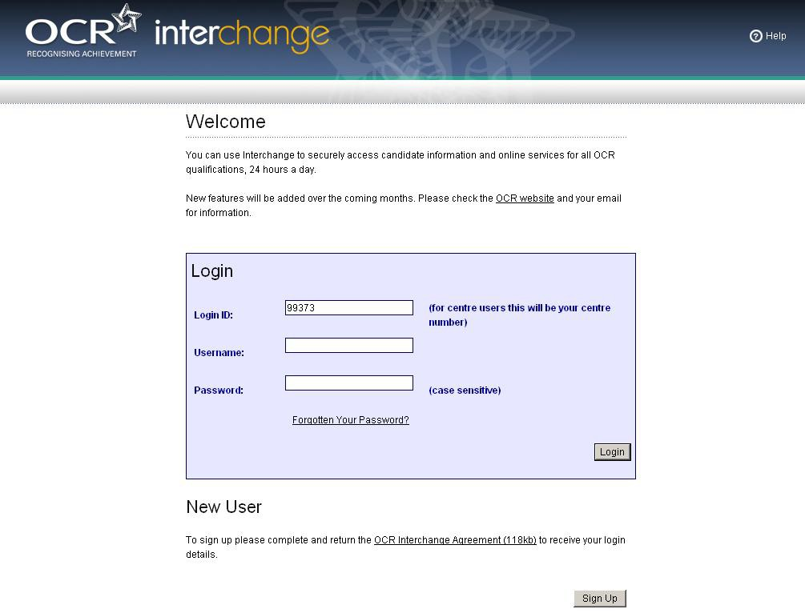
Step 2 – Navigate to Controlled Assessment materials area

Click on ‘Coursework and tests’

Click on ‘Controlled Assessment materials’

** If you are unable to see either of these menu items then it is likely that you do not have the
‘Tutor / teacher’ role assigned to you.

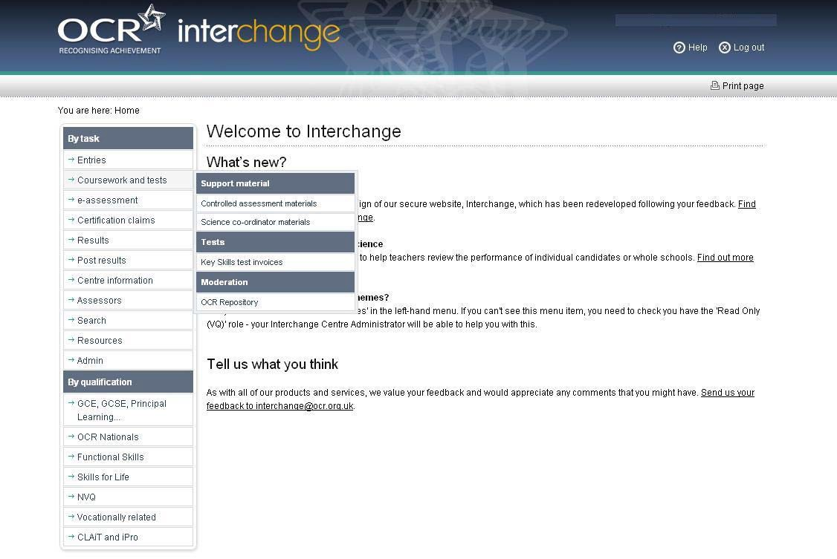
Step 3 – Search for materials

You can search for materials by unit code. Enter the unit code and click on the ‘search’ button.

Or, you can search for materials by subject information by selecting from the ‘drop down’ options. All available documents will be displayed below the search.
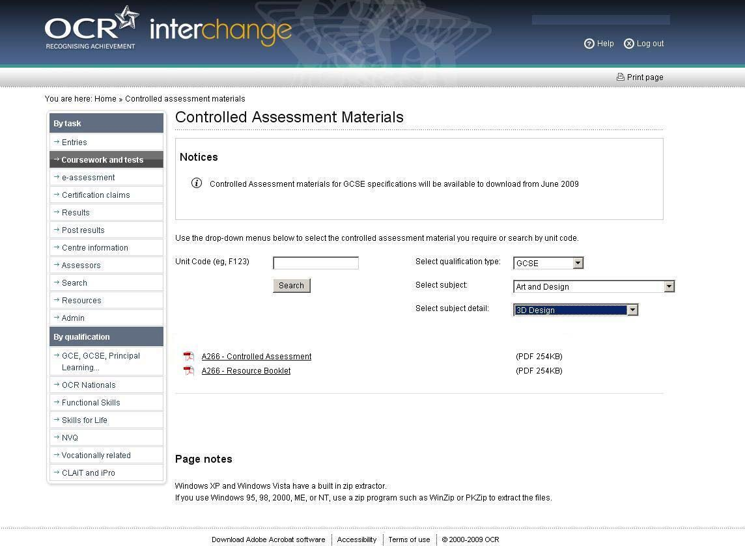
Step 4 – Open materials

Click on the document link, the document will open in your browser

Click on ‘Save As’ to save to a location of your choice.

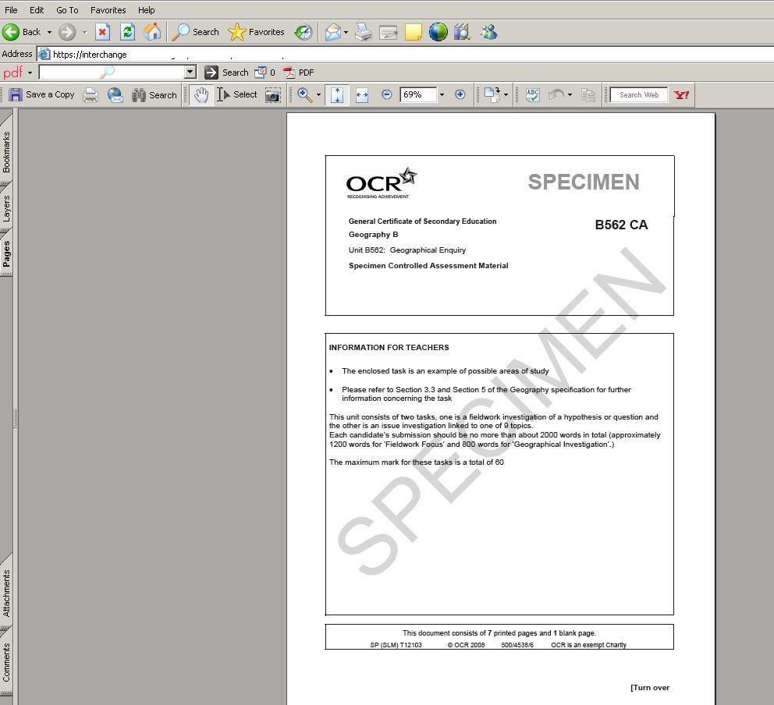
Step 5- Troubleshooting

If you search for an invalid unit code, the following error message will be displayed.

Q.Sc interchange ®Help ®Logout
---- - --

You are here:Home» Controlled assessment materials
Bytask Controlled Assessment Materials

Entries
Coursework andtests Notices

...... a-assessment

...... Certification claims
...... Results Use the drop-downmenus below to select the controlled assessment materialyou require or search by unit code.

...... Post results

...... Centre information

...... Assessors

Unit Code (eg,F123) Jsqset
CDInvalid Unit Code entered
Select qualification type: [·Please Select·::::J

Select subject: [·Nothing to Select·::::J

...... Search Select subject detail: [·Nothing to Select·::::J

...... Resources

...... Admin

By qualification

GCE. GCSE.Principal
Learning...

Page notes

OCR Nationals Windows XP and Windows Vista have a built in zip extractor.

Functional Skills

...... Skills for Life

NVQ

Vocationally related

CLAiT and iPro
If you use Windows 95, 98, 2000, ME, or NT, use a zip program such as WinZip or PKZip to extract the files.

Download Adobe Acrobat software Accessibility Terms of use @ 2000-2009 OCR

If you search for a valid unit code but there is no document currently available, the following message will be displayed.

Q.Sc interchange 0Help @ Logout
·-- - -'--

You are here:Home» Controlled assessment materials
Bytask Controlled Assessment Materials

-+ Entries
-+ Coursework andtests Notices

-+ e-assessment

-+ Certification claims
-+ Results Use the drop-downmenus below to select the controlled assessment materialyou require or search by unit code.
-+ Post results Unit Code (eg,F123) JA982 Select qualification type· J -Piease Select- :::J
-+ Centre information
,@, Print page

-+ Assessors
Select subject J -Nothing to Select· :::J

-+ Search Select subject detail:

-+ Resources

-+ Admin No document available.Please check the unit code.
J -Nothing to Select· :::J

By qualifiCatiOn

-> GCE,GCSE, Principal
Learning

-+ OCR Nationals

-+ Functional Skills
-+ Skills for Life Page notes

-> NVQ

-+ vocationally related

Windows XP and Windows Vista have a built in zip extractor.
If you use Windows 95,98, 2000,ME, or NT, use a zip program such as WinZip or PKZip to extract the tiles.

-+ CLAiT and iPro

If you search via the 'drop down' menus but there is no document currently available, the following message will be displayed.

Q.Sc interchange {?)Help (X)Logout

----Y-ou-are-he-re:-Ho-me-» C-on-tro-lled-as-se-ssm-en-t m-at-eria-ls -------- ---- -- --------------------------
Bytask Controlled Assessment Materials

Entries
"'"* Coursework andtests Notices

"'"* e-assessment

"'"* Certification claims

"'"* Results

"'"* Post results

"'"* Centre information

(]) Controlled Assessment materials for GCSE specifications will be available to download from June 2009

Use the drop-downmenus below to select the controlled assessment materialyou require or search by unit code

"'"* Assessors Unit Code (eg.F123) Select qualification type: IGCSE

"'"* Search Select subject: lt.!IQ!.!:J.Q!.!IG.!,,!,,!I!,!i¥11!.!,
"'"* Resources

Admin
Select subject detail IDeveloping Bus Comm Systems :o:J

By qualification

GCE, GCSE, Principal
Learning...

No document available.Please check the search details.

OCR Nationals

--+ FunctionalSkills

Skills for Life

- ----'.... _._ -
13 Prrnt page
NVQ

Vocationally related

CLAiT and iPro

Page notes

Windows XP and Windows Vista have a built in zip extractor.
If you use Windows 95, 98, 2000, ME, or NT, use a zip program such as WinZip or PKZip to extract the files.

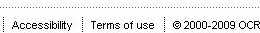
Download Adobe Acrobat software

8 Guidance for the production of electronic
Controlled Assessment

Structure for evidence

A Controlled Assessment portfolio is a collection of folders and files containing the candidate’s evidence. Folders should be organised in a structured way so that the evidence can be accessed easily by a teacher or moderator. This structure is commonly known as a folder tree. It would be helpful if the location of particular evidence is made clear by naming each file and folder appropriately and by use of an index called ‘Home Page’.

There should be a top level folder detailing the candidate’s centre number, candidate number, surname and forename, together with the unit code B033, so that the portfolio is clearly identified as the work of one candidate.

Each candidate produces an assignment for Controlled Assessment. The evidence should be contained within a separate folder within the portfolio. This folder may contain separate files.

Each candidate’s Controlled Assessment portfolio should be stored in a secure area on the Centre’s network. Prior to submitting the Controlled Assessment portfolio to OCR, the centre should add a folder to the folder tree containing Controlled Assessment and summary forms.

Data formats for evidence

In order to minimise software and hardware compatibility issues it will be necessary to save candidates' work using an appropriate file format.

Candidates must use formats appropriate to the evidence that they are providing and appropriate to viewing for assessment and moderation. Open file formats or proprietary formats for which a downloadable reader or player is available are acceptable. Where this is not available, the file format is not acceptable.

Electronic Controlled Assessment is designed to give candidates an opportunity to demonstrate what they know, understand and can do using current technology. Candidates do not gain marks for using more sophisticated formats or for using a range of formats. A candidate who chooses to use only word documents will not be disadvantaged by that choice.

Evidence submitted is likely to be in the form of word processed documents, PowerPoint presentations, digital photos and digital video.

To ensure compatibility, all files submitted must be in the formats listed below. Where new formats become available that might be acceptable, OCR will provide further guidance. OCR advises against changing the file format that the document was originally created in. It is the centre’s responsibility to ensure that the electronic portfolios submitted for moderation are accessible to the moderator and fully represent the evidence available for each candidate.
Accepted File Formats

Movie formats for digital video evidence

MPEG (*.mpg)

QuickTime movie (*.mov) Macromedia Shockwave (*.aam) Macromedia Shockwave (*.dcr) Flash (*.swf)
Windows Media File (*.wmf) MPEG Video Layer 4 (*.mp4) Audio or sound formats MPEG Audio Layer 3 (*.mp3)
Graphics formats including photographic evidence

JPEG (*.jpg) Graphics file (*.pcx) MS bitmap (*.bmp) GIF images (*.gif) Animation formats
Macromedia Flash (*.fla) Structured markup formats XML (*xml)
Text formats

PDF (.pdf)

Comma Separated Values (.csv) Rich text format (.rtf)
Text document (.txt) Microsoft Office suite PowerPoint (.ppt) Word (.doc)
Excel (.xls) Visio (.vsd) Project (.mpp)
OCR would like to acknowledge the contribution of schools to the best practice contained in this handbook. The following schools have made a particular contribution:

• Langdon Park School, Tower Hamlets

• Eastlea Community School, Newham

• Cavendish School, Eastbourne

• Kingston College, Surrey

• Monkseaton High School, Whitley Bay

• The Hurst Community School, Hampshire

www.ocr.org.uk
OCR customer contact centre
General qualifications
Telephone 01223 553998
Facsimile 01223 552627
Email general.qualifications@ocr.org.uk

For staff training purposes and as part of our quality assurance programme your call may be recorded or monitored.
© OCR 2011 Oxford Cambridge and RSA Examinations is a Company Limited by Guarantee. Registered in England. Registered office 1 Hills Road, Cambridge CB1 2EU. Registered company number 3484466. OCR is an exempt charity.




FS 27093

