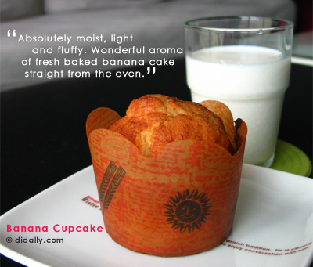

My first experience in baking a real dessert was a banana cake. What I meant by real was because I tested out my oven using Betty Cocker’s chocolate cake and blueberry muffin premix. It’s still real baking, just that a premix definitely tastes good. And baking a cake from scratch is more experimental. Joanne from Kitchen Capers contributed this recipe. It seemed to get good raves from the many members who have tried the recipe, and foolproof was one of the words they use. Ah…. foolproof sounds good to me. This is the one cake that I’ve baked many times for the past year.
This is really one easy cake to bake. Simple and straightforward. You need ripe bananas to get a really fragrant banana cake. Ripe bananas are sweeter, thus you can reduce the amount of sugar as stated in the recipe by a quarter. Don’t get Del Monte bananas or any other similar ones. Use local bananas or what they call ‘pang jio’.
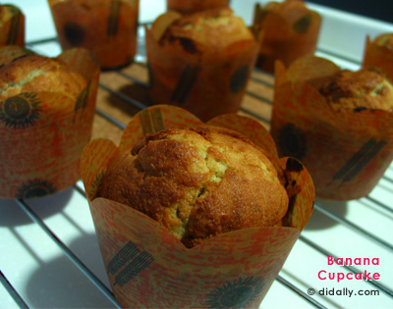
Result is a very moist and fluffy cake. The strong banana fragrance, its scent fills your whole home with a wonderful aroma. Banana Bliss!
Need some energy before you go for your workout? Suffers a diarrhea? Eat some bananas then. It’s low in calories, fat, sodium and is a good source of vitamin B6 and potassium. It’s easily a tropical fruit loved by many. My nieces love them to bits. They can’t see bananas hanging in the kitchen, they gotta eat it. LOL.
Banana Cake
Recipe adapted from Joanne in Kitchen Capers
1oz = 30grams
6oz butter
6 oz caster sugar
2 eggs, large
3 tbsp milk
3 large banana (riped, mashed)
8 oz plain flour
1tsp baking powder
1tsp bicarbonate soda
Preheat oven to 180°C. Grease a 8 x 8 inch square tin. Beat butter & sugar together using a mixer until creamy and smooth. Add eggs, one at a time until it’s well corporated. Add milk and banana, mix well. Sift flour, baking powder & bicarbonate soda and add to mixture. Pour batter into the tin and bake for 1 hour.
The oven duration really depends on the oven. My oven took only about 40 minutes, faster if I were to use fan-assisted mode. So set your timer earlier and test the cake by inserting a toothpick. If the toothpick comes out clean or with a bit of crumbs, it’s done. Else bake a while longer, but do keep track of the time. And if you use individual cupcake cases like me, the time needed is even shorter. Perhaps, 20 to 30 minutes.
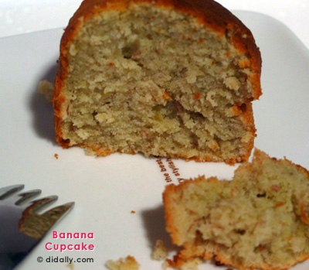
For a variation, mix in a handful of chocolate chips into the cake batter before baking it in the oven. If you intend to add in chocolate chips, remember to reduce the amount of sugar before you cream with butter, cos you don’t want your cake too sweet. Yummy… chocolate and bananas goes hand in hand. Try it and let me know how it goes, yah?

