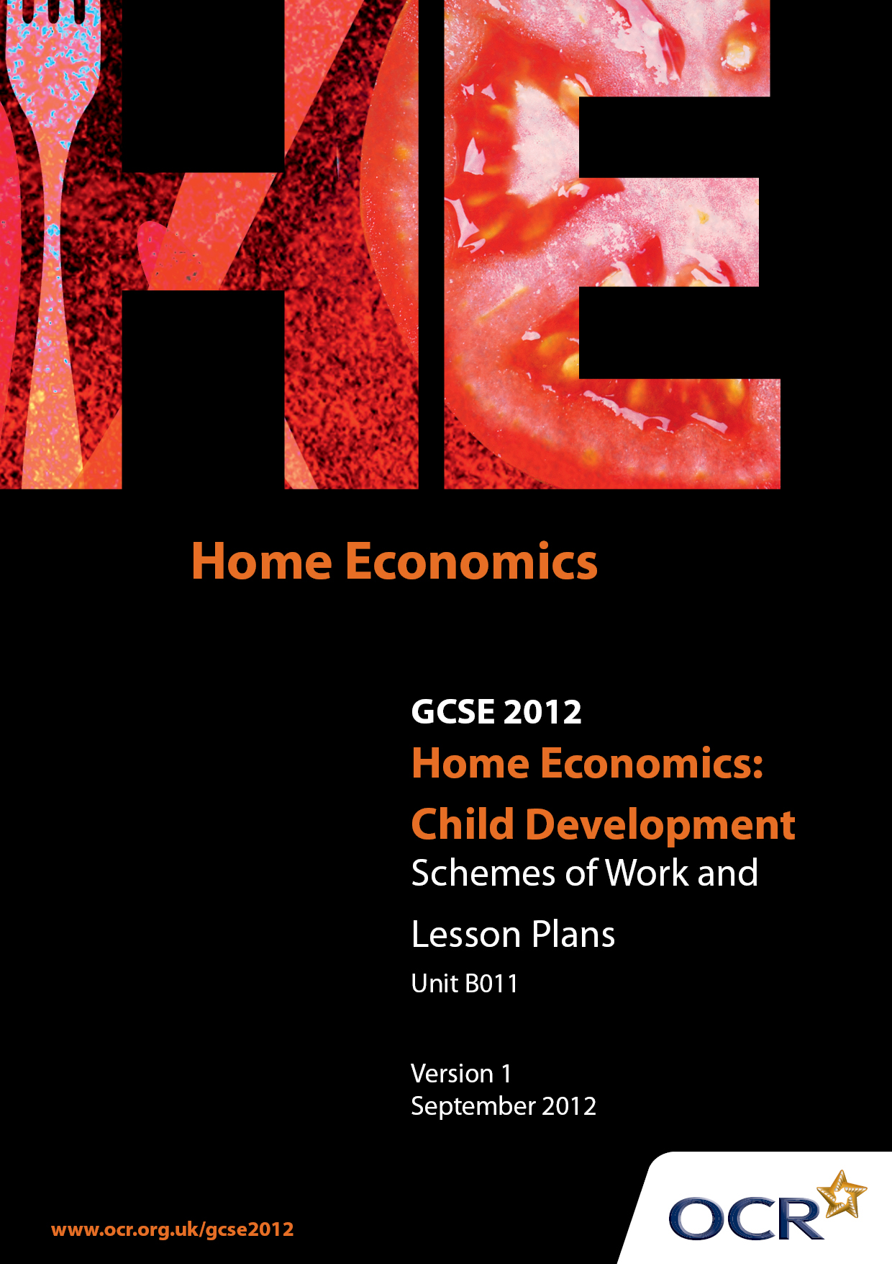

Contents
Contents 2
Introduction 3
Sample Scheme of Work: OCR GCSE Home Economics (Child Development) Unit B011: Short Task 5
Sample Lesson Plan: OCR GCSE Home Economics (Child Development) Unit B011: Short Task 9

Introduction

Background
OCR has produced a summary brochure, which summarises the changes to Home Economics (Child Development). This can be found at www.ocr.org.uk, along with the 2012 specification.
In order to help you plan effectively for the implementation of the new specification we have produced these schemes of work and sample lesson plans for Home Economics (Child Development). These support materials are designed for guidance only and play a secondary role to the specification.

Our Ethos
OCR involves teachers in the development of new support materials to capture current teaching practices tailored to our new specifications. These support materials are designed to inspire teachers and facilitate different ideas and teaching practices.
Each scheme of work and set of sample lesson plans are provided in Word format to be used as a foundation to build upon and amend the content to suit your teaching style and students’ needs.
The scheme of work and sample lesson plans provide examples of how to deliver these units and suggested teaching hours which could be applicable to your teaching.
The specification is the document on which assessment is based and specifies what content and skills need to be covered in delivering the course. At all times, therefore, this support material booklet should be read in conjunction with the specification. Any clarification should be found in the specification.

A Guided Tour through the Scheme of Work

= Innovative Teaching Idea
This icon is used to highlight exceptionally innovative ideas.


= ICT Opportunity
This icon is used to illustrate when an activity could be taught using ICT facilities.

OCR GCSE Home Economics (Child Development) Unit B011:
Short Task
Suggested teaching time | 7 hours | Topic | To produce a child’s health record
Topic outline |  | Suggested teaching and homework activities |  | Suggested resources | Points to note
Introduction |  | - General discussion – The purpose/ importance of keeping a personal health record of a child. Using samples of health records discuss layout, content, presentation, size, construction methods, Class discussion on what information should be included in a child’s health record. |  | - Internet  - Books  - Sample health records  - Interactive white board/projector | - Searching on the internet  - Looking at sample health record cards/booklets  - Classwork
Planning – mind map and resources table. |  | - Recap from previous week. Using the resources from the previous lesson complete a mind map “what should be included in a personal health record”.  - Complete a resources table/chart which includes; resources identified and how these resources are to be used when students construct a Child’s Health Record.  - Students should include/complete a clear plan of action. |  | - Internet  - Text books  - Sample health record  - Proformas – mind maps/resources table  - Writing frames | - Less able candidates may benefit from a writing frame with the headings already identified. (mind map/ resources chart) Homework - Pupils to be encouraged to gain local information from: health visitor, health visitor/centre, hospital, school nurse  Students to interview related health worker to gain information on Child’s Health Record.
Planning – Purpose, materials, costs. |  | - Using the information and resources from the previous lesson students will identify purpose, materials to be used with costs  - A draft layout may be constructed |  | - Information and materials gained from previous suggested Homework  - Use of computer
Carrying out - Child's Health Record |  | - Students use a range of methods to start to draft their planned Child’s Health Record  - Concurrently teacher demonstrates how pupils can present their record card informatively and attractively as possible  - Review draft layout and highlight improvements to be made |  | - Exemplar samples/software packages  - Hand construction if computer/software unavailable/undesirable | - Detailed written evidence should be included to support all work carried out in this section
Carrying out – Child's Health Record. |  | - Using knowledge and understanding gained from previous lesson, students start to construct their Child's Health Record using their planned resources correctly and safely. Teacher to support and encourage candidates on an individual basis |  | - Card, pictures of newborn babies, paper, coloured crayons, glue, soft pen, clip art, &/or art & design packages | - Candidates should refer back and use their plan of action/draft layout which they completed in previous lesson/ planning section of the task
Carrying out – Child's Health Record |  | - Teacher and students to identify good practice in the construction of the Childs' Health Record and areas where improvements can be made. Candidates to complete their Child’s Health Record |  | - As above | - If candidates do not work independently for example where support is given though a Teaching Assistant this needs to be identified on the marking front cover sheet
Carrying out – Child’s Health Record |  | - Teacher to give pupils the opportunity to make any final changes/improvements on any aspect of their Child's Health Records with the resources and ICT available before final completion depending upon time available |  | - As above | - If changes are made candidates should give an explanation of why these changes were made. These points can be reviewed and justified in their evaluation
Evaluation - Introduction |  | - Group discussion on the outcomes of the Child’s Heath Records. Highlight quality outcomes and why they are successful. Identify other Child’s Health Records that illustrate weaknesses and the reasons |  | - Health Records of group  - Interactive White board | - Good practice to be clearly identified and agreed upon. Weaknesses in content, construction and or presentation to be highlighted
Evaluation - Complete |  | - Discuss the importance of evaluating work and areas to be reviewed – strengths and weaknesses suggesting improvements  - Refer back to the task title and overall results/ conclusions  - Students to complete their own evaluations addressing all the points previously discussed |  | - Paper, pens, computer use  - Evaluation proformas  - Writing frames | - Headings/ proformas/writing frames may be useful for less able candidates for example: Outcome, Planning Strengths, Planning Weaknesses , Improvements, Conclusion

OCR GCSE Home Economics (Child Development) Unit B011: Short Task

Childs Health Record - Evaluation
OCR recognises that the teaching of this qualification above will vary greatly from school to school and from teacher to teacher. With that in mind this lesson plan is offered as a possible approach but will be subject to modifications by the individual teacher.
Lesson length is assumed to be one hour.

Learning Objectives for the Lesson
Objective 1 | Students to make informed decisions with regard to their Child's Health record outcome.
Objective 2 | Students to critically evaluate their outcome identifying strengths and weaknesses.
Objective 3 | Students to suggest ways to improve upon weaknesses identified.
Objective 4 | Students to interpret the results of their outcome referring back to the task title with overall conclusions.

Recap of Previous Experience and Prior Knowledge
- Refer back to the group discussion on the outcomes of their health records where good practice and successful outcomes were highlighted. Weaknesses and how to improve certain aspects of the health records were also debated.

Content
Time | Content
10 minutes | Recap on previous lesson to access prior knowledge. Question and answer session. Discussion on the importance of evaluating work.
10 minutes | Explanation: Under relevant headings students to complete individual evaluations referring back to the task title, their strengths and weaknesses, recommendations for improvement and an overall conclusion.
15 minutes | Student activity: Students to complete their evaluations independently. Teacher to clarify if necessary.
15 minutes | Student activity: Students continue to complete their evaluations asking the teacher questions to ensure they fully understand the requirements of the task.

Consolidation
Time | Content
10 minutes | Teacher to briefly recap on key points that must be included in their evaluations. Teacher questions students to ensure they have clearly understood.

