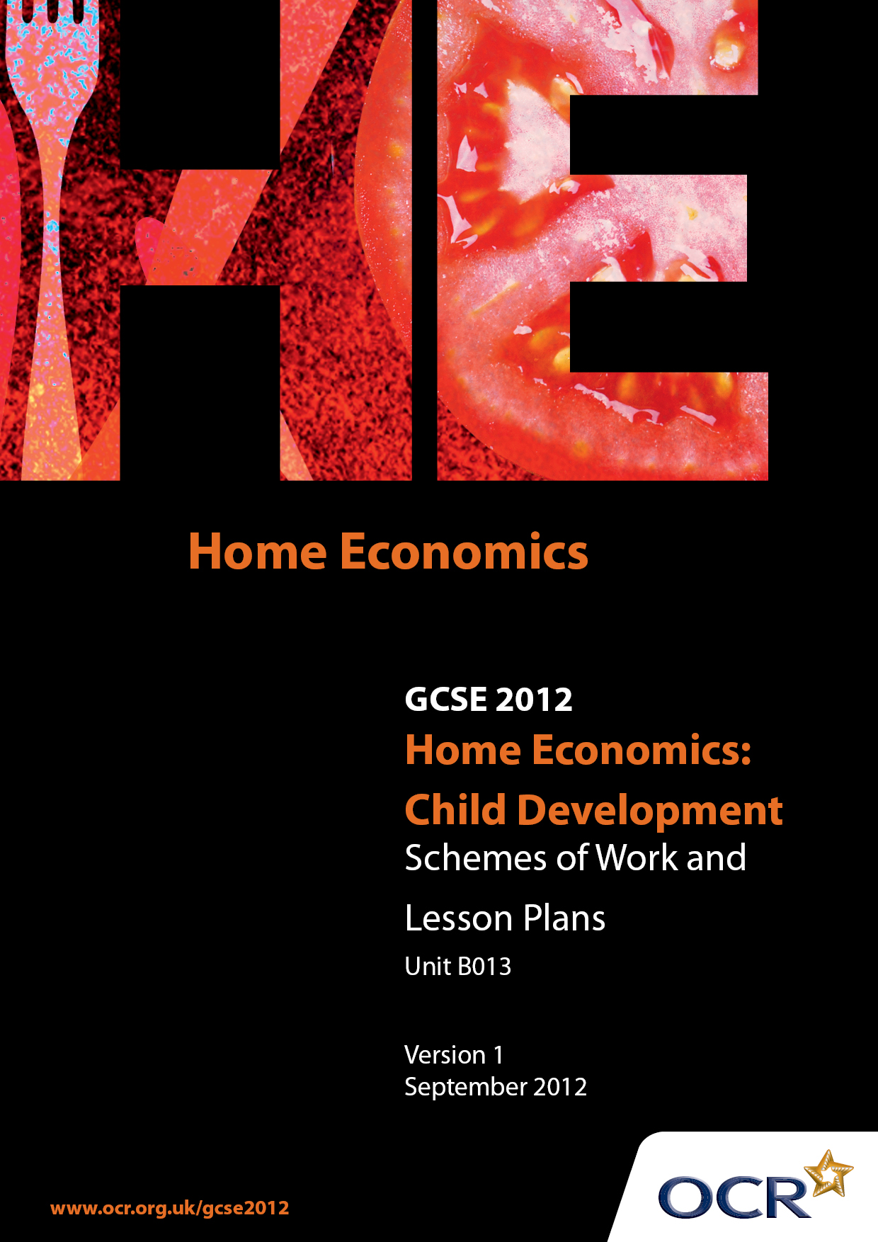

Contents
Contents 2
Introduction 3
Sample Scheme of Work: OCR GCSE Home Economics (Child Development) Unit B013: Principles of Child Development 5
Sample Lesson Plan: OCR GCSE Home Economics (Child Development) Unit B013: Principles of Child Development 9

Introduction

Background
OCR has produced a summary brochure, which summarises the changes to Home Economics (Child Development). This can be found at www.ocr.org.uk, along with the 2012 specification.
In order to help you plan effectively for the implementation of the new specification we have produced these schemes of work and sample lesson plans for Home Economics (Child Development). These support materials are designed for guidance only and play a secondary role to the specification.

Our Ethos
OCR involves teachers in the development of new support materials to capture current teaching practices tailored to our new specifications. These support materials are designed to inspire teachers and facilitate different ideas and teaching practices.
Each scheme of work and set of sample lesson plans are provided in Word format to be used as a foundation to build upon and amend the content to suit your teaching style and students’ needs.
The scheme of work and sample lesson plans provide examples of how to deliver these units and suggested teaching hours which could be applicable to your teaching.
The specification is the document on which assessment is based and specifies what content and skills need to be covered in delivering the course. At all times, therefore, this support material booklet should be read in conjunction with the specification. Any clarification should be found in the specification.

A Guided Tour through the Scheme of Work

= Innovative Teaching Idea
This icon is used to highlight exceptionally innovative ideas.


= ICT Opportunity
This icon is used to illustrate when an activity could be taught using ICT facilities.

OCR GCSE Home Economics (Child Development) Unit B013: Principles of Child Development
Suggested teaching time | 6 hours | Topic | Response to infection
Topic outline |  | Suggested teaching and homework activities |  | Suggested resources | Points to note
Recognising signs of illness. when to seek treatment by a doctor and when emergency medical help should be sought. |  | - Card sorting games to identify seriousness of different symptoms and appropriate action  - Leaflet on levels of seriousness of signs: when to nurse at home; when to visit doctor; when and how to summon help in an emergency  - Practise taking temperatures  - Role play making emergency telephone calls |  | - Clinical thermometers – standard pattern, digital and strip types | - Distinguish between signs (objective) and symptoms (subjective)  - Care needed with glass thermometers  - Stress importance of not abusing emergency call facilities
How to recognise, prevent and manage common childhood ailments and diseases. |  | - Individuals or pairs research one common childhood illness and its management and prepare a presentation for the rest of the class  - Students prepare a poster/leaflet/ICT presentation on ways of preventing illness |  | - Symptoms card game | - Possible Short Task: book for new mothers about childhood illnesses  - Or Health Record book
Immunity |  | - Explain how antibodies work. Make simple models to show antibodies matching antigens on surface of viruses or bacteria  - Explain why a different antibody is needed for each disease organism  - Make a glossary of technical terms used |  | - IWB | - Cross-curricular link with Science  - Recap presence of antibodies in breast milk for protection of newborn baby
Acquired immunity |  | - Draw a simple flow chart to show infection, incubation time, recognition of the disease organism, antibody release and recovery  - Explain that antibodies remain in blood after recovery and prevent incubation after re-infection |  | - IWB or OHT with flow chart steps to arrange in order | - Cross-curricular link with Science
Vaccination programmes |  | - Use the internet or health professional to find out about the vaccination programme offered in UK  - Discuss the reasons for, and potential consequences of, refusing vaccination  - Research vaccination programmes in other countries |  | - Health professional visitor | - Possible Short Task: producing immunisation booklet for a new mother or a fact sheet on immunisation  - World citizenship link/Cultural society
Physical, social and emotional needs of a sick child. |  | - Modify a drawing of a child’s bedroom to show items needed if the child is unwell. Explain the items.  - List the extra tasks a carer would have to do for a sick child. Write a 24 hour schedule for a carer nursing a sick child |  | - IWB or OHT drawing and labels | - Physical, social and emotional needs of a sick child
Preparing a child for a stay in hospital. |  | - Review books for toddlers about hospitals  - Write child-level descriptions of jobs done by various hospital staff  - Write and illustrate a story which could be used to prepare a child for a hospital visit  - Pack a suitcase for a child to go into hospital. Importance of involving child in this |  | - Suitcase and selection of suitable and unsuitable items  - IWB | - Possible Short Task: book review  - Possible Short Task: hospital story

OCR GCSE Home Economics (Child Development) Unit B013: Principles of Child Development

Recognising when a child is ill
OCR recognises that the teaching of this qualification above will vary greatly from school to school and from teacher to teacher. With that in mind this lesson plan is offered as a possible approach but will be subject to modifications by the individual teacher.
Lesson length is assumed to be one hour.

Learning Objectives for the Lesson
Objective 1 | Understand what is meant by “signs of illness”
Objective 2 | Be able to recognise some common signs of illness in children
Objective 3 | Know that some signs of illness need immediate medical help

Recap of Previous Experience and Prior Knowledge
- Brief mention of ways of preventing illness would be appropriate here e.g. food safety, hygiene, vaccination. Despite our best efforts, however, illnesses do occur.

Content
Time | Content
5 minutes | Explain that a sign is objective – it can be seen or otherwise detected by the parent/carer (as opposed to a symptom which is subjective and can be felt only by the child e.g. pain)
10 minutes | Students to think about their own or their siblings’ childhood illnesses. Each to suggest one sign of illness.
5 minutes | Explain that some signs of illnesses require emergency attention while others do not. Give three or four examples of signs needing emergency action.
15 minutes | Give out cards with sets of signs of illness. Ask students in small groups to sort the cards into: those needing home care; those requiring a visit to or by a doctor; those requiring emergency action.
5-10 minutes | Each group to explain their decisions to the rest of the class.

Consolidation
Time | Content
15 minutes | Students prepare an information sheet/poster/computer presentation to show signs of illness which indicate emergency attention is required and how it may be obtained.
5 minutes | Plenary: match terminology used in lesson with definitions on interactive whiteboard or OHP

