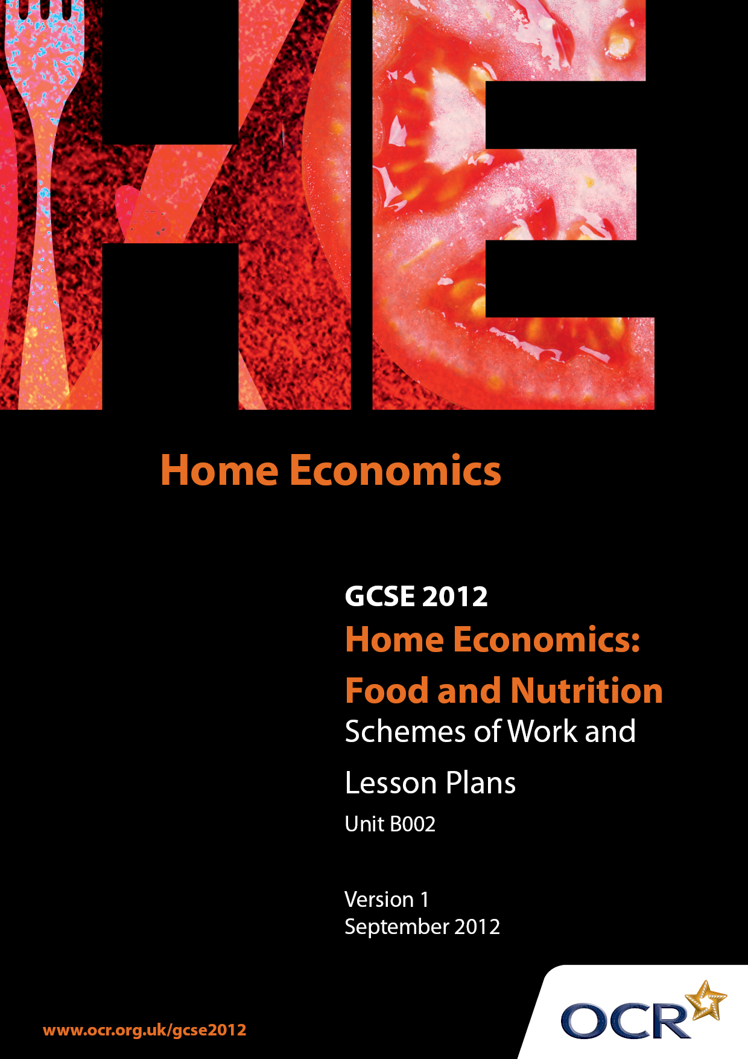

Contents
Contents 2
Introduction 3
Sample Scheme of Work: OCR GCSE Home Economics (Food and Nutrition) Unit B002: Food Study 5
Sample Lesson Plan: OCR GCSE Home Economics (Food and Nutrition) B002: Food Study 10

Introduction

Background
OCR has produced a summary brochure, which summarises the changes to Home Economics (Food and Nutrition). This can be found at www.ocr.org.uk, along with the 2012 specification.
In order to help you plan effectively for the implementation of the new specification we have produced these Schemes of Work and Sample Lesson Plans for Home Economics (Food and Nutrition). These Support Materials are designed for guidance only and play a secondary role to the Specification.

Our Ethos
OCR involves teachers in the development of new support materials to capture current teaching practices tailored to our new specifications. These support materials are designed to inspire teachers and facilitate different ideas and teaching practices.
Each scheme of work and sample Lesson Plans are in Word format to be used as a foundation to build upon and amend the content to suit your teaching style and students’ needs.
The scheme of work and sample Lesson Plans provide examples of how to deliver these units and suggested teaching hours, which could be applicable to your teaching.
The Specification is the document on which assessment is based and specifies what content and skills need to be covered in delivering the course. At all times, therefore, this Support Material booklet should be read in conjunction with the Specification. Any clarification should be found in the Specification.

A Guided Tour through the Scheme of Work

= Innovative Teaching Idea
This icon is used to highlight exceptionally innovative ideas.


= ICT Opportunity
This icon is used to illustrate when an activity could be taught using ICT facilities.

OCR GCSE Home Economics (Food and Nutrition) Unit B002: Food Study
Suggested teaching time | 3 Lessons | Topic | Food Study Research Skills (these are in addition to Short Task Skills)
Topic outline |  | Suggested teaching and homework activities |  | Suggested resources | Points to note
Producing a task title and carrying out research |  | - Teacher input – how to write a task title from a theme  - Pupil activity – brainstorm possible task titles from a given theme e.g. healthy eating  - Teacher input – what is secondary research? Pupils carry out a small piece of research into a given topic and present a fact sheet on it, to show selection of information skills  - Teacher input – what is primary research?  - Primary research methods e.g. questionnaires, surveys, interviews, case studies and food diaries |  | - Handout containing a variety of task titles  - from a theme in the specification  - Textbooks  - Internet access  - Examples of fact sheets | - Pupils should be encouraged to select and summarise information for their fact sheet
Planning a questionnaire or interview and presenting results |  | - Teacher input – what makes a good questionnaire (e.g. it has an aim, carefully worded questions, easy to analyse etc)  - Pupil activity – look at good and bad examples and styles of questionnaires and evaluate them  - Teacher input – using open and closed questions  - Pupil activity – pupils write their own open and closed questions and trial them.  - Pupils display results using appropriate presentation style e.g. charts, graphs etc.  - and draw conclusions |  | - Examples of questionnaires to show different styles and good/bad examples
Food Study Task  Theme: Healthy Eating |  | - See Lesson Plan on Healthy Eating for introduction to the Task
Food Study Task  Producing a Task title  Identifying key point  Carrying out secondary research |  | - Pupils write their own task title and identify key points  - Pupils carry out secondary research |  | - Possible title might be  - It is recommended that we eat 5 portions of fruit and vegetables in our diet. Research this statement. Demonstrate how fruit and vegetables can be included in the diet of teenagers in a variety of interesting and appealing ways  - Textbooks  - Food magazines  - Internet  - Leaflets on fruit and vegetables and ‘5 a day’ | - Teachers should encourage pupils to include:  - Several valid reasons for their choice of task title  - Identify a range of named sources of information and resources  - Carry out detailed research using a range of secondary sources (books, internet, magazines, leaflets) which they select and summarise e.g. into the 5 a day scheme and the types and availability of fruits and vegetables. Also include teenage nutritional requirements and eating styles  - Pupils should be encouraged to evaluate after each section of the Task
Carrying out primary research |  | - Pupils plan and carry out 2 primary research methods  - Pupils present their results and draw conclusions |  | - Example work | - A pupil may carry out a survey of teenage preferences for fruit and vegetables, costings of fruit and vegetables, interviews with teenagers or school meals staff  - Questionnaire results may be presented in charts, graphs etc
Selecting and planning |  | - Pupils select and assess ideas from their research results |  | - Example work | - Pupils may carry out a nutritional analysis of their ideas to check out suitability for teenagers  - They could trial some of their ideas and organise taste tests with teenagers
Making and justifying choices and justifies |  | - Pupils make at least 4 choices for their practical work (a minimum of 3 choices must be food based)  - Pupils fully justify their choices referring to research results and to the assessment of ideas that they made |  | - Example work | - The choices of practical work should show a variety of practical skills  - Pupils fully justify their choices referring to research results and to the assessment of ideas that they made
Planning practical work |  | - Pupils will produce accurate timed plans and recording sheets for all food based work. They should also include clear plans for taste panels |  | - Example work | - Practical work can include the production of leaflets, powerpoint presentations, displays etc
Practical work |  | - Careful following of plans and recipes  - Process and food handling skills  - Personal assessment/ marking skills |  | - Marking grid. | - Follows plans effectively  - Organises resources independently  - Uses equipment safely & independently  - Competently demonstrates a range of skills across a number of practical tasks
Outcomes |  | - Pupils carry out all practical activities and recording of results  - Keep a log of practical work |  | - Recording and evaluative examples | - For Log of Practical Work – see teacher guidance  - Pupils should be encouraged to evaluate after each practical activity and record results
Conclusion and Evaluation |  | - Pupils evaluate their work and draw conclusions |  |  | - Pupils should be encouraged to:  - Review all aspects of the Task  - Identify strengths and areas to improve,  - Draw conclusions that relate to the task title  - Suggest improvements or how the work could be extended  - Demonstrate a high level of written communication skills

OCR GCSE Home Economics (Food and Nutrition) B002: Food Study

Healthy Eating
OCR recognises that the teaching of this qualification above will vary greatly from school to school and from teacher to teacher. With that in mind this lesson plan is offered as a possible approach but will be subject to modifications by the individual teacher.
Lesson length is assumed to be one hour,

Learning Objectives for the Lesson
Objective 1 | Understand what is meant by healthy eating
Objective 2 | Be able to recognise the Eatwell Plate
Objective 3 | Analyse their own food choices and explain how they could be improved
Objective 4 | Be able to name some of the foods we should eat more of and less of in our daily diets

Recap of Previous Experience and Prior Knowledge
- Ask students to look at magazine pictures of different foods and place them into groups according to their knowledge of which foods we should eat more of and less of

Content
Time | Content
5 minutes | Starter – each student in turn names a food they like/ate yesterday
10 minutes | Discuss what is meant by healthy eating. Introduce/revise the Eatwell plate.  Refer to their prior knowledge as discussed in the Recap.
10 minutes | Activity – in pairs or small groups ask students to go back to their pictures of foods and sort these into different categories according to the Eatwell Plate.  Check their responses.
20 minutes | Ask students to write down what they ate yesterday (or today or at the weekend).  In pairs, ask students to look at each others daily intake and comment on how healthy their diets are. Ask students to suggest how to improve each other’s diets.

Consolidation
Time | Content
10 minutes | Hold up pictures of foods, ask individual students to suggest whether we should eat more of or less of the food in the picture.  Alternatively, give students a suggested lunch or evening meal and ask them to record their thoughts on how healthy that meal is or is not.

