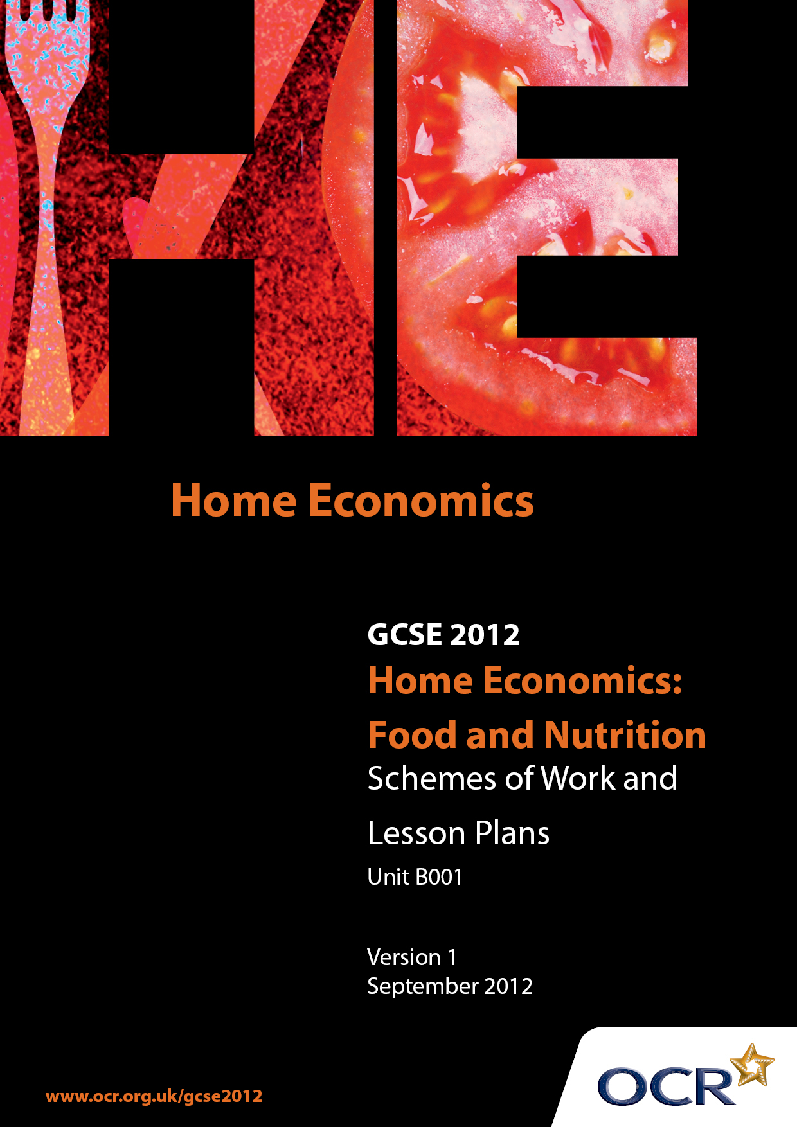

Contents
Contents 2
Introduction 3
Sample Scheme of Work: OCR GCSE Home Economics (Food and Nutrition) Unit B001: Short Task 3
Sample Lesson Plan: OCR GCSE Home Economics (Food and Nutrition) Unit B001: Short Task 3

Introduction

Background
OCR has produced a summary brochure, which summarises the changes to Home Economics (Food and Nutrition). This can be found at www.ocr.org.uk, along with the 2012 specification.
In order to help you plan effectively for the implementation of the new specification we have produced these schemes of work and sample lesson plans for Home Economics (Food and Nutrition). These support materials are designed for guidance only and play a secondary role to the specification.

Our Ethos
OCR involves teachers in the development of new support materials to capture current teaching practices tailored to our new specifications. These support materials are designed to inspire teachers and facilitate different ideas and teaching practices.
Each scheme of work and set of sample lesson plans are provided in Word format to be used as a foundation to build upon and amend the content to suit your teaching style and students’ needs.
The scheme of work and sample lesson plans provide examples of how to deliver these units and suggested teaching hours which could be applicable to your teaching.
The specification is the document on which assessment is based and specifies what content and skills need to be covered in delivering the course. At all times, therefore, this support material booklet should be read in conjunction with the specification. Any clarification should be found in the specification.

A Guided Tour through the Scheme of Work

= Innovative Teaching Idea
This icon is used to highlight exceptionally innovative ideas.


= ICT Opportunity
This icon is used to illustrate when an activity could be taught using ICT facilities.

OCR GCSE Home Economics (Food and Nutrition) Unit B001: Short Task
Suggested teaching time | 3 Lessons + | Topic | Short Task Skills Teaching necessary skills
Topic outline |  | Suggested teaching and homework activities |  | Suggested resources | Points to note
Planning skills  Identify key points within the task title  Making suitable choices  Producing reasons for choice Producing an accurate and detailed time plans |  | - Teacher input on analysing the task. Discussion on prior learning on the subject  - Pupils underline or highlight key points in the task  - Teacher input and pupil activity on accurate use of recipe books – use of index and searching for recipes  - Teacher guidance on suitability of choices and how to modify recipes  - Pupils work in pairs or groups to brainstorm ideas or use statement cards to sort reasons for choice that are relevant to the task  - Pupils carry out a sequencing activity to sort recipe statements into correct sequence |  | - Practical Cooking Activities to develop Short Task Skills  - Plan and make 2 basic items to demonstrate your ability to produce an accurate and detailed timed plan  - Plan and make 2 items suitable for a child’s packed lunch to demonstrate your ability to write suitable reasons for choice.  - Recipe books  - Basic recipes set out on cards for pupils to sort into correct sequence  - Timed Plan proforma for pupils to complete  - Reasons for choice statement cards | - Depending on the length of lesson teaching of planning skills may extend into a number of separate lessons
Planning skills – developing recording charts for practical work |  | - Teacher input – what is a recording chart and why it is used. Using word banks of words to use when tasting foods/dishes  - Pupil activity – food tasting and sensory analysis using appropriate words from word bank  - Pupil activity – food tasting using and evaluating different styles of recording chart  - Teacher input and pupil activity – how to use and comment on nutritional data  - Teacher input on how to cost a recipe and awareness of costs per portion |  | - Range of different styles of recording charts e.g. smiley faces, star diagrams etc  - Nutritional Data reference material and software  - Recipes to analyse for specific nutrients  - Recipes to cost out  - Costing charts
Practical work skills and outcomes |  | - Set a series of practical sessions that will allow the development of practical cooking skills |  | - Recipes and suitable facilities | - This should be a development of skills already acquired, so time needed will depend on previous skill level
Evaluation  Identify strengths and areas to improve and draw conclusions |  | - Teacher input – what is an evaluation and what make a good evaluation (one that is not too descriptive and reviews the whole task)  - Pupil activity assessing exemplar evaluations highlighting evaluative statements and descriptive statements |  | - Good and poor examples of evaluations for pupils to assess  - Pupils own evaluations of practical work for paired peer assessment of strengths and areas to improve
 |  | - Pupil activity – pupils work in pairs to assess each other’s strengths and areas to improve giving examples to support their ideas  - Teacher input – how to draw conclusions  - Pupil activity – drawing conclusions from their own work |  | - Suitable practical work

OCR GCSE Home Economics (Food and Nutrition) Unit B001: Short Task
Suggested teaching time | 7 hours | Topic | Short task, plus prior teaching on Cooking Methods
Topic outline |  | Suggested teaching and homework activities |  | Suggested resources | Points to note
Cooking Methods and heat transfer |  | - Teacher input why do we cook food and how does cooking effect food? Class brainstorms ideas  - Teacher input and class brainstorm of different methods we use to cook food  - Pupil activity sorting methods into moist and dry methods  - Teacher input – advantages and disadvantages of different methods  - Assessment for learning – pupils could produce materials for display or a leaflet on the advantages of different cooking methods |  | - Raw and cooked foods for pupils to taste e.g. carrots  - Interactive whiteboard with methods of cooking written on it for pupils to sort into moist and dry methods | - Advantages and disadvantages may include:  - Effect on nutritional value  - Effect on the nature of food e.g tenderisation  - Effect on appearance and taste of the food  - Capability of the person doing to cooking  - Time and facilities available  - Safety aspects  - Costs
Heat transfer |  | - Teacher input – how is heat transferred – conduction, convection and radiation  - Pupils do practical activities to demonstrate methods of heat transfer  - Assessment for learning – crossword on methods of heat transfer and cooking methods |  | - Handout of methods of heat transfer  - Practical activities for conduction, convection, radiation e.g. toast
Planning a Short Task on Cooking Methods |  | - Teacher input into planning the task and methods of recording  - Pupils organise their methods of recording results of the practical  - Pupils plan their task |  | - Short Task Title  - Nadia works full time and needs nutritious quickly prepared meals when she gets home in the evening. Plan and make one or two suitable main course dishes for her evening meal showing your knowledge of cooking methods and their advantages  - Recipe ideas | - Pupils should already have developed short task planning and evaluation skills  - Teachers will need to give guidance about the number of practical dishes and the range of practical skills that should be shown  - The range of skills can include: food preparation skills, ICT skills, costing and taste testing
Carrying out practical work  Evaluation |  | - Pupils demonstrate the following skills in carrying out their practical work:  - Follow their timed plan effectively  - Organisation of resources  - Safe and independent use of equipment  - Competent demonstration of a range of skills  - Produce well presented quality outcomes with accurately completed recording charts.  - Evaluation of strengths and areas to improve and suggested improvements /conclusions can be done for homework |  | - Suitable facilities  - Recording documents | - Recording charts needed as appropriate  - Always aim to draw conclusions from work
Cooking Methods and heat transfer |  | - Teacher input why do we cook food and how does cooking effect food? Class brainstorms ideas  - Teacher input and class brainstorm of different methods we use to cook food  - Pupil activity sorting methods into moist and dry methods  - Teacher input – advantages and disadvantages of different methods  - Assessment for learning – pupils could produce materials for display or a leaflet on the advantages of different cooking methods |  | - Raw and cooked foods for pupils to taste e.g. carrots  - Interactive whiteboard with methods of cooking written on it for pupils to sort into moist and dry methods | - Advantages and disadvantages may include:  - Effect on nutritional value  - Effect on the nature of food eg tenderisation  - Effect on appearance and taste of the food  - Capability of the person doing to cooking  - Time and facilities available  - Safety aspects  - Costs

OCR GCSE Home Economics (Food and Nutrition) Unit B001: Short Task

Nutritional Needs of Different groups
OCR recognises that the teaching of this qualification above will vary greatly from school to school and from teacher to teacher. With that in mind this lesson plan is offered as a possible approach but will be subject to modifications by the individual teacher.
Lesson length is assumed to be one hour,

Learning Objectives for the Lesson
Objective 1 | Recognise the factors that should be considered when planning and serving balanced meals for different people
Objective 2 | Research into the dietary needs of young children
Objective 3 | Be able to suggest suitable meals or dishes for young children
Objective 4 | Present their ideas to the group

Recap of Previous Experience and Prior Knowledge
- Ask student to write down or think about what they usually have for breakfast or for lunch on a week day. Produce a list of all the reasons why they ate the foods that they had. What factors influenced their choices?

Content
Time | Content
5 minutes | Starter – Each student to name their favourite food (now or when they were a child).
10 minutes | Discuss the factors that influence our food choices. Include cost, shopping facilities, like, dislikes, age, state of health, culture/religious beliefs, personal beliefs and so on.
10 minutes | Activity. – In small groups students are to imagine that they have to look after and feed a young child for one day at the weekend. Ask student to discuss all the factors that they would need to think about when choosing foods for the child. Each pair can feedback their ideas.
25 minutes | Students work in small groups. Give each group information sheets or text book references relating to the nutritional needs of young children. Ask each group to summarise the main nutrients that children need, why they need them and possible sources of the main nutrients. This could be presented to the rest of the group in another lesson.

Consolidation
Time | Content
10 minutes | Ask each group to give one fact that they have found out from their research.

