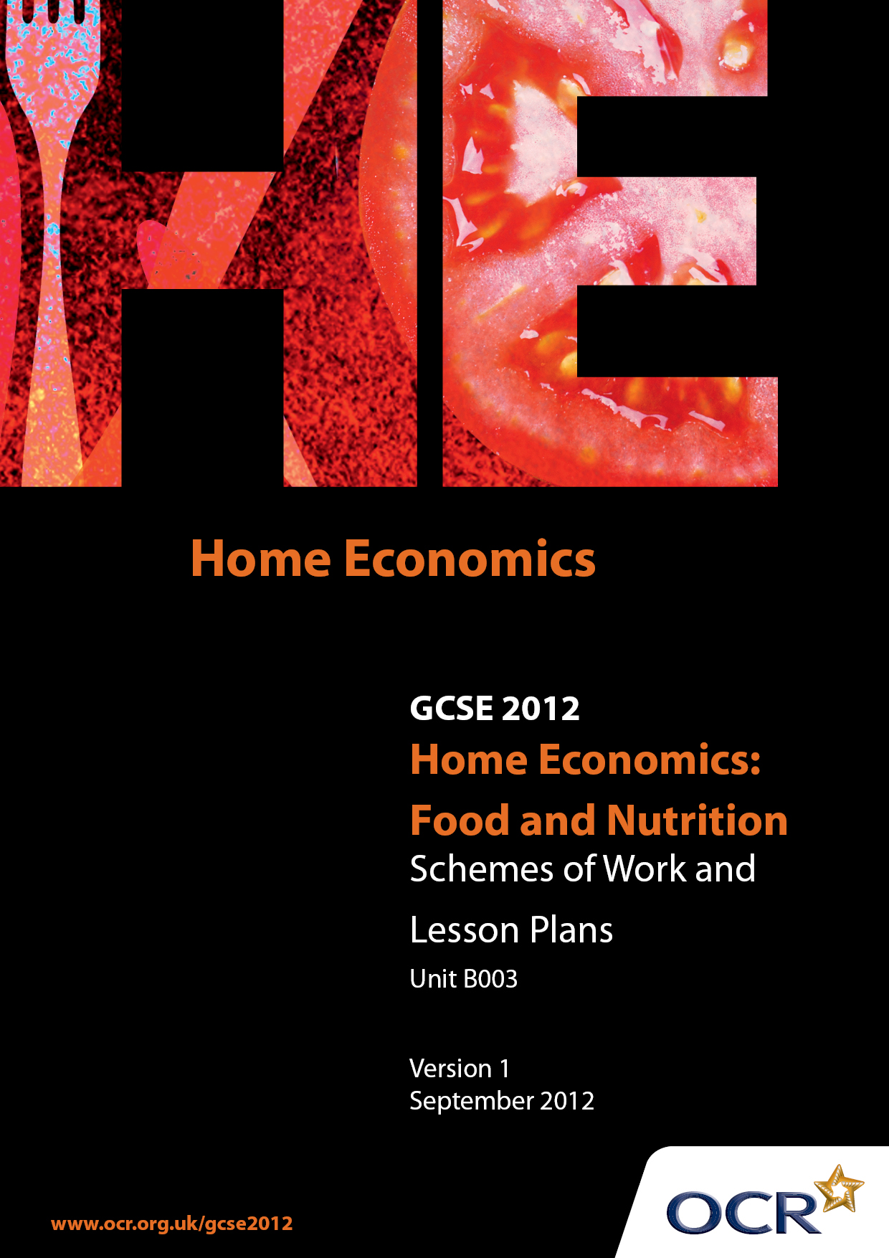

Contents
Contents 2
Introduction 3
Sample Scheme of Work: OCR GCSE Home Economics (Food and Nutrition) Unit B003: Principles of Food and Nutrition 5
Sample Lesson Plan: OCR GCSE Home Economics (Food and Nutrition) Unit B003: Principles of Food and Nutrition 9

Introduction

Background
OCR has produced a summary brochure, which summarises the changes to Home Economics (Food and Nutrition). This can be found at www.ocr.org.uk, along with the 2012 specification.
In order to help you plan effectively for the implementation of the new specification we have produced these schemes of work and sample lesson plans for Home Economics (Food and Nutrition). These support materials are designed for guidance only and play a secondary role to the specification.

Our Ethos
OCR involves teachers in the development of new support materials to capture current teaching practices tailored to our new specifications. These support materials are designed to inspire teachers and facilitate different ideas and teaching practices.
Each scheme of work and sample lesson plans are in Word format to be used as a foundation to build upon and amend the content to suit your teaching style and students’ needs.
The scheme of work and sample lesson plans provide examples of how to deliver these units and suggested teaching hours which could be applicable to your teaching.
The specification is the document on which assessment is based and specifies what content and skills need to be covered in delivering the course. At all times, therefore, this support material booklet should be read in conjunction with the specification. Any clarification should be found in the specification.

A Guided Tour through the Scheme of Work

= Innovative Teaching Idea
This icon is used to highlight exceptionally innovative ideas.


= ICT Opportunity
This icon is used to illustrate when an activity could be taught using ICT facilities.

OCR GCSE Home Economics (Food and Nutrition) Unit B003: Principles of Food and Nutrition
Suggested teaching time | 10 hours | Topic | Consumer Education
Topic outline |  | Suggested teaching and homework activities |  | Suggested resources | Points to note
That purchase of food is dependent upon shopping trends, facilities and environmental issues |  | 1) Student activity: Ask each student to write down what they had for dinner last night, breakfast this morning, what they are planning to have for lunch and dinner tonight. Class to feedback and discuss the results of the above activity.  Teacher led discussion asking the students how and why they made these choices. Expand and add to the discussion where necessary and link to the wider community /audience. Include:  - Influence of time – preparation of food and shopping for food  - Influence of money – to buy food, availability/affordability of transport to get to shops  - Influence of availability of food as well as places to buy food  - Influence of facilities – space to cook and store foods  - Influence of skill and knowledge of the ‘cook’  - Influence of beliefs and values – vegetarian, vegan  - Influence of culture and religion  - Influence of environmental factors such as drought – lack of rice (cultural staple in China/India)  - Specific goals – weight loss, sports nutrition, health  - Specific needs – pregnancy, infants, illness  - Ethics and environment – free range, organic, recycling of packaging/resources.  - Appreciation that many factors link and cannot always be looked at or considered individually.  Student activity: Quiz (pre-prepared work sheet) – list 10 points that they consider when choosing something for lunch. Rank the 10 points from ‘Most important to me’ to ‘Least important to me’.  Class survey to find out the 3 most important points for the class. Analysis and discussion of class results. Would the results be different with a different (age, culture, religion) group of people?  Student activity: Look at the current economic climate and how this affects food choices. For example the increasing cost of food. Look how the average shopping basket has changed in price over the last 50 years and discuss why this is and what impacts this has.  2. Explanation of other factors such as facilities and environmental issues affecting food choice. This should include:  - Facilities available in the home to store, prepare and cook foods  - Proximity and transport to the nearest food shop(s)  - Changes in economic and political climates, such as droughts, floods and wars on food availability and price  - Global warming on crop growth |  | 1)  - Flip chart/OHT/white board  2)  - Office of National Statistics – www.statistics.gov.uk  - Media – BBC, Guardian  - Anita Tull, Food & Nutrition  - Jenny Ridgwell, Examining Food and Nutrition  - Media sources including the BBC  - Office of National Statistics – www.statistics.gov.uk  - Food Standards Agency – www.food.gov.uk  - World Health Organisation – www.who.int | 1) It is not important to know what the students chose but WHY they chose it.  2) Encourage students to talk about or find out about other cultures, beliefs and religions. Some students may have relatives or friends in other countries, encourage them to talk about their lifestyles and choices regarding food and also how the economic, political climate has/is affecting them.  Stretch task  Economic climate, or other current topic relating to food choice and or availability can be used.  Stretch task – look at national and international news/trends and state how these trends (i.e.) war, drought and economic climate will, or have affected food choices, availability of food nationally and internationally.

OCR GCSE Home Economics (Food and Nutrition) Unit B003: Principles of Food and Nutrition

That the purchase of food is dependant upon shopping trends, facilities and environmental issues
OCR recognises that the teaching of this qualification above will vary greatly from school to school and from teacher to teacher. With that in mind this lesson plan is offered as a possible approach but will be subject to modifications by the individual teacher.
Lesson length is assumed to be one hour.

Learning Objectives for the Lesson
Objective 1 | Students will be able to understand that there are a range factors that influence food choice.
Objective 2 | Students will be able to explain how the economic conditions and environmental factors affect food choice, at a home level and a community level.

Recap of Previous Experience and Prior Knowledge
- Recap how advertising influences food choices and extend this to include economic, social, cultural and environmental factors.

Content
Time | Content
5 minutes | Recap as above
10-15 minutes | Student activity: Quiz (pre-prepared work sheet) – list 10 points that they consider when choosing something for lunch. Rank these in order of importance to them as individuals. Class survey to find out which 3 are the most important in the class. Quick analysis and discussion of the class rank order.
10-15 minutes | ICT. Student activity: Look at how the average shopping basket has changed in price and discuss why this is and implications. Use the Office of National Statistics website or paper based resources.
20 minutes | Explanation of other factors such as facilities and environmental issues affecting food choice.  Stretch task – look at national and international news/trends and state how these trends (i.e.) war, drought and economic climate will or have affected food choices, availability and trends nationally and internationally.

Consolidation
Time | Content
5 minutes | Recap on how the standard food basket has changed and the implications this may have, how people are influenced by different factors when making food choices, how facilities and environmental issues also have an effect on food choice.  Homework: Investigate the current economic conditions and find out how this has affected the students’ parents/carers choice of food and food shopping habits. Write up and hand in findings.

