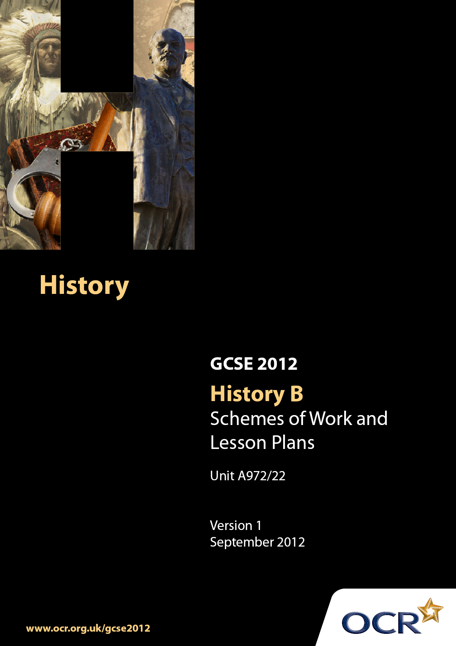

Contents
Contents 2
Introduction 3
Scheme of Work: Unit A972/22: How far did British society change, 1939–1975? 6
Lesson Plan: Unit A972/22: How far did British society change, 1939–1975? 16

Introduction

Background
Following a review of 14–19 education and the Secondary Curriculum Review, the Qualifications and Curriculum Authority (QCA) has revised the subject criteria for GCSEs for first teaching in September 2009. This applies to all awarding bodies.
The new GCSEs have more up-to-date content and encourage the development of personal learning and thinking skills in your students.
We have taken this opportunity to redevelop all our GCSEs to ensure they meet your requirements. These changes will give you greater control of assessment activities and make the assessment process more manageable for you and your students. Controlled assessment will be introduced for most subjects.
From September 2012 assessment tasks may be undertaken at any point between release of the task and the examination series for which the task must be submitted. Centres must ensure that candidates undertake a task that is valid for submission in the year in which the candidate intends to submit it.
OCR has produced a summary brochure, which summarises the changes to History. This can be found at www.ocr.org.uk along with the new specification.
In order to help you plan effectively for the implementation of the new specification, we have produced these Schemes of Work and sample Lesson Plans for History. These Support Materials are designed for guidance only and play a secondary role to the Specification.

Our Ethos
OCR involves teachers in the development of new support materials to capture current teaching practices tailored to our new specifications. These support materials are designed to inspire teachers and facilitate different ideas and teaching practices.
Each Scheme of Work and set of sample Lesson Plans is provided in Word format – so that you can use it as a foundation to build upon and amend the content to suit your teaching style and students’ needs.
The Scheme of Work and sample Lesson Plans provide examples of how to teach this unit and the teaching hours are suggestions only. Some or all of them may be applicable to your teaching.
The specification is the document on which assessment is based and specifies what content and skills need to be covered in delivering the course. At all times, therefore, this Support Material booklet should be read in conjunction with the specification. If clarification on a particular point is sought, then that clarification should be found in the specification itself.

A Guided Tour through the Scheme of Work

= Innovative Teaching Idea
This icon is used to highlight exceptionally innovative ideas.


= ICT Opportunity
This icon is used to illustrate when an activity could be taught using ICT facilities.

Unit A972/22: How far did British society change,1939–1975?
Suggested teaching time | 8 hours | Topic | How far did British society change between 1939 and 1975? Teenagers in the 1950s, 1960s and 1970s.
Topic outline |  | Suggested teaching and homework activities |  | Suggested resources | Points to note
Introduction |  | - Students could be provided with essential information relevant to this unit. This could include a brief summary of the scheme of work, an overview of the assessment requirements and a list of resources to be used. The teacher should also emphasise the skills nature of this unit  - There are a number of ways that this unit could be delivered in the classroom, depending on specific teaching/school/department styles. This could include a knowledge -based background to the unit followed by the use of historical sources or an approach via historical sources relevant to the topic supported through knowledge  - The key themes of the focus points include:  - The lives of teenagers in the 1950s  - The impact of increased affluence  - The impact of American culture on British teenagers  - The introduction of comprehensive education and university expansion  - Student protests in the 1960s  - Youth culture, for example, Mods and Rockers, the growing popularity and impact of rock music, clothes and fashion  - Teenagers as consumers  - The reactions of the authorities to these changes  - The extent to which the lives of all teenagers were changed by the mid 1970s |  | - Unit A972 Specification  - At the moment there are few available textbooks that cover this period but they will become available during 2009. However, a number of Social and Economic History textbooks do contain chapters on this period  - OCR exemplar/past examination papers  - There is a plethora of websites on this period. Teachers may find the following websites useful as a starter:  - http://www.fashion-era.com/1950s/index.htm  - http://news.bbc.co.uk/1/hi/magazine/decades/1950s/default.stm  - http://news.bbc.co.uk/1/hi/magazine/decades/1960s/default.stm  - http://news.bbc.co.uk/1/hi/magazine/decades/1970s/default.stm  - http://www.reminiscethis.co.uk  - www.screenonline.co.uk  - Personal reminiscences of people would be another useful resource, e.g. family members, neighbours etc  - A number of DVDs exist that could be used, e.g. ‘Those were the days’ (some are located for sale on Ebay) | - Teachers may find it useful to produce a ‘Course Booklet’. This may contain the summary of the unit specification, assessment criteria and may also contain textbook titles and a sources pack of material. This may be a completely online resource made available through the school intranet or similar  - This unit involves historical enquiry into a period of British history. It gives candidates opportunities to investigate specific historical questions, problems and issues; use a range of historical sources and reach reasoned conclusions; and analyse and evaluate how the past has been interpreted and represented in different ways. Candidates will be expected to use their contextual knowledge to help them comprehend, interpret, evaluate and use sources and historical interpretations and representations  - Throughout this topic the emphasis should be on the understanding of the background, the reasons why the lives of teenagers changed in the 1950s, 1960s and 1970s  - It is suggested that at the end of each topic, GCSE examination style questions should be set using a variety of resources that test this aspect of the British Depth Study
What was it like growing up in the 1950s? |  | - A starting point for this unit would be to consider life for teenagers in 2008 and then compare this with the 1950s  - A timeline would also be a useful resource starting in 1945, locating a number of important dates and events up to the present day  - Consideration should be given to life after the 2nd World War and how it had affected people’s lives  - Research to be undertaken on life in the 1950s using the internet, DVDs and textbooks  - Interesting aspects of this research could include fashion, music (e.g. Elvis Presley etc) and Teddy Boys. The use and discussion of images and written sources would enhance this section  - Pupils should make notes on the above |  | - Websites:  - http://www.fashion-era.com/1950s/index.htm  - http://news.bbc.co.uk/1/hi/magazine/decades/1950s/default.stm  - http://www.greatereasterhouse.co.uk/geln  - lochend_fam_learn/LFL_subjects/local_history/daily_life50s.html  - http://www.reminiscethis.co.uk  - www.screenonline.co.uk
Why were there changes in the lives of teenagers in the 1960s? |  | - An overview of changes in the 1960s could be considered in the first instance, focussing on such aspects of society as music, fashion, sport, education and the increase in consumer goods. The use and discussion of images and written sources would enhance this section  - A brainstorming session could be held on why these changes took place which should then lead to a defined list  - Pupils should make notes on the above |  | - Websites:  - http://news.bbc.co.uk/1/hi/magazine/decades/1960s/default.stm  - http://www.reminiscethis.co.uk  - www.screenonline.co.uk  - http://www.bbc.co.uk/cult/ilove/years/60sindex.shtml  - http://www.sixtiescity.com/index.shtm  - http://www.backdate.co.uk
How did teenagers and students behave in the 1960s and early 1970s? |  | - DVD/film/graphics and written sources would provide a good opportunity for discussion about the behaviour of teenagers at this time  - Notes should made listing the way in which teenagers behaved at this time |  | - Websites:  - http://news.bbc.co.uk/1/hi/magazine/decades/1960s/default.stm  - http://www.reminiscethis.co.uk  - www.screenonline.co.uk  - http://www.bbc.co.uk/cult/ilove/years/70sindex.shtml  - http://www.backdate.co.uk/
How far did the lives of all teenagers change in the 1960s and early 1970s? |  | - DVD/film/graphics and written sources would provide a good opportunity for discussion about the behaviour of teenagers at this time  - Notes should made listing the way in which teenagers behaved at this time |  | - Websites:  - http://news.bbc.co.uk/1/hi/magazine/decades/1960s/default.stm  - http://www.reminiscethis.co.uk  - www.screenonline.co.uk

Unit A972/22: How far did British Society change between 1939 and 1975?

Why were there changes in the lives of teenagers in the 1960s?
OCR recognises that the teaching of this qualification will vary greatly from school to school and from teacher to teacher. With that in mind, this lesson plan is offered as a possible approach but will be subject to modification by the individual teacher.
Lesson length is assumed to be one hour.

Learning Objectives for the Lesson
Objective 1 | To understand the reasons why the lives of teenagers changed in the 1960s
Objective 2 | To understand the factors that influenced the lives of teenagers in the 1960s
Objective 3 | To be able to comprehend and interpret cartoons, videos, photographs and written sources for their message

Recap of Previous Experience and Prior Knowledge
- Students understand the major events that took place in the 1950s and 1960s.
- Students are aware of the factors that influenced their grandparents’ lives in the 1960s
- Students understand the nature of the term ‘teenager’.

Content
Time | Content
5 minutes | - Starter: Teacher establishes the learning objectives for the lesson. This will show students how the lesson will begin to help them understand the reasons why the lives of teenagers changed in the 1960s.
10 minutes | - Introduction: Teacher explains the context of the lesson – life in the 1960s - and sets the lesson in the context of a homework exercise in which students have previously spoken to grandparents/neighbours about their lives in the 1960s (or have read about it) – and points to future activities and discussions.  - Teacher leads a discussion with the students that identifies a number of factors that influenced the lives of teenagers in the 1960s, using the information obtained from conversations with grandparents and neighbours and a range of sources shown on the whiteboard.

30 minutes | - Students have to complete research on the internet from a number of identified websites (see scheme of work). This research will focus on such topics as music, fashion, sport and consumer goods. They are also given a pro-forma that they will be able to complete that will identify some aspects of each of these topics.  - Students should identify the main aspects of these topics and download/copy and paste material into their user area to be used at a later date.  - Teacher leads the feedback by extracting information from students about these factors. Teacher also checks that learning is taking place with quick question and answer session.
5 minutes | - Students complete the pro-forma.

Consolidation
Time | Content
5 minutes | - Plenary: Teacher re-caps on the lesson and outlines to students what they have learned in terms of both content and skills.
5 minutes | - Homework set: Students are to plan a PowerPoint Presentation using a storyboard pro-forma that they will construct next lesson of the factors that influenced the lives of teenagers in the 1960s.

