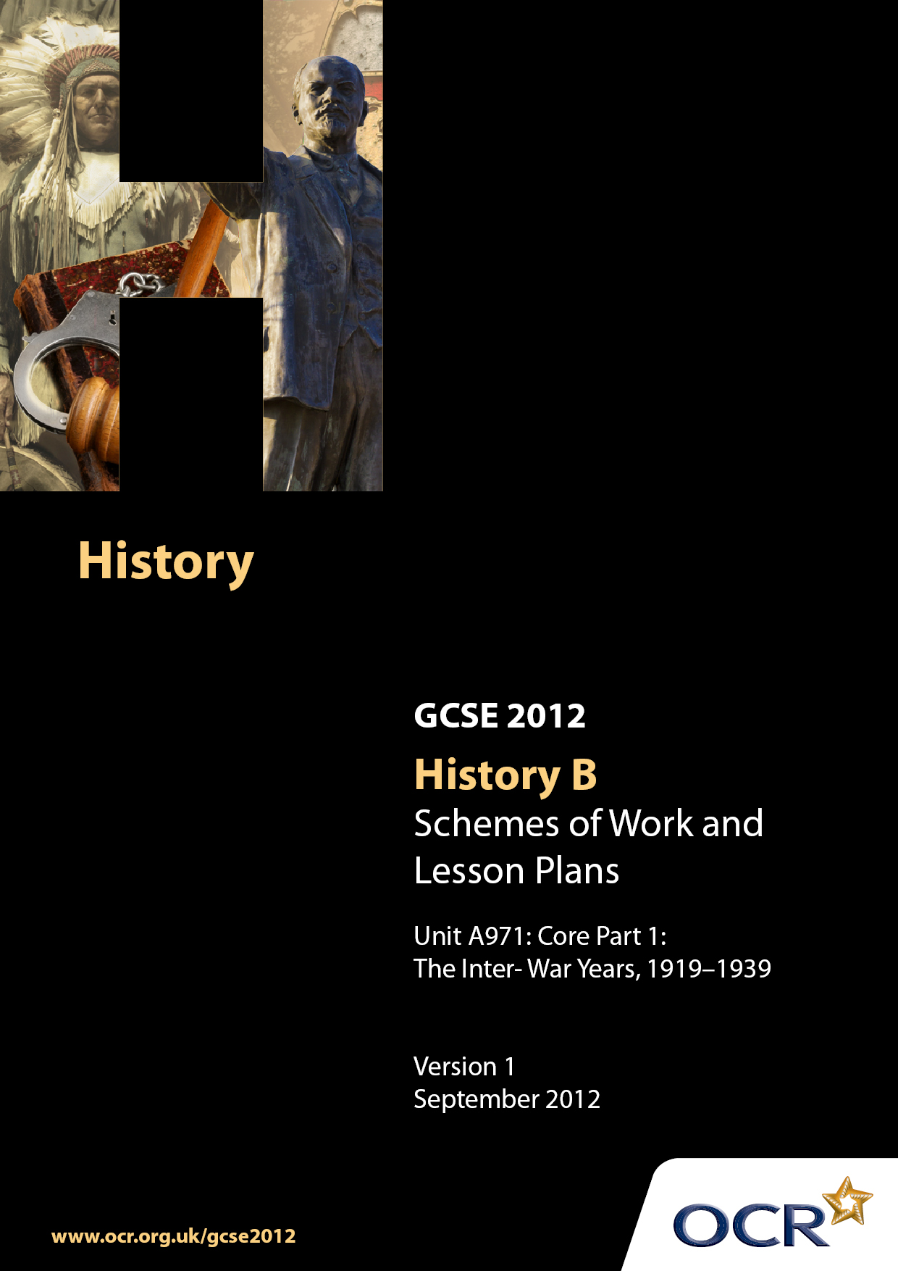

Contents
Introduction 3
Sample Scheme of Work: Unit A971: Core Part 1: The Inter-War Years, 1919–1939 6
Sample Lesson Plan: Unit A971: Core Part 1: The Inter-War Years, 1919–1939 31

Introduction

Background
Following a review of 14–19 education and the Secondary Curriculum Review, the Qualifications and Curriculum Authority (QCA) has revised the subject criteria for GCSEs for first teaching in September 2009. This applies to all awarding bodies.
The new GCSEs have more up-to-date content and encourage the development of personal learning and thinking skills in your students.
We have taken this opportunity to redevelop all our GCSEs to ensure they meet your requirements. These changes will give you greater control of assessment activities and make the assessment process more manageable for you and your students. Controlled assessment will be introduced for most subjects.
From September 2012 assessment tasks may be undertaken at any point between release of the task and the examination series for which the task must be submitted. Centres must ensure that candidates undertake a task that is valid for submission in the year in which the candidate intends to submit it.
OCR has produced a summary brochure, which summarises the changes to History B. This can be found at www.ocr.org.uk along with the new specification.
In order to help you plan effectively for the implementation of the new specification, we have produced these Schemes of Work and sample Lesson Plans for History B. These Support Materials are designed for guidance only and play a secondary role to the Specification.

Our Ethos
OCR involves teachers in the development of new support materials to capture current teaching practices tailored to our new specifications. These support materials are designed to inspire teachers and facilitate different ideas and teaching practices.
Each Scheme of Work and set of sample Lesson Plans is provided in Word format – so that you can use it as a foundation to build upon and amend the content to suit your teaching style and students’ needs.
The Scheme of Work and sample Lesson Plans provide examples of how to teach this unit and the teaching hours are suggestions only. Some or all of them may be applicable to your teaching.
The specification is the document on which assessment is based and specifies what content and skills need to be covered in delivering the course. At all times, therefore, this Support Material booklet should be read in conjunction with the specification. If clarification on a particular point is sought, then that clarification should be found in the specification itself.

A Guided Tour through the Scheme of Work

= Innovative Teaching Idea
This icon is used to highlight exceptionally innovative ideas.


= ICT Opportunity
This icon is used to illustrate when an activity could be taught using ICT facilities.

Unit A971: Core Part 1: The Inter- War Years, 1919-1939
Suggested teaching time | 10-15 hours | Topic | The Inter -War Years
Topic outline |  | Suggested teaching and homework activities |  | Suggested resources | Points to note
Were the Peace Treaties of 1919-1923 fair? | What were the motives and aims of the Big Three at Versailles?  - Begin by looking at the key terms of the Treaties of Versailles (particularly focused on Germany), Trianon (particularly focused on Austria-Hungary), St Germain (focused on Austria-Hungary), Sevres (Ottoman Empire) and Lausanne (Ottoman Empire). This could be devised as an activity which is where pupils or groups of pupils are called upon to represent one individual (Clemenceau, Lloyd George or Wilson) with other individuals representing Germany (not allowed to speak!) Prepare briefing notes with key attitudes towards the situation in Europe and ask pupils to write down to share with other pupils their reactions to the treaties (particularly the Treaty of Versailles) Key points from each of the Big Three’s perspective (plus Germany) can then be collated  Why did the victors not get everything they wanted?  - It is important to get the pupils to think about the constraints and problems that the Big Three face in dealing with the problem of the end of World War I. Produce a factsheet on the Big Three countries and how the war affected them. This should particularly focus upon the impact the war has had (money, casualties, fears for the future, spectre of a communist Russia). Pupils could perhaps stay representing the country they were originally which they then share within the group  - Go back to the original question – trying to discuss the reasons why each country was perhaps dissatisfied. Produce a list of reasons on whiteboard or smartboard and ask pupils to analyse the main reasons why this was so  What were the immediate reactions to the peace settlement?  - Find sources from commentators at the time on the settlement from France, Britain, USA and Germany’s perspective. Produce a chart in which pupils make notes about reactions – emphasise positive and negative reactions. After class feedback set up work showing examples from website in next column (or devised by school). Each pupil has to take one country and produce a cartoon or a pictorial reaction to the peace settlement  - Could the treaties be justified at the time? I suggest that this question is used as the basis for an initial essay style assessment. Construct a writing frame to consider this question, pull apart the key words within the question etc. Ask the pupils to produce a detailed plan which can be discussed with peers and teacher. Essay to be written at home or in test conditions (in which case a detailed plan could be produced at home)  - Alternatively, use this question as the basis to produce a detailed mindmap of the Peace Treaties and the issues they present for international relations |  | - There is scope to use maps (widely available on the web to look at Europe and the Middle East before and after World War I for pupils to identify the differences between the two)  - Although designed for A level, War and Peace: International Relations 1914-45 is an extremely useful resource for reference purposes  - Scope to develop the idea used in the Rediscovering the Modern World text  - This website may give some useful ideas for the activity suggested  - http://ourcartoons.blogspot.com/2007/10/  gcse-modern-world-history.html – these can be shared with pupils |  | - There doesn’t need to be much information on the other treaties – various texts and resources have summaries of this document but there is a useful table in GCSE Modern World History, The Revision Guide page 27  - Key point to note and emphasise is the need for compromise and the limitations for each country  - It is important to note the failure of the USA to ratify this treaty and how this was to lead to instability in Europe in particular over the next 20 years  - It may be a good idea to scan good examples of work produced to use to produce a movie for revision purposes. This activity should help to produce good display material as well
To what extent was the League of Nations a success? | What were the aims of the League?  - Ask pupils to brainstorm the setting up of an organisation to ensure that another war doesn’t happen. Set the pupils a series of questions to help them such as who should be involved, how should decisions be reached, should this organisation have an army? Build up a flowchart on the board or Smartboard of agreed proposals behind the League of Nations. Compare this with a pre-prepared diagram showing the League of Nations and its organisation. Pupils at this stage should be able to begin to identify strengths and weaknesses of this organisation  How successful was the League in the 1920s?  - Produce a case study on the League of Nations in the 1920s. Perhaps this could be done as an end of decade report. It would probably be best to look at the weaknesses too. This can be written up in the form of a report  How far did weaknesses in the League’s organisation make failure inevitable?  - Prepare a series of cards which point out the strengths and weaknesses of the League of Nations. Pupils should be given scope to make their own cards to contribute to this discussion. Pupils should divide these cards into the 2 categories and prioritise. This will help them to address this question – there should be scope to discuss how the weaknesses were far more significant than the strengths. This should enable teacher and pupil to discuss the concept of inevitability. This card sort exercise can be used as the basis for writing an essay based upon this.  - A teacher could also prepare inference diagrams with relevant cartoons making comments about the League of Nations to draw out and come to conclusions about the weaknesses of this organisation.  How far did the Depression make the work of the League more difficult?  - Produce case studies on the effect of the depression on different countries, particularly France, Britain, Germany, Italy and Japan. Provide some source material and information from textbooks to investigate the impact of the Depression. Ask the pupils to summarise the impact on one piece of paper or even better, a PowerPoint slide. This can also be done as a jigsaw exercise where there are original groups investigating one country which then splits up to form groups with representatives from other countries to feed back – this could even be done completely using pictures and no words. Teacher leads discussion and then there is discussion over the likely impact on the League of Nations  Why did the League fail over Manchuria and Abyssinia?  - Select relevant clips from the film The Last Emperor to show the events surrounding the invasion of Manchuria. Provide resources or use textbook to discuss how the League reacted. Pupils to summarise the key problems that this invasion showed up within the League  - Using the Learning Curve website ‘heroes and villains’ use this as an ICT task whereby information is gathered about the invasion of Abyssinia and looking at the role of the League of Nations. Particularly focus on the section called ‘Was the League of Nations a villain in this conflict?  - Suggestion – use the material studied to produce a PowerPoint pointing out the strengths and the weaknesses of the League with particular relevance to Manchuria and Abyssinia |  | - http://www.schoolhistory.co.uk/gcselinks/  modern/betweenwars/leagueofnations.ppt  #259,4,Structure  - http://www.schoolhistory.co.uk/gcselinks/  modern/betweenwars/failuresleague.ppt  #259,4,Sanctions  - http://www.schoolhistory.co.uk/resources/  - The above are useful PowerPoint presentations available on the school history website which could be used to summarise key issues relating to the League of Nations  - This is covered well in main textbooks  - For more detailed notes on the League of Nations the Access to History text, Britain: Foreign and Domestic Affairs, Alan Farmer, is a useful resource  - This website contains some useful cartoons (from an American perspective) about the League – check other sites for relevant material  - http://www.authentichistory.com/ww1/  cartoons/ww1politicalcartoonsLON01.html  - This resource is useful in giving a lot of information about the invasion of Abyssinia – the focus is Mussolini but will give good background information which will help pupils to answer the general question.  - http://www.learningcurve.gov.uk/  heroesvillains/g3/ |  | - This should look at the successes (Upper Silesia, Bulgaria, fight against diseases) and failures such as the Corfu incident. There should be reference to the role of this organisation in promoting disarmament , the work of the International Court of Justice, the International Labour Organisation and the Special Commissions  - Obviously access to computers will be required for this task, please note that there are different kinds of sources including sound files  - Although not contained in the specified content a brief explanation of the significance of the Hoare Laval Pact would help to illustrate the attitudes of the big two towards a small state like Abyssinia  - There are masses of cartoon sources available and other resources available on the net in addition to the textbooks – there should be a copy of examples of these pictures with this information
Why had international peace collapsed by 1939? | What were the long-term consequences of the peace treaties of 1919-1923?  What were the consequences of the failures of the League in the 1930s?  How far was Hitler’s foreign policy to blame for the outbreak of war in 1939?  Was the policy of appeasement justified?  How important was the Nazi-Soviet Pact?  Why did Britain and France declare war on Germany in September 1939? |  | - This is a good opportunity to recap on the peace treaties and how they impacted on countries. Focus in on Italy and Japan (following the Washington Naval Treaty and depression). Germany is obviously most important. If enough information is available then this could be done as a living graph for each country to indicate how warlike each country gets between 1919 and 1939. This will give an important overview  - Teachers may decide to incorporate this into earlier learning opportunities about the League of Nations or give an opportunity to recap to emphasise how the organisation that is hoped to maintain world peace has failed by the mid 1930s  - http://www.bbc.co.uk/schools/gcsebitesize/  history/mwh/ir1/hitlersaimsandactionsrev2.shtml This is a good website that summarises nicely Hitler’s foreign policy  - Pupils should be reminded of the aims of Hitler’s foreign policy on becoming Chancellor and subsequently dictator. Produce a chronological table showing Hitler’s actions after coming to power from orders to rearm to September 1939 giving detail. In a separate column there must be a discussion as to how the Allies react to these moves. Pupils need to be given a range of information to help them produce this table. From this you can ask the pupils to spot when attitudes to Germany harden and why Hitler was able to get away with aggressive behaviour for so long  - Start by giving an explanation of the term appeasement as used to describe British policy in the mid to late 1930s. Point back to the work looked at previously and organise a debate to look at whether the policy was justified. Put the class into 2 large groups which can be made into smaller groups. Give a series of cards or make pupils produce a series of cards with arguments to support this policy or not. Organise a class debate focused upon this question with pre-arranged criteria for judging the quality of the debate.  - Display a map of central Europe on the whiteboard pointing out the proximity of Poland to the Soviet Union and Germany. Recap on the reasons why Hitler would want to occupy this country. Perhaps use the visual image of a seesaw, one side attacking Poland without alliance with Soviet Union and the other side making an alliance. Ask pupils to suggest reasons for both arguments; provide snippets of pre-prepared information to help the small group discussion. This can then be fed back to the class. Come to a judgement about which side of the seesaw is likely to be heavier. Against this discussion explain what happened in August 1939  - It is suggested that arguments for and against going to war with Germany over the invasion of Poland should be discussed here. Present a piece of film (this is covered well in the World at War series) showing what happened at the beginning of September – pupils to note down key events. Pupils should now consider the pros and the cons of going to war with Germany at this stage  - There is a good BBC programme which looks at International Relations which nicely summarises issues discussed in this part of the specification |  | - Please emphasise how events in different countries affect reactions (for example, Abyssinia at the same time as Rhineland crisis)  - This can be followed up with this set as an essay to judge understanding  - http://www.learningcurve.gov.uk/snapshots  /snapshot31/snapshot31.htm - this is a good resource which looks at documents relating to the policy of appeasement which could be used as the basis of an ICT lesson or as an ICT based homework  - Once this is done then there is scope to ask the question about the likely reaction to this news in Poland and Britain (which leads us to the last question)  - It may be interesting to discuss the possible reasons why there was a delay between the invasion of Poland and Britain (and then France) declaring war on Germany  - A good A level text which certainly deals well with a number of issues raised by this book is Britain: Foreign Affairs 1919-1939, Alan Farmer

Unit A971: Core part 1: The Inter War Years 1919–1939

How far was Hitler’s foreign policy to blame for the outbreak of war in 1939?
OCR recognises that the teaching of this qualification will vary greatly from school to school and from teacher to teacher. With that in mind, this lesson plan is offered as a possible approach but will be subject to modification by the individual teacher.
Lesson length is assumed to be one hour.

Learning Objectives for the Lesson
Objective 1 | To understand the development of Hitler’s foreign policy
Objective 2 | To begin to consider how far this was responsible for the outbreak of war in 1939

Recap of Previous Experience and Prior Knowledge
- It would be good to recap on some of the possible reasons for war breaking out that have already been discussed, not least the failure of the League of Nations, the legacy of the Treaties and the impact of the depression

Content
Time | Content
5 minutes | Summarise possible reasons for war identified in earlier lessons
10 minutes | Pupils asked to recap Hitler’s ideas relating to foreign policy – this can be prompted with the use of aims of the Nazi party and what potential conflicts this may lead to (problems with France, Poland, Czechoslovakia and Soviet Union) – discuss ideas with class
15 minutes | Pupils to use either textbooks or handout provided to produce a living graph along the vertical axis should be numbered up to 10 relating to likeliness to lead to war; along the horizontal axis should just be the dates. Ensure that pupils have access to key information. They should ensure the line is annotated to show key points
10 minutes | Teachers to discuss the findings of these graphs – from their understanding when does it look as if war becomes more likely? That is, when does Hitler appear to be particularly aggressive? Suggestion that teacher has their own version of this exercise on the board (Smartboard). Pose the question of when the Allies may have gone to war
10 minutes | Introduce to the discussion and living graph crisis moments – ie the invasion of the Rhineland, Anschluss, Sudetenland – give pupils snippets of information. Ask them to suggest other reasons

Consolidation
Time | Content
10 minutes (including consolidation) | Ask pupils to write a paragraph answering the question set – get some to read out their answers to test understanding

