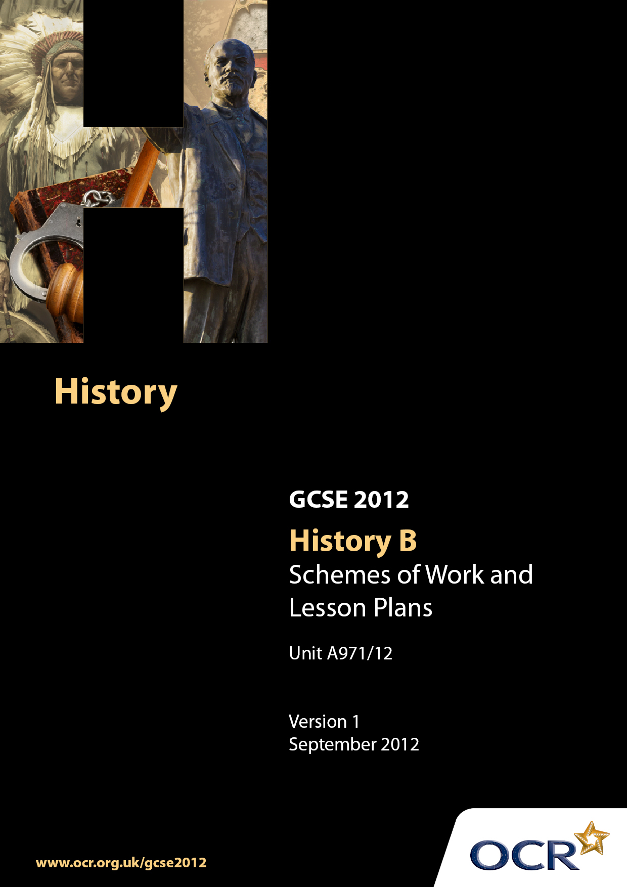

Contents
Introduction 3
Sample Scheme of Work : Unit A971/12: Russia, 1905–1941 5
Sample Lesson Plan: Unit A971/12: Russia, 1905–1941 12

Introduction

Background
Following a review of 14–19 education and the Secondary Curriculum Review, the Qualifications and Curriculum Authority (QCA) has revised the subject criteria for GCSEs, for first teaching in September 2009. This applies to all awarding bodies.
The new GCSEs have more up-to-date content and encourage the development of personal, learning and thinking skills in your students.
We have taken this opportunity to redevelop all our GCSEs, to ensure they meet your requirements. These changes will give you greater control of assessment activities and make the assessment process more manageable for you and your students. Controlled assessment will be introduced for most subjects.
From September 2012 assessment tasks may be undertaken at any point between release of the task and the examination series for which the task must be submitted. Centres must ensure that candidates undertake a task that is valid for submission in the year in which the candidate intends to submit it.
OCR has produced a summary brochure which summarises the changes to History B (Modern World). This can be found at www.ocr.org.uk, along with the new specification.
In order to help you plan effectively for the implementation of the new specification we have produced these Schemes of Work and sample Lesson Plans for History B. These Support Materials are designed for guidance only and play a secondary role to the Specification.

Our Ethos
OCR involves teachers in the development of new support materials to capture current teaching practices tailored to our new specifications. These support materials are designed to inspire teachers and facilitate different ideas and teaching practices.
Each Scheme of Work and set of sample Lesson Plans is provided in Word format – so that you can use it as a foundation to build upon and amend the content to suit your teaching style and students’ needs.
The Scheme of Work and sample Lesson Plans provide examples of how to teach this unit and the teaching hours are suggestions only. Some or all of them may be applicable to your teaching.
The Specification is the document on which assessment is based and specifies what content and skills need to be covered in delivering the course. At all times, therefore, this Support Material booklet should be read in conjunction with the Specification. If clarification on a particular point is sought then that clarification should be found in the Specification itself.

A Guided Tour through the Scheme of Work

= Innovative Teaching Idea
This icon is used to highlight exceptionally innovative ideas.


= ICT Opportunity
This icon is used to illustrate when an activity could be taught using ICT facilities.

Unit A971/12: Russia, 1905–1941
Suggested teaching time | 7 hours | Topic | How did the Bolsheviks gain power and how did they consolidate their rule?
Topic outline |  | Suggested teaching and homework activities |  | Suggested resources | Points to note
1. How effectively did the provisional government rule Russia during March to November 1917? |  | - Teacher presents  - July Days  - Continuation of war  - Delay of land reform  - Delay of election for Constituent Assembly  - Korniloff Revolt  - Pupils research Kerensky’s government  - Homework: either a) advise Kerensky on a survival plan or (b) make notes on: how would each of the following react to the Provisional Government: soldiers; peasants; factory workers; supporters of democracy? |  | - Interactive/ white board  - GCSE History textbooks  - Teacher notes  - Internet | - Understanding of terms: e.g. ‘provisional’; ‘July Days’; ’Korniloff Revolt’  - Achievements of the provisional government, e.g. factory legislation
2. Why were the Bolsheviks able to seize power in November 1917? |  | - Divide class into two groups  - Group 1: research failures of Provisional Government e.g. no land reform; no end to war; food shortage; no elections  - Group 2: growing strength of Bolsheviks e.g. control of Petrograd Soviets; return of Lenin; use of effective propaganda; ennobled by Korniloff Revolt; lessons learnt from July Days  - Homework: either a) put into rank order the reasons for the Bolshevik’s seizure of power and explain the importance of each. Or b) compile a profile of Lenin, identifying his strengths |  | - Interactive/ white board  - GCSE History textbooks  - Teacher notes  - Internet | - key terms: propaganda; Petrograd Soviets; April Thesis
3. How were the Bolsheviks able to seize power in November 1917? |  | - City plan of St Petersburg  - In small groups identify the strategically important buildings/ areas and explain their importance to the rest of the class  - Class discussion: was success down to luck or planning?  - Homework: as a foreign reporter, write an article about the events of 6/7 November 1917, commenting on atmosphere, the mood of the people, use of violence, if any, and nature and extent of opposition, if any. Also speculate on the historical significance of the events you have witnessed |  | - City plan of St Petersburg  - Interactive/ white board  - GCSE History textbooks  - Teacher notes  - Internet  - Film: “October” Eisenstein | - Leadership of Lenin and Trotsky  - Planning and idea of ‘revolution by timetable’  - Myths and reality/ role of the media and the arts in turning myth into reality  - Terminology: popular revolution versus coup d’état or putsch?
4. How did Lenin consolidate power (part 1) after November 1917? |  | - Research the nature of Bolshevik rule using textbooks/ ICT website. Write notes  - Peace with Germany; write a paragraph each on the benefits and costs to Russia of peace  - Homework: The suppression of the ‘Kronstat Revolt’; in 1917 the Kronstat sailors supported the Bolshevik Revolution. Why did the same sailors revolt against Lenin in 1921? |  | - Interactive/ white board  - GCSE History textbooks  - Teacher notes  - Internet | - Dictatorship  - Positive and negative aspects of Lenin’s rule  - Did Lenin make the correct decisions?
5. How did Lenin consolidate Power (part 2) after November 1917? |  | - Why did the Bolsheviks win the Civil War? Class divided into two groups: Bolsheviks: these are our strengths and weaknesses; Whites: these are our strengths and weaknesses. Pupils discuss amongst themselves and report back to teacher, who records their ideas  - Homework: Worksheet: place the following reasons for Bolshevik victory in the Civil War in rank order of importance; justify your selection  - Control of major cities  - Control of major communications  - Role of Trotsky  - Foreign intervention  - Division within ranks of Whites  - Propaganda  - Attitude of peasants/ ordinary Russians |  | - Worksheet: place the following reasons for Bolshevik victory in the Civil War  - Interactive/ white board  - GCSE History textbooks  - Teacher notes  - Internet | - Causes of the Civil War  - Who were the Whites?  - Nature of the war/ barbarity  - Reasons for Bolshevik victory  - Key terms: Cheka; political commissars
6. What were War Communism and the New Economic Policy? |  | - Pair work: person A looks at photo 1 and person B looks at photo 2, analysing the surface features of each source. Each pair presents to the class and teacher then draws together the salient features, putting them as bullet points on the white or interactive board  - Homework: essay: How different were War Communism and NEP? (NB This type of question is also an invitation to consider similarities) |  | - Photo (1) of Requisition Squad in the countryside and (2) photo of market place in Moscow following introduction of NEP 1921  - Interactive/ white board  - GCSE History textbooks  - Teacher notes  - Internet | - Key terms: Nepmen; private enterprise; state capitalism; requisition squads
7. Assessment: how important was Trotsky to the Bolshevik success in the Civil War? |  | - Test essay on one aspect of the key question (under test conditions):  - ‘How important was Trotsky to the Bolshevik success in the Civil War?’ |  | - Mark scheme. Total 10 marks  - Level 1 (1-2 marks) general answer, lacking specific detail e.g. Trotsky was important because of the things he did  - Level 2 (3-4 marks) identifies reasons e.g. Trotsky was a good commander. I mark for each  - Level 3 (4-6 marks) explains role of Trotsky or other reasons  - Level 4 (6-9 marks) both sides of level 3  - Level 5 (9-10 marks) construction of an argument of relative importance. Attempts judgment | - Allow ½ hour revision and ½ for the test

Unit A971/12: Russia, 1905–1941

The Nature of the Bolshevik Revolution November 1917
OCR recognises that the teaching of this qualification will vary greatly from school to school and from teacher to teacher. With that in mind this lesson plan is offered as a possible approach but will be subject to modification by the individual teacher.
Lesson length is assumed to be one hour.

Learning Objectives for the Lesson
Objective 1 | Understanding the nature of Bolshevik Revolution November 1917
Objective 2 | Knowledge and understanding of events surrounding 6 and 7 November 1917
Objective 3 | Distinguish between different interpretations of historical events
Objective 4 | Develop evaluative skills
Objective 5 | Develop investigative skills

Recap of Previous Experience and Prior Knowledge

Brief question and answer session of the Provisional Government, March- November 1917

Content
Time | Content
5 minutes | Introduction: ask the students if they can explain the difference between a popular revolution and a coup d’état.
10 minutes | Introduce and show an excerpt from the film: ‘October’ by Eisenstein to illustrate the concept of ‘popular revolution’
5-10 minutes | Hand out copies of a passage from a popular textbook (Walsh): “the Bolsheviks did not have the support of the majority of the Russian people; Lenin was the overall planner who led a small group totally dedicated to the Revolution.”
15 minutes | Class divides into two groups: Group X to collate evidence in support of popular revolution view, e.g. increase in support for Bolsheviks; increase in membership; Group Y: to collate evidence in support of coup d’état, e.g. small group of fanatics; secretive; did not represent opinion throughout Russia; plot by a small group.
10 minutes | Presentation of their case by each group using a Brain’s Trust Forum approach.

Consolidation
Time | Content
5 minutes | Ask class to explain the difference between a popular revolution and a coup d’état.
10 minutes | The teacher then asks: “the November Revolution, was it a popular revolution or a coup d’état?” Then s/he leads a spider graph session on the board, with ‘November Revolution’ at the centre; students recap, presenting their findings / feedback as satellites; the different views and possible interpretations are linked to the main focus of the graph, clearly separating the two interpretations. The work is retained as the basis for a future essay.
Resources Needed: | Film: Eisenstein’s “October”; textbook Walsh: Modern World History, sources 32 to 37 publ. by John Murray

