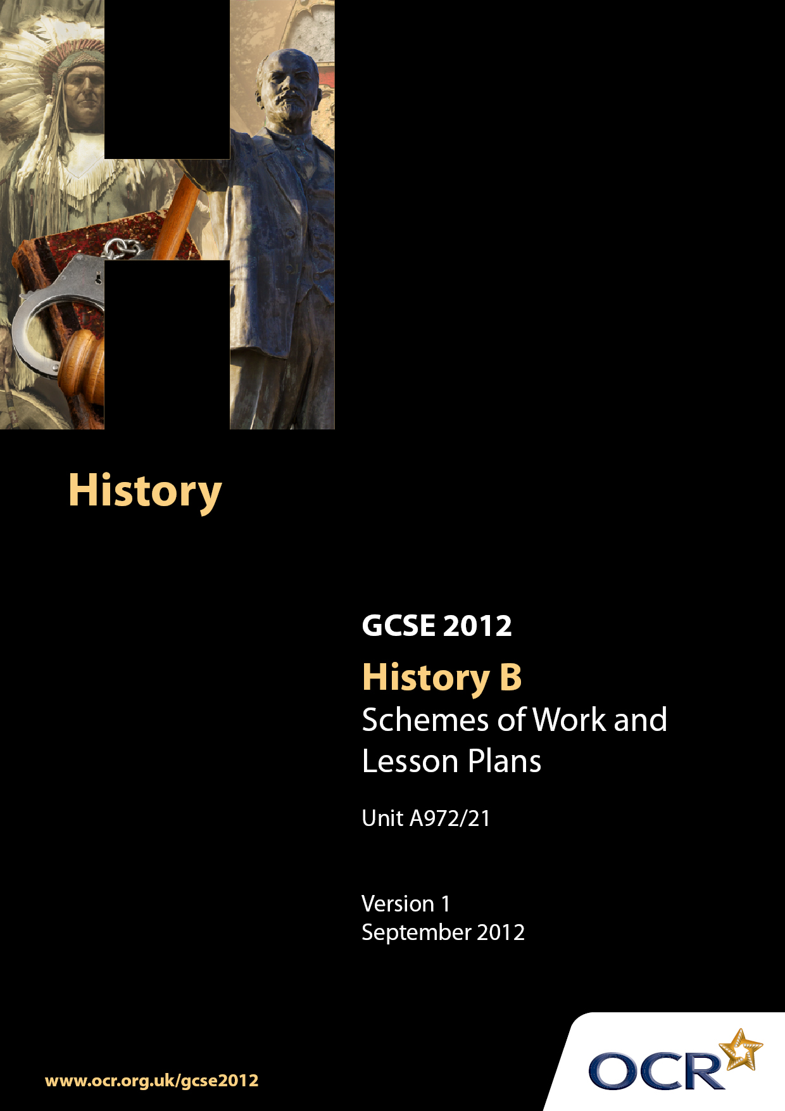

Contents
Contents 2
Introduction 3
Scheme of Work:Unit A972/21: How was British society changed, 1890–1918? 6
Lesson Plan: Unit A972/21:How was British society changed, 1890–1918? 15

Introduction

Background
Following a review of 14–19 education and the Secondary Curriculum Review, the Qualifications and Curriculum Authority (QCA) has revised the subject criteria for GCSEs for first teaching in September 2009. This applies to all awarding bodies.
The new GCSEs have more up-to-date content and encourage the development of personal learning and thinking skills in your students.
We have taken this opportunity to redevelop all our GCSEs to ensure they meet your requirements. These changes will give you greater control of assessment activities and make the assessment process more manageable for you and your students. Controlled assessment will be introduced for most subjects.
From September 2012 assessment tasks may be undertaken at any point between release of the task and the examination series for which the task must be submitted. Centres must ensure that candidates undertake a task that is valid for submission in the year in which the candidate intends to submit it.
OCR has produced a summary brochure, which summarises the changes to History. This can be found at www.ocr.org.uk along with the new specification.
In order to help you plan effectively for the implementation of the new specification, we have produced these Schemes of Work and sample Lesson Plans for History. These Support Materials are designed for guidance only and play a secondary role to the Specification.

Our Ethos
OCR involves teachers in the development of new support materials to capture current teaching practices tailored to our new specifications. These support materials are designed to inspire teachers and facilitate different ideas and teaching practices.
Each Scheme of Work and set of sample Lesson Plans is provided in Word format – so that you can use it as a foundation to build upon and amend the content to suit your teaching style and students’ needs.
The Scheme of Work and sample Lesson Plans provide examples of how to teach this unit and the teaching hours are suggestions only. Some or all of them may be applicable to your teaching.
The specification is the document on which assessment is based and specifies what content and skills need to be covered in delivering the course. At all times, therefore, this Support Material booklet should be read in conjunction with the specification. If clarification on a particular point is sought, then that clarification should be found in the specification itself.

A Guided Tour through the Scheme of Work

= Innovative Teaching Idea
This icon is used to highlight exceptionally innovative ideas.


= ICT Opportunity
This icon is used to illustrate when an activity could be
taught using ICT facilities.

Unit A972/21: How was British society changed, 1890-1918?

Suggested teaching time | 8 hours | Topic | How was British society changed, 1890-1918? Liberal Reforms 1906-1918
Topic outline |  | Suggested teaching and homework activities |  | Suggested resources | Points to note
Introduction |  | - Students could be provided with essential information relevant to this unit. This could include a brief summary of the scheme of work, an overview of the assessment requirements and a list of resources to be used. The teacher should also emphasise the skills nature of this unit  - There are a number of ways that this unit could be delivered in the classroom, depending on specific teaching/school/department styles. This could include a knowledge- based background to the unit followed by the use of historical sources or an approach via historical sources relevant to the topic supported through knowledge  - The key themes of the focus points include:  - Poverty and distress in the 1890s  - The work and impact of Charles Booth and Seebohm Rowntree  - Reasons for the Liberal victory in the 1906 election  - Reasons for the Liberal reforms, for example, the extent of poverty, New Liberalism, the roles of Lloyd George and Churchill, the threat from the recently formed Labour Party  - The Children’s Charter  - Compulsory medical inspections in schools  - Free medical treatment and free school meals for the poor  - The establishment of juvenile courts and borstals  - Old age pensions 1909  - Labour exchanges 1909  - The National Insurance Act 1911  - Attempts to reform the Poor Law |  | - Unit A972 Specification  - Available textbooks  - OCR exemplar/past examination papers  - Teachers may find the following textbooks useful, but others will become available in due course:  - Modern World History – N. Kelly and G. Lacey  - Britain 1906–1918 – R Radway  - Britain 1900-51 – R Radway  - Teachers may also find the following websites useful:  - http://www.activehistory.co.uk/  - http://www.learningcurve.gov.uk/  - http://www.reminiscethis.co.uk  - www.screenonline.co.uk  - http://www.historylearningsite.co.uk/  - http://www.johndclare.net  - http://www.spartacus.schoolnet.co.uk/  - http://www.bbc.co.uk  - http://www.backdate.co.uk/  - http://www.comptonhistory.com | - Centres may find it useful to produce a ‘Course Booklet’. This could contain a summary of the unit specification, assessment criteria and may also contain textbook titles and a resources pack of source material. This could be a completely online resource made available through the school intranet or similar  - This unit involves historical enquiry into a period of British history. It gives candidates opportunities to investigate specific historical questions, problems and issues; use a range of historical sources and reach reasoned conclusions; and analyse and evaluate how the past has been interpreted and represented in different ways. Candidates will be expected to use their contextual knowledge to help them comprehend, interpret, evaluate and use sources and historical interpretations and representations  - Throughout this topic the emphasis should be on the understanding of the background, the reasons why and the implementation of the Liberal reforms  - However, the overall theme of this topic is the understanding of the reforms through the evaluation of sources relevant to the period  - It is suggested that at the end of each topic, GCSE examination style questions should be set using a variety of resources that test this aspect of the British Depth Study
What were working and living conditions like for the poor in the 1890s? |  | - Students are presented with a series of pictures and descriptions of working and living conditions from the 1890s  - Working in pairs they brainstorm what the sources show and how they represent conditions at the time  - They present their findings in a presentation that could be PowerPoint or just feedback to the class  - The teacher summarises all the findings of the groups and compares this information with his/her own conclusions  - Notes are then made of the conditions that existed at this time |  | - Websites:  - http://www.learningcurve.gov.uk/britain1906to1918/g1/gallery1.htm  - http://www.jrf.org.uk/centenary/poverty.html  - http://en.wikipedia.org/wiki/Benjamin_Seebohm_Rowntree  - http://booth.lse.ac.uk/static/a/3.html#i
How were social reformers reacting to the social problems of the 1890s? |  | - The investigations undertaken by Charles Booth and Seebohm Rowntree should be considered in respect to their findings about poverty  - Notes should be made on their main findings  - Resources relating to their findings could be discussed and evaluated |  | - Websites:  - http://www.learningcurve.gov.uk/britain1906to1918/g1/gallery1.htm  - http://www.jrf.org.uk/centenary/poverty.html  - http://en.wikipedia.org/wiki/Benjamin_Seebohm_Rowntree  - http://booth.lse.ac.uk/static/a/3.html#i
Why did the Liberal government introduce reforms to help the young, old and unemployed? |  | - Students could be presented with images concerning the conditions of the young, old and employed and asked to summarise the conditions of each group in 1906  - Students should research the background relating to the political situation in 1905-1906 regarding the Conservatives, the Labour Party, the Liberals and the election of 1905  - Discussion should be undertaken about possible reasons for introducing reforms for these three groups  - Notes should be made on the reasons why the Liberal government introduced reforms to help the young, old and unemployed |  | - Textbooks:  - Modern World History – N. Kelly and G. Lacey  - Britain 1906–1918 – R Radway  - Britain 1900-51 – R Radway  - Websites:  - http://www.learningcurve.gov.uk/britain1906to1918/g1/gallery1.htm
How effective were these reforms? |  | - Students should research or be given a summary of each of the reforms introduced by the Liberals  - Using a variety of resources (written and images) students should brainstorm the effectiveness of each (group) of these reforms  - Students should summarise and write up the notes on each |  | - Textbooks:  - Modern World History – N. Kelly and G. Lacey  - Britain 1906–1918 – R Radway  - Britain 1900-51 – R Radway  - Websites:  - http://www.learningcurve.gov.uk/britain1906to1918/g1/gallery1.htm

Unit A972/21: How was British society changed, 1890-1918?

Why did the Liberal government introduce reforms to help the young, old and unemployed?
OCR recognises that the teaching of this qualification above will vary greatly from school to school and from teacher to teacher. With that in mind this lesson plan is offered as a possible approach but will be subject to modifications by the individual teacher.
Lesson length is assumed to be one hour.

Learning Objectives for the Lesson
Objective 1 | To understand the factors that influenced the Liberals to reform the conditions of the poor.
Objective 2 | To understand the reasons why free school meals and health inspections of children were necessary
Objective 3 | To understand the problems that faced the old and the unemployed
Objective 4 | To be able to comprehend and interpret cartoons, photographs and written sources for their message

Recap of Previous Experience and Prior Knowledge
- Students understand the problems of working and living conditions of the poor.
- Students are aware of the findings of investigations such as those undertaken by Seebohm Rowntree and Charles Booth.
- Students are aware that the Liberals won the 1905 General Election.

Content
Time | Content
5 minutes | - Starter: Teacher starts the lesson with some quick- fire questions and answers with regard to the conditions of the poor, listing these on the whiteboard. Teacher extracts a number of definitions of the meaning of poverty. A general re-cap on the circumstances that led to the election of a Liberal government in 1905.
5 minutes | - Introduction: Teacher establishes the learning objectives for the lesson. This will show students how the lesson will begin to help them understand the reasons why the Liberals introduced reforms for the poor.  - Teacher explains the context of the lesson – a new government with a landslide victory – and sets the lesson in the context of previous lessons on the problems of poor – and points to future activities and discussions.

15 minutes | - Students are divided into pairs and presented with a ‘Heads and Tails’ worksheet and that provides a list of possible factors that influenced the Liberals to introduce welfare reforms for the poor (Heads) and a list of descriptions/explanations of these factors (Tails). A second worksheet is also provided that lists reforms that were introduced for the three groups. Students match up the two lists and identify the link to the appropriate reforms.  - Teacher leads feedback discussion and develops a whiteboard spider diagram that identifies and links the reasons to the reforms.
15 minutes | - Students are then provided with a number of sources that are divided into 3 groups: those that relate to children, the old and unemployed. These sources could include photographs, written sources and cartoons.  - Students interpret these sources to provide additional reasons why reforms were necessary and then feedback.  - Teacher leads the feedback by extracting further reasons and/or exemplifying existing reasons identified for introducing reforms. Teacher also checks that learning is taking place with quick question and answer session.
10 minutes | - Students make a summary of the reasons for reform for each group of individuals (children, old and unemployed) together with any more general reasons.

Consolidation
Time | Content
5 minutes | - Plenary: Teacher re-caps on the lesson and outlines to students what they have learned in terms of both content and skills.
5 minutes | - Homework set: Teacher gives out a worksheet that identifies a summary of the reforms introduced for children, the old and unemployed and a biography of David Lloyd George. Students are expected to read this sheet for homework and use their textbook and internet to research other details on these reforms and the work of Lloyd George in preparation for the next lesson.

