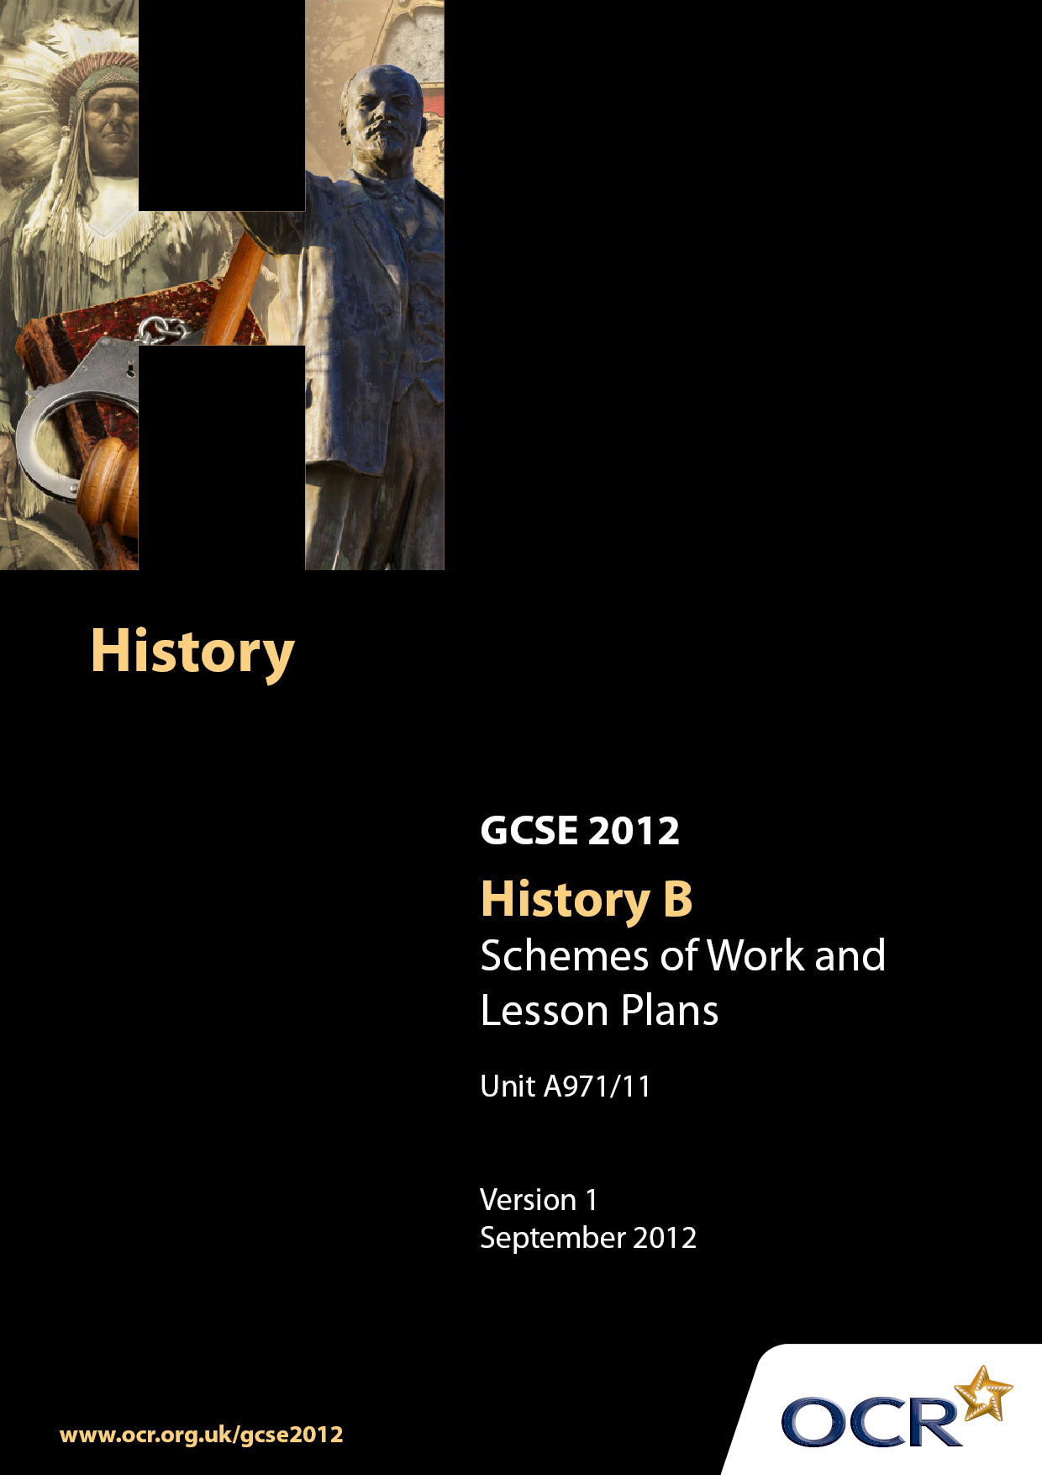

Contents
Introduction 3
Sample Scheme of Work: Unit A971/11: Germany 1918–1945 5
Sample Lesson Plan: Unit A971/11: Germany 1918–1945 20

Introduction

Background
Following a review of 14–19 education and the Secondary Curriculum Review, the Qualifications and Curriculum Authority (QCA) has revised the subject criteria for GCSEs, for first teaching in September 2009. This applies to all awarding bodies.
The new GCSEs have more up-to-date content and encourage the development of personal, learning and thinking skills in your students.
We have taken this opportunity to redevelop all our GCSEs, to ensure they meet your requirements. These changes will give you greater control of assessment activities and make the assessment process more manageable for you and your students. Controlled assessment will be introduced for most subjects.
From September 2012 assessment tasks may be undertaken at any point between release of the task and the examination series for which the task must be submitted. Centres must ensure that candidates undertake a task that is valid for submission in the year in which the candidate intends to submit it.
OCR has produced a summary document which summarises the changes to History B. This can be found at www.ocr.org.uk, along with the new specification.
In order to help you plan effectively for the implementation of the new specification we have produced these Schemes of Work and Sample Lesson Plans for History B. These Support Materials are designed for guidance only and play a secondary role to the Specification.

Our Ethos
OCR involves teachers in the development of new support materials to capture current teaching practices tailored to our new specifications. These support materials are designed to inspire teachers and facilitate different ideas and teaching practices.
Each Scheme of Work and set of Sample Lesson Plans is provided in Word format so that you can use it as a foundation to build upon and amend the content to suit your teaching style and students’ needs.
The Scheme of Work and Sample Lesson plans provide examples of how to teach this unit and the teaching hours are suggestions only. Some or all of them may be applicable to your teaching.
The Specification is the document on which assessment is based and specifies what content and skills need to be covered in delivering the course. At all times, therefore, this Support Material booklet should be read in conjunction with the Specification. If clarification on a particular point is sought then that clarification should be found in the Specification itself.

A Guided Tour through the Scheme of Work

= Innovative Teaching Idea
This icon is used to highlight exceptionally innovative ideas.


= ICT Opportunity
This icon is used to illustrate when an activity could be taught using ICT facilities.

OCR GCSE History B Unit A971/11 Germany, 1918–1945
Suggested teaching time | 35 hours | Topic |  | Depth Study 11: Germany, 1918–1945
Topic outline |  | Suggested teaching and homework activities |  |  | Suggested resources | Points to note
Was the Weimar Republic doomed from the start? |  |  | - Introduction and overview – what were the key issues, themes and events in Germany during the period 1919-1945? Teacher to provide a series of pictures (using Powerpoint or Smartboard) to illustrate this period. Pupils use these to sort according to particular categories (chronology, key individuals, key events, economy). Pupils produce a timeline highlighting key events during this period  - What was Germany like before 1918? Discussion of the history of Germany (unification, industrialisation, military success, how it was ruled). Produce a spider diagram illustrating Germany’s strengths and potential weaknesses  - What was the impact of war upon Germany? Look briefly at the economic, military and political effects of the war on Germany  - Pupils could write a series of diary extracts or produce a spider diagram describing key events in Germany  - How did Germany emerge from defeat in the First World War? Political impact of Germany’s defeat. Explain the concept of political spectrum, pupils to produce a diagram with examples of political parties and key ideas (crucial to emphasise differences between Socialists, Communists and Nationalists) What are the main strengths and weaknesses of the Weimar Constitution? Pupils could complete this as a homework task  - What was the economic and political impact of the Treaty of Versailles on the Weimar Republic? The Treaty of Versailles and its impact. Terms, impact on Germany (economic to be covered later, political opposition) Possible essay – ‘The Treaty of Versailles was unfair’. Do you agree? Alternatively, produce a cartoon supportive of or opposing the Treaty of Versailles – teachers to show examples  - Political problems in Germany. Spartacist rising, Kapp Putsch, Red Rising. Political viewpoint, leaders, actions, result. How big a threat were they to the Weimar Republic? Small groups look at different rebellions and class feedback. (Note: you might want to include the Munich Putsch here)  - What were the causes and effects of hyperinflation? – A good activity is to produce a flow chart explaining the causes of hyperinflation and the resulting effects. Once this information has been covered the teacher could return to the overarching question relating to the Treaty of Versailles and its impact. This could be tackled in the form of an essay, a detailed essay plan using information cards or a mindmap  - To what extent did the Republic recover after 1923? Pupils work in groups looking at positive aspects of the period including Dawes Plan, Young Plan, League of Nations entry, Locarno, cultural development, Stresemann resolving problems with the economy. Contrast this with underlying problems that Germany still faced to establish some kind of judgement on this question  - What were the achievements of the Weimar period? A useful moment to look back over the work. Either produce a series of cards with either events or achievements or statements relating to successes (and failures) and ask the pupils to either identify the achievements or prioritise them. Pupils complete a written exercise where they evaluate the most important achievement of the Weimar Republic |  | - Good picture resources are to be found with Google pictures, picsearch and http://www.spartacus.schoolnet.co.uk/Germany.htm  - There is a good summary (which can be simplified) in Germany 1918-1945, a Study in Depth, Greg Lacey, Keith Shephard, 07195-7059-x  - Pupils draw a political spectrum (semi-circle) and are then required to put political parties onto this after discussion (use NSDAP as a difficult example)  - Produce a diagram to show the new German Constitution  - Find cartoon sources on the Treaty of Versailles (pro- and anti-German) to explain attitudes towards the Treaty  - Scope to use pupil essays as exemplars to discuss and suggest improvement. (AFL)  - Produce small case studies on various rebellions where pupils have to gauge the threat  - Essential Germany 1918-1945, Banham and Culpin has a good section on this  - The first half of Make Germany pay also covers this topic well  - This activity is discussed in the Essential Germany books  - This is covered well in most texts, particularly in Lacey et al which looks at different aspects including Bauhaus. The Essential Germany does a useful exercise with a cartoon showing Germany walking a tightrope – teachers may want to develop this analogy in their teaching | - Depending upon the ability of the group you can add or take away pictures and add layers of complexity  - There is a simple version of this idea in Weimar and Nazi Germany, Eric Wilmot  - It would be a good idea to start to construct a working vocabulary of terms and ideas associated with Germany or more generally (eg, dictatorship, democracy) in which words can be added as the course progresses  - It may also be good to get pupils to have a map of Germany from this time too!  - Emphasise the importance of the ‘November Criminals’ and the ‘Stab in the back’ myth
Why was Hitler able to dominate Germany by 1933? |  |  | - What did the Nazi Party stand for in the 1920s? Using internet, library and textbook materials produce a biography on Hitler prior to 1923, looking at his personality, wartime experience, political ideas etc. There is scope to look at the Nazi Party Programme to see who this would appeal to and who would dislike it  - What was the significance of the 1923 Munich Putsch? Pupils to produce a timeline of key events and to address key questions. What did he hope to achieve? Why did this rebellion fail? What were the key lessons that Hitler learned from this experience? Activity to draw out the answers to these key questions  - It would be a good idea to develop a task which draws pupils’ understanding together having gathered lots of information – begin to discuss reasons for failure in the 1920s  - Why did the Nazis have little success before 1930? Focus on lack of popularity and focus (economic prosperity, extremist policies, lack of appeal amongst working classes and middle classes, religion)  - Why was Hitler able to become Chancellor by 1933? What caused the breakthrough? (Alliance with the nationalists, appealing to middle classes and rural workers)  - The impact of the Wall Street Crash on Germany? Explain why this event caused enormous problems in Germany and how the Nazi Party were able to exploit these problems. (Show electoral success in Germany, political weakness with the emergency decrees, propaganda, role of the SA)  - Why was Hitler invited into power? Pupils produce a diagram (use pictures of key figures) showing how he came to be invited. Pupils should then be able to explain the motives behind the plot  - How did Hitler consolidate his power in 1933? What was the significance of the Reichstag Fire? There is scope to do source analysis here looking at various explanations, eg a communist plot, van der Lubbe acting on his own or organised by the Nazis. Key learning point is to emphasise that Hitler’s position with regard to opposition is strengthened with the removal of the communists  - The passing of the Enabling Law – this can be covered at the same time as the last in terms of an overall investigation. Pupils to feedback what happened and the result of this event  - Pupils could consider the most important reason for the consolidation of Nazi power – perhaps in the form of an essay |  | - All major textbooks for Nazi Germany cover this well, the film ‘Hitler, a study in evil’ is also useful (starring Robert Carlyle)  - First episode described in film noted above  - Covered well in most texts such as Wilmot  - There is a useful school video that looks at Hitler’s rise to power – this summarises the key events  - Lacey and Shephard provide an excellent summary as to the relationship between all of the key players (Papen, Schleicher and Hindenburg)  - Lacey and Shephard cover the Reichstag fire well. The second episode of the DVD ‘Hitler, a study in evil’ is also very good in looking at this event and how it was exploited by the Nazis  - Please note that Lacey and Shephard also explain the process of gleichschaltung in the town of Northeim which really consolidates learning as to the steps taken in the consolidation process. All texts cover this well | - It would be helpful in this section for pupils to begin to gather fact files on leading Nazis, roles, significance etc. It is suggested that the following people are included; Ernst Rohm, Heinrich Himmler, Joseph Goebbels as a bare minimum. There is scope to set this as a research based homework  - Please note ‘holding my nose and entering the Reichstag’ and the significance of Mein Kampf  - Please emphasise the difference in approach between 1923 and 1929!  - Emphasise that at no stage did the majority of German people vote for Hitler to become Chancellor – if anything his support was dwindling!
The Nazi regime: How effectively did the Nazis control Germany, 1933-1945? |  |  | - How much opposition was there to the Nazi regime? Case studies looking at different groups of opponents (youth movements, church organisations, military opposition, low-level opposition). There is potential to do group work here looking at a specific opposition group, the reasons for their opposition, their activities, what happened to them, level of success  - How effectively did the Nazis deal with their political opponents? (Please note, it may be helpful to cover this topic prior to looking at opposition in general) Pupils need to understand Hitler’s dilemma regarding the role of the SA or the role of the Army and his relationship with Ernst Rohm. Scope to look at arguments to support the SA and arguments to support the Army. Investigate what happened. Consider who were the key beneficiaries of the brutal events in June 1934 (Hitler, the Army, the SS). Ensure that pupils understand the significance of the death of Hindenburg  - How did the Nazis use culture, propaganda and the mass media to control people? Excellent opportunity to look at different elements of propaganda in Germany, film, the Olympics, posters. Teacher to devise a worked example of a powerpoint presentation of a piece of propaganda labelling key features such as colours, symbols, phrases and ideas. Pupils then go on to select their own posters which they can label. Key question – what messages did the Nazis try to convey through the use of propaganda?  - Why did the Nazis persecute many groups in German society? Present a series of pictures of groups persecuted by the Nazis (Jews, gypsies, disabled, homosexuals, criminals etc) Pupils should produce a table on reasons for hostility and how each group was treated. With the Jews pupils should produce a timeline identifying the key developments as they happened culminating in the Final Solution  - Exercise that returns to the key question of this section. A good way of doing this is to get pupils to identify the carrots and the sticks that are used to control the people. Further questions can be used to develop thinking such as when did the control begin to break down. Produce this in the form of a mindmap. Seek out past exam questions to test knowledge of control |  | - In the videos relating to the Nazis, there is one that looks at opposition and can be recommended as an overview. Look out for material associated with the Tom Cruise film relating to the Stauffenburg plot. Lots of web resources available such as http://www.ushmm.org/wlc/media_oi.php?lang=en&ModuleId=10005208&Mediald=1236  - ‘Hitler, a study in evil’ covers the Night of the Long Knives very well and nicely ties in with work from previous lessons looking at opposition  - Look for film clips that show the army swearing the oath of allegiance – a useful hook into this topic  - http://www.calvin.edu/academic/cas/gpa/ww2era.htm is excellent in terms of providing a lot of material relating to propaganda. Alternatively history departments may have an old recording looking at Goebbels ‘Master of Propaganda’. You could also make good use of Youtube clips from the Leni Riefenstahl classic to demonstrate the use of propaganda  - The school video series mentioned above has a film looking at minorities. Also the video that accompanied ‘Schindler’s List’ has an excellent documentary explaining the stages in the build up to the Holocaust | - Care needed with material used here – be careful to follow school and departmental policies
The Nazi regime: what was it like to live in Nazi Germany? |  |  | - What was the purpose of the Hitler Youth? Pupils to describe the work of these organisations and in particular the aims. Given resources, pupils produce a poster explaining policies towards young people. Class discussion (revision) relating to success in terms of opposition  - How successful were Nazi policies towards women and the family? This can be done in conjunction with youth policy whereby pupils are divided into groups and become experts on their topic which is discussed with those who have done the other topic with individuals acting as experts. There is also scope to use ICT for this exercise  - Were most people better off under Nazi rule? Pupils should be able to make a judgement relating to this question from prior knowledge (ie women, youth, Jews, church). Teachers should prepare and feed in information relating to work and the economy. Exercise that relates to the Nazis adopting a war economy and the impact that this has on ordinary Germans. Teachers should set this as an essay style question planned and discussed together in class  - How did the coming war change life in Germany? There is scope to do the same sort of exercise for World War II as was done previously for World War I. Look at different aspects of life during the war and how it affected various people. This question could be tackled prior to the previous question |  | - All textbooks cover youth policy and women well http://www.calvin.edu/academic/cas/gpa/ww2era.htm is again to be recommended  - Lacey and Shephard cover the economy well and can be used to add illustration to this question. Teachers could provide pupils with a series of cards (use the SmartBoard) with key ideas, groups and individuals (perhaps invent particular types of people) this should promote discussion on this topic  - Textbooks cover the impact of the war on Germany well | - Make sure that pupils are aware of the differences between youth movement policies and the policies followed at school

OCR GCSE History B Unit A971/11 Germany, 1918–1945

Why did Hitler come to power in January 1933?
OCR recognises that the teaching of this qualification will vary greatly from school to school and from teacher to teacher. With that in mind this lesson plan is offered as a possible approach but will be subject to modification by the individual teacher.
Lesson length is assumed to be one hour.

Learning Objectives for the Lesson
Objective 1 | For pupils to be able to explain the skills that Hitler used to come to power in Germany
Objective 2 | For pupils to be able to explain the circumstances that Hitler was able to exploit in Germany in order to come to power (depression and political division)

Recap of Previous Experience and Prior Knowledge
- It is assumed that the pupils have looked at the impact of the Wall Street Crash on Germany and how Hitler and the Nazis were able to exploit this situation

Content
Time | Content
5 minutes | Teacher to hand out small pieces of card to pupils and give instructions. On separate pieces of card pupils are to write down reasons from the video
20 minutes | Show the video from the Schools series that looks at Hitler’s rise to power
10 minutes | Working with a partner pupils are to agree upon reasons they have put down on card and sort into two lots – reasons to do with Hitler and problems that Germany faced – allow pupils to establish links between causes and emphasise those that they think are most important
15 minutes | Teacher led discussion showing how Hitler’s support was dropping through 1932 – why then did he come to power? Explain the relationship between Hitler, Schleicher, Von Papen and Hindenburg – works really well as a story. Pupils are given pictures of these people with which they draw a diagram showing the events leading to Hitler taking power in 1933
5 minutes | Add to cards and make necessary adjustments

Consolidation
Time | Content
5 minutes | Using cards as a plan, pupils asked to write an essay explaining why Hitler came to power in 1933.
Please note, this would be a helpful exercise to follow up by getting pupils to identify a good essay which could use examination mark schemes.

Unit A971/11 Germany 1919–1945

What was the most effective way of controlling people in Nazi Germany?
OCR recognises that the teaching of this qualification will vary greatly from school to school and from teacher to teacher. With that in mind this lesson plan is offered as a possible approach but will be subject to modification by the individual teacher.
Lesson length is assumed to be one hour.

Learning Objectives for the Lesson
Objective 1 | To evaluate whether carrot or stick was the best way of controlling the German people

Recap of Previous Experience and Prior Knowledge
- It is expected that pupils will have covered key topics such as propaganda and the role of the SS beforehand

Content
Time | Content
10 minutes | Produce a whole series of pictures associated with this topic to use in small groups (pictures of Goebbels, Himmler etc). Have a clue for each picture and award points to the group which identifies the correct picture first.
10 minutes | Divide the class into two large groups. One group is looking at examples of the carrot approach (reducing unemployment, films, festivals etc) and one thinking about examples of the stick approach.
10 minutes | An extensive list is to be put on the board – encourage pupils to give as many specific examples as possible
25 minutes | Pupils to start in small groups or individually based upon resources to produce a Movie or a PowerPoint identifying carrot and stick. Key requirement is to look at examples of both sides and come to a conclusion as to the most effective. This will need to be completed for homework

Consolidation
Time | Content
5 minutes | Pick on individual pupils and ask them to say which they think was more important and why
Good examples of work produced should be made available for revision purposes.

Unit A971/11 Germany 1919–1945

What was it like for women to live in Nazi Germany?
OCR recognises that the teaching of this qualification will vary greatly from school to school and from teacher to teacher. With that in mind this lesson plan is offered as a possible approach but will be subject to modification by the individual teacher.
Lesson length is assumed to be one hour.

Learning Objectives for the Lesson
Objective 1 | That Hitler had particular ideas about the role of women within society
Objective 2 | That the role of women had to change as a result of the Second World War

Recap of Previous Experience and Prior Knowledge
- Some ideas may have been picked up in previous lessons but this lesson will be about making the Nazis’ attitudes clear. For example, if pupils have already looked at Youth Policy, then they will have covered attitudes to women in school.

Content
Time | Content
5 minutes | Get pupils to draw a diagram with labels, of the ideal woman as far as the Nazis are concerned
5 minutes | Pupils are invited to share their ideas with the class – put the key ideas on the board
15 minutes | Either on sheets or preferably using a whiteboard produce a number of sources and pieces of information relating to women in Nazi Germany – pupils to make rough notes on the ideas coming from this (use film clips if possible too!) Produce a definitive list of key attitudes by Nazis towards women
15 minutes | Discuss changing attitudes towards women as a result of the Second World War – get pupils to think why there were such changes to policy
10 minutes | Consider the success or failure of this policy (comparison with women in Weimar Germany and ask how important women really were to the Nazis)
5 minutes | Produce a detailed revision sheet or mindmap showing the Nazis’ policy towards women – good examples can be used as wall displays or can be put in revision booklets

Consolidation
Time | Content
5 minutes | Ask pupils to return to the picture that they drew at the beginning of the lesson – what is the difference between their initial view and their view now? Ask pupils to share their ideas.

