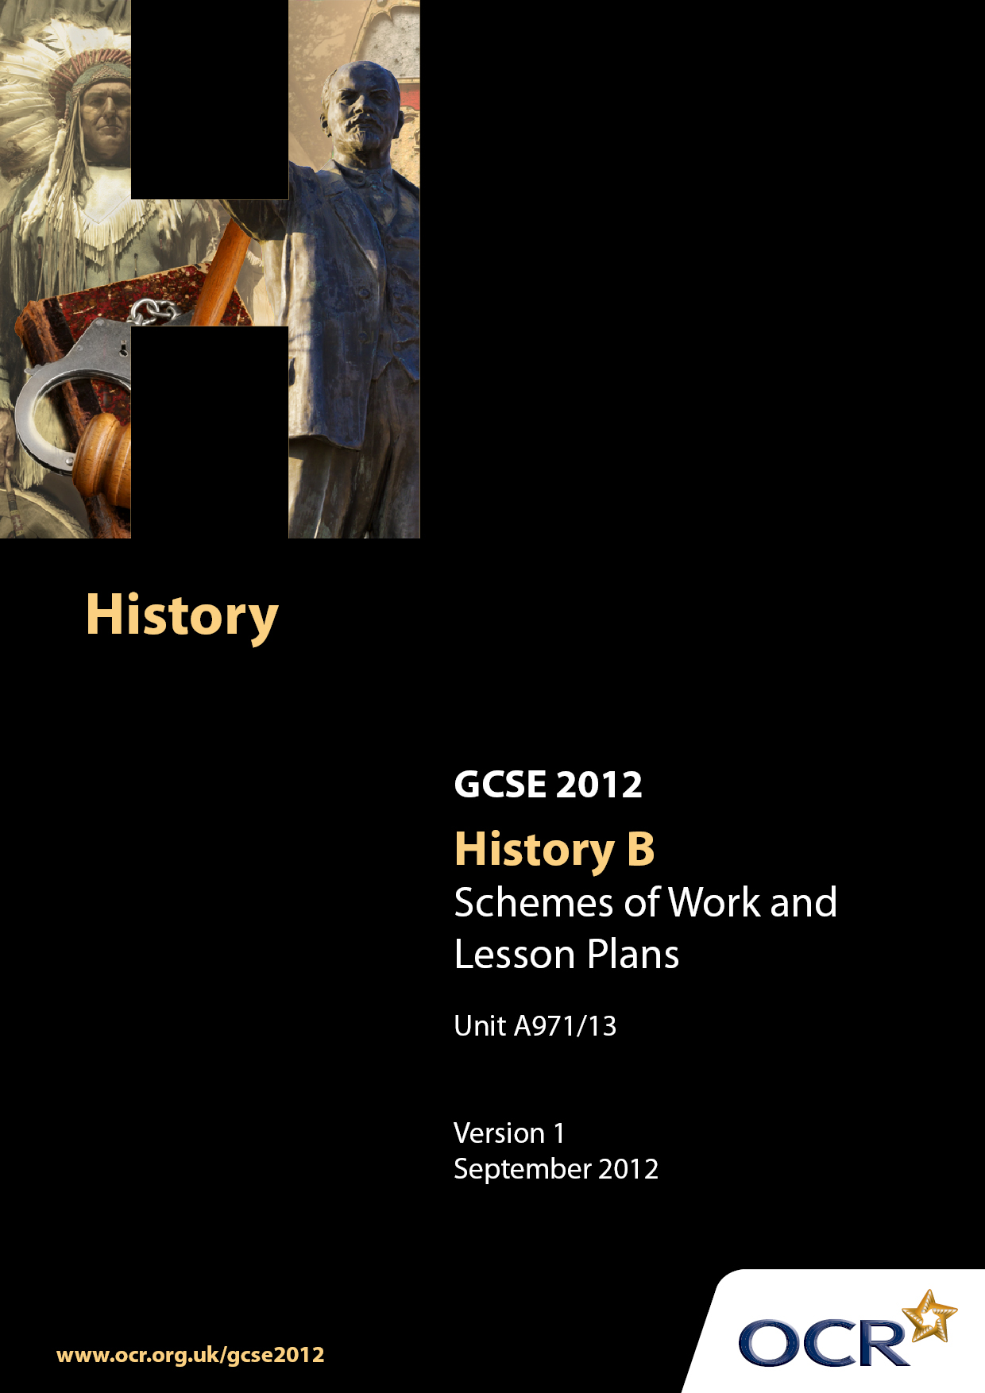

Contents
Introduction 3
Sample Scheme of Work: Unit A971/13: The USA, 1919–1941 5
Sample Lesson Plan: Unit A971/13:The USA, 1919–1941 16

Introduction

Background
Following a review of 14–19 education and the Secondary Curriculum Review, the Qualifications and Curriculum Authority (QCA) has revised the subject criteria for GCSEs, for first teaching in September 2009. This applies to all awarding bodies.
The new GCSEs have more up-to-date content and encourage the development of personal, learning and thinking skills in your students.
We have taken this opportunity to redevelop all our GCSEs, to ensure they meet your requirements. These changes will give you greater control of assessment activities and make the assessment process more manageable for you and your students. Controlled assessment will be introduced for most subjects.
From September 2012 assessment tasks may be undertaken at any point between release of the task and the examination series for which the task must be submitted. Centres must ensure that candidates undertake a task that is valid for submission in the year in which the candidate intends to submit it.
OCR has produced a summary brochure which summarises the changes to History B (Modern World). This can be found at www.ocr.org.uk, along with the new specification.
In order to help you plan effectively for the implementation of the new specification we have produced these Schemes of Work and Sample Lesson Plans for History B. These Support Materials are designed for guidance only and play a secondary role to the Specification.

Our Ethos
OCR involves teachers in the development of new support materials to capture current teaching practices tailored to our new specifications. These support materials are designed to inspire teachers and facilitate different ideas and teaching practices.
Each Scheme of Work and set of Sample Lesson Plans is provided in Word format – so that you can use it as a foundation to build upon and amend the content to suit your teaching style and students’ needs.
The Scheme of Work and Sample Lesson plans provide examples of how to teach this unit and the teaching hours are suggestions only. Some or all of them may be applicable to your teaching.
The Specification is the document on which assessment is based and specifies what content and skills need to be covered in delivering the course. At all times, therefore, this Support Material booklet should be read in conjunction with the Specification. If clarification on a particular point is sought then that clarification should be found in the Specification itself.

A Guided Tour through the Scheme of Work

= Innovative Teaching Idea
This icon is used to highlight exceptionally innovative ideas.


= ICT Opportunity
This icon is used to illustrate when an activity could be taught using ICT facilities.

Unit A971/13: The USA, 1919–1941
Suggested teaching time | 10–15 hours | Topic | The USA, 1919-1941
Topic outline |  | Suggested teaching and homework activities |  | Suggested resources | Points to note
Introduction; studying early 20th century American History |  | - Mini-enquiry; what were the key features of American society by 1920? Exploration of the key aspects of early 20th century American society, including the two main political parties, the US states and key differences between North and South, and some of the key vocabulary students might encounter on the course itself. |  | - Maps, images, details from textbooks. As a follow-up activity, students might prepare a fictional “rough guide” for a British citizen visiting the USA in 1920 | - This is not strictly part of the course specification, but centres might find that dealing with these issues at the start of the course will allow students to access the main learning more easily and provide them with a glossary of key terms, issues, and the basis geographical layout of the US.
Key Question: How far did the US economy boom in the 1920s? |  | - What was the boom like? Students investigate how the economic boom changed life in America.  - Why was the boom possible? Students examine a range of factors (as set out in the course specification) that make the boom possible, and consider ways in which these factors interact. They follow this up by completing an A3 grid to show their understanding of each factor.  - Who didn’t gain from the boom? An examination of the “flip side” of the boom, and those areas (like traditional industries, farmers and black workers) who did less well in the 1920s.  - Assessment: Essay question based on Questions 5 and 6 of the Depth Study; Describe the key features of the boom (4); Explain why farmers didn’t share in the boom in the 1920s (6); The following were all equally important reasons why there was an economic boom in the 1920s. 1. The impact of the First World War. 2. Republican Policies. 3. Mass Production. How far do you agree with this statement? Explain your answer, referring to 1, 2 and 3 (10). |  | - Series of images giving an impression of different aspects of the boom (possibly presented through data projector, overhead projector, card sort activity or worksheet).  - PowerPoint presentation / textbook / video input, blank A3 research grid.  - Worksheet / textbook activities looking at the groups who suffered economically, including sources highlighting the plight of farmers and black sharecroppers.  - Mark scheme, model answer written by teacher to give to students to help with an Assessment for Learning activity after their essays have been assessed. | - As set out in the scheme of work, centres might find their students are engaged by the initial notion that all US citizens gain from the boom, and by crushing this notion later through introducing the concept of ‘losers’ to contrast with the ‘winners’.  - Students could be given a copy of the factors grid completed by the teacher on receipt of their own completed grids, to reduce time spent on marking.  - Students will be in a position to develop their understanding of the issues black people faced in the USA during this period across all four Key Questions; economic in 1, 3 and 4, and social in 2.  - Essays on factors bringing the boom about have been a common source of examination questions in the previous specification; centres might find it a useful area in which to develop their students’ skills of explanation and evaluation.
Key Question: How far did US society change in the 1920s? |  | - What was new in American society in the 1920s? Students make some comparisons between the “old” and the “new” in US society.  - Was everybody prejudiced in 1920s America? Students examine a range of minority groups across 1920s American society (including blacks and Italian immigrants) and the prejudice they faced, and whether this prejudice was spread uniformly across all of America or whether different prejudice was seen in different regions.  - Prohibition; what was it, and why did it fail? Students examine a range of factors as to why prohibition was introduced, its effects on society (including the growth of corruption and organised crime) and the reasons for its failure.  - Were flappers everywhere? Students examine the way in which the roles of some young urban women change in the 1920s, leading to a wider enquiry in which students assess the extent to which different social groups changed for the better in 1920s USA.  - Assessment: Source exercise, based on Question 4 of the Depth Study. Three sources based on prohibition, with questions designed for students to use their contextual knowledge to develop the points they can infer from the sources |  | - Card sorting activity where students match up the “old” image (for example the horse and cart) with its “new” partner (the motor vehicle) and use their knowledge of Key Question 1 to draw conclusions about why things have changed and who might have gained from the change.  - “Shock tactics” imagery might be used here to stimulate students (there is a clear Citizenship opportunity to link this to contemporary issues in the United States following the recent Presidential Election). Opportunity to sort a range of issues – whether by card or on a PC – on a sliding scale of bigotry; these might include extracts from Jim Crow laws at one end of the scale or pictures of black jazz musicians at the other – to help reach judgments about how equally spread prejudice was. Billie Holiday’s Strange Fruit might be played and its lyrics analysed.  - Input, whether through PowerPoint presentation, class discussion, textbook about the main issues set out in the teaching activities. A short clip from the film The Untouchables might engage the students more fully with the topic.  - PowerPoint presentation / textbook / worksheet / images of different social classes of women (there are abundant images of these across several textbooks). Short clip from the film Chicago. Map of the USA and labelled pins for each social group allowing students to understand the spread of social change in 1920s USA.  - Mark scheme, model answer written by teacher to give to students to help with an Assessment for Learning activity after their essays have been assessed. | - Students will be able to use the understanding gained to allow them to understand the extent to which social groups are positively affected by the boom elsewhere across this Key Question.  - There are a number of recent feature films made which capture different aspects of 1920s USA, and centres might wish to use short extracts from these to support and engage students with different aspects of the course.  - Students’ general understanding of the key terms and concepts in US society (such as WASPs) should help them access this focus point more fully.
Key Question: What were the causes and consequences of the Wall Street Crash? |  | - Did greedy Americans bring about the Wall Street Crash? Students investigate the range of reasons for the Wall Street crash and, as with the boom, make judgments about relative importance and interaction.  - What happened to the American people because of the Crash? Students explore evidence about the effects and impact of the Wall Street crash in both rural and urban America.  - Hoover v Roosevelt; why did Hoover lose so badly? Students examine the key differences in outlook and policy between the two Presidential candidates of 1932 and use these to make judgments about why Roosevelt was successful |  | - Teacher-led explanation of the reasons behind the Wall Street crash. This might be underpinned by students breaking off into groups to research and produce short presentations about key terms, such as ‘speculation’ or ‘buying on the margin’.  - Use of strong visual imagery – such as destitute families in soup kitchen queues or of Hoovervilles - to stimulate students. Wider card sorting activity; students sort a range of sources showing the impact of the Crash into a range of relevant categories, such as homelessness (including the Bonus Marchers), the collapse of banks and unemployment. This could be made more challenging by having the sources’ provenance detached from the source itself and for students to match these also. A short extract from the recent remake of King Kong might help students to gain a ‘fix’ on the way in which the Crash changed life in the USA.  - Discussion of the key policies of both men, and how they were viewed by many American people. Use of political cartoons from the 1932 election campaign to help students develop their understanding. Students then match up a series of statements to either Hoover or Roosevelt, demonstrating their understanding of the key differences between the two | - There are clear Citizenship opportunities here to link the Crash of 1929 with the current ‘economic downturn’.  - Students would be able to draw on their knowledge of the limitations or issues with the economic boom from Key Question 1 to allow them to more fully access this focus point.
Key Questions: How successful was the New Deal? |  | - What were Roosevelt’s aims for the New Deal in 1933? An enquiry into the main objectives of the Hundred Days and the First New Deal and their key measures  - Was the Second New Deal different from the First? Students look at a wider range of Roosevelt’s actions and make judgments about how different the initial measures were from the subsequent reforms.  - Who liked the New Deal? Students consider the range of opinions held about the New Deal in terms of who gained from it, who was overlooked by it, and who opposed the measures  - Did the New Deal save America? Students weigh up the impact of the New Deal and the extent to which it was able to lift the US out of the Depression by the end of the specification period |  | - Input presentation using PowerPoint / source material stimulus with examination style focus. Students may use source material, available from many recent textbooks, to create “CV” for Roosevelt and his plans for the USA under the New Deal.  - Similar “input” exercises, involving PowerPoint work / worksheets / textbook / didactic input. Students might complete an A3 grid, requiring them to use their notes and research material to complete key details about a range of “Alphabet Agencies”, such as the acronym’s meaning, the key functions of the Agency and whether it can be deemed a success. Parts of the grid might already be completed, acting both as a model and to step the task in terms of difficulty  - Students might undertake a source-based enquiry, reviewing a range of sources to help them understand the range of opinions people held about the New Deal. This could in turn be consolidated in a “human card sort” task, with each member of the class being given a card detailing an individual (possibly representing a social group) and asked to stand in areas of the classroom to show feelings on elements of the New Deal.  - Students review the “problems” that were referred to in the tasks on the Wall Street Crash and weigh up measures taken by Roosevelt to combat these. For each they agree “success criteria” required to ‘save America’ and then assess how successful each measure in the New Deal was in achieving a solution to the problem it was tackling. This could be done with a modified “zone of relevance” card sort task, in which measures are placed closer to the middle the more successful they were on a large mat, or else student creation of a simple board game with cards created to represent different measures allowing players to move forward (or back) towards “safety” as the USA. | - As with the A3 grid referred to in Key Question 1, the teacher might wish to fully complete a grid and hand this back to students to reduce marking pressures and allow for swifter feedback
Revision; a review of the USA between 1919 and 1941 |  | - Students review the specification period and so demonstrate an understanding of the events and social groups studied on the course. |  | - Students complete a “happy / sad” grid, tracking the relative fortunes of different groups in American society during the specification (for example Republicans, black Americans, women and farmers) to show their understanding of how different events between 1919-41 affect their positions in society and their relative “happiness”. A version of the grid might be projected onto a whiteboard, which the teacher might overmark to show the whole class a model. Students could also add specific events to different points on the grid so as to build up its benefit as a revision aid.

Unit A971/13: The USA, 1919–1941

What were the effects of the Wall Street Crash?
OCR recognises that the teaching of this qualification will vary greatly from school to school and from teacher to teacher. With that in mind, this lesson plan is offered as a possible approach but will be subject to modification by the individual teacher.
Lesson length is assumed to be one hour.

Learning Objectives for the Lesson
Objective 1 | Students can recall key effects of the Wall Street Crash on American citizens
Objective 2 | Students can deploy this information in plenary exercises

Recap of Previous Experience and Prior Knowledge
- Starter / intrigue. Use of two contrasting images as stimulus (preferably using a data projector), a positive one from the 1920s and a less positive one from the Depression (possibly a photograph of a Hooverville) without their provenance. Students then consider what the provenance might be; given their understanding of the Crash from previous lessons they should, collectively, be able to deduce the “before and after” nature of the images. Reveal the provenance, discuss the key aspects of both images, and set out the learning objectives (10 minutes).

Content
Time | Content
15-20 minutes | Main input: using PowerPoint presentation, (built up over one “slide” only so as to assist with students’ note-taking) give students some essential information about the effects of the Crash (for this lesson they would be split into four areas; collapse of banks, unemployment, homelessness and “dust bowls”). This information should be accompanied by striking images (for example, of a half-buried farm) to help the students understand the impact and pique their interest. Students should take notes as this aspect of the lesson unfolds. They might be provided with a printout of the slide, whether as a whole class or to differentiate for those who have more difficulty in taking notes. Use some of the sources on the slide to split up this didactic input into more manageable chunks, for example, by using questioning similar to that in the starter activity.
5-10 minutes | Consolidation: Issue students with an envelope containing a range of cards, containing three types: four themed headings (as per the themes on the PowerPoint slide), a range of issue cards, and an equal number of description cards expanding on those issues. Students, in pairs, then match the appropriate “issue” card with the appropriate “description” card and place each pair under the relevant heading (for example, the “Hoover stew” issue card would be paired with “the mocking name given to the soup handed out free to those people who couldn’t afford to buy food” description card and together would be placed under the “Unemployment” theme card). As an extension exercise, students might be asked to give examples of how some of the headings interact with each other (and the cards would help with this). Offer support as appropriate during this aspect of the lesson.
10-15 minutes | Student feedback. Using outside versions of the students’ cards and Blu-Tack, replicate their card sorting task on the whiteboard (cards should be large enough for all students to easily see) based on student ideas and suggestions. Use lesson time remaining to expand on some of the issues raised in the cards, expanding or compressing this depending on how time has progressed during the lesson.

Consolidation
Time | Content
5-10 minutes | Review. “Loop cards”. Give each pair of students one card, split into two. Each card has two boxes on it, the first card has “START” on the left and a question on the right, the last card has an answer to a question on the left and “FINISH” on the right. The cards in between have answers on the left hand sides and questions on the right which, if students read them through together in the correct order, will naturally take them through the cards without the need for prompting. In this way, all students’ learning can be (briefly) assessed. As a homework task, students might be asked to print off copies of the cards from the school network and arrange them across a sheet of A3 paper, so as to create a permanent record of the main lesson activity. Dismiss class.

