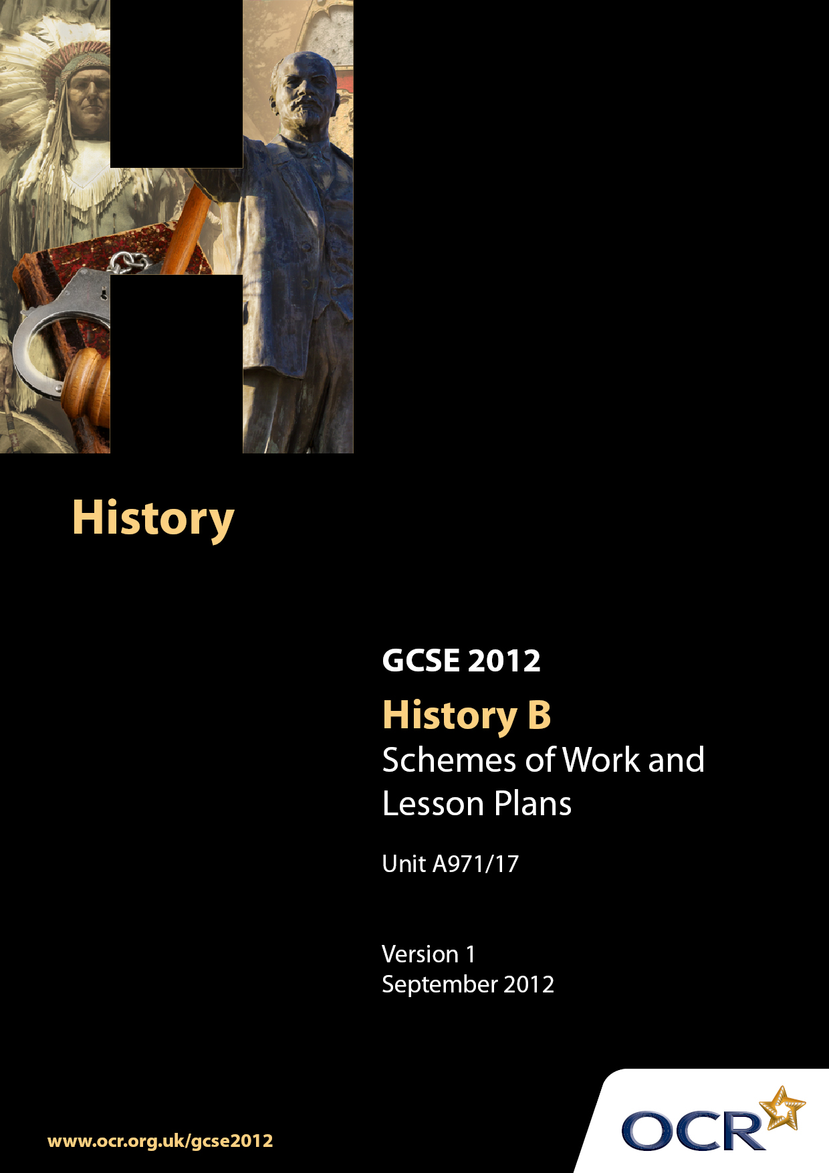

Contents
Contents 2
Introduction 3
Scheme of Work: Unit A971/17: The USA, 1945-1975: Land of Freedom? 5
Lesson Plan: Unit A971/17: The USA, 1945-1975: Land of Freedom? 19

Introduction

Background
Following a review of 14–19 education and the Secondary Curriculum Review, the Qualifications and Curriculum Authority (QCA) has revised the subject criteria for GCSEs, for first teaching in September 2009. This applies to all awarding bodies.
The new GCSEs have more up-to-date content and encourage the development of personal, learning and thinking skills in your students.
We have taken this opportunity to redevelop all our GCSEs, to ensure they meet your requirements. These changes will give you greater control of assessment activities and make the assessment process more manageable for you and your students. Controlled assessment will be introduced for most subjects.
From September 2012 assessment tasks may be undertaken at any point between release of the task and the examination series for which the task must be submitted. Centres must ensure that candidates undertake a task that is valid for submission in the year in which the candidate intends to submit it.
OCR has produced a summary brochure which summarises the changes to History. This can be found at www.ocr.org.uk, along with the new specification.
In order to help you plan effectively for the implementation of the new specification we have produced these Schemes of Work and Sample Lesson Plans for History. These Support Materials are designed for guidance only and play a secondary role to the Specification.

Our Ethos
OCR involves teachers in the development of new support materials to capture current teaching practices tailored to our new specifications. These support materials are designed to inspire teachers and facilitate different ideas and teaching practices.
Each Scheme of Work and set of Sample Lesson Plans is provided in Word format – so that you can use it as a foundation to build upon and amend the content to suit your teaching style and students’ needs.
The Scheme of Work and Sample Lesson plans provide examples of how to teach this unit and the teaching hours are suggestions only. Some or all of it may be applicable to your teaching.
The Specification is the document on which assessment is based and specifies what content and skills need to be covered in delivering the course. At all times, therefore, this Support Material booklet should be read in conjunction with the Specification. If clarification on a particular point is sought then that clarification should be found in the Specification itself.

A Guided Tour through the Scheme of Work

= Innovative Teaching Idea
This icon is used to highlight exceptionally innovative ideas.


= ICT Opportunity
This icon is used to illustrate when an activity could be taught using ICT facilities.

Unit A971/17: The USA, 1945-1975: Land of Freedom?
Suggested teaching time | 1 hour | Topic | How successful was the struggle for civil rights in the 1950s?
Topic outline |  | Suggested teaching and homework activities | Suggested resources | Points to note
What was the political, economic and social position of African Americans in c.1945? |  | - Students require an introduction to the experience of Black Americans up to 1945. Students should consider –  - The Constitution and slavery  - The South and slavery / Northern discrimination  - The Civil War  - Reconstruction  - Black Codes  - Segregation and White Supremacy  - Plessy V Ferguson  - The ‘Great Migration’  - The Ku Klux Klan revival  - WW1  - Increasing sense of community  - The New Deal  - Students draw two graphs charting the political progress that Black Americans in the South and North made in seeking to attain equal rights between 1800 and 1945  - Ask students to formulate a mind map of the most pressing concerns for Black Americans in the South pre-Civil War and post- Civil War. How much better off were Black Americans following the end of slavery? | - Sanders, V, 2008, Civil Rights in the USA 1945-68, Chapter 1  - Library of Congress http://memory.loc.gov  - http://www.spartacus.schoolnet.co.uk/USAslavery.htm - slavery  - http://www.spartacus.schoolnet.co.uk/USASplan.htm - reconstruction  - http://www.spartacus.schoolnet.co.uk/USASreconstruction.htm - reconstruction  - http://www.spartacus.schoolnet.co.uk/USASblackcodes.htm - black codes  - http://www.spartacus.schoolnet.co.uk/USAjimcrow.htm - ‘Jim Crow’  - http://www.spartacus.schoolnet.co.uk/USAkkk.htm - Ku Klux Klan  - http://users.erols.com/mwhite28/usa-riot.htm - Lynching stats  - http://www.spartacus.schoolnet.co.uk/USACstacy.htm - lynching  - http://www.pbs.org/wnet/aaworld/reference/articles/great_migration.html - Great Migration  - Gregory, JN, 2005, The Southern Diaspora, How the Great Migrations of Black and White Southerners Transformed America  - Walsh B, (1996), GCSE Modern World History, pp201-203  - Kelly, N and Lacey, G, 2001, Modern World History, pp146-147  - http://www.naacp.org/about/history/timeline/index.htm | - Emancipation  - ‘Jim Crow’  - Abolitionists  - Lynching  - Federal vs State rights  - WW1  - Harlem Renaissance  - Booker T Washington  - WEB Du Bois  - Marcus Garvey  - NAACP  - Black consciousness  - The Great Depression
Did the Second World War have an impact on the position of African Americans? |  | - The Second World War brought rapid social and economic changes to the USA. Students should consider what impact the war had on the situation of Black Americans  - Military segregation  - Migration and labour shortages  - Congress of Racial Equality (CORE)  - Trade Unions and NAACP  - Federal assistance  - Growing Black middle class  - Compare photos of slaves with photos of black troops in WW2. What differences can the students see? Ask them to imagine how they felt about their relative conditions  - Ask students to imagine they are a black serviceman or woman returning home after serving your country and risking your life  - Describe the reception you expect to receive when you get home and the response from the government. Were you satisfied with the conditions when you got home? | - Sanders, V, 2008, Civil Rights in the USA 1945-68, Chapter 2  - Library of Congress http://memory.loc.gov  - CORE http://www.spartacus.schoolnet.co.uk/USAjor.htm  - Photos of African-Americans in WW2 http://www.historyplace.com/unitedstates/aframerwar  - http://encarta.msn.com/encyclopedia_761595158_8/African_American_History.htm  - PBS, 1987, Eyes on the Prize, America’s Civil Rights Movement, 1954-1985, documentary | - War industries  - Overcrowded cities  - Sit-ins and boycotts  - Fair Employment Practices Commission  - US Justice Dept, Civil Rights Section  - The Supreme Court (Smith vs Allwright)  - GI Bill
How much progress was made during the Truman administration? |  | - The Truman administration raised the profile of civil rights at a federal level. The federal government began to initiate policies and legislation to address discrimination. Students should explore Truman’s initiatives and consider what was the driving force behind his intervention.  - Truman his life, career and attitudes to race  - Political situation, Cold War and increasing importance of black voters, communism and civil rights  - To Secure These Rights (1947), Liberal Civil Rights Committee  - Executive Order ending discrimination among federal employees / federal contracts  - Dixiecrats, Southern Democrats and the 1948 presidential election  - Provide students with a list of the recommendations in the ‘To Secure These Rights’ report. Ask students to research which of the recommendations were implemented during the Truman administration  - Using a range of sources produce a biography of Truman. Was he a likely champion of civil rights? | - Sanders, V, 2008, Civil Rights in the USA 1945-68, Chapter 3  - http://www.loc.gov/exhibits/civilrights/cr-exhibit.html  - Truman Library carries many documents relating to this period including the report ‘To Secure These Rights’ http://www.trumanlibrary.org/civilrights/srights2.htm  - Truman addresses the NAACP in 1947, audio  - http://www.trumanlibrary.org/audio/sr64-54.ram  - Hubert Humphrey and the 1948 election http://www.senate.gov/artandhistory/history/common/generic/VP_Hubert_Humphrey.htm  - Dixiecrats – http://www.u-s-history.com/pages/h1751.html  - http://www.spartacus.schoolnet.co.uk/USAkkk.htm  - http://www.spartacus.schoolnet.co.uk/USAnaacp.htm  - PBS, 1987, Eyes on the Prize, America’s Civil Rights Movement, 1954-1985, 14 hour documentary | - Racist attacks on black servicemen  - State of the Union Addresses 1947, 1948  - Fair Employment Board  - Supreme Court – Shelley v Kremer  - Strom Thurmond  - Hubert Humphrey  - Executive Order  - Committee on Government Contract Compliance
How did the NAACP and other civil rights groups exert pressure on the government between 1945 and 1960? |  | - Civil rights organisations such as Core, the Southern Christian Leadership Conference and NAACP used a variety of methods to exert pressure on Truman and Eisenhower. Students should explore how this was achieved and examine the key victories during this period  - NAACP attack Plessy v Ferguson, ‘separate but equal’ through the courts  - Brown v Board of Education 1954  - Sit-ins  - Economic boycotts  - Rosa Parks and Montgomery Bus Boycott  - Dr Martin Luther King Jr, his speeches and the role of the churches  - Ask students to produce a spider diagram illustrating the positive and negative effects of the Brown v Board of Trade decision  - Ask students to design campaign posters for the bus boycott in Montgomery, the students should be asked to design posters for different parts of the community;  - To get support from the local black population  - To highlight the injustice to the local white population  - To encourage federal support  - To encourage local businessmen to consider the economic effect  - Show students footage of Dr King speaking and show them transcriptions of some speeches. Ask students to write a letter that tells a friend about hearing Martin Luther King give a sermon / speech. The letter should explain why they went, who was there, what they heard, how the speech was delivered, how it made them feel and why. Do they think Dr King is the right man to lead the Civil Rights Movement? | - Sanders, V, 2008, Civil Rights in the USA 1945-68, Chapters 3 and 4  - Baton Rouge, Bus Boycott, 1953  - http://www.npr.org/templates/story/story.php?storyId=1304163  - MontgomeryBus Boycott 1956  - http://www.watson.org/~lisa/blackhistory/civilrights-55-65/montbus.html  - Journey of Reconciliation 1947  - http://www.spartacus.schoolnet.co.uk/USAjor.htm  - Audio interview with ‘freedom rider’ Bayard Rustin  - http://historymatters.gmu.edu/d/6909/  - Sit-ins  - http://www.watson.org/~lisa/blackhistory/civilrights-55-65/sit-ins.html  - Greensboro Woolworth sit-in, newspaper reports  - http://www.sitins.com/index.shtml  - PBS, 1987, Eyes on the Prize, America’s Civil Rights Movement, 1954-1985, 14 hour documentary  - Rosa Parks Biography  - http://www.rosaparks.org/bio.html  - Photos and biography  - http://www.rosapark.com  - Dr Martin Luther King, biog and excerpts from speeches  - http://www.spartacus.schoolnet.co.uk/USAkingML.htm  - Dr King – speeches, some audio  - http://www.mlkonline.net/  - Dr King speeches, some early ones  - http://www.stanford.edu/group/King/publications/speeches/contents.htm | - Freedom Rides and ‘Journey of Reconciliation’  - Civil disobedience  - Henderson v US  - McLaurin v Oklahoma State Regents  - Sweatt v Painter  - Earl Warren  - Emmett Till  - Autherine Lucy  - Browder v Gayle  - Women’s Political Council  - Student Non-Violent Coordinating Committee
How did the Southern States and Federal Government respond to the Civil Rights Movement between 1952 and 1960? |  | - The Civil Rights Movement provoked a resumption of the battle between state rights and federal control that had underpinned the Civil War nearly 100 years before. Students should understand the constitutional reasons for this conflict and examine the various ways that the States and Federal Government asserted themselves during this period  - Eisenhower’s response to the Brown ruling  - White Citizens Councils  - Re-emergence of KKK  - Southern Manifesto  - State Resistance and refusal to desegregate  - Reaction to Montgomery Bus Boycott  - Supreme Court decisions  - Little Rock 1957 and federal intervention  - Civil Rights Acts 1957 and 1960  - Federal Intervention and the Cold War  - Show students film footage or photos of the black students attempting to enter the school in Little Rock. Ask them to create Soviet propaganda posters describing the lack of freedom in the USA  - The Montgomery Bus Boycott is seen as a turning point in the fight for civil rights. Ask students to produce a mind map illustrating the ways that the civil rights movement had developed  - Produce a spider diagram indicating the strengths and weaknesses of the civil rights movement by 1960  - Consider the different tactics employed by Southern racists and the civil rights movement, which were more effective and why?  - Many historians argue that the Brown decision signalled the start of the civil rights movement, do you agree? | - Sanders, V, 2008, Civil Rights in the USA 1945-68, Chapter 3  - State vs Federal Rights  - http://usgovinfo.about.com/od/rightsandfreedoms/a/federalism.htm  - Little Rock (photos)  - http://www.pbs.org/wgbh/amex/eyesontheprize/story/03_schools.html  - Eisenhower Library has a wide range of primary sources relating to the Civil Rights Movement, see digital documents  - http://www.eisenhower.archives.gov  - The Southern Manifesto  - http://www.strom.clemson.edu/strom/manifesto.html  - MontgomeryBus Boycott 1956  - http://www.watson.org/~lisa/blackhistory/civilrights-55-65/montbus.html  - Dudziak, ML, 2002, Cold War Civil Rights: Race and the Image of American Democracy  - Civil Rights and the Cold War http://baic.house.gov/historical-ssays/essay.html?intID=6&intSectionID=37 | - Eisenhower  - Earl Warren  - Governor Orval Faubus of Arkansas  - Melba Pattillo

Unit A971/17: The USA, 1945-1975: Land of Freedom?
OCR recognises that the teaching of this qualification will vary greatly from school to school and from teacher to teacher. With that in mind this lesson plan is offered as a possible approach but will be subject to modification by the individual teacher.
Lesson length is assumed to be one hour.

Learning Objectives for the Lesson
Objective 1 | To understand why the Montgomery Bus Boycott was a success.
Objective 2 | To understand why the Montgomery Bus Boycott proved a turning point for the civil rights movement.

Recap of Previous Experience and Prior Knowledge
- Students have already studied the emergence of the Jim Crow laws, Black Codes and Plessy v Ferguson, NAACP and the effect of World War Two on Black Americans and improvements under the Truman Administration.

Content
Time | Content
5 minutes | "Back then we didn't have any civil rights. It was just a matter of survival, of existing from one day to the next. I remember going to sleep as a girl hearing the Klan ride at night and hearing a lynching and being afraid the house would burn down." Rosa Parks talking about her childhood in Alabama in the 1920s.  Ask students to mind map how Black Americans would have felt about the conditions they were forced to endure in the Jim Crow South.
10 minutes | Groups should produce timelines of the events relating to the Montgomery Bus Boycott.
10 minutes | Class discussion – what was different about this campaign from many that had gone before? Discuss the organisation, community action, economic consequences, the emergence of leadership, and national coverage
15 minutes | Ask students in groups to write a job description and personal specification for a leadership role within the civil rights movement. Provide students with CVs of Rosa Parks and Dr Martin Luther King. In groups ask them to consider whether they have the appropriate qualities to become leaders or figureheads of the civil rights movement?
10 minutes | Provide students with a list of legal, cultural, economic and social problems that confronted Black Americans in the South in 1950s. Ask them which of these had been overcome by the success of the Montgomery Bus Boycott? The answer should be that not much had changed. Most of Montgomery, for instance, was still segregated

Consolidation
Time | Content
10 minutes | Refer students to the original Rosa Parks quote and then present them with the famous photo of Rosa Parks sitting at the front of a bus in Montgomery in 1956. Now ask them again what the Montgomery Bus Boycott had achieved.

