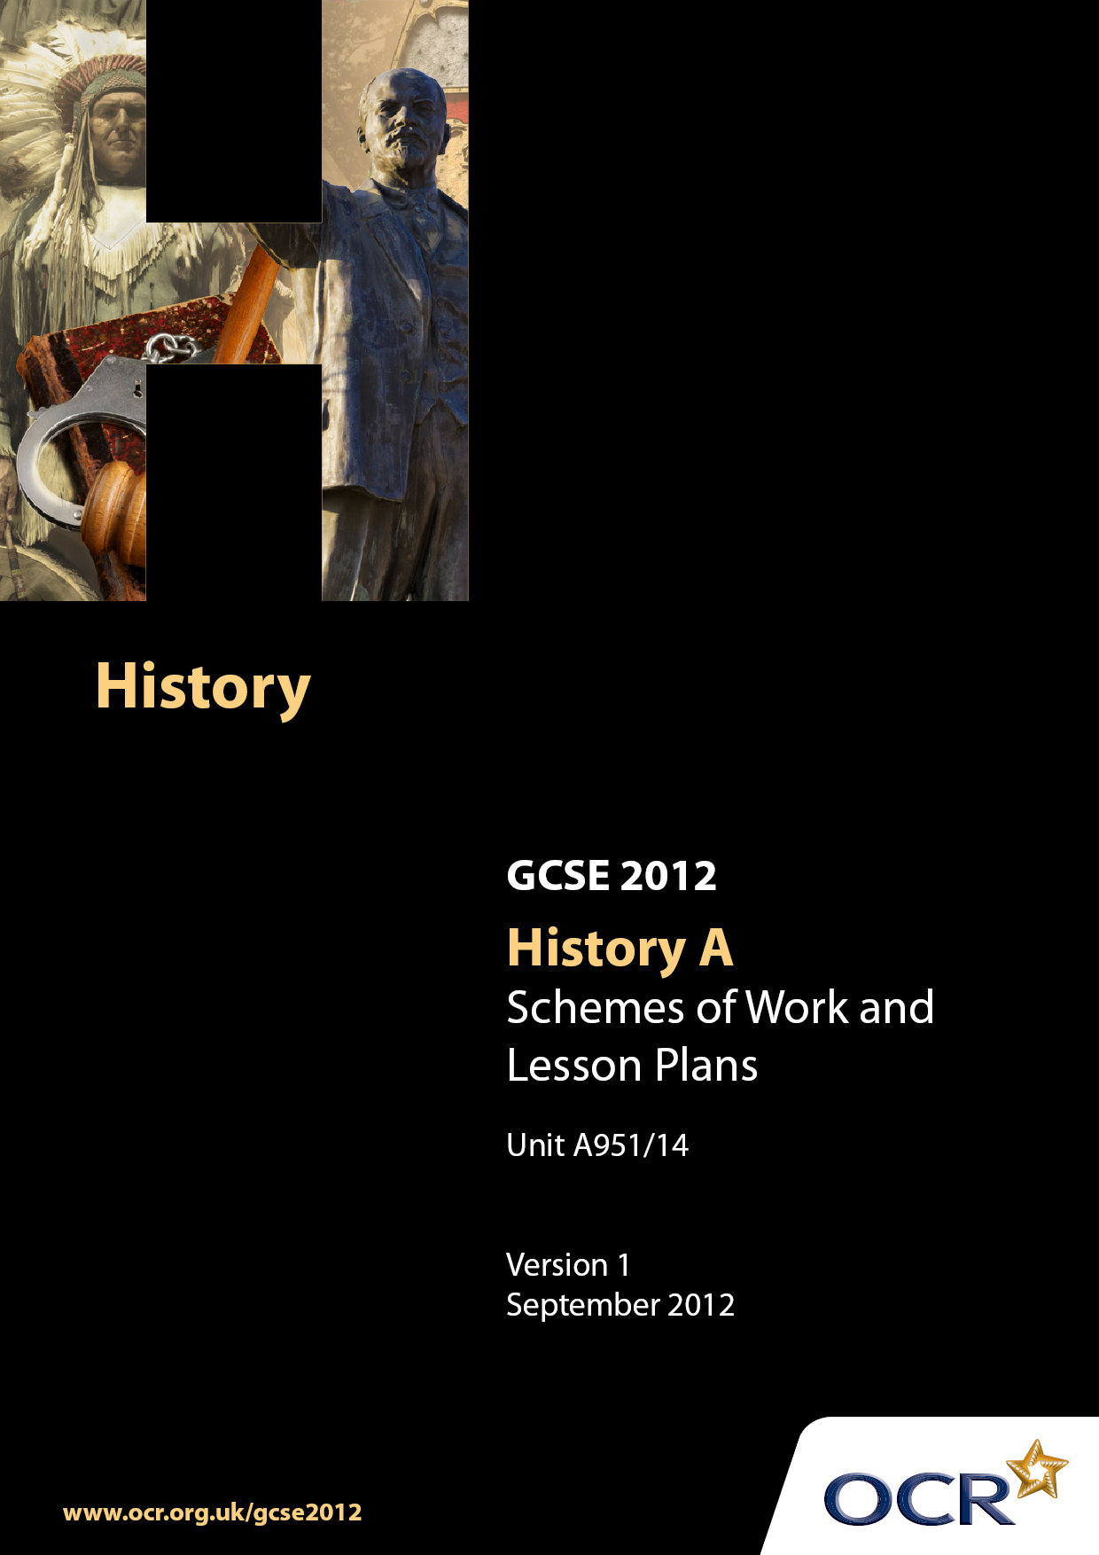

Contents
Contents 2
Introduction 3
Sample Scheme of Work: Unit A951: Depth Study 14: Germany, c.1919–1945 6
Sample Lesson Plan: Unit A951: Depth Sudy 14:Germany, c. 1919–1945 20

Introduction

Background
Following a review of 14–19 education and the Secondary Curriculum Review, the Qualifications and Curriculum Authority (QCA) has revised the subject criteria for GCSEs for first teaching in September 2009. This applies to all awarding bodies.
The new GCSEs have more up-to-date content and encourage the development of personal learning and thinking skills in your students.
We have taken this opportunity to redevelop all our GCSEs to ensure they meet your requirements. These changes will give you greater control of assessment activities and make the assessment process more manageable for you and your students. Controlled assessment will be introduced for most subjects.
From September 2012, assessment tasks may be undertaken at any point between release of the task and the examination series for which the task must be submitted. Centres must ensure that candidates undertake a task that is valid for submission in the year in which the candidate intends to submit it.
OCR has produced a summary brochure, which summarises the changes to History A. This can be found at www.ocr.org.uk along with the new specification.
In order to help you plan effectively for the implementation of the new specification, we have produced these Schemes of Work and sample Lesson Plans for History A. These Support Materials are designed for guidance only and play a secondary role to the Specification.

Our Ethos
OCR involves teachers in the development of new support materials to capture current teaching practices tailored to our new specifications. These support materials are designed to inspire teachers and facilitate different ideas and teaching practices.
Each Scheme of Work and set of sample Lesson Plans is provided in Word format – so that you can use it as a foundation to build upon and amend the content to suit your teaching style and students’ needs.
The Scheme of Work and sample Lesson Plans provide examples of how to teach this unit and the teaching hours are suggestions only. Some or all of them may be applicable to your teaching.
The specification is the document on which assessment is based and specifies what content and skills need to be covered in delivering the course. At all times, therefore, this Support Material booklet should be read in conjunction with the specification. If clarification on a particular point is sought, then that clarification should be found in the specification itself.

A Guided Tour through the Scheme of Work

= Innovative Teaching Idea
This icon is used to highlight exceptionally innovative ideas.


= ICT Opportunity
This icon is used to illustrate when an activity could be taught using ICT facilities.

Unit A951/14 Germany, c.1919–1945
Suggested teaching time | 7 hours | Topic |  | Germany
Topic outline |  | Suggested teaching and homework activities |  |  | Suggested resources |  |  | Points to note
Was the Weimar Republic doomed from the start? |  |  | - Introduction and overview – what were the key issues, themes and events in Germany during the period 1919-1945? Teacher to provide a series of pictures (using PowerPoint or Smart board) to illustrate this period. Pupils use these to sort according to particular categories (chronology, key individuals, key events, economy). Pupils produce a timeline highlighting key events during this period  - What was Germany like before 1918? Discussion of the history of Germany (unification, industrialisation, military success, how it was ruled). Produce a spider diagram illustrating Germany’s strengths and potential weaknesses  - What was the impact of war upon Germany? Look briefly at the economic, military and political effects of the war on Germany. Pupils could produce a spider diagram or write a series of diary extracts describing key events in Germany  - Political impact of Germany’s defeat. Explain the concept of political spectrum, pupils to produce a diagram with examples of political parties and key ideas (crucial to emphasise differences between Socialists, Communists and Nationalists) What are the main strengths and weaknesses of the Weimar Constitution? Pupils could complete this as a homework task  - The Treaty of Versailles and its impact. Terms, impact on Germany (economic to be covered later, political opposition). Possible essay – ‘The Treaty of Versailles was unfair’.Do you agree? Alternatively; produce a cartoon supportive of or opposing the Treaty of Versailles  - Political problems in Germany, Spartacist rising, Kapp Putsch, Red Rising. Political viewpoint, leaders, actions, result. How big a threat were they to the Weimar Republic? Small groups look at different rebellions and class feedback. (Note: you might want to include the Munich Putsch here)  - What were the causes and effects of hyperinflation? A good activity is to produce a flow chart explaining the causes of hyperinflation and the resulting effects  - Discuss and produce a MindMap (key problems, links between problems etc) for the problems facing Germany between 1919 and 1923. Prepare to answer essay style question – what was the most difficult problem that Germany faced in this period?  - To what extent did the Republic recover after 1923? Pupils work in groups looking at positive aspects of the period including Dawes Plan, Young Plan, League of Nations entry, Locarno, cultural development, Stresemann resolving problems with the economy. Contrast this with underlying problems that Germany still faced  - What were the achievements of the Weimar period? A useful moment to look back over the work. Either produce a series of cards with either events or achievements (and failures) and ask them to either identify the achievements or prioritise them. Pupils complete a written exercise where they evaluate the most important achievement of the Weimar Republic. |  |  | - Good picture resources are to be found with Google pictures, Picsearch and http://www.spartacus.schoolnet.co.uk/Germany.htm  - There is a good summary (which can be simplified) in Germany 1918-1945, a study in depth, Greg Lacey, Keith Shephard, 07195-7059-x  - Covered reasonably well in textbooks available especially above  - Pupils draw a political spectrum (semi-circle) and are then required to put politcal parties onto this diagram after discussion  - Produce a diagram to show the new German Constitution  - Find cartoon sources on the Treaty of Versailles (pro and anti-German) to explain attitudes towards the Treaty  - Scope to use pupil essays as exemplars to discuss and suggest improvement (AFL)  - Produce case studies on various rebellions where pupils have to gauge the threat  - Essential Germany 1918-1945, Banham and Culpin 07195 7753-5 has a good section on this  - The old video ‘Make Germany pay’ (first half) is very good on this. It is well covered in the various textbooks  - This activity is discussed in the Essential series book  - This is covered well in the books; particularly in Lacey etal which looks at lots of different aspects including Bauhaus.  - The Essential Germany book does a useful exercise with a cartoon showing Germany walking a tightrope – teachers may want to develop this analogy in their teaching | - Depending upon the ability of the group you can add or take away pictures and add layers of complexity.  - There is a simple version of this idea in Weimar and Nazi Germany, Eric Wilmot  - It would be a good idea to start to construct a working vocabulary of terms and ideas associated with Germany or more generally (dictatorship, democracy) in which words can be added as the course progresses  - It may also be good to get pupils to have a map of Germany from this time too!  - Emphasise the importance of the ‘November Criminals’ and the ‘Stab in the back’ myth  - Stretch and challenge task – who posed the greatest threat to Weimar Germany; the left or the right?
How was Hitler able to come to power in Germany? |  |  | - What did the Nazi Party stand for in the 1920s? Using internet, library and textbook materials produce a biography of Hitler prior to 1923, looking at his personality, wartime experience, political ideas etc. There is scope to look at the Nazi Party Programme to see who this would appeal to and who would dislike it.  - What was the significance of the 1923 Munich Putsch. Pupils to produce a timeline of key events and to address key questions. What did he hope to achieve? Why did this rebellion fail? What were the key lessons that Hitler learnt from this experience? Activity to draw out the answers to these key questions  - Why did the Nazis have little success before 1929? Focus on lack of popularity and focus (economic prosperity, extremist policies, lack of appeal amongst working classes and middle classes, religion)  - What were the causes of success after 1929? What caused the breakthrough? (alliance with the nationalists, appealing to middle classes and rural workers)  - The impact of the Wall Street Crash on Germany. Explain why this event caused enormous problems in Germany and how the Nazi Party were able to exploit these problems. (Show electoral success in Germany, political weakness with the emergency decrees, propaganda, role of the SA)  - Why was Hitler invited into power? Pupils produce a diagram (use pictures of key figures) showing how he came to be invited. Pupils should then be able to explain the motives behind the plot |  |  | - All major textbooks for Nazi Germany cover this well, film ‘Hitler a study in evil’ is also useful (starring Robert Carlyle)  - First episode of DVD above shows some of the key events  - Wilmot has a good exercise looking at this issue but it is covered well in other texts too  - This is covered well in textbooks and there is a video on Hitler’s rise to power which is very useful in summarising the key reasons why Hitler was able to take power by January 1933  - Lacey and Shephard provide an excellent summary as to the relationship between all the key players (Papen, Schleicher and Hindenburg) | - It would be helpful in this section, for pupils to begin to gather fact files on leading Nazis, roles, significance etc. It is suggested that the following people are included; Ernst Rohm, Heinrich Himmler, Joseph Goebbels as a bare minimum. There is scope to set this as a research based homework  - Hitler’s realisation that he must take power through the Reichstag and the significance of writing Mein Kampf  - Please emphasise difference in approach between 1923 and 1929!  - Emphasise that at no stage did the majority of German people vote for Hitler to become Chancellor – if anything – his support was reducing!
The Nazi regime: How effectively did the Nazis control Germany, 1933-1945? |  |  | - How did Hitler become dictator of Germany? What was the significance of the Reichstag fire? There is scope to do source analysis here looking at various explanations i.e. a communist plot, van der Lubbe acting on his own or organised by the Nazis. Key learning point is to emphasise that Hitler’s position with regard to opposition is strengthened with the removal of the communists  - The passing of the Enabling Law – this can be covered at the same time as the last in terms of an overall investigation. Pupils to feedback what happened and the result of this event  - Scope to test understanding either through asking a question relating to Hitler’s rise to power or his consolidation of power.  - How much opposition was there to the Nazi regime? Case studies looking at different groups of opponents (youth movements, church organisations, military opposition, low-level opposition) there is potential to do group work here looking at a specific opposition group; the reasons for their opposition, their activities, what happened to them, level of success)  - How effectively did the Nazis deal with their political opponents? (Please note; it may be helpful to cover this topic prior to looking at opposition in general) Pupils need to understand Hitler’s dilemma regarding the role of the SA or the role of the Army and his relationship with Ernst Rohm. Scope to look at arguments to support the SA and arguments to support the Army. Investigate what happened. Consider who were the key beneficiaries of the brutal events in June 1934 (Hitler, the Army, and the SS). Ensure that pupils understand the significance of the death of Hindenburg. I suggest an exercise that looks at key points in the relationship with the army after 1934; Hitler announces his plans, the removal of opposition, the early part of the war and from around 1942. This should build on prior learning relating to the von Stauffenburg plot.  - How did Hitler use culture, propaganda and the mass media to control people? Excellent opportunity to look at different elements of propaganda in Germany, film, the Olympics, posters. Teacher to devise a worked example of a PowerPoint presentation of a piece of propaganda labelling key features such as colours, symbols, phrases and ideas. Pupils then go on to select their own posters which they can label. Key question – what messages did the Nazis try to convey through the use of propaganda?  - Why did the Nazis persecute many groups in German society? Present a series of pictures of groups persecuted by the Nazis (Jews, gypsies, disabled, homosexuals, criminals etc) Pupils should produce a table on reasons for hostility and how each group was treated. With the Jews pupils should produce a timeline identifying the key developments as they happened culminating in the Final Solution  - Exercise that returns to the key question of this section. A good way of doing this is to get pupils to identify the carrots and the sticks that are used to control the people. Further questions can be used to develop thinking such as when did the control begin to break down. Produce this in the form of a mind map. Seek out past exam questions to test knowledge of control |  |  | - Lacey and Shephard provide a good activity looking at the Reichstag fire. The second episode of ‘Hitler, a Study in Evil’ is also excellent in looking at this event  - Please note that Lacey and Shephard also explain the processes of gleichschaltung in the town of Northeim which may prove to be useful.  - All texts do this well (relevant sections in the work on Northeim for example). There is a video that looks specifically at opposition which is good, look out for information following the Tom Cruise film relating to Stauffenburg. Lots of web resources such as http://www.ushmm.org/wlc/media_oi.php?lang=en&ModuleId=10005208&MediaId=1236,  - ‘Hitler, a study in evil’ covers the Night of the Long Knives well and nicely ties in with work from previous lessons about opposition  - http://www.calvin.edu/academic/cas/gpa/ww2era.htm is excellent in terms of providing material relating to propaganda posters  - Alternatively, departments may have an old video which looked at the role of Goebbels, ‘Master of Propaganda’. Use YouTube clips on the Leni Riefenstahl ‘Triumph of the Will’ film to demonstrate the use of propaganda  - The school video series mentioned above has a film looking at minorities. Also the video that accompanied Schindler’s List has an excellent documentary explaining the stages in the persecution of the Jews | - Care needed with material used here – be careful to follow school policies
The Nazi regime: What was it like to live in Nazi Germany? |  |  | - What was the purpose of the Hitler Youth? Pupils to describe the work of these organisations and in particular the aims. Given resources, pupils produce a poster explaining policies towards young people. Class discussion (revision) relating to success in terms of opposition  - How successful were Nazi policies towards women and the family? This can be done in conjunction with youth policy whereby pupils are divided into groups and become experts on their topic which is discussed with those who have done the other topic with individuals acting as experts. There is also scope to use ICT for this exercise  - Were most people better off under Nazi rule? Pupils should be able to make a judgement relating to this question from prior knowledge (i.e. women, youth, Jews, church). Teachers should prepare and feed in information relating to work and the economy. Exercise that relates to the Nazis adopting a war economy and the impact that this has on ordinary Germans. Teachers should set this as an essay style question planned and discussed together in class |  |  | - All textbooks cover youth policy and women well  - http://www.calvin.edu/academic/cas/gpa/ww2era.htm#Posters has excellent stimulus material to look at attitudes towards women  - Lacey and Shephard cover the economy well. Teachers could devise a series of cards or if appropriate use a SmartBoard to create cards with key ideas, groups to promote discussion on this topic  - Your school may have invested in Boardworks software which should be useful for various elements of this course | - Make sure that pupils are aware of the differences between youth movement policies and the nature of schooling

Unit A951/14 Germany, c.1919–1945

How did Hitler use various forms of propaganda to convey his ideas in Nazi Germany?
OCR recognises that the teaching of this qualification will vary greatly from school to school and from teacher to teacher. With that in mind, this lesson plan is offered as a possible approach but will be subject to modification by the individual teacher.
Lesson length is assumed to be one hour.

Learning Objectives for the Lesson
Objective 1 | The positive aspects of Nazi propaganda – what did the Nazis want German people to be like or how to behave?
Objective 2 | The negative aspects of Nazi propaganda – what sort of things did the Nazis want German people to dislike or hate?

Recap of Previous Experience and Prior Knowledge
- This lesson will take place once the Nazis are in power and probably once elements of consolidation have been covered. It relates to Key Question 3 and helps to discuss the ways in which the Nazis controlled Germany.

Content
Time | Content
5 minutes | Pupils to come up with a list of different ways in which the Nazis used propaganda.
5 minutes | Pupils to feedback ideas to teacher – a large list put on Smartboard or whiteboard – scope to fill in gaps such as the use of propaganda at work etc
15 minutes | Pupils to be given a handout about the types of propaganda used in Germany – pupils to fill in a chart (differentiated according to ability).
15 minutes | Pupils given a small selection of propaganda (posters) using inference diagram (copy included) – a picture needs to be put in the middle of the sheet – there should be scope to do more than 1 here (I suggest that the teacher models an example of this).
15 minutes | Feedback – allow pupils to feedback their information – teachers produce a list of the key messages that the Nazis wanted to convey through propaganda.

Consolidation
Time | Content
5 minutes | Pupils to write down a key negative message conveyed in propaganda or a positive message (divide the group in half) Get individuals to read out their response.
Please note, there is real scope to carry this on with a presentation either using PowerPoint or Moviemaker (scope to use videos from Youtube for this) modelled by the teacher, devised and presented by groups of pupils. (This is a really good form of revision too if the best ones are kept for future use!)

Unit A951: A951/14 Germany, c. 1919–1945

Why was 1923 a year of crisis in Weimar Germany?
OCR recognises that the teaching of this qualification above will vary greatly from school to school and from teacher to teacher. With that in mind, this lesson plan is offered as a possible approach but will be subject to modification by the individual teacher.
Lesson length is assumed to be one hour.

Learning Objectives for the Lesson
Objective 1 | To understand the impact of reparations upon Germany and why Germany claimed that they couldn’t afford to pay
Objective 2 | To understand the impact of the French and Belgian invasion of the Ruhr

Recap of Previous Experience and Prior Knowledge
- This should come towards the end of a series of lessons which look at the problems facing Germany between 1919 and 1923. Pupils should understand the impact of the war and particularly the Treaty of Versailles, the nature of the terms and the impact on Germany. The Munich Putsch has not been included in this plan but could add another layer of complexity if appropriate.

Content
Time | Content
5 minutes | A recap on the problems facing Germany before or reintroduction to BART (Blame, Army, Reparations, Territory) – the terms of the Treaty of Versailles.
10 minutes | Most departments should have a copy of ‘Make Germany pay’ .Ask pupils to write down a timeline or chronology of events – alternatively use a textbook.
15 minutes | Discussion – teacher working with pupils to model key events that happened – opportunity to explain concept of Inflation and Hyperinflation – suggestion that pupils produce a flow diagram showing how the crisis developed and how it was eventually solved.
15 -20 minutes | Teacher prepares a series of individuals (this can be made up) preferably put onto paper or card and distributed to small groups – to discuss their likely response to the events of 1923 (suggested individuals, a retired person with savings and a pension, a public sector worker, an ex-soldier, ex Freikorp). Try to encourage them to think carefully about the possible consequences of this trouble. Teacher has details on Smartboard or board (even if this is just the name) and summarises possible reactions to this crisis.
5 minutes | After class discussion, pupils could be given the individuals concerned where they have to provide detailed thought bubbles to present with their work.

Consolidation
Time | Content
5 minutes | Each individual to provide 3 key things that they have learnt during today’s lesson. Devise a way in which to get pupils to randomly relate to their learning points.

Unit A951: A951/14 Germany,c.1919–1945

What were the achievements of the Weimar period?
OCR recognises that the teaching of this qualification will vary greatly from school to school and from teacher to teacher. With that in mind, this lesson plan is offered as a possible approach but will be subject to modification by the individual teacher.
Lesson length is assumed to be one hour.

Learning Objectives for the Lesson
Objective 1 | To understand the domestic achievements of the Weimar period
Objective 2 | To understand the foreign policy achievements of the Weimar Period
Objective 3 | To begin to think about the limitations of the successes

Recap of Previous Experience and Prior Knowledge
- Pupils will have spent the previous lessons looking at the problems of the early period specifically up to 1923 and up to approximately October 1929 with the Wall Street Crash

Content
Time | Content
10 minutes | Pupils to work in groups of 3 or 4 to play a bidding game in which they recap problems and issues from the Weimar Republic so far, the idea being that in each category, teams have to produce a list (maximum 10) of ideas which they can bid against other groups. Suggested categories, problems faced in Germany up to 1923, important individuals in Germany discussed, terms of the Treaty of Versailles. The group with the highest bid has to recount their list etc… Prioritise problems
5 minutes | Teacher organises next activity, looking at aspects of successes of Weimar Republic – small groups with information and questions to feedback to class. Categories to look at Locarno, League of Nations, Dawes and Young Plan – description, why did these make Weimar a success? Cultural and social revolution in Germany – what sort of people would enjoy this sort of activity? Perhaps a pre-prepared sheet to jot notes
10 minutes | Group activity initially finding out information in one group
15 minutes | Rearrange groups with experts from each topic to disseminate information to group members
5 minutes | Class discussion as to the greatest success of the Weimar period – scope to add other ideas here if necessary

Consolidation
Time | Content
10 minutes | Teacher presents the idea of a tightrope or iceberg to enable pupils to think about the problems that were still present beneath the surface (how friendly were they with other countries, the problem of debt, extremism still there etc). Teacher to use resources to tease this out of the pupils.
5 minutes | Set up homework task whereby pupils produce an essay plan for the question asked at the beginning of the lesson.

