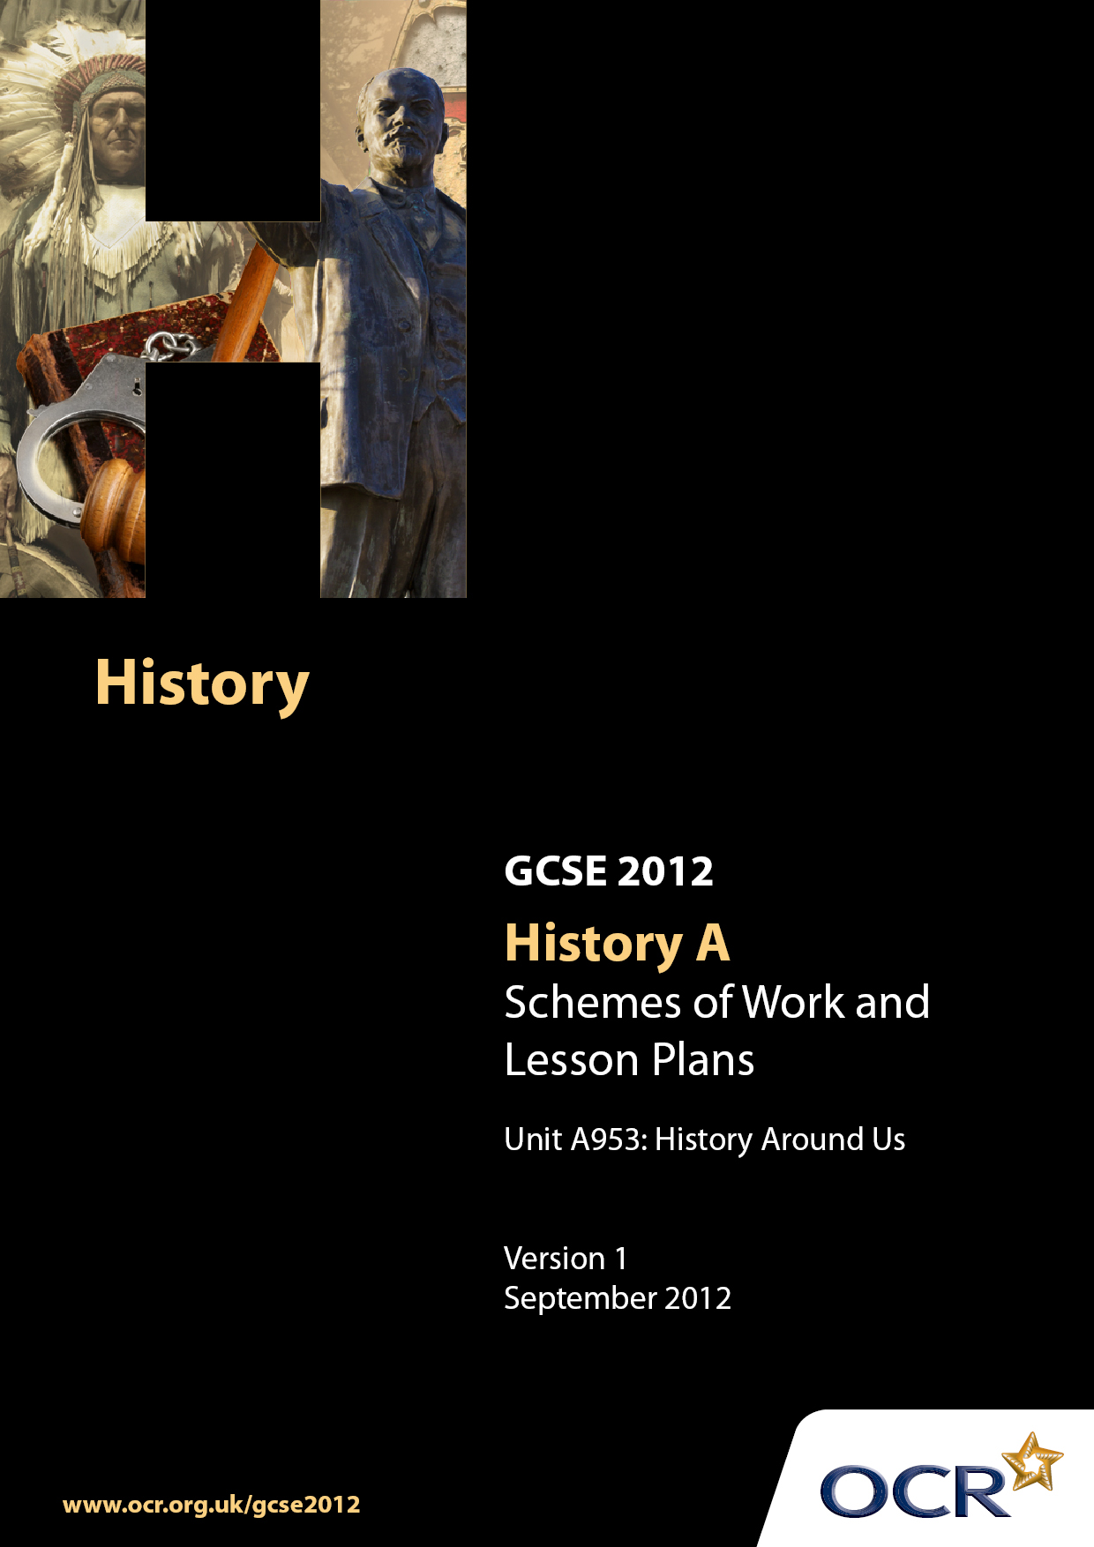

Contents
Contents 2
Introduction 3
Sample Scheme of Work: Unit A953: History Around Us 6
Sample Lesson Plan: Unit A953: History Around Us 13

Introduction

Background
Following a review of 14–19 education and the Secondary Curriculum Review, the Qualifications and Curriculum Authority (QCA) has revised the subject criteria for GCSEs for first teaching in September 2009. This applies to all awarding bodies.
The new GCSEs have more up-to-date content and encourage the development of personal learning and thinking skills in your students.
We have taken this opportunity to redevelop all our GCSEs to ensure they meet your requirements. These changes will give you greater control of assessment activities and make the assessment process more manageable for you and your students. Controlled assessment will be introduced for most subjects.

From September 2012, assessment tasks may be undertaken at any point between release of the task and the examination series for which the task must be submitted. Centres must ensure that candidates undertake a task that is valid for submission in the year in which the candidate intends to submit it.
OCR has produced a summary brochure, which summarises the changes to History. This can be found at www.ocr.org.uk along with the new specification.
In order to help you plan effectively for the implementation of the new specification, we have produced these Schemes of Work and sample Lesson Plans for History. These Support Materials are designed for guidance only and play a secondary role to the Specification.

Our Ethos
OCR involves teachers in the development of new support materials to capture current teaching practices tailored to our new specifications. These support materials are designed to inspire teachers and facilitate different ideas and teaching practices.
Each Scheme of Work and set of sample Lesson Plans is provided in Word format – so that you can use it as a foundation to build upon and amend the content to suit your teaching style and students’ needs.
The Scheme of Work and sample Lesson Plans provide examples of how to teach this unit and the teaching hours are suggestions only. Some or all of them may be applicable to your teaching.
The specification is the document on which assessment is based and specifies what content and skills need to be covered in delivering the course. At all times, therefore, this Support Material booklet should be read in conjunction with the specification. If clarification on a particular point is sought, then that clarification should be found in the specification itself.

A Guided Tour through the Scheme of Work

= Innovative Teaching Idea
This icon is used to highlight exceptionally innovative ideas.


= ICT Opportunity
This icon is used to illustrate when an activity could be taught using ICT facilities.

Unit A953: History Around Us
Suggested teaching time | 5 hours | Topic | History Around Us: Dover Castle
Topic outline |  | Suggested teaching and homework activities |  | Suggested resources | Points to note
What is there at Dover Castle? |  | - Pupils will develop independent research skills  - Pupils given atlas and asked to locate Dover on a national map of Britain. Pupils asked to note anything special or unique about Dover (it’s the closest point to France)  - Pupils given series of photographs of different parts of Dover Castle. Task is to identify what each bit is. eg. Pharos Lighthouse  - Paired task to research a description of what each part of Dover Castle looks like, when and by whom it was made. For example, St Mary’s church  - Pupils are to produce their own guide book to describe Dover Castle to a visitor |  | - Guide book to Dover Castle  - Atlas | - Due to the huge time period of history at Dover Castle I have chosen to limit my investigation to the end of the reign of Henry III as large scale building stops at the site in this period
How has Dover Castle changed through time?  Where does Dover Castle fit in the story of castle development?  How typical was Dover Castle of castles of its time? |  | - Pupils will have a chronological sequence of the developments in castle building in England  - Class to attempt to arrange pictures of Iron Age Hill Forts, Roman Pharos Lighthouses, Saxon burghs, Motte and Bailey Castles, Square keeps and curtain walls and concentric castles on the board chronologically. To be left on board throughout lesson  - Groups will take responsibility for researching one of the following periods in castle building in England (linked to the development of Dover Castle)  - Groups will produce a presentation for their peers with a description of what their topic is, illustrations, list of construction materials and potential weaknesses/ strengths to their castle (with exception of Pharos lighthouse which is not a fortification but designed to foster trade)  - Groups present their presentations to class. Pupils should take notes/receive handouts on each presentation topic  - If class did not correctly sequence pictures at start of lesson repeat activity to demonstrate their knowledge  - This work should be based on one stage of Dover Castle's development. Using textbooks/materials about castles built at same time, pupils asked to compare Dover with general trends in castle building at the time and to explain: how typical was Dover Castle of castles at that time? |  | - Iron Age Hill Forts:  - Guide to Maiden Castle (Iron Age Hill Fort)  - http://enHill Forts:Wikipedia.org.wikipedia.org/wiki/Hill_fort  Roman lighthouses:  - Pharos lighthouse: Dover Musuem  - Roman lighthouse: Channel 4  - Boulogne’s lighthouses :Theotherside.co.uk  Saxon Burghs:  - Saxon burghs: earlybritishkingdoms.com  - Saxon burghs: Legendarydartmoor.co.uk  Motte and Bailey castles:  - Interactive Motte and Bailey castle tour: Pastperfect.org  - Motte and Bailey: Castles-of-britain.com  Square Keeps:  - Guide to Rochester Castle (Square keep with one curtain wall)  - Problems of a square keep: Schoolshistory.org  Concentric Castles:  - Concentric Castles: Castles-of-britain.com  - Concentric Castles: Middle-ages.org | - Teachers will need to provide materials on Iron Age Hill Forts, Roman Pharos Lighthouses, Saxon burghs, Motte and Bailey Castles, Square keeps and curtain walls and concentric castles
Field work |  | - As this is an offsite educational visit teachers must ensure they follow all national protocols surrounding educational visits  - Pupils will need to visit the following at the castle  - Pre Historic Iron Age Hill Fort  - (Best viewed from Constable’s gateway and St Mary’s Church)  - Roman Pharos Light house (draw attention to the other lighthouse which was on the western heights)  - Saxon Burgh (St Mary’s Church was one of the few Saxon stone churches and would have been located in the centre of the Burgh  - Motte and Bailey Castle 1066 (No evidence remains of this but Motte would have been the hill on which the Pharos lighthouse and St Mary’s stands upon and the bailey where the square keep is today- some suggestion their were two Mottes at Dover Castle)  - Square Keep Inner and Outer Walls  - Siege of 1216 exhibit  - Building works of Henry III (located at various points around the castle  - Whilst pupils are examining each site they must record the following sections  - Describe what each part is and record its purpose  - Take some evidence of its existence  - Explain the significance of each object at Dover Castle  - In the siege of 1216 exhibit pupils are to take notes on what happened and the significance of the besieged defenders holding out against Prince Louis |  | - Access to Dover Castle | - All pupils will need to visit the historic site
How do interpretations of the result of the siege of 1216 differ? |  | - Pupils will examine historical sources on the siege of 1216 to learn of the different interpretations surrounding this event  - Pupils write a summation of the 1216 exhibit at Dover Castle. Pupils to be directed to focus on the significance of Dover Castle in helping to defeat Prince Louis’ invasion  - Class to watch http://www.english-heritage.org.uk/server/show/nav.19451 to view a second interpretation of the Castle’s role in the defeat of Prince Louis. Teacher to direct students to examine who has produced both sources and to explain why the interpretations are so similar  - Groups to use source analysis skills to determine if the two sources examined are useful  - Teacher can introduce Source A if they wish to expand the historiography of emphasising Dover Castle’s importance. Pupils to explore significance in defeating Prince Louis’ invasion  - Pairs to study Source B, as a more neutral source, to look for any other reason of the centrality of Dover Castle to defeating the invasion of Prince Louis |  | - English heritage video of Dover Castle  - Historic-Kent: siege of 1216  - (edited versions of the webpage can be found at the bottom of this document)  - Deremilitari- Siege of 1216  - (Edited versions of the webpage can be found at the bottom of this document) | - Pupils will have to go into the siege of 1216 exhibit at Dover Castle and make extensive notes of the siege  - A basic knowledge of the events surrounding the siege of 1216, Prince Louis’ invasion, will also be required
Henry III rebuilding of Dover Castle  Why was Dover Castle important? |  | - Pupils will examine what Henry III rebuilt at Dover then compare to what other work was going on in England in an attempt to draw conclusions about the significance of Dover Castle  - Pupils to use guidebook to familiarise themselves with what Henry III did at Dover, recording what he did  - Pupils to research what Henry III did to the Tower of London  - Pairs to compare the scale of the works undertaken (both similar in scale). Pairs to explore why Henry III would spend such vast resources on two castles. Teacher to direct pupils to strategic importance  - Pupils to answer: What do the works of Henry III reveal about the importance of Dover Castle?  - Pupils to reach conclusions about why Dover Castle was of local/national importance at different times in its development |  | - Guide book to Dover Castle  - Henry III and Dover Castle: Historic-kent  - Henry and Tower of London: Castles.org | - Basic background knowledge of the reign of Henry III would be useful to understand how few castles he rebuilt

Unit A953: History Around Us
OCR recognises that the teaching of this qualification will vary greatly from school to school and from teacher to teacher. With that in mind, this lesson plan is offered as a possible approach but will be subject to modification by the individual teacher.
Lesson length is assumed to be one hour.

Learning Objectives for the Lesson
Objective 1 | To understand the significance of the siege of 1216 has been interpreted in different ways
Objective 2 | To know the central differences between some of the historiography surrounding the siege of 1216
Objective 3 | To be able to infer why there might be these differences

Recap of Previous Experience and Prior Knowledge
- Fieldtrip to Dover Castle must have been completed. Pupils must also have a general knowledge of the siege of 1216

Content
Time | Content
10 minutes | - Pupils write a summation of the 1216 exhibit at Dover Castle using notes made during field trip.  - Teacher to direct focus to significance of Dover Castle in helping to defeat Prince Louis’ invasion.  - Ask pupils who produced the exhibit at Dover Castle and how this will impact upon what they say.
10 minutes | - Teacher to inform class they are going to watch an English heritage video (www.english-heritage.org.uk/server/show/nav.19451) pupils to make link between what they are about to see and what they viewed on the fieldtrip being produced by the same people. (Watch video until end of Prince Louis’ invasion)  - Teacher to direct focus to significance of Dover Castle in helping to defeat Prince Louis’ invasion.  - Why are the two interpretations of the significance of the role played by Dover Castle in the defeat of Prince Louis’ invasion so similar?
5 minutes | - Groups to use source analysis skills to determine if the two sources examined are useful.  - Can complete useful/ not useful table
15 minutes | - Teacher to introduce Source A (extract from Historic Kent’s website on the siege of 1216 www.historic-kent.co.uk) to expand historiography of emphasising Dover Castle’s importance.  - Pairs to read source together  - Pupils to explore significance in defeating Prince Louis’ invasion.  - Pupils can complete another useful/ not useful table
10 minutes | - Pairs to read Source B (extract from Deremilitari (French) website on the siege of 1216 www.deremilitari.org/resources/articles/goodall.html)  - Repeat above task  - Can pupils identify why it gives different reasons for the defeat of Prince Louis?

Consolidation
Time | Content
5 minutes | Teacher recaps on what has been learned in the lesson, what skills have been used and outlines how this could be used in the future
5 minutes | Teacher starts a sentence  “Today I have learnt …..”  “English Heritage and Historic Kent interpret events …………”  “Whilst Demilitari views events differently…………”  “The reason they differ is because………….”  With pupils providing the rest of the sentence.  Teacher to write key words such as interpretation of events, historiography on the board to ensure they are used

