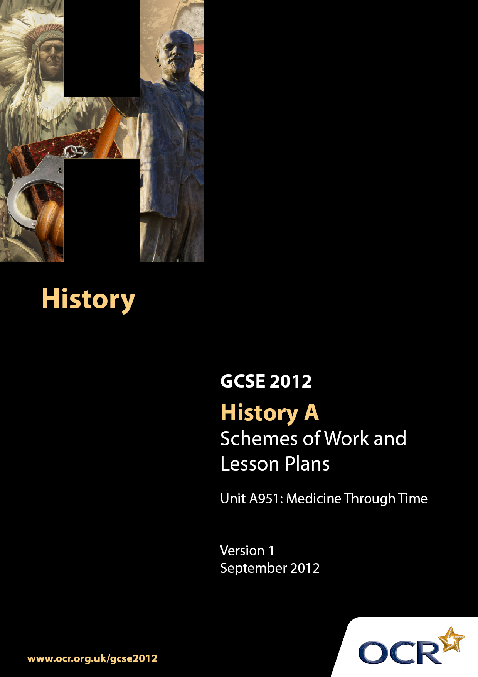

Contents
Contents 2
Introduction 3
Sample Scheme of work: Unit A951: Medicine Through Time 6
Sample Lesson Plan: Unit A951: Medicine Through Time 13

Introduction

Background
Following a review of 14–19 education and the Secondary Curriculum Review, the Qualifications and Curriculum Authority (QCA) has revised the subject criteria for GCSEs for first teaching in September 2009. This applies to all awarding bodies.
The new GCSEs have more up-to-date content and encourage the development of personal learning and thinking skills in your students.
We have taken this opportunity to redevelop all our GCSEs to ensure they meet your requirements. These changes will give you greater control of assessment activities and make the assessment process more manageable for you and your students. Controlled assessment will be introduced for most subjects.
From September 2012, assessment tasks may be undertaken at any point between release of the task and the examination series for which the task must be submitted. Centres must ensure that candidates undertake a task that is valid for submission in the year in which the candidate intends to submit it.
OCR has produced a summary brochure, which summarises the changes to History. This can be found at www.ocr.org.uk along with the new specification.
In order to help you plan effectively for the implementation of the new specification, we have produced these Schemes of Work and sample Lesson Plans for History. These Support Materials are designed for guidance only and play a secondary role to the Specification.

Our Ethos
OCR involves teachers in the development of new support materials to capture current teaching practices tailored to our new specifications. These support materials are designed to inspire teachers and facilitate different ideas and teaching practices.
Each Scheme of Work and set of sample Lesson Plans is provided in Word format – so that you can use it as a foundation to build upon and amend the content to suit your teaching style and students’ needs.
The Scheme of Work and sample Lesson Plans provide examples of how to teach this unit and the teaching hours are suggestions only. Some or all of them may be applicable to your teaching.
The specification is the document on which assessment is based and specifies what content and skills need to be covered in delivering the course. At all times, therefore, this Support Material booklet should be read in conjunction with the specification. If clarification on a particular point is sought, then that clarification should be found in the specification itself.

A Guided Tour through the Scheme of Work

= Innovative Teaching Idea
This icon is used to highlight exceptionally innovative ideas.


= ICT Opportunity
This icon is used to illustrate when an activity could be taught using ICT facilities.

Unit A951: Medicine Through Time
Suggested teaching time | 5 hours |  | Topic | Medicine in the Middle Ages
Topic outline |  |  | Suggested teaching and homework activities |  | Suggested resources |  |  | Points to note
The influence of the Church in the Middle Ages |  | - Students need to have an understanding of how the Church hindered medical progress and how it helped advance knowledge. The tasks in this part of the scheme would allow students to begin to develop skills of source comprehension and evaluation. There are a number of ways in which this could be achieved:  - Teachers could provide a basic understanding of Medieval Church practices through an introductory presentation, highlighting the crossovers between Church and medical life.  - Teacher’s should provide students with a range of sources about the Medieval Church’s impact on medicine and a table to record onto. Students should record appropriate evidence showing how the Medieval church either helped or hindered medicine.  - Pupils to compare the different evidence they have recorded and evaluate if the Medieval Church helped or hindered medicine. Pupils will present their findings via an ICT presentation, complete with analysis of sources and an evaluation of the Medieval Church’s impact on medicine. |  |  |  | Useful books for work on Medieval medicine:  - The Development of Medicine for OCR GCSE, Colin Shephard, Hodder  - Medicine and Health through Time: an SHP Development Study, Ian Dawson and Ian Coulson, Hodder Murray  - overview of Medicine and Religion in the Middle ages- intermaggie | - These activities would help students to develop evaluation skills and improve their ability to justify statements. These are important skills for students to develop
Was Medieval surgery more advanced than surgery from the ancient world? |  | - Students will gain knowledge of surgery within the Medieval world, examining both progression and regression. Students will further compare surgery through time by making a direct comparison between ancient and Medieval surgery in an exam style question. Pupils will further gain from working with historical sources.  - Teacher delivers a quiz for students on ancient medical surgery, designed to refresh pupils’ knowledge of how surgery advanced in ancient times.  - Teacher- led introduction to Medieval surgery using picture which highlights the link between Church and medicine. Pupils to make comparison between ancient surgical techniques and Medieval, assessing progression/regression  - Pupils can undertake a GCSE bite size source activity reading more on advance and regression in Medieval surgery completing questions at end of section  BBC bite size medieval surgery quiz  - Teacher to issue students with an information sheet to compare Medieval and ancient surgical worlds  - Home work - pupils answer essay style question (adapted from OCR sample assessment material), Medieval surgery was not as advanced as surgery in the ancient world. Explain how far you agree with this statement. |  |  |  | - Schoolshistory.org medieval surgery  http://www.bbc.co.uk/schools/gcsebitesize  /history/shp/middleages/medievalsurgeryrev1.shtml | - Teachers will need to adapt a mark scheme to fit the exam style question. Past papers and mark schemes (with similar questions) can be found at OCR assessment materials
Medieval Public Health |  | - Pupils will benefit from understanding how Medieval public health was not able to stop the spread of disease through examining a range of sources  - Watch Black Adder: episode where he’s selling his house. Need the section where they talk about toilets and Black adder claims to have the best in modern latrines, ‘Crap out of the window’  - Teacher to hand out image of Medieval town. Medieval Town image Pupils to circle public health problems then explain how these would cause problems for the town’s population  - Teacher to provide comparison to Roman public health system  - Pupils to examine Royal Public Health decree examining how it attempted to solve problems  - Students to compare Medieval solutions with Roman solutions to public health and evaluate the medieval solutions |  |  |  | - BBC Bite size Medieval public health revision | - Students should be encouraged to compare Medieval solutions to Roman ideas to foster the idea of evaluation continually through the lesson
How did people try and cure the Black death? |  | - Pupils to gain a basic knowledge of what the Black Death was, but primarily focusing upon the Medieval solutions for curing the Black Death  - Teacher to illustrate the rapid advance of Black Death using interactive map Black Death interactive map  - Students to record symptoms of Black Death from teacher- created Power Point  - Students to sing Ring- a- Ring- a- Roses. Teacher to give students transcripts to be analysed highlighting potential cures  - Students to investigate how Medieval people attempted to cure the Black Death (can be attempted as research project online). Pupils should look to classify cures in spiritual/ herbal remedies |  |  |  | - cures for the black death- history learning site  - Source work sheets on Plague- Wellcome resource  - Useful source exercise on 'How far were Medieval attempts to prevent the plague a waste of time?' in Medicine Investigations, C Shephard and R Rees, John Murray | - First part of case study on what the Black Death reveals to us about Medieval medicine
What does the Black Death reveal about what Medieval people think caused disease? |  | - Pupils will discover what the treatment of the Black Death reveals about Medieval understanding of medicine. Pupils will then seek to answer why there was so little progress made in medicine during Medieval times  - Pupils to use information of suggested cures of the Black Death to infer what each suggested treatment reveals about Medieval understanding of the cause of disease  - Pupils to make comparisons between Medieval understanding of disease and previous age ideas. Pupils to evaluate if any progress was made during the Medieval period in the understanding of disease  - Pupils to use evidence to explain why there was little progress in the understanding of disease. Task could be broken down into sections examining:  - Medieval Church and God  - Astrology  - Technology  - Government  - How were doctors trained? |  |  |  | - Medieval thought on the causes of the Black Death- igsonline  - Medieval causes of the Black death- schools history  - Useful source exercise on 'What did people in the Middle Ages believe about disease? in Medicine Investigations, C Shephard and R Rees, John Murray | - Students will be asked to make comparisons between different time periods. Students will further develop their evaluation and explanation skills

Unit A951: Medicine Through Time
OCR recognises that the teaching of this qualification will vary greatly from school to school and from teacher to teacher. With that in mind, this lesson plan is offered as a possible approach but will be subject to modification by the individual teacher.
Lesson length is assumed to be one hour.

Learning Objectives for the Lesson
Objective 1 | To evaluate how the Medieval Church helped and hindered medicine
Objective 2 | To select evidence to support statements about the past

Recap of Previous Experience and Prior Knowledge

Content
Time | Content
5 minutes | - Starter quiz on forms of spiritual medicine in the Ancient and Dark Age World
10 minutes | - Teacher- led presentation into the role of the Medieval Church in society, with special emphasis on medicine
10 minutes | - Pupils to be given a range of historical sources determining if they show the Medieval Church helped or hindered medicine in the Middle Ages
20 minutes | - Pupils to prepare an ICT presentation on the Medieval Church’s impact on medicine complete with  - Historical sources  - Explanations of how the sources illustrate the Church’s impact  (both positively and negatively)  - Conclusion of the impact of the Medieval Church on medicine

Consolidation
Time | Content
15 minutes | - Pupils to present their presentations to the class  - Peer assessment: peers grade each presentation on content, source analysis, skills displayed and evaluation

