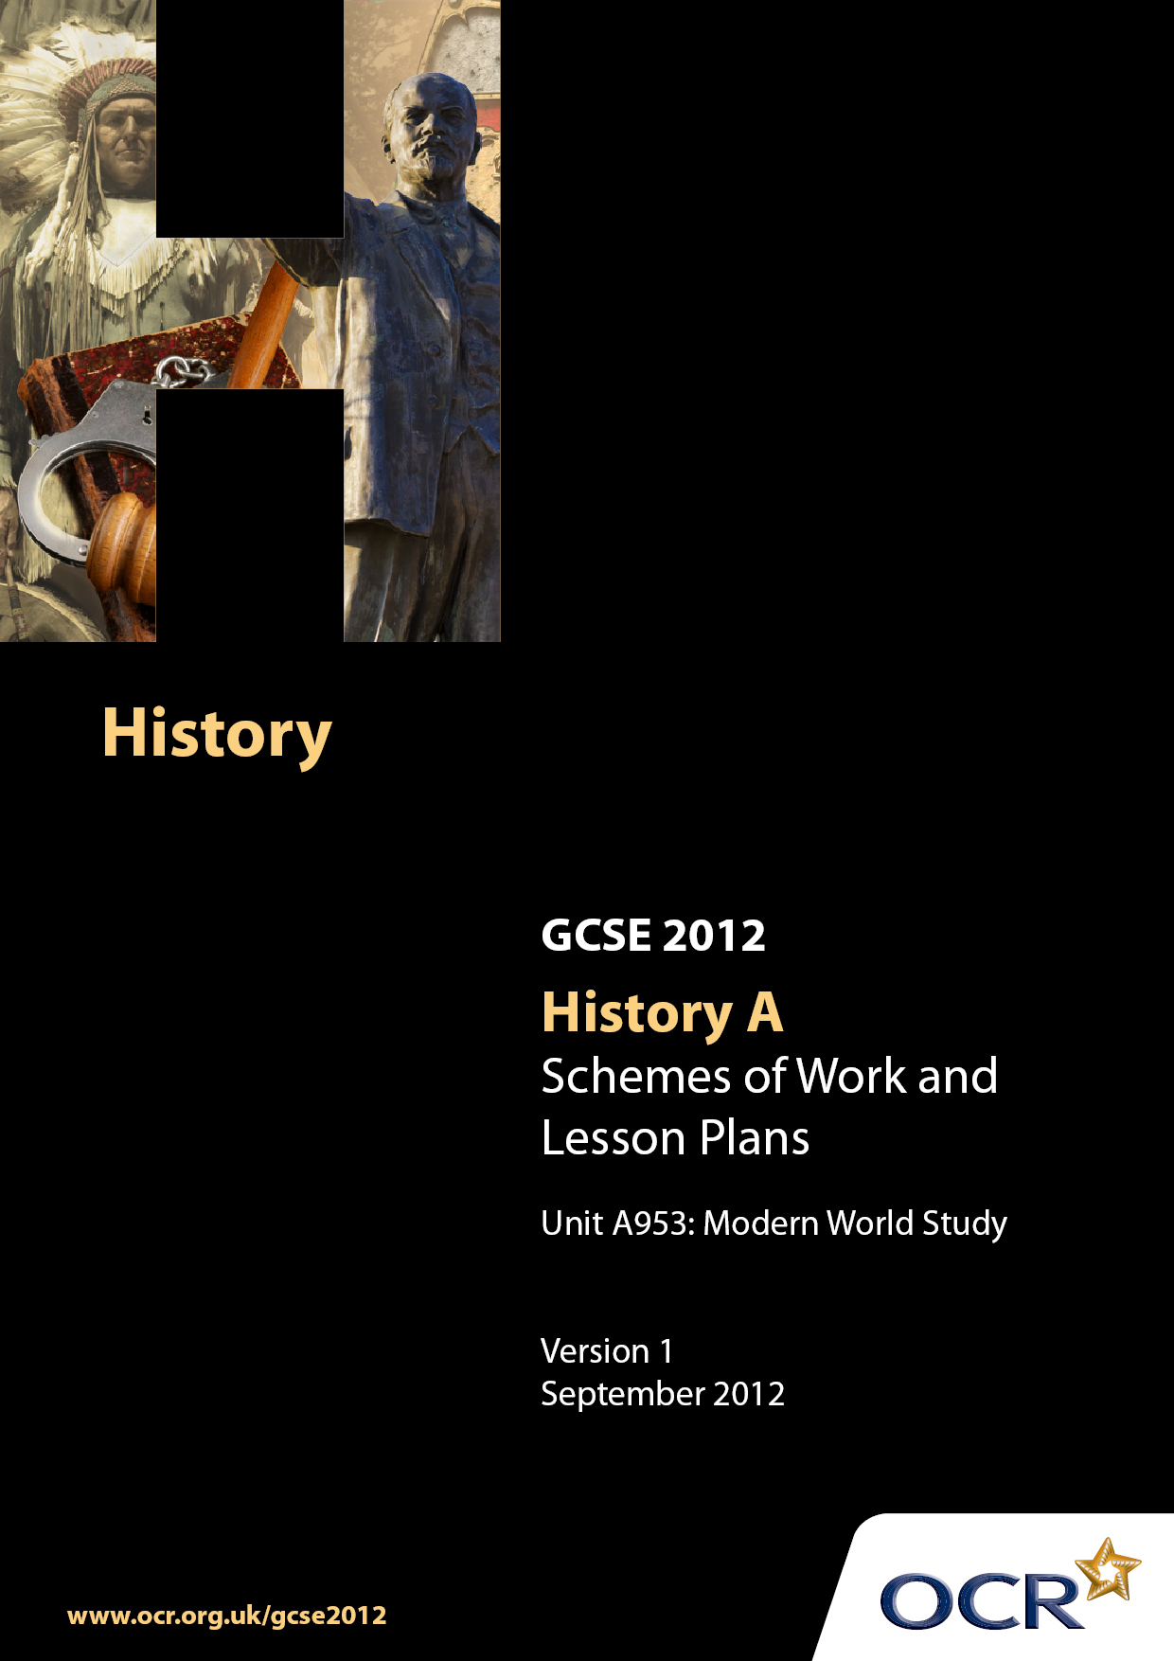

Contents
Introduction 3
Sample Scheme of Work: Unit A953: Modern World Study 6
Sample Lesson Plan: Unit A953:Modern World Study 9

Introduction

Background
Following a review of 14– 19 education and the Secondary Curriculum Review, the Qualifications and Curriculum Authority (QCA) has revised the subject criteria for GCSEs for first teaching in September 2009. This applies to all awarding bodies.
The new GCSEs have more up-to-date content and encourage the development of personal learning and thinking skills in your students.
We have taken this opportunity to redevelop all our GCSEs to ensure they meet your requirements. These changes will give you greater control of assessment activities and make the assessment process more manageable for you and your students. Controlled assessment will be introduced for most subjects.
From September 2012 assessment tasks may be undertaken at any point between release of the task and the examination series for which the task must be submitted. Centres must ensure that candidates undertake a task that is valid for submission in the year in which the candidate intends to submit it.
OCR has produced a summary brochure, which summarises the changes to History A. This can be found at www.ocr.org.uk along with the new specification.
In order to help you plan effectively for the implementation of the new specification, we have produced these Schemes of Work and sample Lesson Plans for History A. These Support Materials are designed for guidance only and play a secondary role to the Specification.

Our Ethos
OCR involves teachers in the development of new support materials to capture current teaching practices tailored to our new specifications. These support materials are designed to inspire teachers and facilitate different ideas and teaching practices.
Each Scheme of Work and set of sample Lesson Plans is provided in Word format – so that you can use it as a foundation to build upon and amend the content to suit your teaching style and students’ needs.
The Scheme of Work and sample Lesson Plans provide examples of how to teach this unit and the teaching hours are suggestions only. Some or all of them may be applicable to your teaching.
The specification is the document on which assessment is based and specifies what content and skills need to be covered in delivering the course. At all times, therefore, this Support Material booklet should be read in conjunction with the specification. If clarification on a particular point is sought, then that clarification should be found in the specification itself.

A Guided Tour through the Scheme of Work

= Innovative Teaching Idea
This icon is used to highlight exceptionally innovative ideas.


= ICT Opportunity
This icon is used to illustrate when an activity could be taught using ICT facilities.

Unit A953: Modern World Study
Suggested teaching time | 6 hours | Topic | The election of president Obama: A long time coming?  Explain how important the election of president Obama has been in changing perceptions of the united states
Topic outline |  | Suggested teaching and homework activities |  | Suggested resources | Points to note
Introduction  (one hour) |  | - See Lesson Plan |  | - Coursework pack (individual copies of relevant cartoons)  - IWB with cartoons loaded onto system  - A3 paper/marker pens | - Designed to engage students’ interest and give them ownership of the coursework – what do they need to find out given the coursework question and how will THEY move this on?
Martin Luther King and Civil Rights Movement  (2 hours) |  | - Timeline of activity – colour coded according to type of action (i.e. violent – code red, non-violent – code green etc.  - Write speech trying to persuade people to become involved.  - Write television report based on a series of events using sources to highlight different events. |  | - Modern World History: Ben Walsh  - USA 1917-1980: Nigel Smith  - Video - Channel4: Race in the 20th Century: Civil Rights  - Video - Channel4: Heroes or Villains: Martin Luther King | - Understanding of the depth of feeling is important here as well as an understanding of the huge racial divide
JFK and The New Frontier / LBJ and The Great Society  (1 hours) |  | - What was the New Frontier? /The Great Society. Design the front cover of a book which includes blurb to sum up the achievements of both presidents |  | - Modern World History: Ben Walsh  - USA 1917-1980: Nigel Smith  - Possible ICT application for production of front cover | - The idea is to ask students to focus directly on the achievements
The USA Presidents post Lyndon B Johnson  (4 hours) |  | - Group work to build up a wall of fame on each president since LBJ. Groups work together on a single president and then the exhibition is “opened” and “visited” by all. There should be comment on each president’s achievements and criticisms on that president. George W Bush should not be included. The main features of both domestic and foreign policy should be considered |  | - List of American presidents since LBJ  - ICT and library resources for research | George W Bush should not be included
George W Bush  (10 hours) |  | - Having “visited” their exhibition, students should now commence work on a study of George W Bush as president. The focus should be on how his policies have changed attitudes towards the USA around the world. Different aspects of his policies could be covered e.g. 9/11, the war against terror, the Iraq War, Afghanistan, his policies relating to climate change, some domestic policies...This material could be covered by a mixture of teacher- led lessons and student research. The focus must be on how Bush' s policies have changed attitudes about the USA and its role in the world |  | - ICT and library resources for research

Possible sources for this topic

Source A

DVD footage – from skynews.com published on The Sun website as below.

http://www.thesun.co.uk/sol/homepage/news/the_real_american_idol/article1895211.ece

If copyright problem then the ‘see in pictures’ link on the bbc website is a good alternative but does not move or have speech

http://news.bbc.co.uk/1/hi/world/americas/us_elections_2008/7710449.stm

Source B
The new dawn… Sun cartoon about Obama’s victory published in the Sun 6/11/08
http://www.thesun.co.uk/sol/homepage/news/the_real_american_idol/article1898860.ece

Source C
President-elect Obama speaking on Tuesday 4th November at 11.56pm as his success is confirmed.
http://news.bbc.co.uk/1/hi/world/americas/us_elections_2008/7710038.stm
http://www.barackobama.com/2008/11/04/remarks_of_presidentelect_bara.php

Source D
John McCain speaking on Tuesday 4th November as he welcomed president-elect Barack Obama and conceded defeat as a Republican.
http://opiniojuris.org/2008/11/05/new-dawn-of-american-leadership-is-at-hand/
2nd grey box down

Source E
Shaun Bailey prospective Tory MP

The Sun: 6th November 2008

http://www.thesun.co.uk/sol/homepage/news/the_real_american_idol/article1898860.ece

Unit A953: Modern World Study

Introduction to coursework
OCR recognises that the teaching of this qualification above will vary greatly from school to school and from teacher to teacher. With that in mind this lesson plan is offered, as a possible approach but will be subject to modifications by the individual teacher.
Lesson length is assumed to be one hour.

Learning Objectives for the Lesson
Objective 1 | Introduce topic and engage students’ interest
Objective 2 | Develop students’ thinking skills
Objective 3 | Analysis of sources – how were the interpretations of this event different on the day?
Objective 4 | Develop awareness of knowledge and understanding needed to complete task
Objective 5 | To begin the investigation of this historical event

Recap of Previous Experience and Prior Knowledge
- This is the first lesson but it would be beneficial if students have studied the translantic slave trade and its abolition.

Content
Time | Content
5 minutes | STARTER: Watch Sky News footage or BBC slides showing the election of Barack Obama
10 minutes | The main issue should be displayed for all students to see: “The election of President Barack Obama; a long time coming? Explain how important the election of President Obama has been in changing attitudes in the USA, and attitudes in the rest of the world about the USA”. Divide the class in half (or into threes depending upon the number of cartoons used). Each half (group) is given a copy of one of the cartoons. Students now have to answer the question: “What is the message of this cartoon?” Some groups could consider attitudes within the USA, other groups could consider attitudes of the rest of the world towards the USA.
10-15 minutes | FEEDBACK: A spokesman from each group should come to the front of the class and annotate their copy of the cartoon (either on IWB or by handing out copies of their cartoon).
10 minutes | Students now have to decide what questions they need answered in order to address the main issue. Different cartoons have shown different messages/perceptions at the time, e.g. there is the racial issue (first black president), the second is that there was a desperate need for change in the American leadership, and the third is the USA's attitude towards the rest of the world and the rest of the world's perception of the USA. In silence for three minutes students should write a list of three questions they think should be asked in order to answer the main issue. They then join up with a partner and compare questions and have two minutes to revise the list, which should still include three questions, which are considered the most important. Each pair then joins up with another pair and they decide on a final three questions which they think need to be answered in order to answer this question.
10-15minutes | Students should now choose the most important question to help them address the main issue. Use large pieces of A3 paper and marker pens for each group to write their question. Representative comes to the front of the class to hold up their question and explain why this is their most important question. Fix the pieces of paper to a wall/whiteboard.

Consolidation
Time | Content
10 minutes | PLENARY: Which are the best questions? Students should have raised questions in three categories – those that will allow focus on the civil rights movement, those of which will allow analysis of previous presidents of the USA, and those that focus on attitudes towards the USA in the rest of the world.

