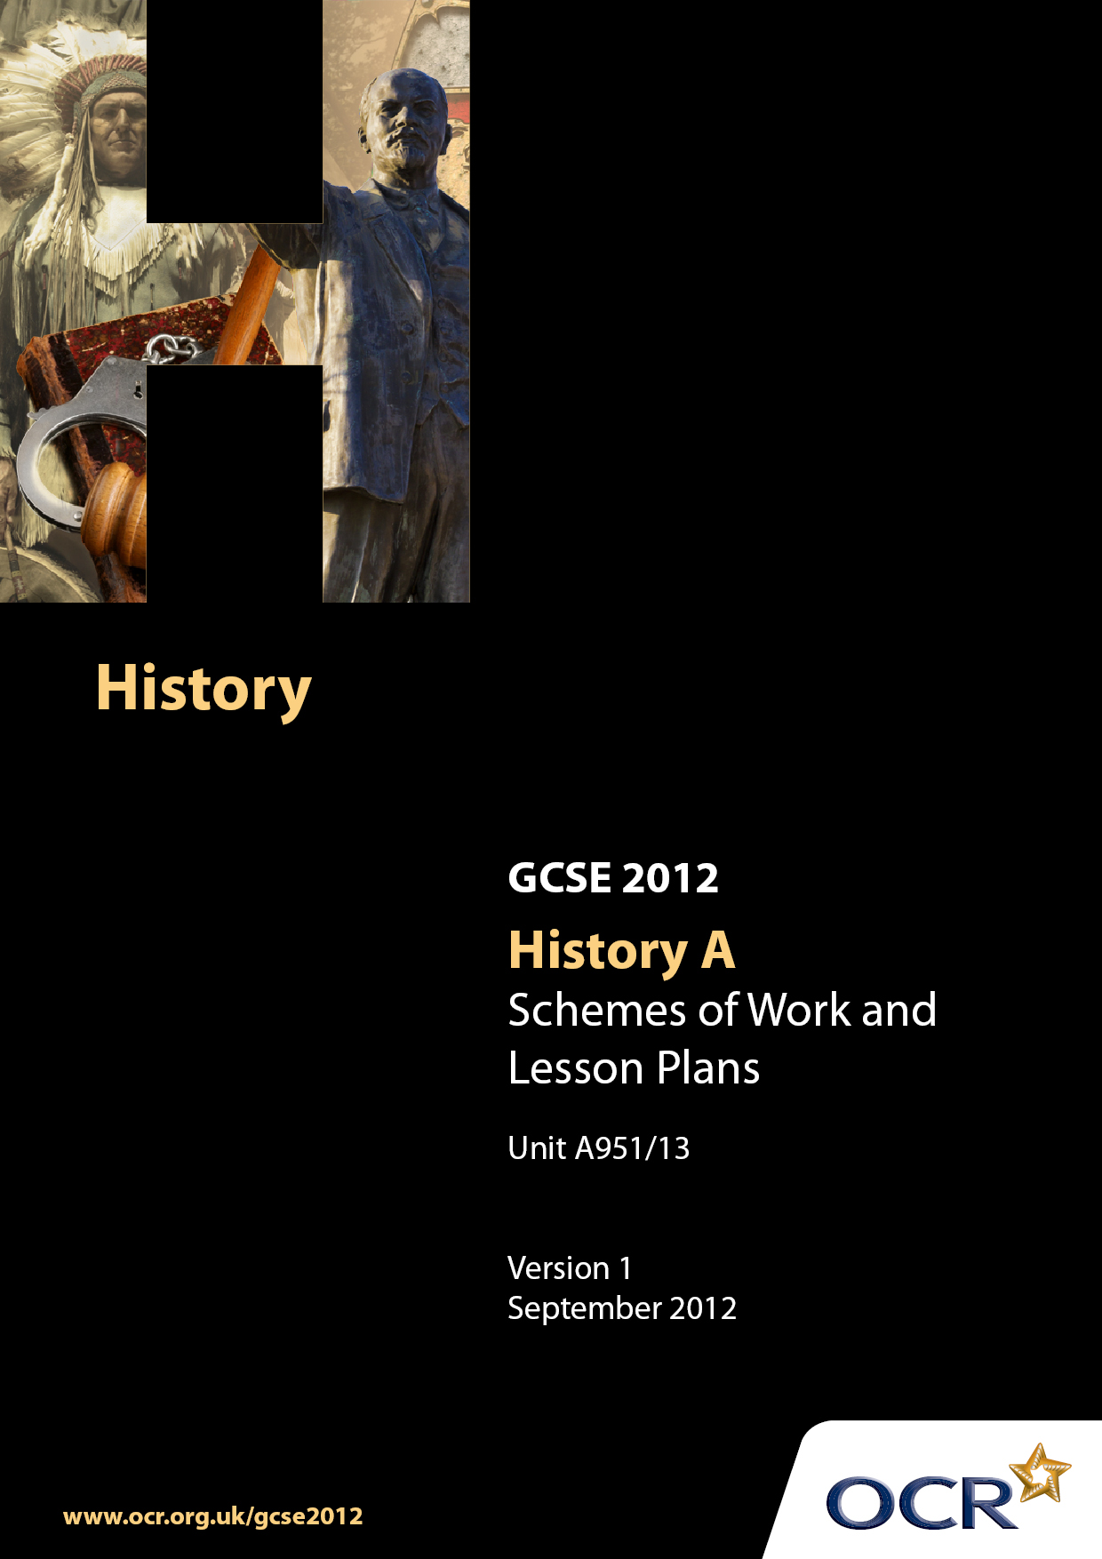

Contents
Contents 2
Introduction 3
Sample Scheme of Work: Unit A951: The American West, 1840–1895 5
Sample Lesson Plan: Unit A951: The American West, 1840–1895 18

Introduction

Background
Following a review of 14–19 education and the Secondary Curriculum Review, the Qualifications and Curriculum Authority (QCA) has revised the subject criteria for GCSEs for first teaching in September 2009. This applies to all awarding bodies.
The new GCSEs have more up-to-date content and encourage the development of personal learning and thinking skills in your students.
We have taken this opportunity to redevelop all our GCSEs to ensure they meet your requirements. These changes will give you greater control of assessment activities and make the assessment process more manageable for you and your students. Controlled assessment will be introduced for most subjects.
From September 2012, assessment tasks may be undertaken at any point between release of the task and the examination series for which the task must be submitted. Centres must ensure that candidates undertake a task that is valid for submission in the year in which the candidate intends to submit it.
OCR has produced a summary brochure, which summarises the changes to History. This can be found at www.ocr.org.uk along with the new specification.
In order to help you plan effectively for the implementation of the new specification, we have produced these Schemes of Work and sample Lesson Plans for History. These Support Materials are designed for guidance only and play a secondary role to the Specification.

Our Ethos
OCR involves teachers in the development of new support materials to capture current teaching practices tailored to our new specifications. These support materials are designed to inspire teachers and facilitate different ideas and teaching practices.
Each Scheme of Work and set of sample Lesson Plans is provided in Word format – so that you can use it as a foundation to build upon and amend the content to suit your teaching style and students’ needs.
The Scheme of Work and sample Lesson Plans provide examples of how to teach this unit and the teaching hours are suggestions only. Some or all of them may be applicable to your teaching.
The specification is the document on which assessment is based and specifies what content and skills need to be covered in delivering the course. At all times, therefore, this Support Material booklet should be read in conjunction with the specification. If clarification on a particular point is sought, then that clarification should be found in the specification itself.

A Guided Tour through the Scheme of Work

= Innovative Teaching Idea
This icon is used to highlight exceptionally innovative ideas.


= ICT Opportunity
This icon is used to illustrate when an activity could be taught using ICT facilities.

Unit A951: The American West, 1840–1895
Suggested teaching time | 10 hours | Topic | The American West
Topic outline |  | Suggested teaching and homework activities |  | Suggested resources | Points to note
Key Question 2: Why did people settle and stay in the West?  Were white Americans likely to settle the Plains?  What was 'Manifest Destiny'? |  | - What were the attitudes of white Americans towards the Native Americans? Give students a range of sources including Catlin, ask them to collect words which might be used by white Americans to describe the Native Americans. Discuss any common patterns / stereotypes. Create a culture clash chart listing Indian and white perspectives on a range of themes, eg beliefs, marriage, property, land, warfare, homes. Put students in groups and ask them to draw or create a freeze frame to represent one aspect of culture clash. Present then ask groups to try to work out a) reasons why these attitudes are so different and b) the likely consequences in terms of settlement on the Plains.  - Students to write two television news reports, one sympathetic and one hostile to the Indians to summarise the issues.  - What was 'Manifest Destiny'? Give students a copy of a painting from p51 Martin & Shephard or a similar illustration including several different people or features. Ask them to add speech bubbles to several people in the scene showing their hopes and fears. Collect range of ideas and compare the sentiments in this source to those in others. Get students to explain the term to each other and to draw images underneath the phrase which exemplify it. A suitable extension tasks would be to work out which groups of people would be likely to promote the ideas of manifest destiny and why. Students to select from a range, eg railway company manager, farmer, politician, East Coast mayor etc.  - Who settled in the West and Why? Introduce the investigation question for the next few weeks, create a display on which to collect key points as the learning progresses |  | - The American West 1840-1895 , Dave Martin & Colin Shephard p44-51, John Murray  - Observations of George Catlin; Catlin classroom.edu  - Illustrations on pages 50-51 of The American West by Martin and Shephard - pictorial representations of Manifest Destiny | Recap prior learning of Plains climate and The Permanent Indian Frontier combined with white American attitudes to set context for likely expansion. Key focus of this introduction is to understand background factors influencing white migration ie why white people were so hostile to the Native Americans and the influence of Manifest Destiny.  Possible stretch and challenge question to link back to learning about Native Americans would be:  What would be the biggest problem for the Native American if the whites began to settle?  - Stress the difference between the term ‘Manifest Destiny’ and the ideas behind it; who might have been likely to have used the term (including its origins) and who might not. Ask the class to identify the biggest barrier to manifest destiny ie that Indians are on the land  - An example of this would be a learning tree to represent the big picture - on which each branch could be a different group and the ideas of manifest destiny and culture clash could be written on the trunk. Use key words and images as appropriate
In what ways were the mountain men important? |  | - Students to quickly mind map Indian lifestyles. Pairs to examine the early experience of mountain men recording how their lifestyles were either similar or different to Native Americans. Show short clip from film including stereotypes of mountain men to review learning. Discuss the interpretation shown and which features seem to be based in reality. Are there any important features which are missing from the film representation? Recap learning by giving students answers to possible questions (rendezvous, Rocky Mountain Fur Company, guides, knowledge of land, fur etc) and ask them to create the questions  - Students write a letter to the Bismarck Tribune in response to an article claiming that mountain men were just as savage as Indians and had nothing to contribute to American civilisation |  | - www.Xmission.com – online resource library  - Mountain Men- History on the net  - First 5 minutes of film, ‘A Man Called Horse’.  - The American West 1840-1895 , Dave Martin & Colin Shephard p54-57, John Murray | - Students will examine the experiences of the first wave who crossed the Plains i.e. mountain men, pioneers and miners  - Letters will explain the impact mountain men have on Native Americans and the Plains in the long term as well as evaluating their similarities with Native Americans
What were the experiences of the first pioneer families in the 1840s when they travelled West? |  | - Students will examine the journey across the Great Plains of early pioneers on the trails to Oregon and California. Students to research information on: i) Why they want to move to Oregon/ California ii) What to pack (preparation) iii) Which trail to follow , iv) What dangers they might face. Share findings including the fact that they think is most surprising and most interesting  - Would the children have enjoyed the journey? Students could reflect in particular on the experience for children ie the excitement, fears, comparison to usual life. They could participate in trail games played by pioneer families: carving soap dollies/ three legged races/ apple bobbing/ marbles/ pick up sticks  - Produce a 'pull and push' chart showing reasons why people went West. Were push factors more important than pull?  - Carry out independent research using text book or web sources. Plot examples of the experiences of 3 different families as they journeyed across the Plains to the far West. Show their experiences on a living graph - look for hopes and happiness and dangers and disasters. Include the infamous Donner Party in your sample of families  - Groups to design a snakes and ladders style board game based on the journey west |  | - www.oregonpioners.com  - Accounts/diaries of pioneers- end of the trail  - The American West 1840-1895 , Dave Martin & Colin Shephard p58-67, John Murray  - Refer to U tube for several spoofs but also  the following documentary featuring the excavation of the Donner site: http://uk.youtube.com/watch?v=WgKSvkLngXI | - Groups to peer assess and award marks for use of knowledge and creativity in applying knowledge
What was life like for the 49ers? |  | - Students to use Museum CA virtual museum to research the lives of the 49ers. Students to focus upon why go west?, the journey, life and work in the towns and conflicts between races. Students to construct a mock interview with a 49’er in 1852 about the last three years of their life. Incorporate questions and answers covering each of the research themes  - Use visual source eg cartoon of a gold miner to reinforce learning ie how useful is this source about life as a gold miner? What does and doesn’t the source reveal? What else might influence its value?  - Contrast the experiences of the journey West with the Mountain Men and Pioneers. Which of the groups would have had most impact on: a) the Native Americans? b) the Plains’ environment c) the public perception of the potential of the Great Plains |  | - The American West 1840-1895, Dave Martin & Colin Shephard p78-81  - Gold Rush site: www.isueducation | - Class to add to learning tree with motives and key features of groups so far
Why did the Mormons go West?  How were the Mormons able to survive the journey and be successful in Salt Lake Valley? |  | - What do we know about the Mormons? Complete a KWL chart as a framework for this sub topic: What do we Know, Want to know and have Learnt? Start with recent newspaper articles about the Mormons then give an overview of their significance within this depth study  - What were the origins of the Mormons? Students could work in pairs: one to read out loud the story of the golden plates from a given source / textbook, the other to draw a cartoon strip to summarise the main events and Mormon ideas  - Create a chart of key Mormon beliefs and beside each the reactions of the gentiles / non Mormon Americans  - Review gentile attitudes towards the Mormons by looking at some anti Mormon propaganda (cartoon and letters are in text books). How much do these sources tell us about the early stages of Mormonism?  - Create a diagram to show the movement of the Mormons up to and including the journey across the Plains. Diagrams should include key reasons why they left each settlement (push and pull factors). Students could compete to work out an effective way of remembering these different towns and the factors behind each move  - Students could be creating factfiles on Young & Smith as an ongoing research homework task  - Research about the journey across the Plains including the advance party and the Winter Quarters. Students can demonstrate their learning by creating a list of rules for Mormons on the move and a series of letters between a member of the advance party and his wife in the main Mormon group. The letters could be written by students working in pairs, one as husband, the other as wife. Compare the Mormon journey to that of the Donner Party  - Make cards of key information surrounding Mormon settlement at Salt Lake Valley and subsequent events leading up to independence in 1896. Give students a key question eg ‘How did the Mormons make a success of Salt Lake Valley?’ or for more able students, ‘How successful were the Mormons in settling on the Plains?’ Students to sort the cards into different categories and construct a diagram on flipchart paper of their answer. Share ideas then check learning by playing taboo on key Mormon words (students describe the term without using a given list of words including the key word itself)  - Compare the contribution of Smith & Young to the success of the Mormons by holding a verbal boxing match / debate. Give the class a hypothesis and allocate 2 sides eg ‘Joseph Smith caused more problems than he solved for the Mormons' (use as a practice match) then ‘Brigham Young was far more important than Smith in making the Mormons a success on the Plains.’ Award points for each argument supported with detail. Vote on whether key points made could be considered knockouts. Declare an overall winning team |  | - The American West 1840-1895 Dave Martin & Colin Shephard, p72-81 | - Stress that the Mormons are a different group to those we have looked at in that they deliberately chose to settle in a particularly inhospitable part of the Plains. They were also outside mainstream American society and as such have an interesting story to tell  - Add key points or images to the learning tree / diagram
Why did people move West to become Homesteaders in the 1860s and 70s?  How did the Homesteaders react to the problems which faced them on the Plains? How far did they solve their problems?  What was life like for women on the homesteads? |  | - Students to examine the main motivations the homesteaders had for settling on the plains. Consider push and pull factors in the 1860s and 70s compared with the 1840s. Collect these on a table or diagram.  - Compare the Homestead Act and the Timber & Culture Act and see if the class can work out the motivation behind each of these pieces of legislation. Add these to the push and pull chart. Discuss whether all homesteaders travelled for the same reasons.  - Put descriptions of each problem and associated solution on different cards and give one to each student. Ask the students to move around the room until they have found their partner ie the matching problem / solution. Encourage them to make three way relationship / links between different factors. Add to their understanding by researching one real family’s experience – write  - Show an example of an exaggerated representation of life on the Plains (cartoon, letter in press, advert). Discuss how and why these sorts of interpretations became popular. How much do they tell us about life on the Great Plains?  - Was life harder for a woman on the Plains than a man? Give criteria which could be considered to answer this question, then research typical experiences and roles of women homesteaders. Class discussion to attempt to agree an answer. Discuss ideas then everyone writes a short summary paragraph. The teacher or an appropriate volunteer writes / types up their short answer to the question. Class then moderates and amends this answer with individual students then amending or rewriting their own summary  - As a review activity, contrast the experiences of those who settled on the plains with those who moved through the plains. Use a word bank for students to match to certain groups to prompt revision of previous groups as well as comparisons ( eg resilient, unlucky, unpopular, savage, threatening…). |  | - The American West 1840-1895 Dave Martin & Colin Shephard, p. 82-93  - http://www.bbc.co.uk/schools/gcsebitesize/hi  story/shp/americanwest/homesteadersprobl  emsrev1.shtml  http://www.pbs.org/weta/thewest/program/  episodes/five/nebraska.htm  Letters from a Homesteader in Nebraska, back to his family (1872).  NB - The PBS The West website accompanied a major US documentary made in 2001. It includes information associated with each episode plus teaching resources and documents.  - Students could test their knowledge using  http://www.bbc.co.uk/apps/ifl/schools/gcsebit  esize/history/quizengine?quiz=homesteader  sproblemstest&templateStyle=history. | - Students will gain knowledge of the people who deliberately settled on the plains as opposed to moving across them (Mountain Men, Miners and Pioneers) or settle in unusual circumstances (Mormons) ie the homesteaders  - Include reference to the Homestead Acts as problems / solutions cards to reinforce understanding here  - A stretch and challenge opportunity would be for students themselves to determine the criteria needed for evaluation of women’s role on the Plains
How important were the railroad and the railroad companies in opening up the West? |  | - Examine railroad company adverts eg Martin & Shephard p83 – a land sale poster. Encourage students to interpret the poster by asking questions about its features including reference to the 5 Ws. What does this poster suggest about the Plains, the railroads and the Homesteaders? Does it match our knowledge of life on the Plains?  - Research to outline the main stages in the building of the railroad and the difference it made to the Homesteaders.  - Consider the impact of the railroads on different groups – rank the importance of the coming of the railroad for different interest groups eg Indians, bank manager, saloon keeper, boss of mining company, politician, journalist etc  - Make links between the coming of the railroads and the government policy of manifest destiny. Are there any other factors which interconnect to act as a turning point in Plains history? |  | - http://www.pbs.org/weta/thewest/program/  episodes/five/grandanvil.htm  - an overview of the coming of the railroad. | - Add to learning tree
How successful were the government and local people in establishing law and order in the mining towns? |  | - Brainstorm all the crimes that we have come across so far in our study of the American West. Review this list and add to it some examples eg claim jumping, fights etc. Then compare it to a list of top 10 crimes today (researched or brainstormed). What are the main causes of crime today? Can the class come up with 3 different causes of crimes in mining towns?  - Investigate the problems and solutions by sending a team of journalists into San Francisco or a similar town in the 1850s. Groups to produce exposes of the main crimes being committed, letters from concerned parties and an editorial offering suggestions to the townsfolk to clean up their town. Include examples of racism and the frustrations of the few townsfolk who want to make the town a permanent and civilised settlement |  |  | - You may chose to study this key question later in the SOW, after the investigation of the cattle industry. This way the turbulent nature of cow towns can be compared to that in mining towns, the conflict between cowboys and Homesteaders can form another element for investigation and the solutions found by miners can be seen against the backdrop of emerging law and order in general. You may also prefer to investigate these specific problems at the same time as studying the 49ers themselves  - Return to the learning tree / big picture diagram. To review the settlers studies in this section and evaluate their successes, the class could award medals or badges to different groups for any smart ideas, clever thinking, good fortune, bad luck or various other criteria

Unit A951/13: American West 1840-1895
OCR recognises that the teaching of this qualification will vary greatly from school to school and from teacher to teacher. With that in mind, this lesson plan is offered as a possible approach but will be subject to modification by the individual teacher.
Lesson length is assumed to be one hour.

Learning Objectives for the Lesson
Objective 1 | To describe the life of the mountain men
Objective 2 | To infer future Native American/ Migrant relations from the impact of the mountain men

Content
Time | Content
15 minutes | - Show short clip of start of film ‘A Man Called Horse’, then give students 5 minutes to create a labelled sketch summing up the type of person portrayed in the excerpt – their key features, skills and qualities.  - Share these with the rest of the class and use the most popular ideas as hypotheses to investigate and return to at the end of the lesson – was there any truth in this interpretation?
15 minutes | - Pairs to examine the early experience of mountain men recording on their sketch whether their initial inferences were accurate or not and adding new information.
10 minutes | - Students then work in small groups to compare mountain men with Indians – recording their ideas on similarities and differences table.  - Groups to share their ideas and establish whether each group found that there are more similarities than differences.  - Whole class discussion to consider the implications of these similarities for relationships with the Indians.
5 minutes | - Groups to discuss the effect mountain men had on Native Americans’ relationship with future migrants and the impact on patterns of migration in general.
10 minutes | - To consolidate learning students plan key features of a letter to the Bismarck Tribune to be completed for homework. The letter should defend the lifestyle of the mountain men, their relationship with the Native Americans and their contribution to American’s civilisation.  - Teacher can prepare a selection of newspapers/ newspaper style writing frame as appropriate for classes.

Consolidation
Time | Content
5 minutes | Write speech and thought bubbles for a range of characters in a painting or cartoon of Native Americans with mountain men eg the painting on p56 of the Martin & Shephard textbook. Ideas could include mixed opinions concerning the wisdom of forming relationships. Return to original hypotheses, how far were mountain men really like those in the film?

